

**Atypon Java and DevOps Bootcamp (Fall 2022)**

**Capstone Project**

**Decentralized Cluster-Based NoSQL DB System**

**Student Name : Diya Momani**

**Email :** [**diyamomani0@gmail.com**](mailto:diyamomani0@gmail.com)

**Github :** [**https://github.com/DiyaMomani**](https://github.com/DiyaMomani)

**Table of Contents**

**Introduction3**

What is the Decentralized Cluster-Based NoSQL DB? 3

What is the data model I used? 8

Why I used JSON files? 9

Schema9

What I used to build database?10

**Type chapter title (level 1)4**

Type chapter title (level 2)5

Type chapter title (level 3)6

**Type chapter title (level 1)4**

Type chapter title (level 2)5

Type chapter title (level 3)6

**Type chapter title (level 1)4**

Type chapter title (level 2)5

Type chapter title (level 3)6

**Type chapter title (level 1)4**

Type chapter title (level 2)5

Type chapter title (level 3)6

**Type chapter title (level 1)4**

Type chapter title (level 2)5

Type chapter title (level 3)6

**Type chapter title (level 1)4**

Type chapter title (level 2)5

Type chapter title (level 3)6

**Type chapter title (level 1)4**

Type chapter title (level 2)5

Type chapter title (level 3)6

**Type chapter title (level 1)4**

Type chapter title (level 2)5

Type chapter title (level 3)6

**Type chapter title (level 1)4**

Type chapter title (level 2)5

Type chapter title (level 3)6

**Introduction**

**What is the Decentralized Cluster-Based NoSQL DB?**

In this project I was asked to create Decentralized Cluster-Based NoSQL DB System, A decentralized cluster-based NoSQL database system is a distributed database system that operates on a peer-to-peer network architecture. It allows multiple nodes to share and store data without the need for a centralized authority. The system is designed to scale horizontally, meaning it can add nodes to the network as the data grows.

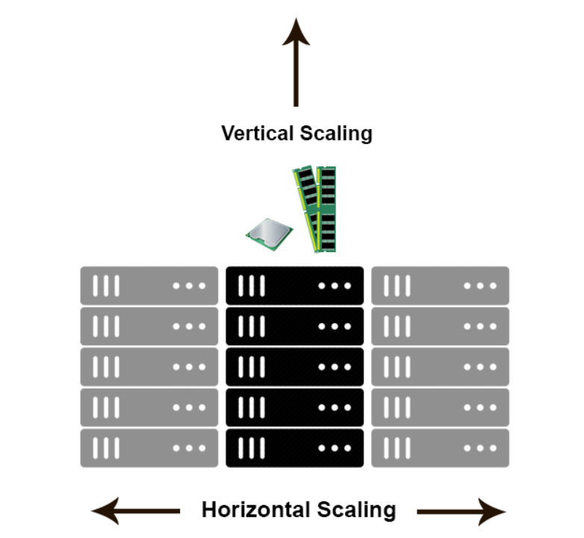

Figure-1 : shows the horizontal scale and how it is more scalable.

NoSQL, which stands for "not only SQL," is a type of database management system that doesn't rely on a traditional relational database structure. Instead, it uses a schemaless data model that allows for more flexible and dynamic data storage. NoSQL databases can store large amounts of unstructured data, making them ideal for big data applications.

NoSQL databases are better suited for applications that require scalability, flexibility, availability, performance, and cost-effectiveness, whereas SQL databases may be a better fit for applications that require strict adherence to a data schema and complex query operations.

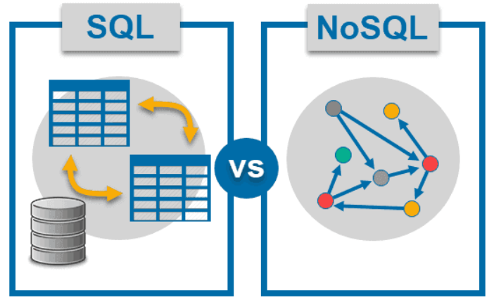

Figure-2 : shows NoSQL vs SQL databases .

In contrast to traditional centralized database systems, where data is stored on a single server, a decentralized cluster-based NoSQL database system allows data to be distributed across multiple nodes. This means that if one node fails, the other nodes can still access the data, ensuring high availability and fault tolerance.

The cluster-based NoSQL database system is also designed to be highly scalable. It can add new nodes to the network as needed to increase storage capacity and processing power. This allows the system to handle increasing amounts of data and growing user demand without any disruption to the service.

There are several types of decentralized cluster-based NoSQL database systems, each with its own unique architecture and features. Some examples include Cassandra, Riak, and Couchbase. And this is an explanation on Casandra database.

Figure-3: shows the Casandra database.

A decentralized cluster-based NoSQL database system is a powerful tool for handling large amounts of unstructured data in a distributed environment. By using a peer-to-peer network architecture and a schemaless data model, these systems can provide high availability, fault tolerance, and scalability for modern applications. As the demand for big data solutions continues to grow, we can expect to see more businesses adopting these decentralized NoSQL database systems to meet their data storage and processing needs.

In this project I focused on completing all the requirements completely , I created 3 main Intellj projects : worker, bootstrap and demo. I created database called worker and used data structures to store, organize, and manipulate data efficiently, making it easier to access and process. I used multithreading and locks to improve performance, responsiveness, resource sharing and synchronization, and also I used hashing to efficiently store and retrieve data in a data structure. I focused on security by using tokens. Top of Formalso I made my code follows the Clean Code principles and solid principles .

**What is the data model I used?**

There is three types of NoSQL database :Key-Value store, Document store and Graph store, I used Document store database because It allows for a flexible data model, as data is stored in documents, which can contain nested and complex data structures, making it easier to store data as it is.

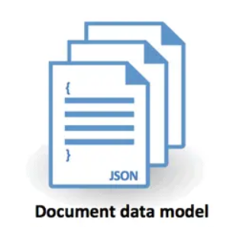

Figure-4: shows the document data model.

**Why I used JSON files?**

I used JSON files because they are Human-readable that means JSON is easy to read and understand for both humans and machines. Also JSON is a lightweight data format, which means that it requires less storage space compared to other data formats. JSON allows for a flexible data model, which is well-suited for document model NoSQL databases. It can represent complex data structures making it easier to store data as it is, without the need for data normalization. I used them to store the users, admins and schemas.

**Schema**

a schema is a logical data model that describes the organization and structure of a database. It can be thought of as a blueprint for a database. It provides a formal framework for organizing and storing data, and it specifies the rules that govern the relationships between the various elements of the database.

There is two types of schemas : strict and flexible , A strict schema is a data model that defines a fixed structure for data, with specific rules and constraints that must be followed. A strict schema is a data model that defines a fixed structure for data, with specific rules and constraints that must be followed.

In my project I gave the user the freedom to choose the type he want , he can enter the schema and store records depends on it , but in demo I allow the user to enter strict schema and the only condition of this schema that he should enter "Id" value.

**What I used to build database?**

I used **Java SE** as main programming language, Maven as build tool and dependency management, **Spring Boot** to create application .

**Database Implementation**

**Over View of system**

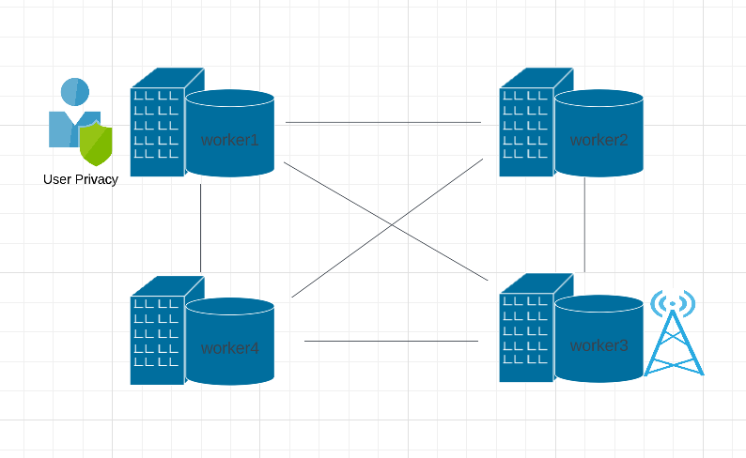

Figure-5: shows the over view of the system

I have four servers : worker1, worker2, worker3 and worker4, each of them has database/s to store records , each worker sends the records it receives to affinity node, and then affinity node will send it to the cluster, and from cluster to all other workers.

**The structure of database**

**The flow of data**

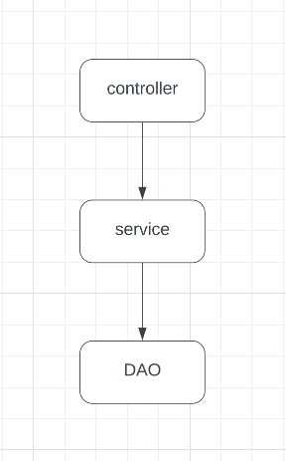

Figure-6: shows the general flow of data

Any request that will be send to server will follows this flow , first it will received by controller and send it to the affinity and check if the user or admin authorized , then send it to the cluster , and from cluster to all workers , and inside workers the controller will invoke the required function in service class, and this function will invoke the required function inside DAO class which will perform the changes required in database.

I will explain how to create database and the structure of it.

**Create database**

The user can create database by sending a request to the create Database URL, then the database will be created in this structure .

Figure-7: shows the database that created

So, when creating database it will create database folder called with the name specified by the user , and create an empty folder called schemas inside it to store the schema JSON file/s that contain the schema/s.

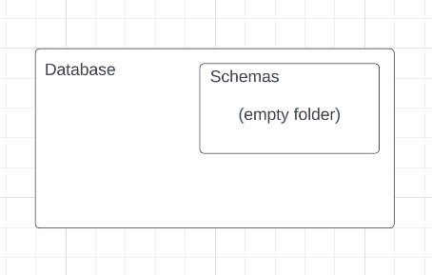

Figure-8: shows the structure of database before adding collection/s.

**Create collection**

The user can create database by sending a request to the create Collection URL, then the collection will be created in this structure .

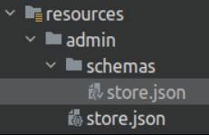

Figure-9: shows the database after add collection

So, when creating database it will create two JSON files called with the name specified by the user , one of them will be inside the schema folder and the another empty one out schema folder but inside database folder, and this is explanation of the structure.

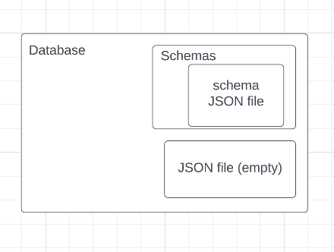

Figure-10: shows the structure of database after adding collection

Figure-11: shows the schema

1. Schema JSON file: the schema JSON file includes the schema that entered by user when creating collections.
2. Empty JSON file : It's outside the schemas file and it used to store all records that inserted by user.

There is a class called Schema checker class that check if the record that inserted by user matches the schema rules , and it follows the single responsibility solid principles.

**Add Record**

The user can add a record to database by sending a request to the add record URL, then the record will be added to the JSON file out the schema folder in this structure .



Figure-12 : shows the record array in json file after adding record.

When adding a record to the database it will be stored in the JSON file by taking the record as string and use objectMapper to read it as a JSON node, And it read this JSON by using objectMapper .

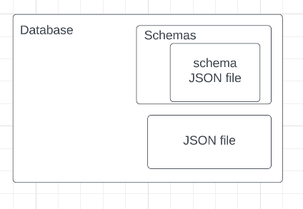

Figure-13: shows the structure of database after adding record

**Indexing and the data structure used**

I used hashing indexing in this project. So Hashing indexing is a technique used in computer science and database systems to quickly retrieve data based on a key or identifier.

The main advantage of using hashing indexing is its ability to provide constant-time access to data, regardless of the size of the dataset. This is achieved by using a hash function to map each key or identifier to a specific location in memory, where the associated data is stored.

Hashing indexing is commonly used in scenarios where data needs to be quickly accessed and retrieved, such as in database management systems, search engines, and data caches. It can be particularly useful in situations where there are large amounts of data to be searched through, as it allows for quick and efficient retrieval of specific data points.

Another advantage of hashing indexing is its ability to handle collisions, which occur when multiple keys map to the same location in memory. Hashing algorithms typically include methods for handling collisions, such as chaining or open addressing, which ensure that all data can still be accessed correctly even in the presence of collisions.

In my project , I implemented three indexing layers : Database Indexing , collection indexing and property indexing.

**Database indexing**

Database indexing is a HashMap , the key of it is a string database name , the value is collection indexing as follow :

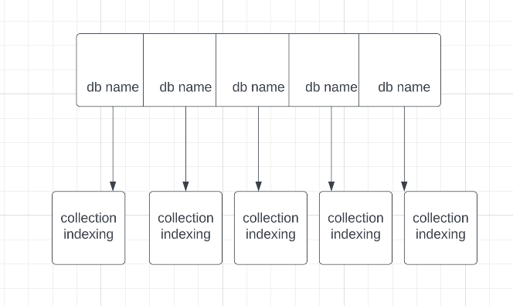

Figure-14: shows the database indexing

**Collection indexing**

Collection indexing is a HashMap , the key of it is a string collection name , the value is property indexing as follow :

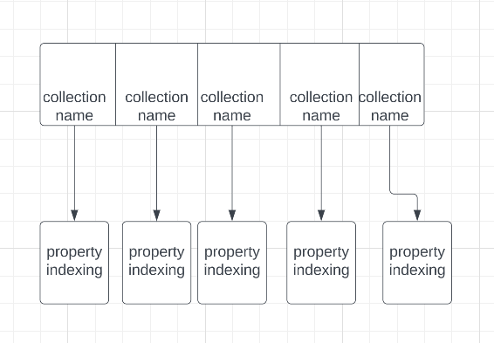

Figure-15: shows the collection indexing

**Property indexing**

Property indexing is a HashMap , the key of it is a string property name , the value is another HashMap that , the key of it is a string value name and the value is an integer list contains the indexes of JsonNode in the ArrayNode that has that value for the that property as a value as follow :

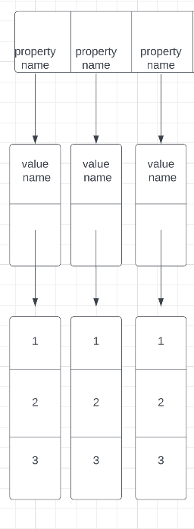

Figure-16: shows the property indexing

**Cluster and broadcasting**

A cluster refers to a group of connected computers that work together as a single system. Clusters are used to improve the performance and availability of computer applications, as well as to enable high-performance computing for scientific research, financial modeling, and other data-intensive tasks.

Clusters offer several benefits over traditional single-computer systems, including:

1. Scalability: Clusters can be easily scaled up or down depending on the needs of the application. This makes it possible to handle large workloads without requiring expensive upgrades to individual computers.
2. Fault tolerance: Clusters are designed to be fault-tolerant, meaning that they can continue to operate even if one or more nodes fail. This ensures that the application remains available and that data is not lost.
3. High performance: Clusters can process data in parallel, which can significantly improve performance for data-intensive tasks.
4. Cost-effectiveness: Clusters can be built using commodity hardware, which can significantly reduce the cost of building and maintaining a high-performance computing environment.

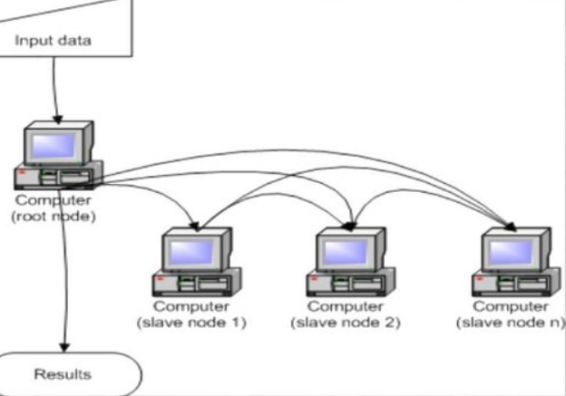

Figure-17 : the cluster explanation

Broadcasting is the process of sending a message or data packet to all devices connected to a network. The purpose of broadcasting is to distribute information or updates to all devices in a network simultaneously.

In the context of a cluster, broadcasting can be used to distribute messages or data between nodes in the cluster. When a message or data packet is broadcast to all nodes in a cluster, it ensures that all nodes receive the same information at the same time, which is essential for maintaining consistency and coordination among the nodes.

For example, in a load-balancing cluster, a central load balancer may broadcast instructions to all the nodes in the cluster, directing them to perform certain tasks or to distribute the workload among the nodes. This ensures that all nodes in the cluster are aware of the current state of the workload and can coordinate their actions accordingly.

Broadcasting can also be used for fault-tolerance in clusters. For instance, in a high-availability cluster, if a node fails, a broadcast message can be sent to all other nodes in the cluster, instructing them to take over the workload of the failed node. This ensures that the workload is distributed evenly across the remaining nodes, preventing any one node from becoming overloaded.



Figure-18: the clusters

In my project I used cluster system , and it is represented with Broadcast class in cluster package . And the flow will be like this :

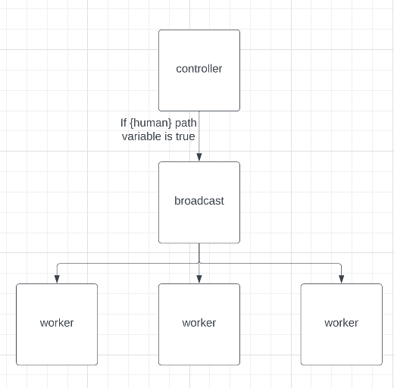

Figure-19: shows the flow of request if it was from human

The controller will receive the request and then check if the path variable {human} in the URL is true (if the URL sent by human not by the cluster ), if it is true , then it will invoke the appropriate function in broadcast class . and the function in broadcast class will send the URL to all workers and change the {human} from true to false to indicate that this time the sender is the cluster class not a human.

The **Broadcast** class has several methods, each responsible for a different HTTP request. The methods are:

* **BuildDataBase**: Sends a GET request to create a new database.
* **buildCollection**: Sends a POST request to create a new collection in a database.
* **addRecord**: Sends a POST request to add a new record to a collection.
* **deleteRecord**: Sends a GET request to delete a record from a collection.
* **Update**: Sends a PUT request to update a property of a record in a collection.
* **deleteDatabase**: Sends a DELETE request to delete a database.

All of the methods take a list of URLs as input and send the same HTTP request to each URL in the list. The response from each request is logged to the console, and if an error occurs, an error message is returned.

I will explain one of these functions line by line, for example:

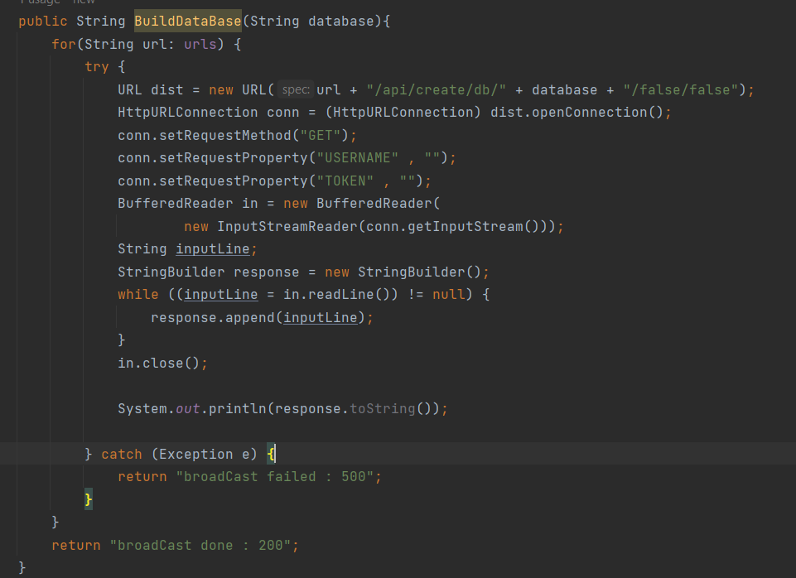

Figure-20: shows the BuildDataBase function in broadcast class

1. **URL dist = new URL(url + "/api/create/db/" + database + "/false/false");**

This line creates a new **URL** object named **dist** by concatenating the **url** variable with a specific string pattern, including the **database** variable in the URL.

1. **HttpURLConnection conn = (HttpURLConnection) dist.openConnection();**

This line opens a connection to the **URL** object **dist** using the **openConnection** method, which returns a **URLConnection** object. This **URLConnection** object is then cast to an **HttpURLConnection** object and assigned to the variable **conn**.

1. **conn.setRequestMethod("GET"); conn.setRequestProperty("USERNAME" , ""); conn.setRequestProperty("TOKEN" , "");**

These lines set the request method to **"GET"** and add two request properties named **"USERNAME"** and **"TOKEN"** to the **HttpURLConnection** object. The values for these properties are empty strings.

1. **BufferedReader in = new BufferedReader( new InputStreamReader(conn.getInputStream()));**

**String inputLine;**

**StringBuilder response = new StringBuilder(); while ((inputLine = in.readLine()) != null) {**

**response.append(inputLine);**

**}**

**in.close();**

This code creates a new **BufferedReader** object called **in** that reads from the input stream of the **HttpURLConnection** object **conn**. The code then reads each line of the input stream using **in.readLine()** and appends each line to a **StringBuilder** object called **response**. The **BufferedReader** is then closed using the **close()** method.

1. **System.out.println(response.toString());**

This line prints the contents of the **StringBuilder** object **response** to the console.

**Affinity and load balancing**

An affinity node is a technique used in computer networking and load balancing to ensure that a user's requests are consistently sent to the same server or node.In a load-balanced environment, requests from a user are distributed across multiple servers to ensure that no single server is overloaded.

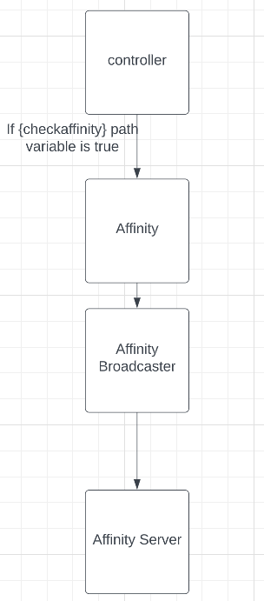

Figure-21: the flow of affinity process in my code

The controller will receive the request and then check if the path variable {checkaffinity} in the URL is true (if the URL sent the first time and required to check the affinity ), if it is true , then it will invoke the appropriate function in Affinity class that generate the port of affinity node server ,and then invoke the appropriate function in AffinityBroadcast that receives the port of affinity node and send the request to it, and change the {checkaffinity} from true to false to indicate that this time it is not needed to check the affinity node.

**Multithreading**

Multithreading is a technique in computer programming where a single program or process can have multiple threads of execution running concurrently, allowing multiple tasks to be performed simultaneously within the same program. A thread is a lightweight sub-process within a program that can be executed independently and shares the same memory space as the main process.

There are several reasons why multithreading is used in computer programming. One of the primary reasons is to improve the overall performance and efficiency of the program. By using multiple threads, a program can take advantage of modern computer architectures with multiple processing cores or CPUs. By dividing a task into smaller sub-tasks and running them in parallel, a multithreaded program can perform calculations or other tasks much faster than a single-threaded program.

Another reason to use multithreading is to improve the responsiveness and interactivity of a program. By separating long-running tasks from the main thread of execution, a program can continue to respond to user input and events in a timely manner, even while performing complex calculations or I/O operations in the background.

Multithreading is also commonly used in networking and server applications, where multiple clients may connect and request services simultaneously. By using a separate thread to handle each client connection, a server can handle multiple requests concurrently without blocking or slowing down other clients.

multithreading also introduces some challenges, such as the need to manage shared resources and prevent race conditions and deadlocks. Proper synchronization techniques and thread-safe programming practices must be used to ensure the correct behavior and performance of a multithreaded program.

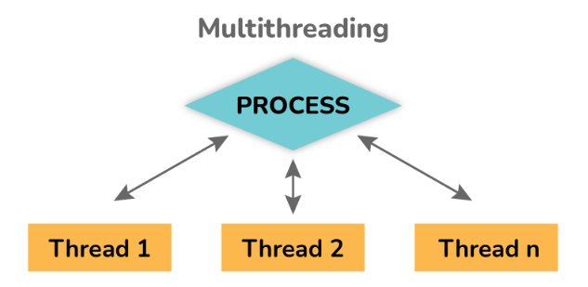

Figure-22: multithreading

I have a package in my code called configuration , that contain one function called AsyncExecuter that configures and returns an Executor bean, which is used for asynchronous method execution in Spring.

I used **@Async** annotation , **@Async** is an annotation used to indicate that a method should be executed asynchronously. When a method is marked with **@Async**, it means that it should be executed in a separate thread from the caller's thread. This allows the caller to continue with its work without waiting for the method to complete, making the application more responsive and efficient.

**Docker and Containerization**

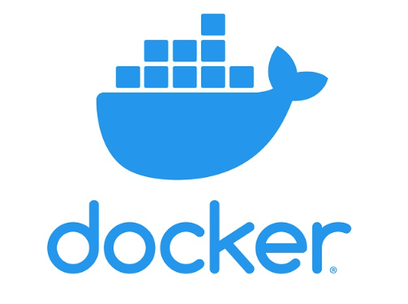

Figure-23: docker logo

**Introduction to Containerization**

Containerization is a technology that enables software to be packaged into self-contained, portable environments that can run consistently across different platforms. In the past, software applications were installed directly onto a host operating system, which could lead to compatibility issues when the same application was run on different platforms. Containerization solves this problem by isolating the application and its dependencies from the host operating system, allowing it to run in a consistent environment across different platforms.

**What is Docker?**

Docker is a platform that enables developers to build, ship, and run applications in containers. Docker provides a set of tools and APIs for creating and managing containers, as well as a registry for storing and sharing container images. With Docker, developers can easily package their applications and dependencies into a single container image, which can then be run on any platform that supports Docker.

**How Does Docker Work?**

Docker uses a client-server architecture, where the Docker client communicates with the Docker daemon to create, manage, and run containers. The Docker daemon runs on the host operating system and is responsible for managing the containers and their resources. Containers are created from images, which are essentially pre-configured templates that define the application and its dependencies. When a container is created, Docker creates a virtual environment that isolates the container from the host operating system, ensuring that it runs consistently across different platforms.

In this project, I have used Docker and containerization to create images for three separate components: Bootstrap, Worker, and demo. This process involved packaging each component into a container, which provides a self-contained, consistent environment that can be easily transported and deployed on different platforms and environments.

By containerizing each component, I was able to simplify the testing and deployment process and ensure that the application runs consistently across different environments. This is because each container includes all the necessary dependencies and libraries, which eliminates compatibility issues and reduces the risk of errors occurring during deployment.

**Docker Files**

The Dockerfiles used in this project started by specifying a base image, which included the OpenJDK runtime environment required for running Java applications. The working directory for the Docker container was then set, and the contents of the application, including code, dependencies, and other necessary files, were copied to the container.

The EXPOSE command was used to specify the port on which the container will be listening for incoming network connections. Finally, the CMD command specified the command to be executed when the container starts up, which in this case was to run the web application JAR file with the java executable and make it accessible through the exposed port. Overall, containerization simplified the testing and deployment process by providing a consistent and portable environment for the application.

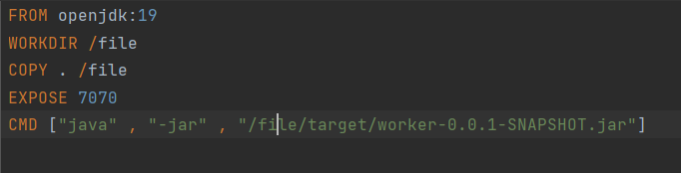

Figure-24: Docker file in my project

**Docker composed file**

A Docker Compose file is a YAML file used to define and configure multiple Docker containers as a single application. It allows you to define the services that make up your application, their dependencies, and how they communicate with each other.

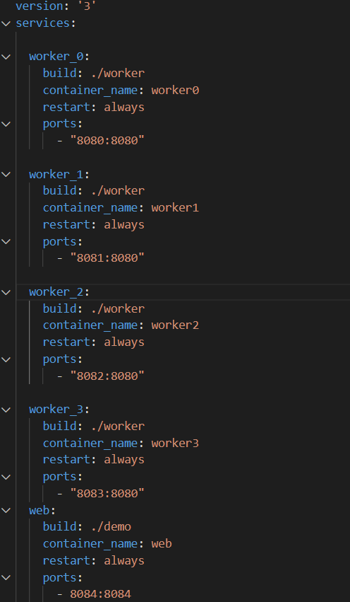

Figure-25: Docker composed

In this example, there are six services defined:

* Four instances of a worker service, each built from the same Dockerfile located in the "./worker" directory. Each instance has a unique name and is exposed on a different port, allowing for load balancing across the workers.
* A web service, built from a Dockerfile in the "./demo" directory. This service is responsible for hosting the web application and is exposed on port 8084.
* A bootstrap service, built from a Dockerfile in the "./bootstrap" directory. This service is responsible for initializing the worker instances and is exposed on port 6060. It depends on the four worker services to be running before it starts.

The configuration options for each service include the build context, container name, restart policy, exposed ports, and dependencies on other services.