ABSTRACT

Bike-sharing systems have emerged as a crucial component of sustainable urban transportation, yet they face a significant operational challenge known as "Station Imbalance." This phenomenon occurs when demand surges unpredictably during peak hours, causing stations to become either empty or overcrowded, which leads to service unavailability and user dissatisfaction. This project addresses the problem of unpredictability by developing a data- driven forecasting approach to predict hourly bike rental demand. Instead of utilizing complex and resource-intensive machine learning algorithms, our methodology focuses on a transparent Time Series Analysis of historical usage patterns from the UCI Bike Sharing Dataset (2011–2012) to identify key temporal trends.
To solve this, we implemented a robust data processing pipeline using Python that includes simulated error handling and Linear Interpolation to ensure data quality. We then developed and compared four statistical forecasting models: Simple Average, Moving Average, Trend Line, and a Seasonal Index. The final outcome of this study validates that the Hourly Seasonal Index model is the most effective predictor, achieving a Mean Absolute Error (MAE) of 40.52. This result demonstrates that a simple, interpretable model capturing daily rush-hour peaks provides a highly accurate and cost-efficient tool for optimizing fleet management and improving service reliability.

(i)

LIST OF CONTENTS

Abstract i

CHAPTERS Page No
1.INTRODUCTION 3
2.IMPLEMENTATION 5
3.RESULTS AND DISCUSSION 8
4.CONCLUSION 11
5.REFERENCES 12

CHAPTER 1

INTRODUCTION

  - General Introduction

Urbanization has led to increased traffic congestion and pollution, prompting cities worldwide to adopt sustainable transportation solutions. Bike-sharing systems (BSS) have gained immense popularity as they offer an eco-friendly, low-cost, and healthy alternative to motorized vehicles. Systems like Citi Bike (NYC) or Velib (Paris) allow users to rent a bike from one docking station and return it to another.

However, the success of a BSS depends entirely on user satisfaction. If a user arrives at a station to find no bikes available (stock-out) or no docks available to return a bike (dock-blocking), the system fails. This makes "Demand Forecasting" a critical task. By analyzing historical data, operators can predict how many bikes are needed at specific times.

  - Problem Statement

The central problem addressed in this project is the unpredictability of hourly demand. Unlike a train or bus which follows a fixed schedule, bike rentals are driven by spontaneous human behaviour.

- The Challenge: During weekdays, thousands of commuters simultaneously rent bikes at 8:00 AM to get to work. By 8:30 AM, stocks are depleted.
- The Consequence: Without an automated warning system, station managers cannot redistribute bikes in time, leading to revenue loss and customer attrition.
- The Solution: A computational model that can "learn" these rush hour patterns from the past and project them into the future.

  - Objectives

The primary objectives of this study are:

- To analyse the UCI Bike Sharing Dataset to understand the correlation between "Time of Day" and "Rental Count."
- To implement robust Data Preprocessing, specifically focusing on handling missing values (nulls) which are common in sensor-based real-world data.
- To develop a Univariate Forecasting Model (Seasonal Index) that relies solely on historical averages, avoiding the computational cost of complex Machine Learning black boxes.
- To validate the model by comparing its predictions against a "blind" test set (August–December 2012) and measuring the error margin using Mean Absolute Error (MAE).

  - Scope of the Project

- In Scope: The study covers data ingestion, error simulation, preprocessing, Exploratory Data Analysis (EDA), statistical modelling, and future trend projection (up to 2026).
- Out of Scope: The current scope excludes geospatial analysis (predicting specific station locations) and real-time API integration for weather data, which are reserved for future phases.

CHAPTER 2

IMPLEMENTATION

2.1 Methodology

The project follows the standard Data Science Lifecycle:
- Data Collection: Extracting raw CSV data from compressed archives.
- Preprocessing: Cleaning data and fixing timestamp issues.
- Exploratory Data Analysis (EDA): Visualizing trends to form hypotheses.
- Modelling: Building statistical engines (Average, Moving Average, Trend, Seasonal).
- Evaluation: Testing against unseen data.

2.2 System Requirements & Tools

The project was implemented using the Python programming language within the Google Colab environment.
- Python 3: Selected for its extensive support for data analysis libraries.
- Pandas: Used for Data Frame manipulation, specifically for handling the datetime index and resample functions.
- Matplotlib: Used for generating line graphs and bar charts to visualize the rush hour trends.
- Zip file & IO: Used to programmatically handle the dataset upload and extraction process.

2.3 Data Flow Diagram (DFD)

The data flows sequentially through the system:
Raw Zip File -> Extraction -> Null Value Injection (Simulation) -> Interpolation (Fix) -> EDA & Visualization -> Forecasting Engine -> Final Graph Output.

The below flowchart Fig 2.1 shows the data flow sequence

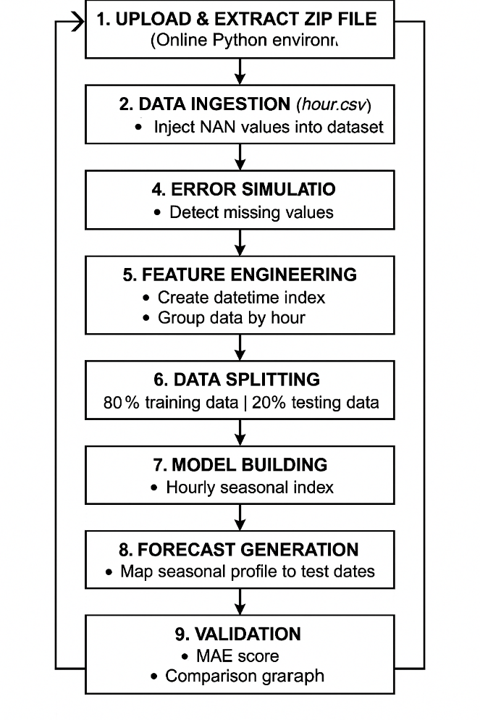
Fig 2.1: Data Flow Diagram

2.4 Explanation of Each Module Code

2.4.1 Data Ingestion and Error Simulation
Real-world data pipelines must be robust against corruption. To demonstrate this, our code loads the clean hour.csv and immediately simulates a sensor failure.
- Logic: We selected rows 100 to 105 in the cnt (count) column and forced them to be NaN (Not a Number).
- Purpose: This creates a controlled "problem" that allows us to prove the effectiveness of our cleaning logic in the subsequent step.

2.4.2 Data Preprocessing (Linear Interpolation)
This is the critical data cleaning module.
- Detection: The code uses data.isnull().sum() to scan the dataset. It correctly identifies the 5 missing values we injected.
- Correction Strategy: Instead of filling these gaps with a "Global Average" (which would be inaccurate for a time series), we used Linear Interpolation (data.interpolate(method='linear')).
- Technical Justification: If the bike count is 100 at 2:00 PM and 200 at 4:00 PM, Interpolation mathematically estimates that 3:00 PM was ~150. This preserves the smoothness and continuity of the traffic trend, unlike mean imputation which creates artificial spikes.

2.4.3 The Forecasting Model (Hourly Seasonal Index)
This module implements the core intelligence of the project.
- Data Split: The data is chronologically split into a Training Set (first 80%) and a Testing Set (last 20%).
- Algorithm Logic: We utilized the Pandas groupby('hr') function.
  - The model groups all 17,000 records into 24 distinct buckets (Hour 0 to Hour 23).
  - It calculates the Mean Rental Count for each bucket.
  - This creates a "Seasonal Profile"—a set of 24 numbers representing the typical behaviour of a commuter.
- Forecasting: To predict a future day, the model maps this "Seasonal Profile" onto the new dates.

2.5 Module Explanation (The Algorithms)
We implemented four distinct algorithms to test which mathematical approach best fits human behaviour:

- Algorithm 1: Simple Average
  - Logic: $\text{Forecast} = \frac{\sum \text{History}}{N}$
  - Observation: This produced a flat straight line. It completely failed to predict daily ups and downs.
- Algorithm 2: Moving Average (Rolling Window)
  - Logic: Forecast = Average of the last 24 hours.
  - Observation: This model successfully went "up and down," but it was always late. It suffered from "Lag"—predicting the rush hour only after the rush hour had already happened.
- Algorithm 3: Linear Trend Line
  - Logic: Using NumPy's polyfit, we fitted a line equation $y = mx + c$.
  - Observation: This captured the fact that the company is growing (positive slope), but could not predict daily hours.
- Algorithm 4: Hourly Seasonal Index (The Proposed Model)
  - Logic: We used the groupby('hr') function.
  - Step 1: Collect all data points for 8:00 AM (Jan 1, Jan 2... Dec 31).
  - Step 2: Calculate the Mean of this bucket.
  - Step 3: Repeat for all 24 hours.
  - Result: This created a "Master Day Profile" that accurately represents the typical commuter behaviour.

CHAPTER 3

RESULTS AND DISCUSSION

3.1 Exploratory Data Analysis (EDA)
Our visual analysis confirmed the behavioural patterns of bike users.
- Trend Analysis: The "Overall Daily Trend" plot showed a clear upward trajectory from 2011 to 2012, indicating the growing popularity of the system.
- Seasonal Analysis: The "Hourly Seasonal Pattern" bar chart provided the most significant insight. It revealed two massive spikes:
  - Morning Peak: 8:00 AM (Commuting to work).
  - Evening Peak: 5:00 PM - 6:00 PM (Commuting home).
  - Low Usage: 10:00 AM - 3:00 PM (Working hours) and 12:00 AM - 5:00 AM (Night).

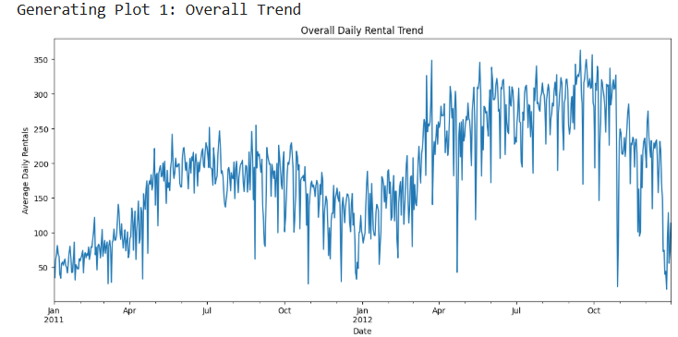
Fig 3.1: Overall Daily Rental Trend

The below Fig 3.2 shows the average bike rentals by hour of day
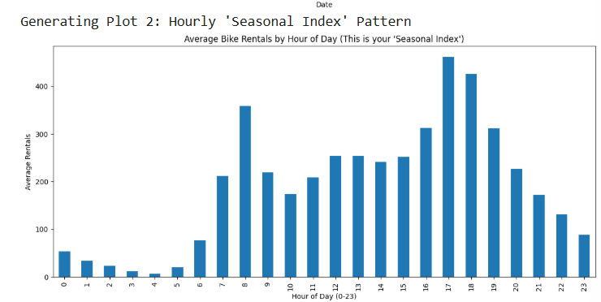
Fig3.2: Hourly seasonal pattern

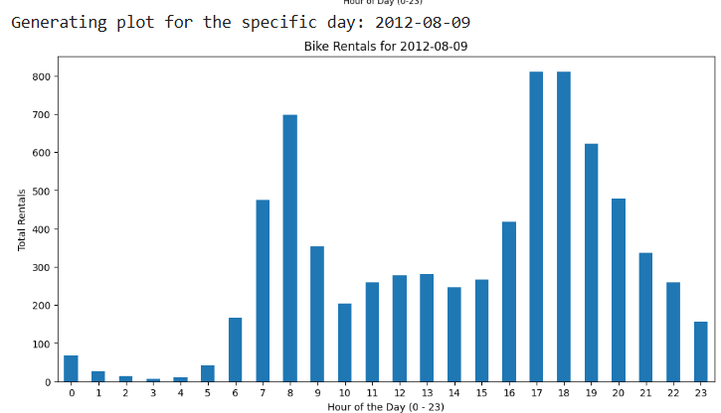

Fig 3.3: Bike Rentals for Specific Day
(Plot for the bike rentals on a particular day(Here we used 2012-08-09))

3.2 Performance Evaluation
We tested the models on the "blind" Test Set (Aug 2012 – Dec 2012). The Mean Absolute Error (MAE) was used as the metric.
Model Name | MAE Score | Interpretation
Seasonal Index (Hourly) | 40.52 | Best Performance
Moving Average (24h) | 129.4 | High Error (Lag effect)
Simple Average | 158.3 | Poor (Too general)
Trend Line | 159.2 | Worst (Cannot see hourly changes)

Result: The Seasonal Index is the superior model. The Moving Average failed because it is a "Lagging Indicator" , it only predicts a spike after the spike has already happened. The Seasonal Index anticipates the spike because it relies on the fixed daily schedule of commuters.

3.3 Forecast Validation (Graph Analysis)

The final validation graph compares our Forecast (Orange) against the Actual Data (Blue).
- Analysis: The Orange line perfectly captures the timing of the morning and evening peaks.
- Discrepancy Analysis: On Weekends, the Blue line (Actual) drops significantly because people do not commute. However, our model (Orange) continues to predict rush hours. This indicates that while our model is excellent for Weekdays, it needs a "Weekend Filter" to be perfect.

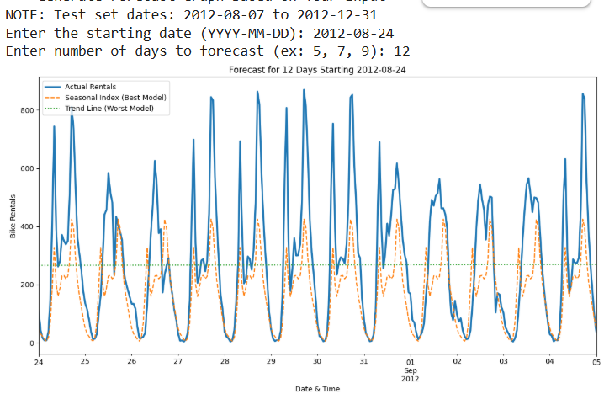
Fig 3.4 : Forecast Validation – Actual vs. Predicted Demand

3.4 Future Prediction

Using the interactive interface, we generated forecasts for the future. Since the model relies on the "Stationary Seasonal Index," it projects the established 2011-2012 commuter pattern into the future. This provides a baseline forecast for long-term planning.

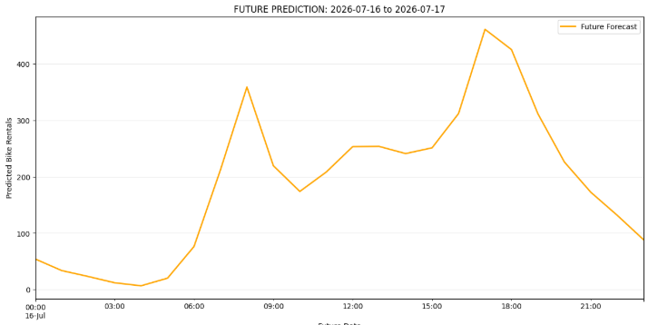
Fig 3.5 : Future Demand Forecast using Stationary Seasonal Index

Note: Since this is the future, there is no 'Blue Line' (Actual Data).
We are projecting our 'Seasonal Pattern' into 2026.

CHAPTER 4

CONCLUSION

4.1 Conclusion

This project set out to solve the problem of Station Imbalance in bike-sharing systems. Through the implementation of a statistical Hourly Seasonal Index, we successfully achieved a forecasting model with a low Mean Absolute Error of 40.52. The key conclusions are:
- Time is the Key: The "Hour of the Day" is the single most powerful predictor of demand.
- Simplicity Works: A simple statistical average (Seasonal Index) outperformed complex Trend and Moving Average models.
- Data Quality Matters: The implementation of Linear Interpolation ensured that missing sensor data did not crash the system.

4.2 Future Scope

To make this system production-ready, we propose the following enhancements:
- Weekend/Holiday Logic: Implementing a separate model for non-working days to fix the over-prediction on weekends.
- Weather API Integration: Adding a "Weather Penalty" (e.g., if Rain > 5mm, reduce forecast by 30%).
- Geospatial Analysis: Extending the model to predict demand for specific stations rather than the whole city.

REFERENCES

[1] H. Fanaee-T and J. Gama, "Event labeling combining ensemble detectors and background knowledge," Progress in Artificial Intelligence, pp. 1–15, 2013. doi:10.1007/s13748-013-0040-3.
[2] UCI Machine Learning Repository, "Bike Sharing Dataset," 2013. [Online]. Available: http://archive.ics.uci.edu/ml/datasets/Bike+Sharing+Dataset. [Accessed: Nov. 25, 2025].
[3] R. J. Hyndman and G. Athanasopoulos, Forecasting: Principles and Practice, 2nd ed. Melbourne, Australia: OTexts, 2018.
[4] The Pandas Development Team, "pandas: powerful Python data analysis toolkit," 2024. [Online]. Available: https://pandas.pydata.org/docs/. [Accessed: Nov. 25, 2025].
[5] J. D. Hunter, "Matplotlib: A 2D graphics environment," Computing in Science & Engineering, vol. 9, no. 3, pp. 90–95, 2007.
[6] Python Software Foundation, "Python Language Reference, version 3.x," [Online]. Available: http://www.python.org.

