**Department of Computer Science and Engineering** **Data Science**

**Academic Year:** 2024-2025 **Name of Student:** Diya Thakkar

**Semester:** VI **Student ID:** 22107040

**Class / Branch:** TE CSE (DS) **Date of Performance:**27-1-25 **Subject:** ML Lab **Date of Submission:**27-1-25

**Name of Instructor:** Prof.Ujwala Pagare

**Experiment No. 1**

**Aim:**- To study and perform simple programs based on basic Python libraries and tools

**Program:-**

**1. NUMPY:**

**import numpy as np**

arr **=** np.array([**1**, **2**, **3**, **4**, **5**])

**print**(arr)

**Output:-**

**

*operations*

**import** numpy **as** np

*# Creating two arrays of rank 2*

x **=** np.array([[**1**, **2**], [**3**, **4**]])

y **=** np.array([[**5**, **6**], [**7**, **8**]])

*# Creating two arrays of rank 1*

v **=** np.array([**9**, **10**])

w **=** np.array([**11**, **12**])

*# Inner product of vectors*

**print**(np.dot(v, w),"\n")

**print**(np.dot(x, v),"\n")

**print**(np.dot(x, y))

**Output:**

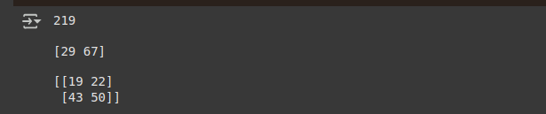**2. PANDAS**

*# arranging a givenset of data into a table*

*# importing pandas as pd*

**import** pandas **as** pd

data **=** {"country": ["Brazil", "Russia", "India", "China", "South Africa"],

"capital": ["Brasilia", "Moscow", "New Delhi", "Beijing", "Pretoria"],

"area": [**8.516**, **17.10**, **3.286**, **9.597**, **1.221**],

"population": [**200.4**, **143.5**, **1252**, **1357**, **52.98**] }

data_table **=** pd.DataFrame(data)

**print**(data_table)

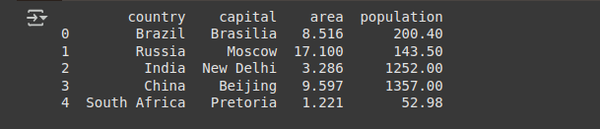**3. MATPLOTLIB:**

**import** matplotlib.pyplot **as** plt

**import** numpy **as** np

xpoints **=** np.array([**0**, **6**])

ypoints **=** np.array([**0**, **250**])

plt.plot(xpoints, ypoints)

plt.show()

**Output:**

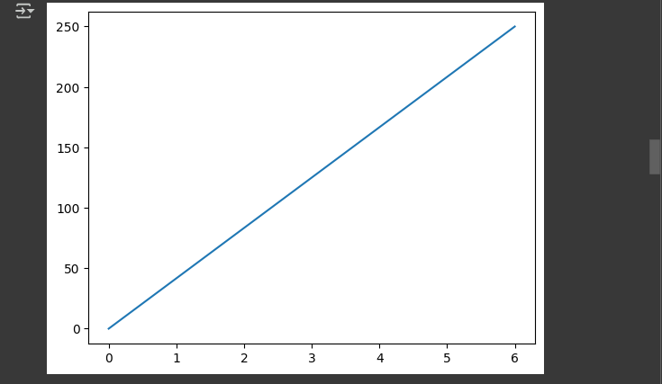

**4. SciPy stands for Scientific Python:**

*#importing the scipy and numpy packages*

**from** scipy **import** linalg

**import** numpy **as** np

*#Declaring the numpy array*

A **=** np.array([[**1**,**2**],[**3**,**4**]])

*#Passing the values to the det function*

x **=** linalg.det(A)

*#printing the result*

**print**(x)

**Output:**

**5. Tensorflow**

**import** tensorflow **as** tf

model **=** tf.keras.models.Sequential([

tf.keras.layers.Flatten(input_shape**=**(**28**, **28**)),

tf.keras.layers.Dense(**128**, activation**=**'relu'),

tf.keras.layers.Dropout(**0.2**),

tf.keras.layers.Dense(**10**)

])

**Output:**