**Department of Computer Science and Engineering** **Data Science**

**Academic Year:** 2024-2025 **Name of Student:** Diya Thakkar

**Semester:** VI **Student ID:** 22107040

**Class / Branch:** TE CSE (DS) **Date of Performance:**27-1-25 **Subject:** ML Lab **Date of Submission:**27-1-25

**Name of Instructor:** Prof.Ujwala Pagare

**Experiment No. 2**

**Aim:**- To implement Linear Regression using python.

**Program:-**

**import pandas as pd**

**import** numpy **as** np

**import** seaborn **as** sns

**import** matplotlib.pyplot **as** plt

**from** sklearn.metrics **import** mean_squared_error

HouseDF **=** pd.read_csv('USA_Housing.csv')

HouseDF.head()

**Output:**

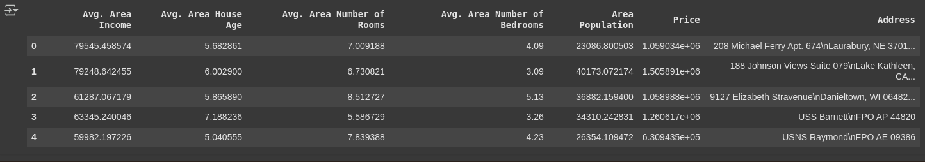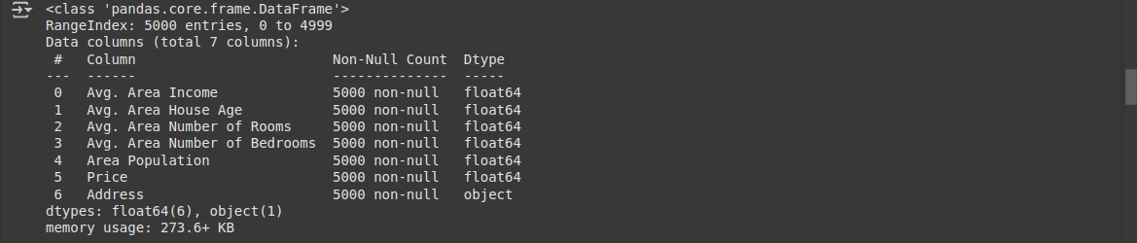HouseDF.info()

HouseDF.describe()

**Output:**

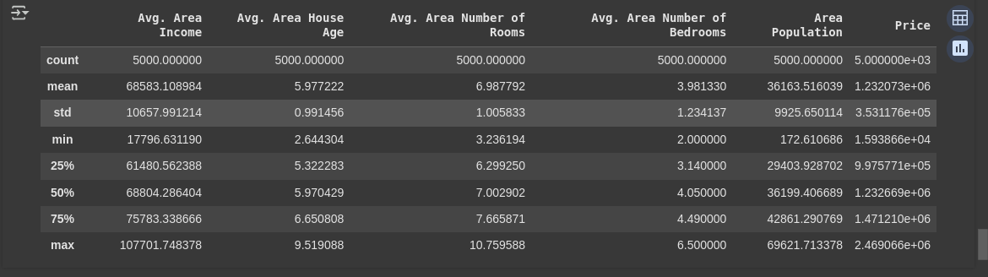HouseDF.columns

Output:



sns.pairplot(HouseDF)

**Output:**

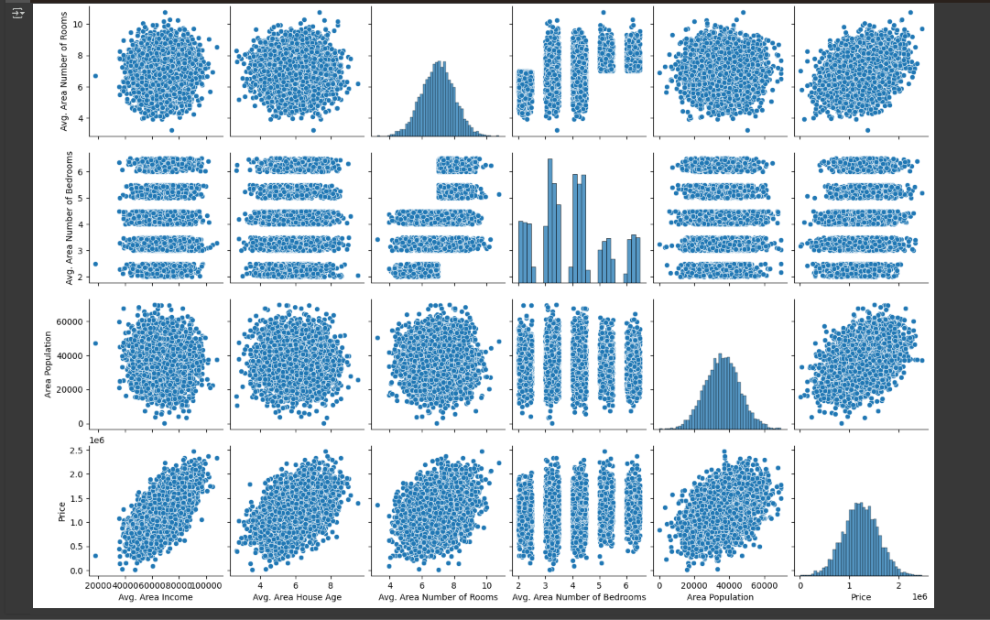

*#sns.heatmap(HouseDF.corr(), annot=True)*

*# Select only numerical features for correlation calculation*

numerical_features **=** HouseDF.select_dtypes(include**=**np.number)

*# Calculate and plot the correlation matrix*

sns.heatmap(numerical_features.corr(), annot**=True**)

**Output:**

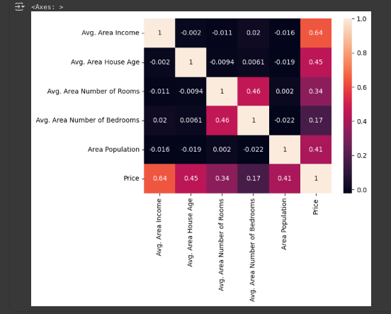

X=HouseDF[['Avg. Area Income', 'Avg. Area House Age', 'Avg. Area Number of Rooms', \

'Avg. Area Number of Bedrooms', 'Area Population']]

y **=** HouseDF['Price']

**from** sklearn.model_selection **import** train_test_split

X_train, X_test, y_train, y_test **=** train_test_split(X, y, test_size**=0.4**,

random_state**=101**)

X_train

Output:

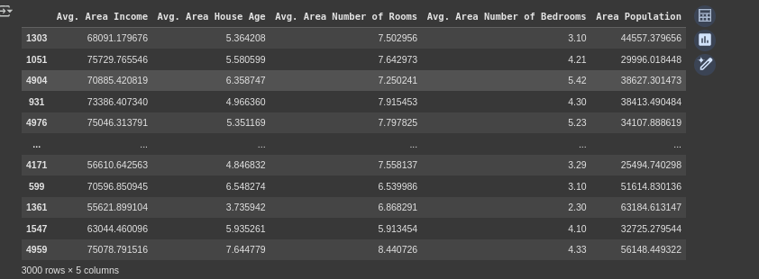

**from** sklearn.linear_model **import** LinearRegression

lm **=** LinearRegression()

lm.fit(X_train,y_train)

**Output:**



coeff_df **=** pd.DataFrame(lm.coef_,X.columns,columns**=**['Coefficient'])

coeff_df

**Output:**

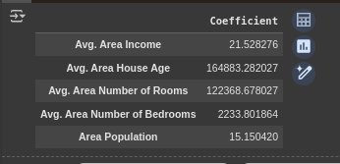

predictions **=** lm.predict(X_test)

plt.scatter(y_test,predictions)

sns.distplot((y_test**-**predictions),bins**=50**);

Output:

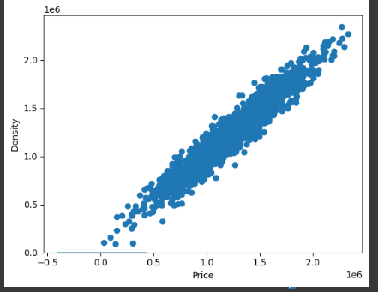

*#Regression Evaluation Metrics*

*#Mean Squared Error and R-squared for model evaluation*

mse **=** mean_squared_error(y_test, predictions)

mse

**from** sklearn **import** metrics

**print**('MAE:', metrics.mean_absolute_error(y_test, predictions))

**print**('MSE:', metrics.mean_squared_error(y_test, predictions))

**print**('RMSE:', np.sqrt(metrics.mean_squared_error(y_test, predictions)))

*# Instead of overwriting y_test, create a new variable*

*# for the numpy array to avoid confusion and potential errors.*

y_test_numeric **=** np.array(HouseDF.loc[X_test.index, 'Price'], dtype**=**np.float64)

*# Now use y_test_numeric for the MSE calculation*

mse_sum **=** **0**

**for** i **in** **range**(**len**(y_test_numeric)):

prediction **=** lm.predict(X_test.iloc[[i]])

mse_sum **+=** (y_test_numeric[i] **-** prediction)**\*\*2**

mse **=** mse_sum **/** **len**(y_test_numeric)

**print**(mse)

**from** sklearn **import** metrics

**print**('MAE:', metrics.mean_absolute_error(y_test, predictions))

**print**('MSE:', metrics.mean_squared_error(y_test, predictions))

**print**('RMSE:', np.sqrt(metrics.mean_squared_error(y_test, predictions)))

