**Department of Computer Science and Engineering** **Data Science**

**Academic Year:** 2024-2025 **Name of Student:** Diya Thakkar

**Semester:** VI **Student ID:** 22107040

**Class / Branch:** TE CSE (DS) **Date of Performance:**10-2-25 **Subject:** ML Lab **Date of Submission:**10-1-25

**Name of Instructor:** Prof.Ujwala Pagare

**Experiment No. 4**

**Aim:**- To implement Support Vector Machine using Python.

**Program:-**

*from sklearn import datasets*

cancer_data = datasets.load_breast_cancer()

print(cancer_data.data[5])

*Output:*

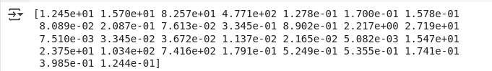

*print(cancer_data.data.shape)*

#target set

print(cancer_data.target)

*ouput:*

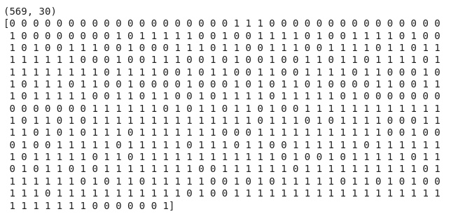

*from sklearn.model_selection import train_test_split*

cancer_data = datasets.load_breast_cancer()

X_train, X_test, y_train, y_test = train_test_split(cancer_data.data,

cancer_data.target, test_size=0.4,random_state=109)

*from sklearn import svm*

#create a classifier

cls = svm.SVC(kernel="linear") # Uncomment this line

#train the model

cls.fit(X_train,y_train)

#predict the response

pred = cls.predict(X_test)

*from sklearn.metrics import accuracy_score, precision_score, recall_score*

# Assuming 'pred' and 'y_test' are defined from your previous code

accuracy = accuracy_score(y_test, pred)

precision = precision_score(y_test, pred)

recall = recall_score(y_test, pred)

print(f"Accuracy: {accuracy}")

print(f"Precision: {precision}")

print(f"Recall: {recall}")

*Output:*

