# Department of Computer Science and Engineering

Data Science

Academic Year: 2024-2025 Name of Student: Diya Thakkar

Semester: V Student ID: 22107040

Class / Branch: CSE(DS) Date Of Performance:19/08/2024

Subject: DWM Date Of Submission: 19/08/2024

Name of Instructor: Prof. Archana Kotangale

Experiment No. 5

Aim:- To implement Data Discretization (any one) & Visualization (any one).

Dataset used: weather.arff (<http://storm.cis.fordham.edu/~gweiss/data-mining/weka-data/weather.arff>)

**Before Filters Applied:**

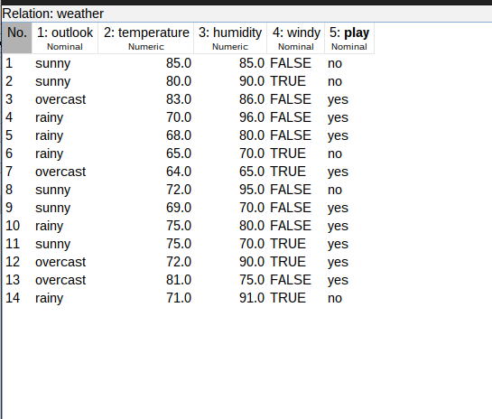

**After Filters Applied:**

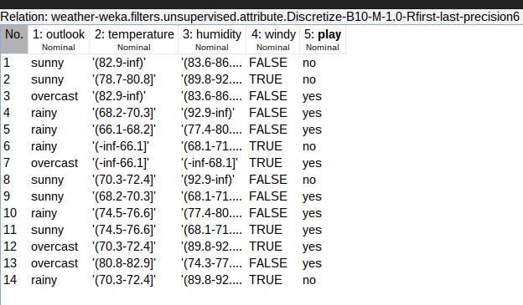**Before Filters Applied Graph:**

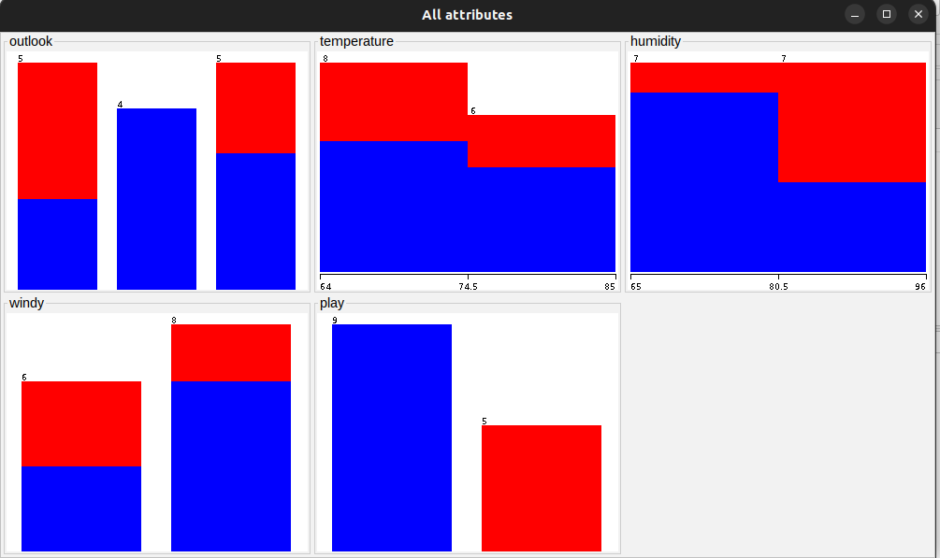

**After Filters Applied Graph:**

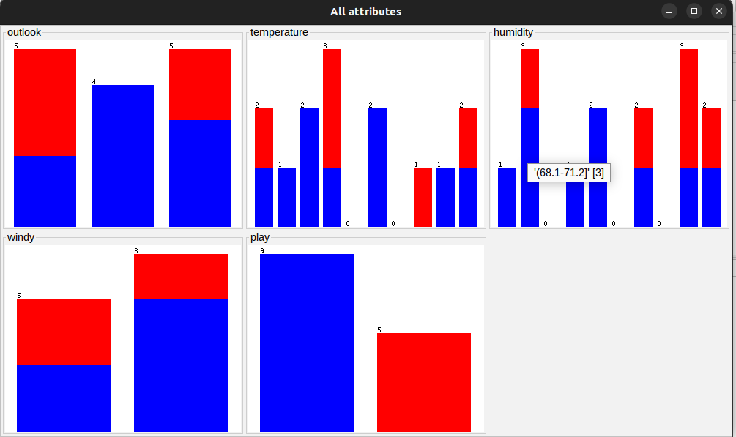

**Filters Applied on:** Temperature and Humidity

**Filters applied are:** weka.filters.unsupervised.attribute.Discretize -B 10 -M -1.0 -R first-last -precision 6