

Department of Computer Science and Engineering

Data Science

Academic Year: 2023-2024 Name of Student: Diya Thakkar

Semester: V Student ID: 22107040

Class / Branch: CSE(DS) Date Of Performance: 17/09/24

Subject: WCN Lab Date Of Submission: 10/10/24 Name of Instructor: Prof. Ashwini Rahude

Experiment No. 5

**Aim:-** Construct front end applications using React and back end using Node.js/express.

**Input:**

Server.js:

var express = require("express");

var mysql = require("mysql");

var app = express();

var con = mysql.createConnection({

host: "localhost",

user: "root",

password: "root",

database: "students",

});

app.get("/", async function (req, res) {

const data = await getAll();

console.log(data);

res.writeHead(200, {

"Content-Type": "text/html",

"Access-Control-Allow-Origin": "*",

});

const putput = JSON.stringify(data);

res.end(putput);

});

app.get("/insert", async function (req, res) {

let TestMessage = { body: "data inserted successfully" };

const jsonContent = JSON.stringify(TestMessage);

const data = await insertData(req.query.email);

console.log(data);

res.writeHead(200, {

"Content-Type": "text/html",

"Access-Control-Allow-Origin": "*",

});

if (data.affectedRows > 0) {

const datas = await getAll();

const putput = JSON.stringify(datas);

res.end(putput);

} else {

const datas = await getAll();

const putput = JSON.stringify(datas);

res.end(putput);

}

});

var server = app.listen(8000, function () {

var host = server.address().address;

var port = server.address().port;

console.log("Example app listening at http://%s:%s", host, port);

});

const getAll = () => {

return new Promise((resolve, reject) => {

con.query("SELECT * FROM std_details", (err, result) => {

if (err) {

reject(err);

} else {

resolve(result);

}

});

});

};

const insertData = (email) => {

return new Promise((resolve, reject) => {

var sql = "INSERT INTO std_details (email) VALUES ?";

var values = [[email]];

con.query(sql, [values], function (err, result) {

if (err) {

reject(err);

} else {

resolve(result);

}

});

});

};

App.js:

import "./App.css";

import "./style.css";

import { useState, useEffect } from "react";

import "bootstrap/dist/css/bootstrap.min.css";

function App() {

const [messages, setMessages] = useState([""]);

const [email, setEmail] = useState("");

useEffect(() => {

fetch("http://localhost:8000/")

.then((res) => res.json())

.then((data) => {

console.log(data);

setMessages(data);

});

}, [email]);

const handleChange = (event) => {

setEmail(event.target.value);

};

const handeSubmit = (event) => {

event.preventDefault();

fetch("http://localhost:8000/insert?email=" + email)

.then((res) => res.json())

.then((data) => {

setMessages(data);

});

};

return (

<div className="App">

<section id="footer">

<section id="banner">

<div className="container-fluid" id="banner-container">

<div className="row" id="banner-row">

<div className="col-md-4" id="footer-col2"></div>

<div className="col-md-4" id="footer-col2">

<h3>Store your email address</h3>

<form onSubmit={handeSubmit} method="GET">

<div className="mb-3">

<input

type="email"

placeholder="Enter Your Email"

className="form-control"

id="exampleInputEmail1"

aria-describedby="emailHelp"

onChange={handleChange}

/>

<div id="emailHelp" className="form-text">

We'll never share your email with anyone else.

</div>

</div>

<button type="submit" className="btn btn-primary">

Submit

</button>

</form>

<table className="table">

<thead>

<tr>

<th scope="col">#</th>

<th scope="col">Email</th>

</tr>

</thead>

<tbody>

{messages.map((message) => (

<tr key={message.id}>

<th scope="row">{message.id}</th>

<td>{message.email}</td>

</tr>

))}

</tbody>

</table>

</div>

</div>

</div>

</section>

</section>

</div>

);

}

export default App;

**App.css and style.css:**

**/* App.css */**

**\* {**

**margin: 0;**

**padding: 0;**

**font-family: 'Roboto Condensed', sans-serif;**

**}**

**/* Navbar */**

**.navbar-nav {**

**margin-right: 0 !important;**

**padding-right: 100px;**

**}**

**.navbar {**

**background-color: #0a193d;**

**color: white !important;**

**}**

**.nav-item a {**

**color: white !important;**

**}**

**.nav-item {**

**padding-left: 2px;**

**}**

**.navbar-brand {**

**color: white !important;**

**padding-left: 100px;**

**}**

**#navbar button {**

**color: white !important;**

**}**

**/* Banner */**

**#banner-container {**

**background-color: #0a193d;**

**color: white !important;**

**padding-top: 80px;**

**padding-bottom: 80px;**

**}**

**#banner-row img {**

**max-width: 70%;**

**height: auto;**

**display: block;**

**padding-left: 30px;**

**}**

**#banner-row h3,**

**p {**

**padding-left: 20px;**

**padding-top: 20px;**

**text-align: center;**

**}**

**#banner-row a {**

**background-color: white !important;**

**color: black !important;**

**border: none;**

**margin-left: 20px;**

**margin-top: 20px;**

**}**

**#banner-col {**

**padding-left: 20px;**

**}**

**/* Footer */**

**.mb-3 {**

**padding-top: 10px;**

**}**

**/* Responsive Design */**

**@media only screen and (max-width: 987px) {**

**.navbar-brand {**

**padding-left: 0px;**

**}**

**}**

**@media only screen and (max-width: 768px) {**

**#banner-row img {**

**padding-top: 20px;**

**}**

**.social-col {**

**width: 33%;**

**}**

**}**

Output:

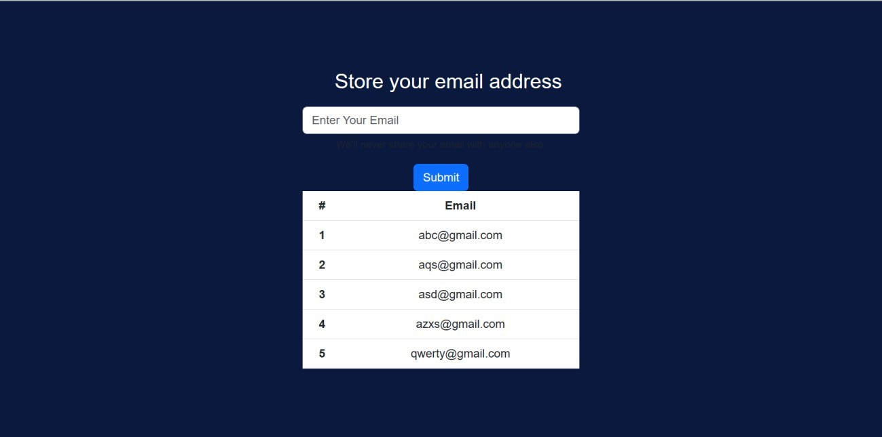

Conclusion:We have successfully Construct front end applications using React and back end using