Rock-Paper-Scissors Game Report

**Purpose**: This report details the implementation of a Rock-Paper-Scissors game using Python.

**Prepared by**: Diya Maheshwari

**University Roll Number**: 202401100300108

**Date:** 11/03/2025

# Introduction

The Rock-Paper-Scissors game is a simple yet popular game where players select one of the three choices: rock, paper, or scissors. The game follows the standard rules:

* + Rock beats Scissors
  + Scissors beat Paper
  + Paper beats Rock

In this project, a Python-based command-line version of the game has been developed. The user plays against the computer, with an option to choose between Best of 3 or Best of 5 rounds. The program ensures fair gameplay with a randomized computer choice, real-time score tracking, and final result announcement.

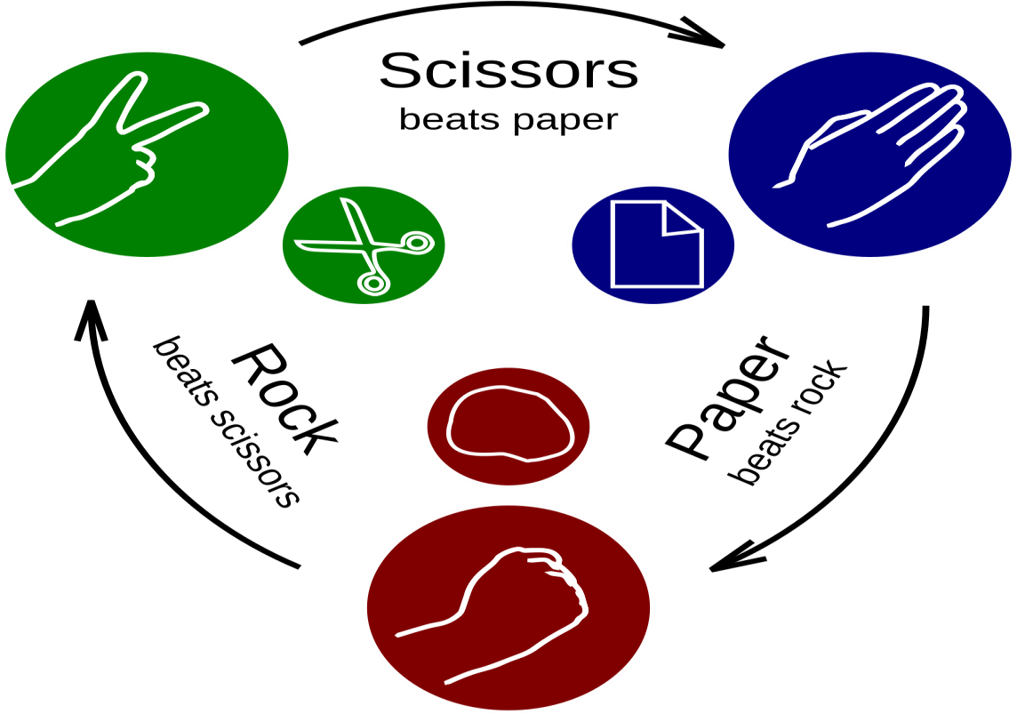

# Methodology

**Development Approach:**

* + Programming Language: Python 3.x
  + Structure: Modular functions for improved readability and maintainability.
  + Input Validation: Ensures users enter valid choices (rock, paper, scissors) and game modes (3 or 5 rounds).
  + Randomized Selection: Uses Python’s `random.choice()` to generate the computer’s move.
  + Game Logic: Determines winners based on Rock-Paper-Scissors rules.
  + User Experience Enhancements: Includes score tracking and result announcements.

## Implementation Steps:

1. User Prompt: Ask the user to select Best of 3 or Best of 5 mode.
2. Game Execution:
   * User inputs choice.
   * Computer generates a random move.
   * Determine round winner and update scores.
3. Final Result:
   * Announce winner based on final scores.
   * Display a motivational message.

## Code Typed

import random # Importing the random module for computer's choice def get_user_choice():

"""Prompts the user for input and ensures it is a valid choice.""" choices = ['rock', 'paper', 'scissors']

user_choice = input("Enter rock, paper, or scissors: ").lower() while user_choice not in choices:

print("Invalid choice. Please enter 'rock', 'paper', or 'scissors'.") user_choice = input("Enter rock, paper, or scissors: ").lower()

return user_choice

def get_computer_choice():

"""Randomly selects and returns the computer's choice.""" return random.choice(['rock', 'paper', 'scissors'])

def determine_winner(user, computer):

"""Determines the winner based on standard Rock-Paper-Scissors rules.""" if user == computer:

return "tie"

elif (user == 'rock' and computer == 'scissors') or \ (user == 'paper' and computer == 'rock') or \ (user == 'scissors' and computer == 'paper'): return "user"

else:

return "computer"

def get_game_mode():

"""Allows the user to select the game mode: Best of 3 or Best of 5 rounds.""" while True:

try:

rounds = int(input("Choose game mode: Best of 3 or Best of 5? (Enter 3 or 5): ")) if rounds in [3, 5]:

return rounds else:

print("Invalid input. Please enter 3 or 5.") except ValueError:

print("Invalid input. Please enter a numerical value (3 or 5).")

def play_game():

"""Manages the Rock-Paper-Scissors game with user-selected settings.""" print("Welcome to Rock, Paper, Scissors!")

rounds = get_game_mode() # User selects game mode user_score = 0

computer_score = 0

for _ in range(rounds):

user_choice = get_user_choice() # Get user input

computer_choice = get_computer_choice() # Get computer's choice print(f"Computer chose: {computer_choice}")

winner = determine_winner(user_choice, computer_choice) # Determine winner

if winner == "user":

print("You win this round!") user_score += 1

elif winner == "computer":

print("Computer wins this round!") computer_score += 1

else:

print("This round is a tie!")

print(f"Current Score -> You: {user_score} | Computer: {computer_score}\n")

print("Game Over!")

if user_score > computer_score: print("Congratulations! You won the game!")

elif computer_score > user_score:

print("Better luck next time! The computer wins the game.") else:

print("It's a draw!")

print("Thank you for playing!")

print("\"The only way to do great work is to love what you do.\" - Steve Jobs")

# Execute the game only if the script is run directly if name == " main ":

play_game()

## Screenshots Output

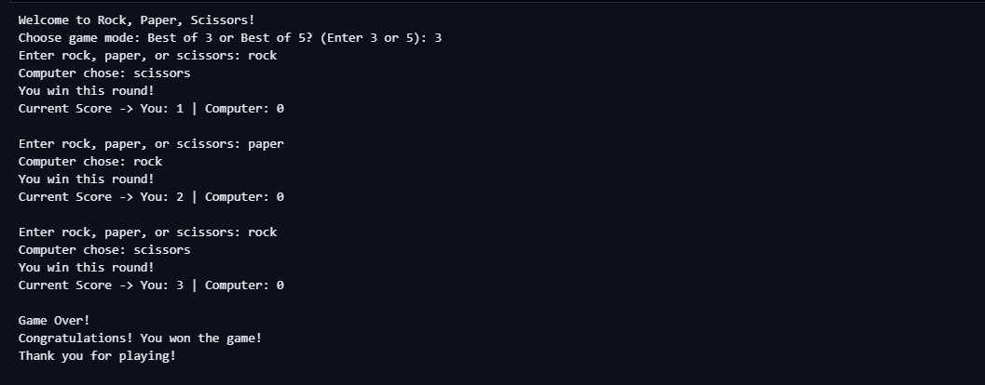

**Conclusion**

The Rock-Paper-Scissors game was successfully implemented using Python. The program follows structured programming principles, ensuring modularity, input validation, and a user-friendly experience. This implementation serves as a basic yet effective demonstration of decision-making, randomization, and user interaction in Python.

## Future Enhancements

* Implement a GUI version using Tkinter or PyQt.
* Add a multiplayer mode.
* Introduce an AI-based strategy for the computer opponent.

## References

* Python Official Documentation: https://docs.python.org/3/
* Random Module Documentation: https://docs.python.org/3/library/random.html