UML and Architecture Diagrams

1. Purpose and Modeling Notes
This document describes the system present in the repository, rather than the original planned design. The diagrams reflect the implementation and the current backend contract as checked against project_reference.md, backend_integration/, models/, and mini_project_ui/.
Important modeling distinctions:
- The /score route runs Transformer, VAE, and DGA inference sequentially. The diagram does not depict parallel detector calls.
- The Fusion threat score is the authoritative final detection decision. The Transformer predicted class is retained as an attack-type hint.
- The backend uses a trained Fusion MLP only when all three signals and the Fusion model/scaler are available. Otherwise it calculates a weighted fallback over active signals; with no usable signals it returns insufficient_models.
- Runtime scoring uses models/transformer/model.py. The explanation route separately loads an attention-capturing model implementation from models/explainibility + SHAP/model.py using the Transformer checkpoint.
- The active dashboard’s scoreFlow helper sends a flows property, while the backend request schema requires flow_sequence. The architecture diagram marks this current interface mismatch.
- In UML, the system is the subject boundary for the use-case diagram, rather than a separate external actor. The requested system context is shown as the boundary; the analyst is the external human actor.

2. Use-Case Diagram
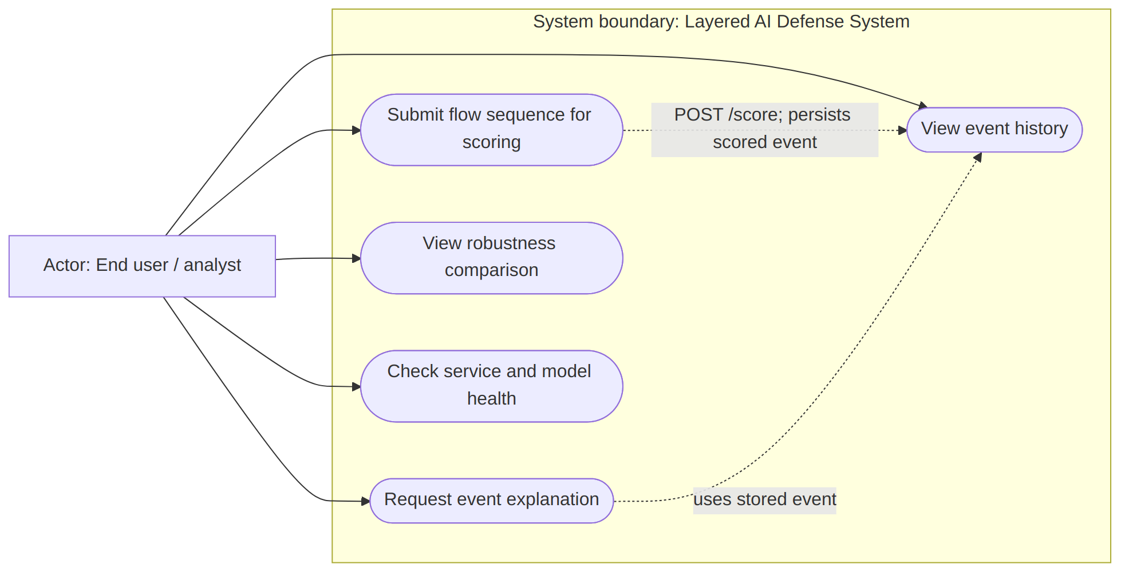
The use cases are available through the HTTP service and dashboard presentation. The scoring use case’s backend contract is implemented, but the dashboard’s current payload field name mismatch prevents the active UI scoring form from matching that contract directly.

3. Core Model Class Diagram
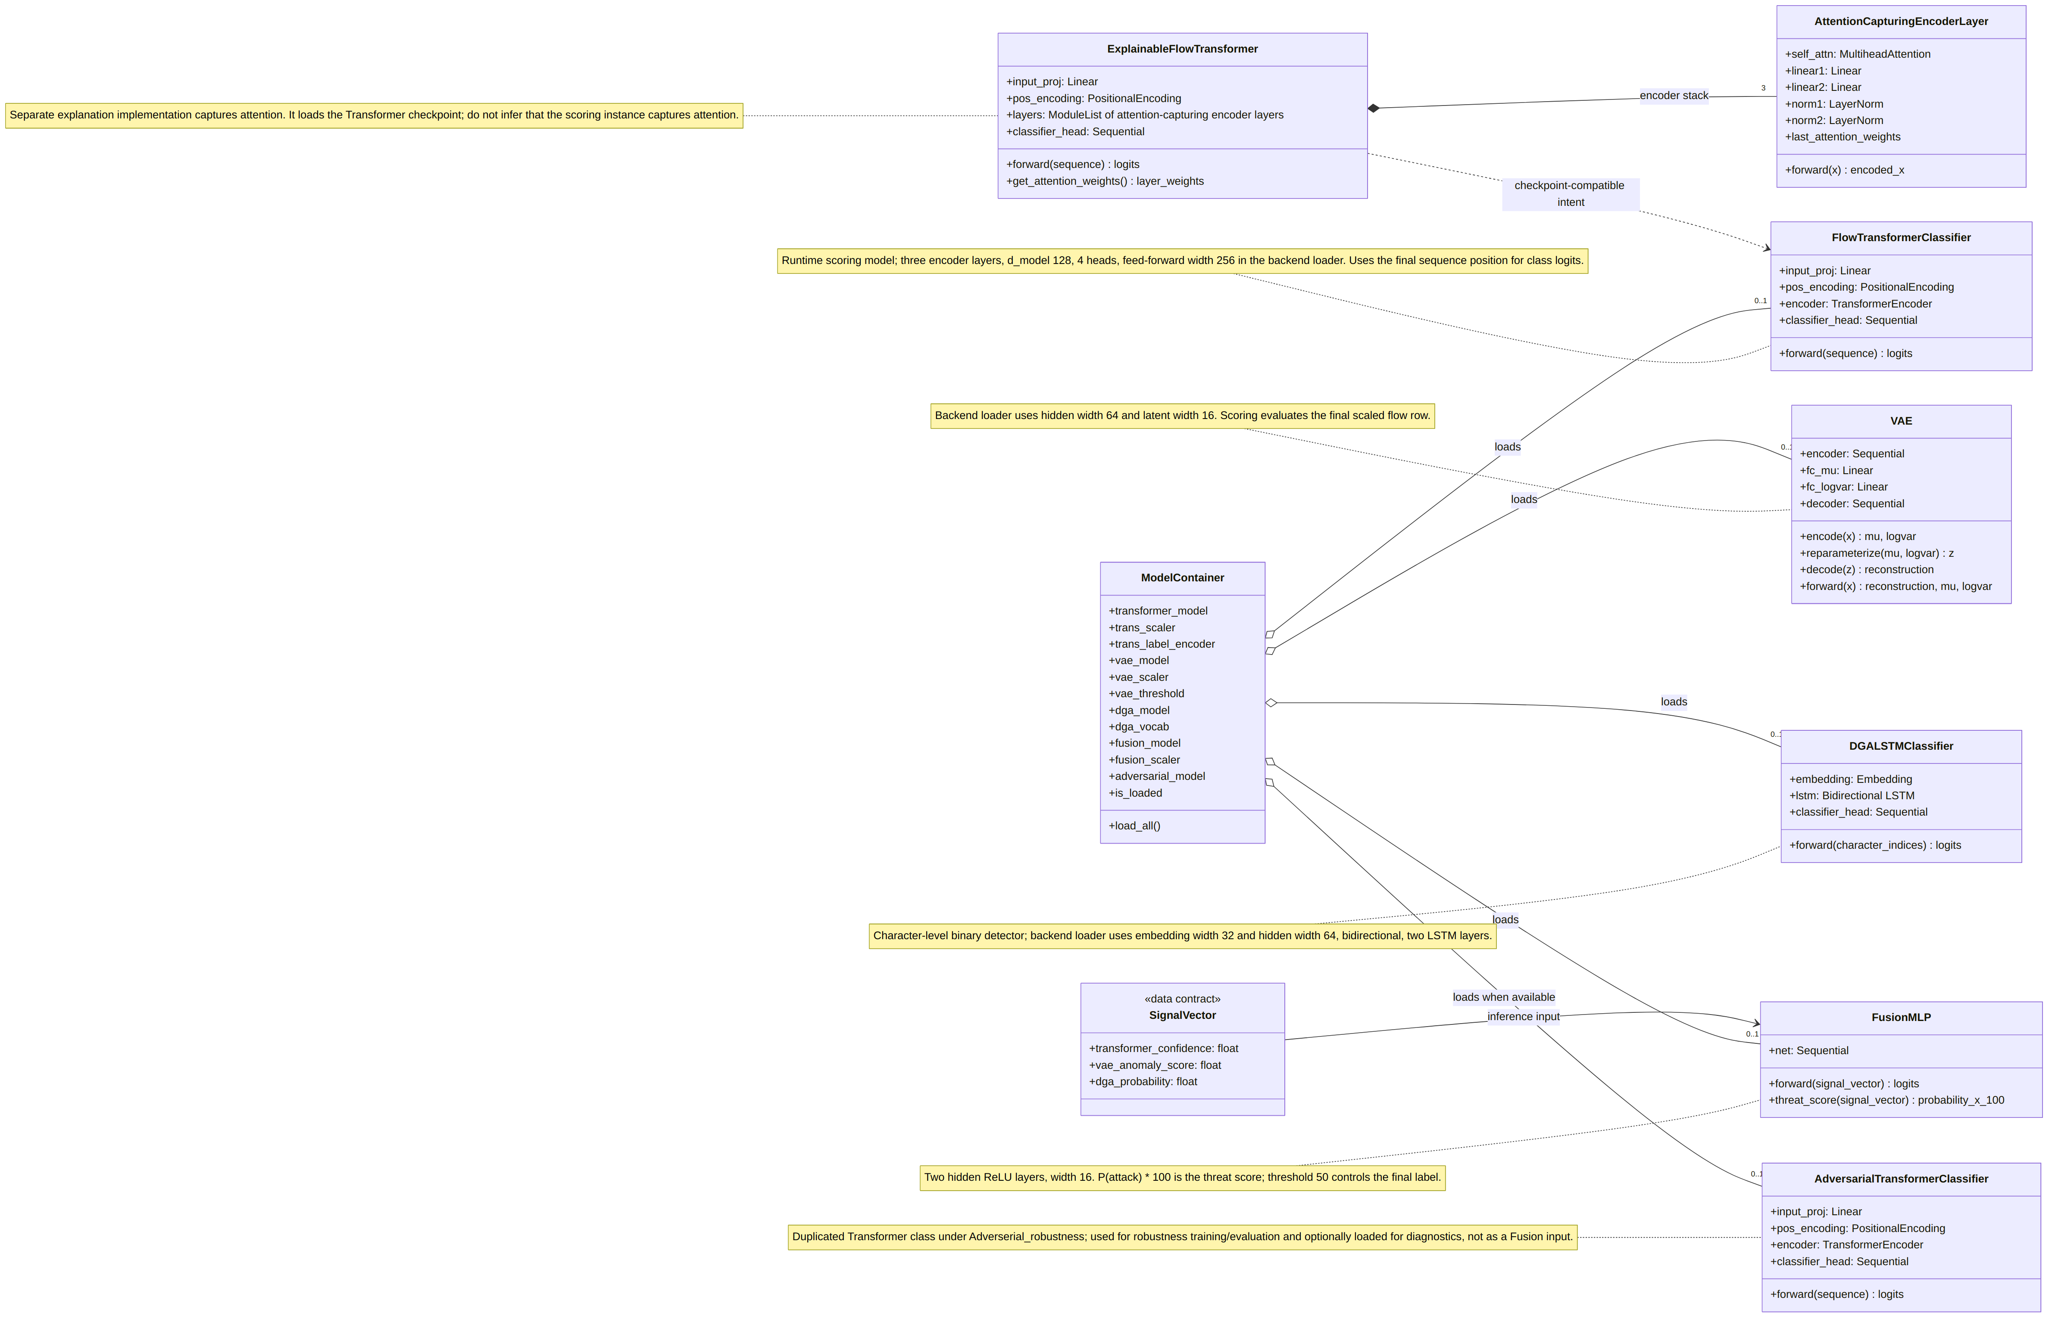
The SignalVector is shown as a data contract rather than as a Python class. The VAE threshold is loaded as an artifact but does not set the /score final decision. AdversarialTransformerClassifier is a duplicate model definition under models/Adverserial_robustness/; it is not a new detector signal in the scoring Fusion vector.

4. Sequence Diagram: Flow Scoring
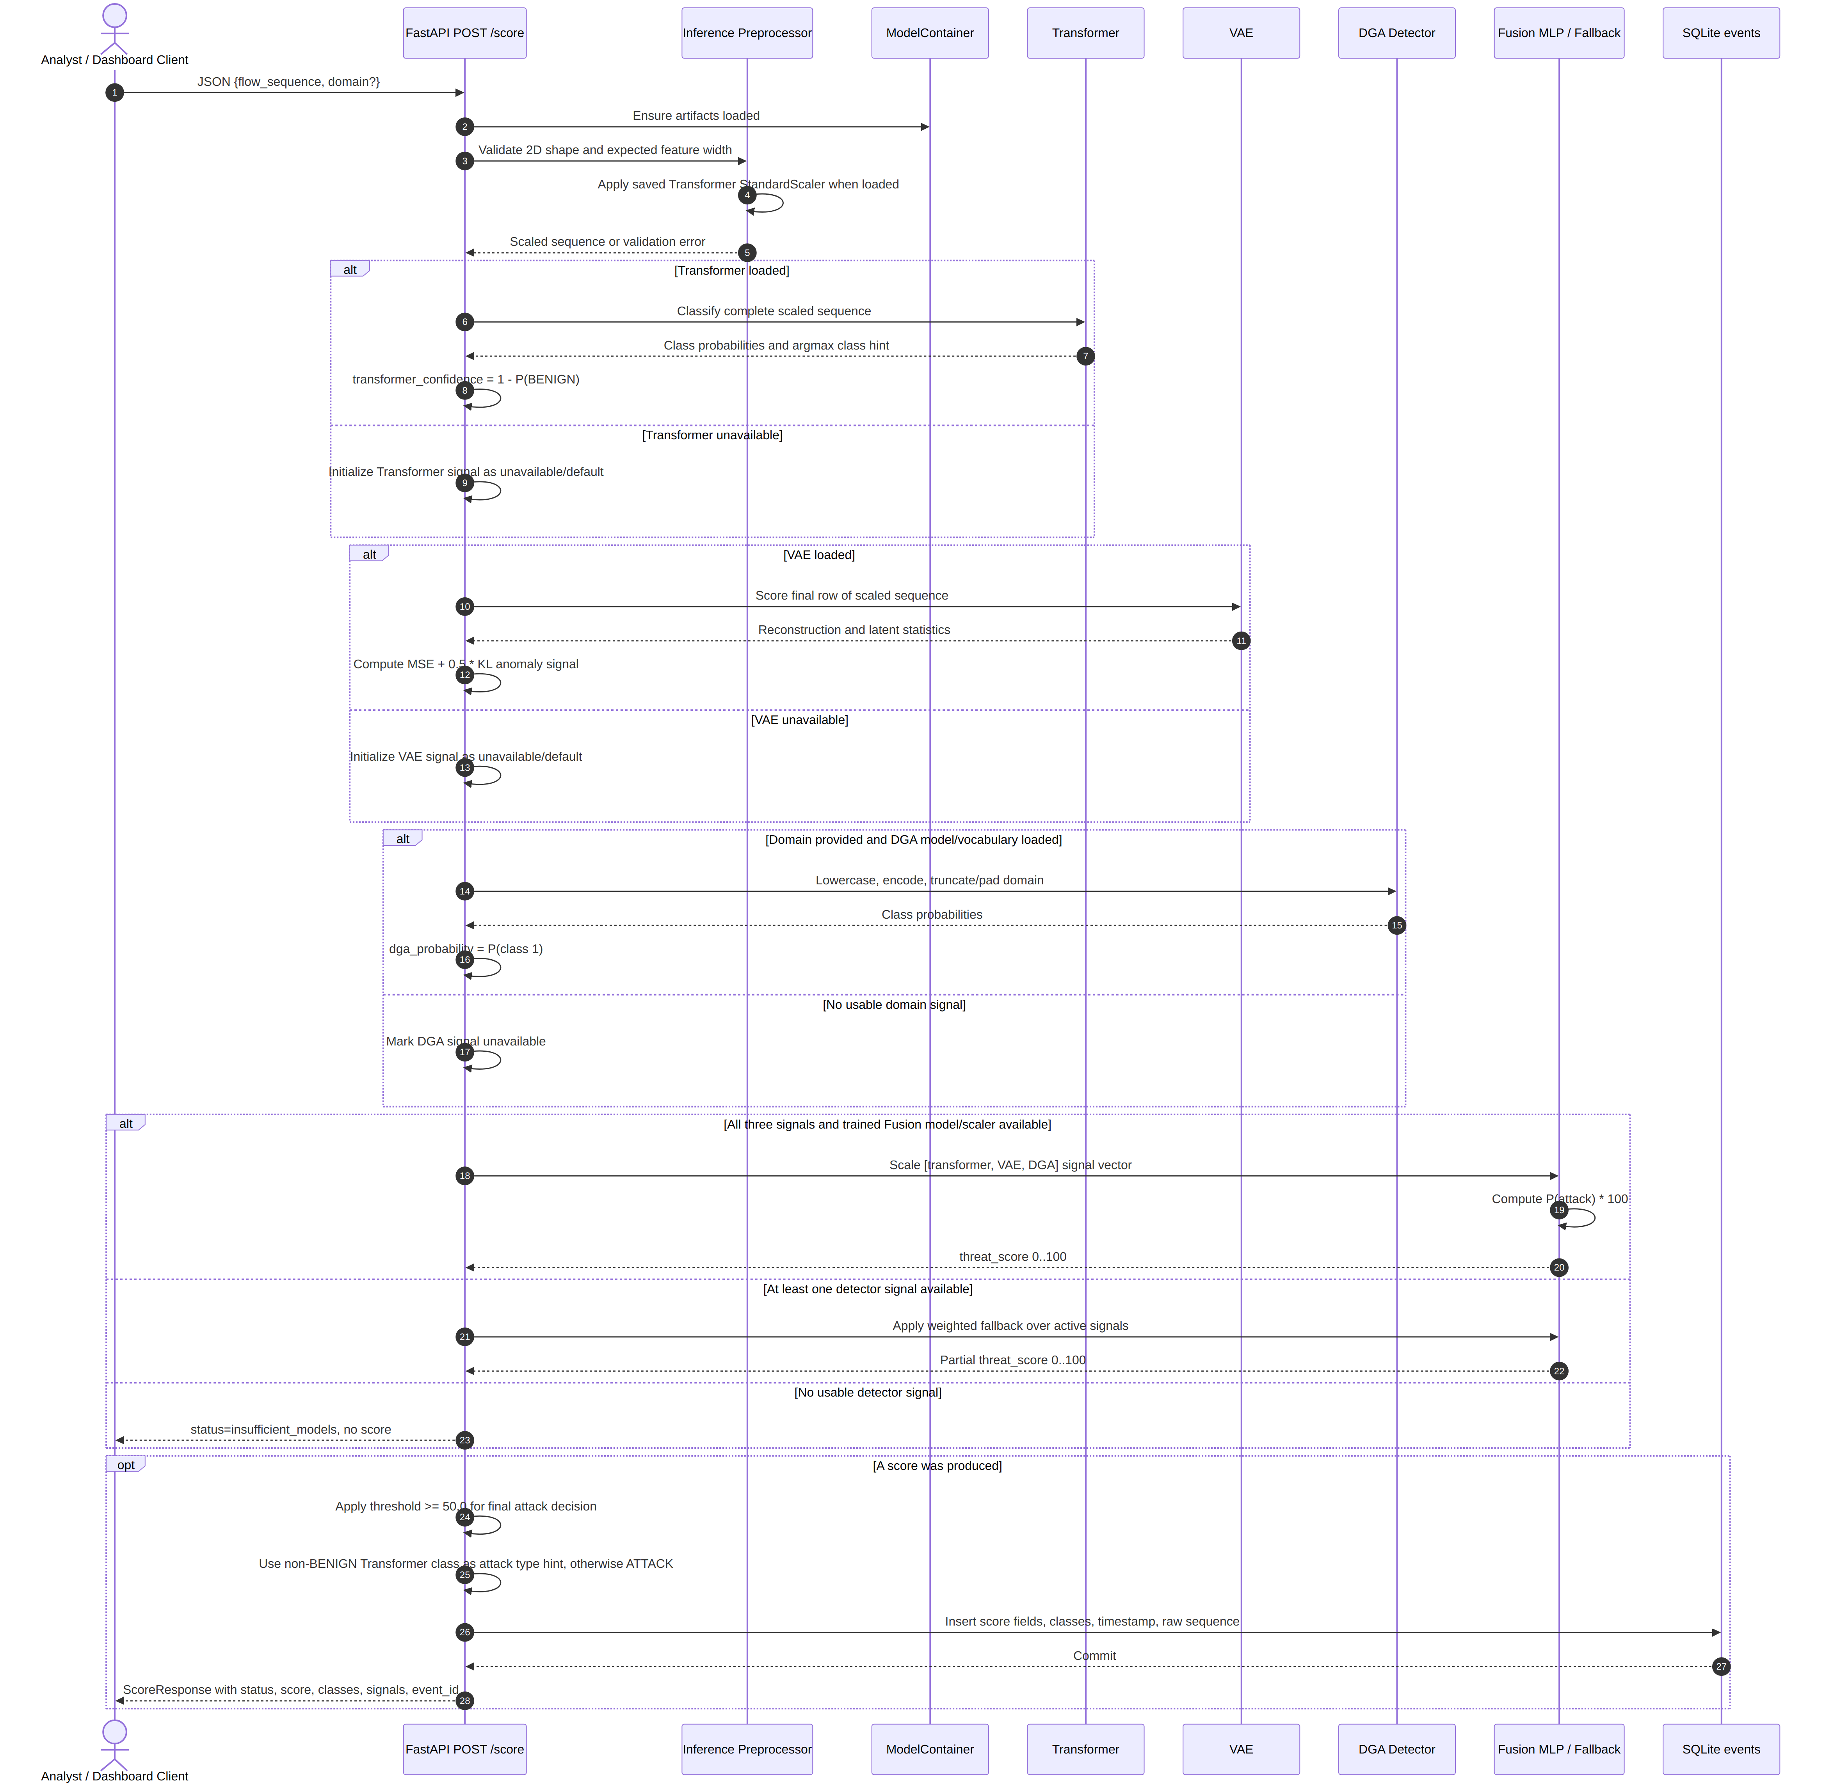
The detector messages are ordered because current routes_score.py evaluates Transformer, VAE, and DGA in sequence. In particular, no concurrent fork/join is implied. The request field shown is the actual backend contract. The current dashboard sends flows instead, so a direct dashboard-to-endpoint scoring request requires that integration mismatch to be corrected.

5. Sequence Diagram: Event Explanation
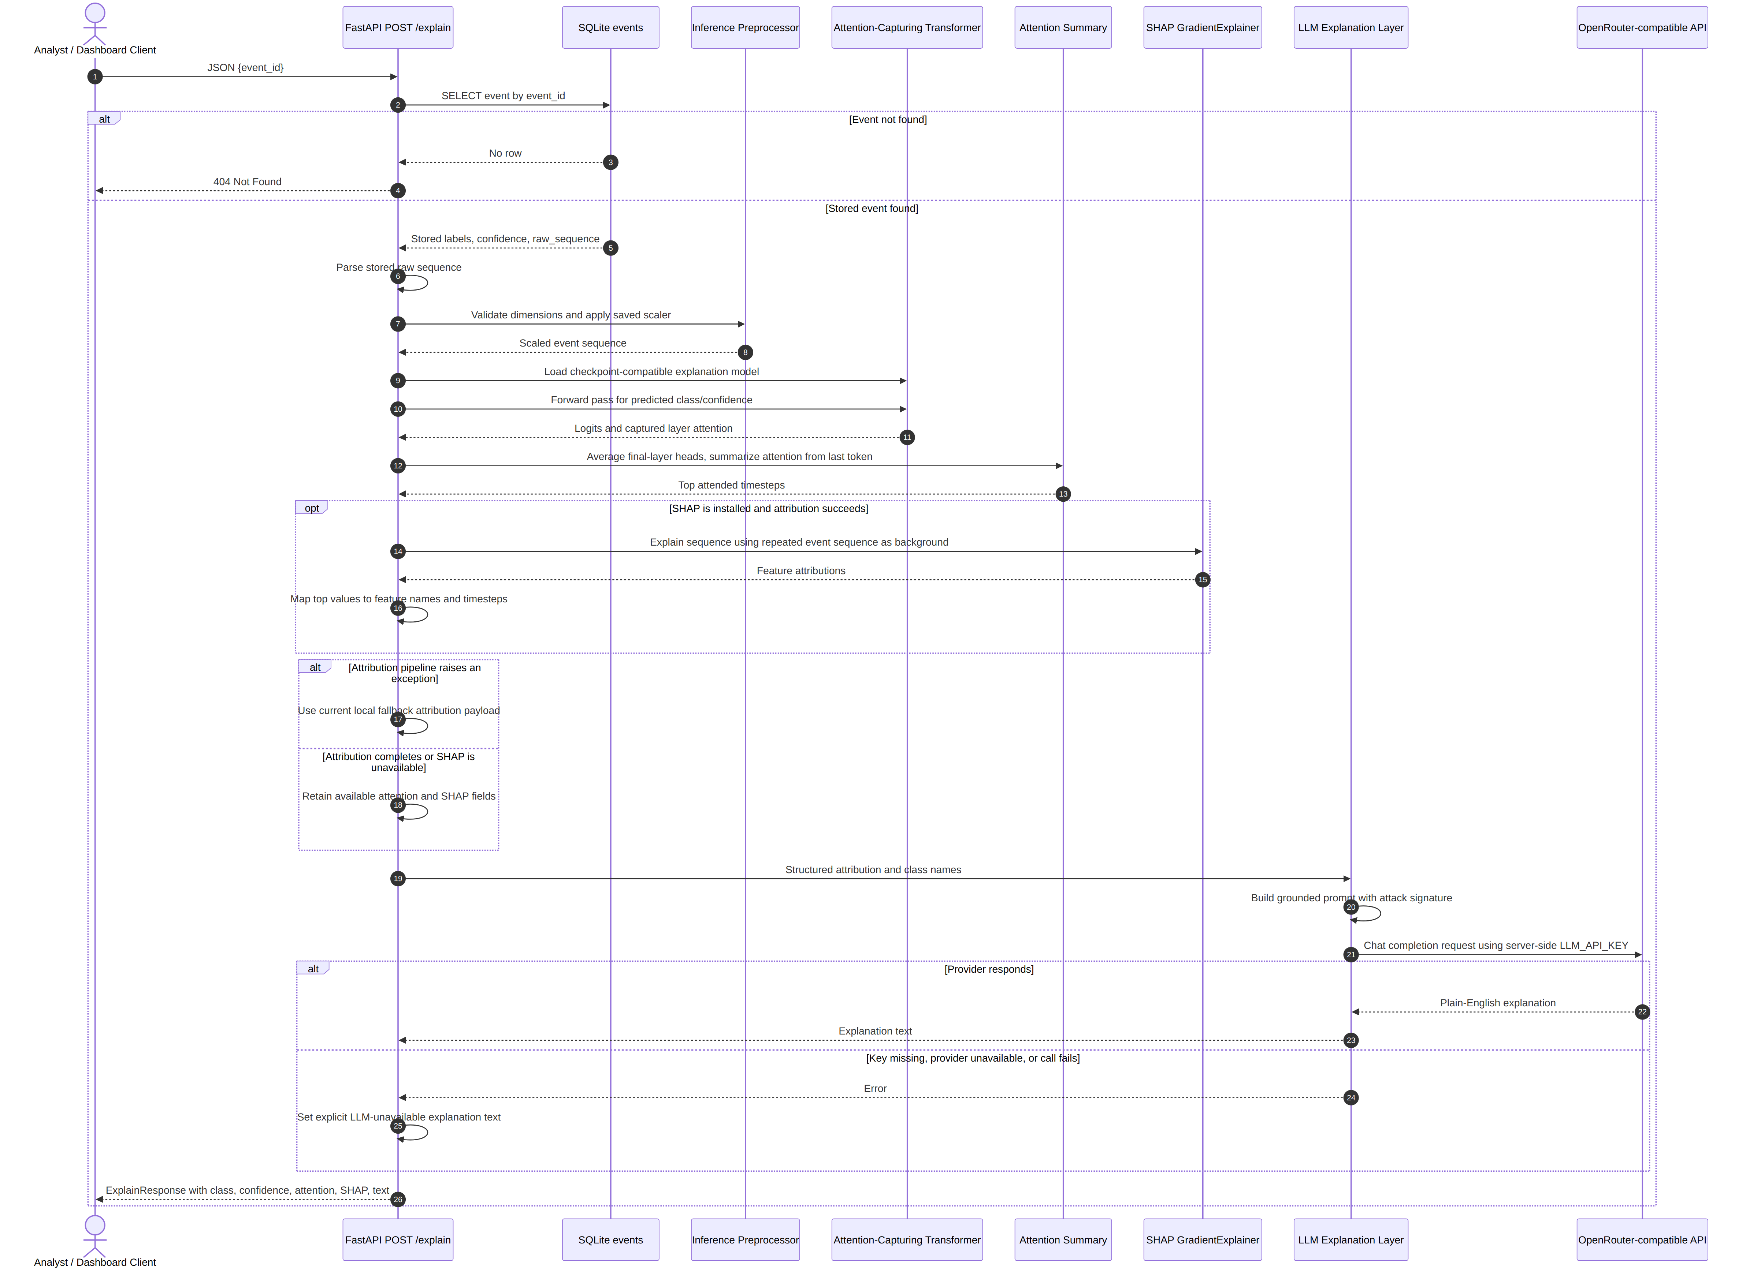
The diagram shows SHAP as conditional because configuration may report it unavailable and the route catches attribution exceptions. The current exception branch uses example attribution values, which are not computed from the event and should be recognized as degraded fallback data. The LLM text is also optional; missing credentials do not prove the local attribution failed.

6. Component and Architecture Diagram
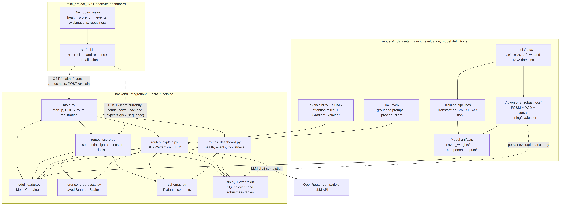

6.1 Component Responsibilities and Data Flow
- Data and model development: flow and domain datasets in models/data/ feed their respective preprocessing, training, and evaluation modules. The Fusion pipeline consumes detector signal data. The adversarial pipeline duplicates the Transformer model definition and performs FGSM/PGD evaluation and adversarial training as a separate study.
- Artifacts: model definitions are implemented in their model folders, while artifact paths are selected by backend_integration/config.py. The backend configuration currently resolves Transformer artifacts from models/saved_weights/, VAE artifacts from models/VAE/outputs/, DGA artifacts from models/DGA_detector/outputs/, Fusion artifacts from models/fusion_head/outputs/, and adversarial weights from the central location with an output-folder fallback.
- Startup and serving: backend_integration/main.py initializes SQLite and calls ModelContainer.load_all() during FastAPI lifespan startup. Routes share the process-level model container and Pydantic schemas.
- Scoring: /score validates and scales input, computes available detector signals sequentially, selects trained Fusion or a documented fallback, derives the Fusion-threshold class, and persists a successful/partial score and raw sequence.
- Explanation: /explain retrieves stored raw input, scales it, invokes an explanation-compatible Transformer plus attention and optional SHAP, then calls the canonical LLM layer. The OpenRouter-compatible provider is an external dependency and requires the server-side key.
- Dashboard and persistence: mini_project_ui/ calls the HTTP API; it does not import models. SQLite stores score events and robustness accuracy results. Dashboard score input is currently out of contract because its helper sends flows, not flow_sequence.

7. Diagram-to-Implementation Traceability
Diagram element | Implementation location
System boundary, user-facing cases | backend_integration/routes_score.py, routes_explain.py, routes_dashboard.py, mini_project_ui/src/components/Dashboard.jsx
Transformer, VAE, DGA, Fusion classes | models/transformer/model.py, models/VAE/model.py, models/DGA_detector/model.py, models/fusion_head/model.py
Loaded model/artifact container | backend_integration/model_loader.py, with paths in backend_integration/config.py
Flow scaling | backend_integration/inference_preprocess.py
Fusion threshold and fallback | backend_integration/routes_score.py, backend_integration/config.py
Attention/SHAP explanation | models/explainibility + SHAP/model.py, attention_explainer.py, shap_explainer.py, explainer.py
Prompt and external LLM call | models/llm_layer/llm_explanation.py, llm_prompting.py, llm_config.py
Event and robustness persistence | backend_integration/db.py; endpoint reads in routes_dashboard.py; robustness writer in models/Adverserial_robustness/evaluate.py
Browser/API integration | mini_project_ui/src/api.js, mini_project_ui/src/components/Dashboard.jsx

