Marwadi University
Faculty of Engineering & Technology
Department of Information and Communication Technology
  Subject: Digital Signal and  Image Processing (01CT1513) | Aim: Simulate discrete time sequences.
Experiment No: 1 | Date: 19-07-2026 | Enrollment No:92400133156

Aim: Simulate discrete time sequences.

Github repo : https://github.com/Diyakalaria19/DSIP_lab_exps

- Unit Impulse signal

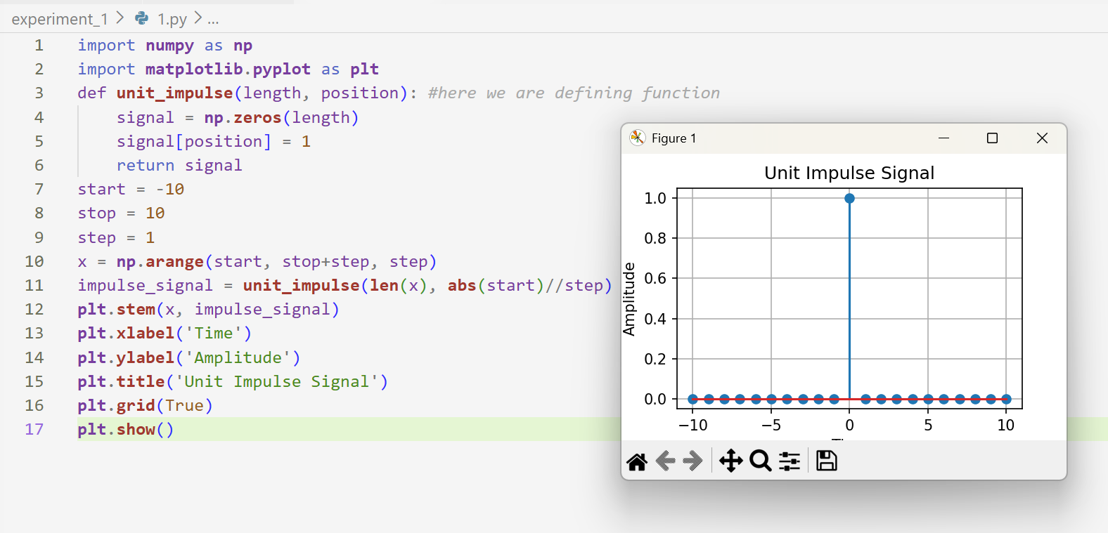

- Unit Step signal

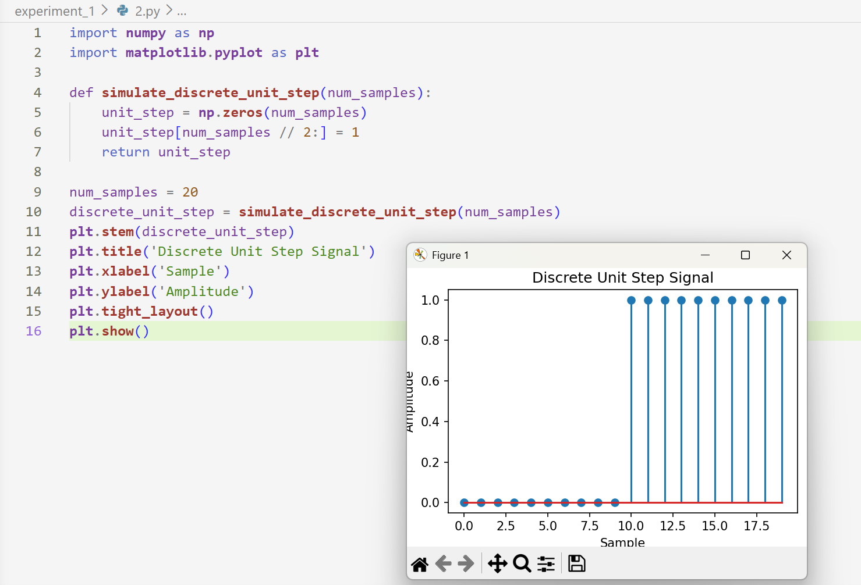
- Ramp signal

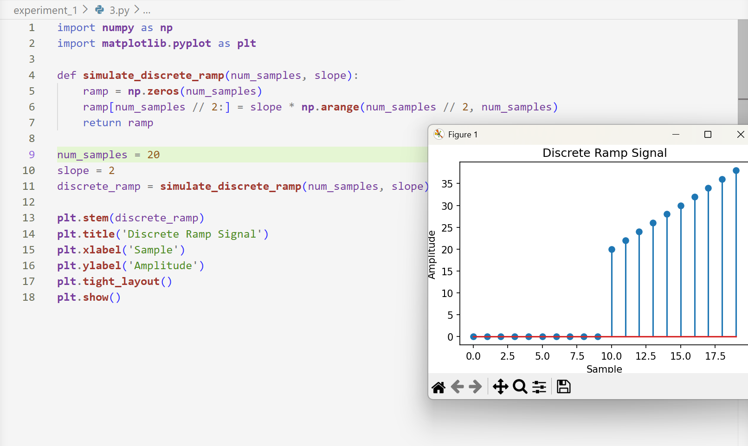

- Exponential signal

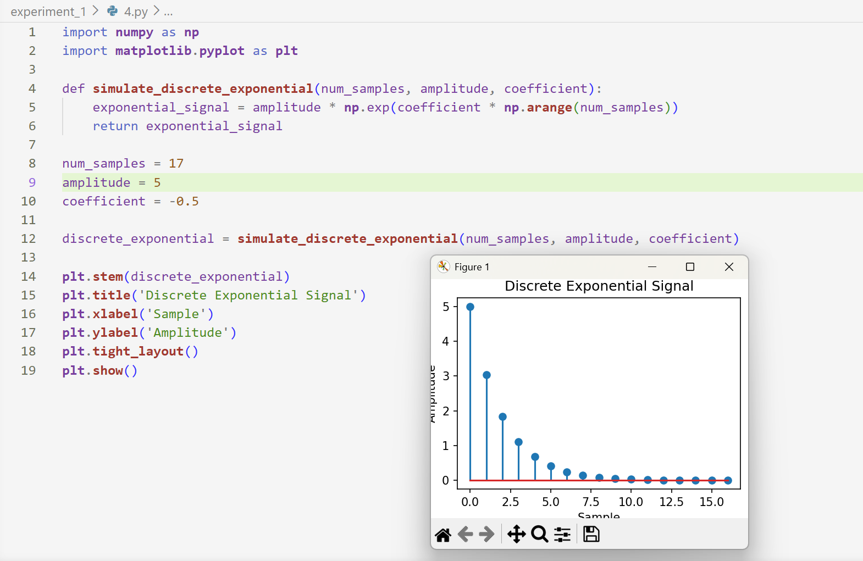

- Discrete sine wave

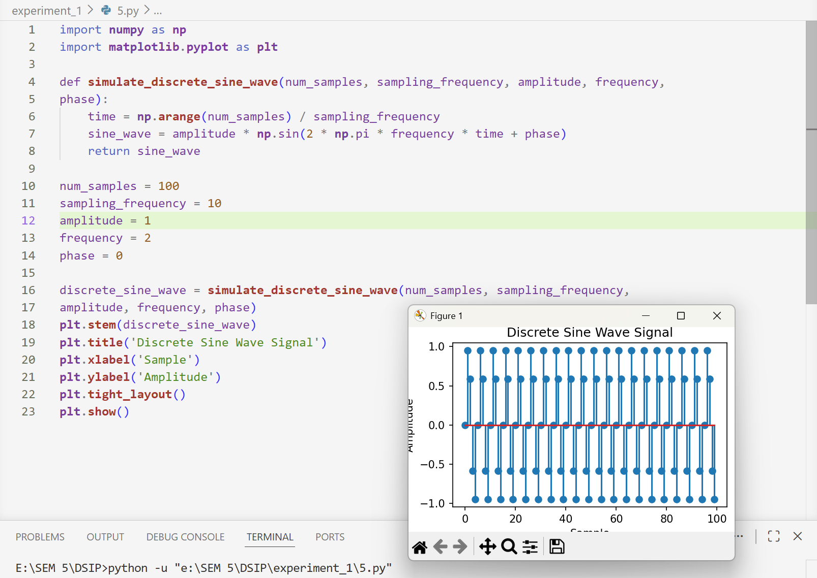

Conclusion : In these experiments, we are using 2 libraries : numpy and matplotlib. After importing, we are defining/creating functions for specific signals : ramp, exponential,ect. After defining function, we are defining/initializing parameters. Then at last we are plotting this using matplot librarty imported earlier by giving appropriate titles on x and y axis.

