

**MSC Coverpage Assignment**

|  |  |
| --- | --- |
| **Name of the Tutor:** | **Chris Pawley** |

|  |  |
| --- | --- |
| Course code: | **PRA3500** |
| Course Title: |  |
| Course Coordinator: | **Chris Pawley** |
| Tutorial Group Number: |  |
| Student Name: | **Diyon Wickremeratne i6176139** |
| Student ID nr.: |  |
| Academic Year: |  |
| Number of Words: |  |
| Title Assignment: |  |
|  |
| Pigeon Hole nr.: |  |

Date: Signature:

______________ ______________

**Tracing back daughter particle trajectories to a mother particle using Monte Carlo data**

**Introduction**

When particles are unstable, they decay into lighter constituent daughter particles. The daughters of a mother particle are able to tell us the composition of the mother. The process of decay takes place in time durations as short as 2.00 ± 0.06×10-13s (Λc+particle) (Calo et al., 2019). The phenomena of particle decay in labs, and in the real world remain unobservable to the naked human eye due to the aforementioned reason. Therefore, we rely on technology and various inferential statistics to determine the nature of these exotic particles.

The Large Hadron Collider beauty (LHCb) is one place that particles created due to high-energy collisions are studied. The LHCb detectors are composed of pixelated layers that mark a point a particular particle passed through, on each layer. Later these points are used to create a trajectory that the particle took. If the composition of the daughter particles is known, and they can successfully be traced back to a common mother particle, then physicists are able to determine the composition of the mother particle before a collision (MSP, 2020).

One of the main challenges in tracing a particle’s trajectory is being able to properly fit the track with a function, which can be used to infer characteristics of the daughter particles and their movement. The process of track fitting is one that relies heavily on statistics and accuracy of the electronic components used in the detector (MSP, 2020). This paper aims to show the process of track fitting from a Monte Carlo sample of data. Once the functions are obtained, they will be assessed on how well they fit the data and the possible benefits and drawbacks of using them.

**Method**

A virtual 3-dimensional coordinate system was created on a Jupiter Notebook, in which a particle was allowed to move in the positive axes, up until 100 units, starting from the origin (0, 0, 0). Each unit the particle moved corresponded to 1 pixel on the detector layer. The measured coordinates for the particle were sets of Monte Carlo data (100 data points), randomly generated and then sorted in ascending order to imitate the particle moving in a positive direction (with respect to all axes). The particle was chosen to be seen as moving in the positive z-direction, thus making the x-y plane a 1 dimensional detection layer.

In order to determine this particle’s trajectory function, 8 detection points in equal steps on the z-axis were chosen. The corresponding x and y coordinates of the detection points were used to fit a function through. The probability of the particle being found in an adjacent x-y coordinate was set to 10%. The angle between the particle’s track and the detection layer was also recorded, as this affected the direction in which the particle could be found in an adjacent pixel. Once the proper x-y coordinates were identified, they were fit using a function that best described their behaviour. The wellness of the fit was assessed by computing the χ2 and χ2/N values, where N was the 7 degrees of freedom resulting in choosing 8 detection points. The programme had a 1% chance of not returning any χ2/N values, in order to simulate bad data from a pixel. In such a case, the programme would return χ2/N = 0.

This process was carried out on 3 particles, with different sets of Monte Carlo data. A final check was done by adding a fourth particle, which was deliberately set to not come from the same mother as the other three. This was achieved by manually setting the intercept of this particle’s trajectory on the x-y plane to 10.

**Results**

The resulting 8 detection points for the first particle are displayed in Figure 1. It can be seen that the particle moved in a straight line, in the positive direction. The other two particles, displayed the exact behaviour. All three particles moved in a line, approximately 0.9553 rad with respect to the x-axis. This suggested that each particle had a 10% probability of being in a pixel above, to the right or one diagonally across to the right and above. Figure 2 displays the particles coordinates at 8 detection points after accounting for the 10% probability.

|  |  |  |  |  |  |  |  |  |
| --- | --- | --- | --- | --- | --- | --- | --- | --- |
|  | **Point 1** | **Point 2** | **Point 3** | **Point 4** | **Point 5** | **Point 6** | **Point 7** | **Point 8** |
| **Z** | 12 | 24 | 36 | 48 | 60 | 72 | 84 | 96 |
| **Y** | 12 | 24 | 36 | 48 | 60 | 72 | 84 | 96 |
| **X** | 12 | 24 | 36 | 48 | 60 | 72 | 84 | 96 |

*Figure 1: A table showing the 8 detection coordinates for the first particle.*

|  |  |  |  |  |  |  |  |  |
| --- | --- | --- | --- | --- | --- | --- | --- | --- |
|  | **Point 1** | **Point 2** | **Point 3** | **Point 4** | **Point 5** | **Point 6** | **Point 7** | **Point 8** |
| **Z** | 12 | 24 | 36 | 48 | 60 | 72 | 84 | 96 |
| **Y** | 12 | 24 | 36 | 48 | 60 | 72 | 84 | 96 |
| **X** | 12 | 24 | 36 | 48 | 60 | 72 | 84 | 96 |

*Figure 2: A table showing the 8 detection coordinates after accounting for adjacent probability of 10%, for the first particle.*

Before proceeding to use the χ2 for a straight line (“Chi Squared Fit”, n.d.) as an assessor of the fits, a test was done on a 100 particles to determine the percentage of cases in which the χ2 would give a good representation of a fit. Figure 3 shows that about 11% of the cases either returned null, or very high χ2 values. This meant that at most, 89% of tests would give us proper results.

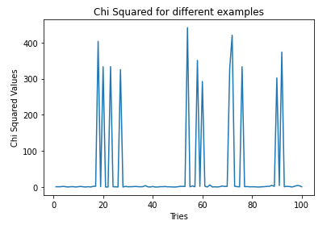

*Figure 3: A graph showing the outcomes of χ2 tests for 100 different particles.*

Figure 4 shows the computed χ2/N values, along with their functions for all particles (including the check particle). In order to compute the χ2/N fit, an arbitrary value of ±1 pixel was chosen as a fitting error. This was due to the lack of information about the detector and the accuracy to which its electrical components were able to function. The code used to compute the χ2/N values included the error as a parameter that the user could tweak to obtain results. It can be seen that the fourth particle, which was deliberately set to not come from the origin, had a poor fit compared to those that did. This indicates that its track could not be traced back to the same mother particle that the other three came from. The code was made to print the functions of each particle, the χ2/N of the fourth particle and the χ2/N values of the other three particles in this stated order.

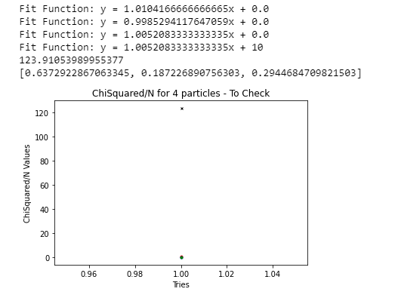

*Figure 4: A graph showing the χ2/N values for all particles. Note: the first 3 particles appear as one point on the graph as they are close to each other*

**Discussion**

The obtained results seem to correctly describe the system that was initially created. The χ2/N values for the first three daughter particles indicate that the fits were fairly accurate. The first three particles have their intercepts at the origin, which means that they came from the same mother particle. The fourth check-particle had a χ2/N that was distinct from the rest. By setting the intercept to 10, the difference in χ2/N (Figure 4) was expected. Although the test had an 11% chance of giving no result or an improper result, the obtained χ2/N values seem to suggest that our test did not fall into this set of possible failed tests.

One issue with the setup was the fact that the first three particles had very similar tracks. The similarity may have arisen due to the scale of the Monte Carlo data samples. The Monte Carlo data sets consisted of a 100 data points each, and only went up to a maximum of 100 pixels. This may have restricted the randomness of the data sets, thus causing all three particles to have similar detection coordinates. Another factor that hindered randomness was the decision to sort the Monte Carlo data sets in ascending order. This ensured that all particles will move in a positive direction (with respect to all axes). Proper randomness could have been achieved if the Monte Carlo data was left untouched. Furthermore, the lack of randomness in the data may have forced the particles to move in a straight line. In reality, particle trajectories are likely to be curved, and would require different track fits. The process of computing χ2/N for fits that are not a straight line, will then be different.

Another issue with this setup was the lack of knowledge about detector specifications. The adjacent pixel probability and fit error were two values that were set arbitrarily. Proper specifications may have changed the outcome of the obtained results.

Overall, the created system was able to track the trajectories of particles, given the conditions that were entered. Should this experiment be repeated with the limitations of the conducted test, the results obtained may better depict a system found in labs and nature.

**References**

Calo et al. (2019). First measurements of the Ξ c+ to Λc+ production ratio in the LHCb experiment. Maastricht University.

“Chi Squared Fit” (n.d.). Lecture about applying the Chi Squared Fit. Lecture slides obtained from: <https://twiki.cern.ch/twiki/pub/Main/MasterElog2014/FitMethods.pdf>

Maastricht Science Programme (MSP) (2020). PRA3500 Data Analysis and Statistics for Physicists Lab Manual. Maastricht University.