Stephen Diniz

Homework 02 - Transposition Research

Transposition Ciphers are essentially taking the same plaintext characters of the string you want to encrypt and mixing them up.

String: BA is a transposition of AB

This is a very small example of the idea, but we can broaden the idea by making:

HONG LIUS SECURITY CLASS IS A LOT OF FUN
To
HLSRC SLFOG ISEUY LSIAO OFNNU CTAST U

This is done using the “Rail Cipher”

You make 3 “rails”

.....................................................................................................................
.....................................................................................................................
.....................................................................................................................

You strip spaces from the string and ride the rails up and down:

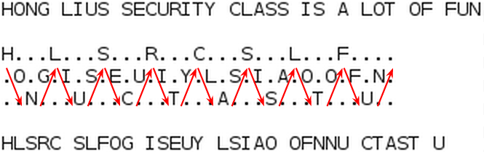

Then, chunk the letters from the rails in groups of 5.

Reading across the top we have: HLSRC SLF.....

Continue chunking until you have a string output:
“HLSRC SLFOG ISEUY LSIAO OFNNU CTAST U”

This can be easily reversed by reconstructing the rail backwards and just tracing it backwards. The problem is that spaces are stripped in the string.

The Rail Cipher can be seen in depth here:
http://en.wikipedia.org/wiki/Rail_fence

