Stephen Diniz
ECE-489
Dr. Liu
24 September 2013

Homework_01

- ) Code for Problem 1 is available on GitHub.com: http://git.io/3ivwLg
First I started with the original image of the license plate:
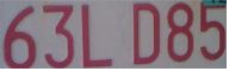

A light image was created by adding white + the last half of every pixel:
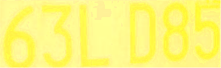
(Notice that the letters are still visible)

A dark image was created by adding dark + the first half of every pixel:

(This image will be harder to view the actual characters because the image is mainly light colors)

2.) Code for Problem 2 is available on GitHub.com: http://git.io/PGLeVQ
Seed value used: 1337
The light and dark images were then xored to create the steganographic images:
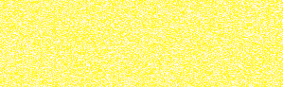
(Light image)

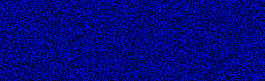
(Dark image)

- ) Code for Problem 3 is available on GitHub.com: http://git.io/SnmMIw

With these two blurred images and an unknown seed value, I attempt to “rebuild” the original image by xoring the random pixel with the last 12 of the dark pixel + the last 12 of the light pixel (dark.substring(12) + light.substring(12))

This yielded a result image of (seed value: 7331):
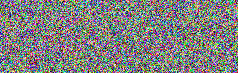

This is clearly not the license plate we were looking for.. This time we use the correct seed value and we get the resulting image (seed value: 1337):

- ) Code for Problem 4 is available on GitHub.com: http://git.io/MP_Lgg
Brute force attack method should be able to get an original picture back with n attempts (n being the largest integer value). As for finding the correct image, this would have to be done manually. If you were simply looking for the numbers on the plate, an OCR scan can be done one every output looking for exactly 6 characters. If 6 characters do not exist, stash the output and continue. If 6 characters DO exist, save the image and continue. At the end of the iteration, a large majority of images will be stored. Many of which should yield the 6 character license plate number. The original image will be included in this pot of images.

5.) You could have two individual keys for the light/dark images. This will make the brute force attack method take “n*n” more time. With 1 key for both images there is “n” amount of attempts, where “n” is the largest integer for the seed value. By adding another seed value, the brute force must go through every possible n value with the first n value being static. Then increment the second n value and start over with the first. It makes the time to brute force O(n²)

