# CN_LAB

**Gourav Samantaray 1906555**

1. **WAP UDP socket to:**
   1. **Print the directory contents given by the client**
   2. **Print the file contents given by the client (Both parts in single program)**

/*

** A datagram sockets "server" demo

*/

#include <stdio.h> #include <stdlib.h> #include <unistd.h> #include <errno.h> #include <string.h> #include <sys/types.h> #include <sys/socket.h> #include <netinet/in.h> #include <arpa/inet.h> #include<dirent.h>

#define MYPORT 4952 // the port users will be connecting to

#define MAXBUFLEN 200 int main()

{

int sockfd;

struct sockaddr_in my_addr; // my address information

struct sockaddr_in their_addr; // connector's address information

socklen_t addr_len; DIR *d;

struct dirent *dir; int numbytes;

char buf[MAXBUFLEN],buf1[MAXBUFLEN];

if ((sockfd = socket(AF_INET, SOCK_DGRAM, 0))

== -1) {

perror("socket"); exit(1);

}

my_addr.sin_family = AF_INET; // host byte order

my_addr.sin_port = htons(MYPORT); // short, network byte order

my_addr.sin_addr.s_addr = INADDR_ANY; // automatically fill with my IP

//memset(my_addr.sin_zero, '\0', sizeof my_addr.sin_zero);

if (bind(sockfd, (struct sockaddr *)&my_addr, sizeof my_addr) == -1) {

perror("bind"); exit(1);

}

addr_len = sizeof their_addr;

if ((numbytes = recvfrom(sockfd, buf, MAXBUFLEN-1 , 0,

(struct sockaddr *)&their_addr, &addr_len))

== -1) {

perror("recvfrom"); exit(1);

}

char abc[10000]; strcpy(abc,"/home/gourav/CN_LAB/"); strcat(abc,buf);

char mn[10]; strcpy(mn,"exit"); d= opendir(abc); if(d)

{

while((dir=readdir(d))!=NULL) printf("%s\n",dir->d_name); closedir(d);

}

/*printf("got packet

from %s\n",inet_ntoa(their_addr.sin_addr)); printf("packet is %d bytes long\n",numbytes); buf[numbytes] = '\0';

printf("packet contains \"%s\"\n",buf);*/ recvfrom(sockfd, buf1, MAXBUFLEN-1 , 0, (struct sockaddr *)&their_addr, &addr_len); FILE *fp;

char ch; fp=fopen(buf1,"r"); while(1)

{

ch=fgetc(fp);

if(ch==EOF) break; printf("%c",ch);

}

fclose(fp); close(sockfd); return 0;

}

/*

** A datagram "client" demo

*/

#include <stdio.h> #include <stdlib.h> #include <unistd.h> #include <errno.h> #include <string.h> #include <sys/types.h> #include <sys/socket.h> #include <netinet/in.h> #include <arpa/inet.h> #include <netdb.h>

#define SERVERPORT 4952 // the port users will be connecting to

int main()

{

int sockfd;

struct sockaddr_in their_addr; // connector's address information

//struct hostent *he; int numbytes;

char arg[30];

if ((sockfd = socket(AF_INET, SOCK_DGRAM, 0))

== -1) {

perror("socket"); exit(1);

}

their_addr.sin_family = AF_INET; // host byte order

their_addr.sin_port = htons(SERVERPORT); // short, network byte order their_addr.sin_addr.s_addr = inet_addr("127.0.0.1");

//memset(their_addr.sin_zero, '\0', sizeof their_addr.sin_zero);

//addr_len = sizeof their_addr; printf("Enter the folder name\n"); scanf("%s",arg);

if ((numbytes = sendto(sockfd, arg, strlen(arg), 0,

(struct sockaddr *)&their_addr, sizeof their_addr)) == -1) { perror("sendto");

exit(1);

}

/*while(1)

{

recvfrom(sockfd, buf, MAXBUFLEN-1 , 0, (struct sockaddr *)&their_addr, &addr_len); if(strcmp(buf,"exit")==0)

break; else

printf("%s\n",buf);

}*/

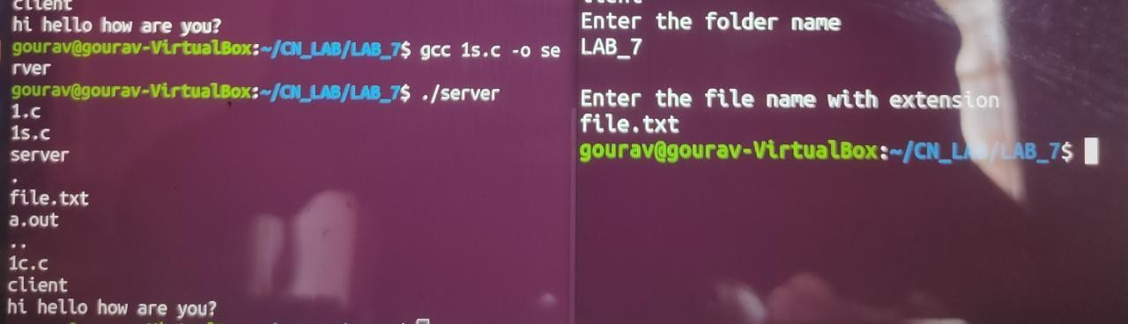

//printf("sent %d bytes to %s\n", numbytes, inet_ntoa(their_addr.sin_addr)); printf("\nEnter the file name with extension\n");

scanf("%s",arg);

sendto(sockfd, arg, strlen(arg), 0, (struct sockaddr *)&their_addr, sizeof their_addr);

close(sockfd); return 0;

}