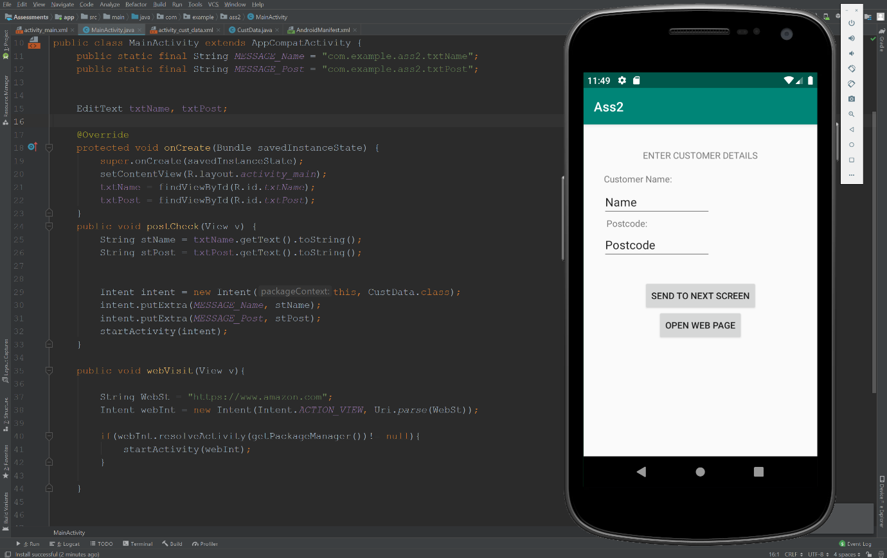  
<https://gyazo.com/7ece3b32de947d0303ce1a8d58195fee>

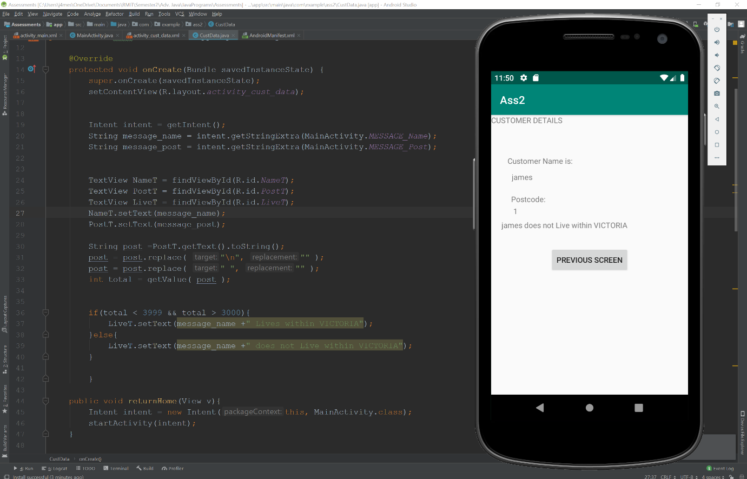  
<https://gyazo.com/f096eb9ec4c33c72ce8716e47f3cb9c9>

  
<https://gyazo.com/015d23ff8b127e87a52f13533da47e41>