README.TXT - This file will help to flash the u-boot binary into the NAND flash of OMAPL138 LCDK.

1. Unzip the folder “FlashingAndBooting”. You will find the following files.
2. sfh_OMAP-L138.exe - Serial flashing utility
3. u-boot-omapl138-lcdk.ais – U-boot binary image
4. Connect the OMAPL138 LCDK to your PC through USB-UART connection.
5. Make sure the DIP Switch settings of OMAPL138 LCDK board are like below.

|  |  |  |  |  |  |  |  |  |
| --- | --- | --- | --- | --- | --- | --- | --- | --- |
| Pin# | 1 | 2 | 3 | 4 | 5 | 6 | 7 | 8 |
| Position | OFF | ON | OFF | ON | OFF | OFF | OFF | OFF |

1. Open teraterm and select the USB serial port like COM3 whichever is appropriate for the OMAPL138 LCDK board UART-USB connection when connected to the PC.

Do the UART settings as 115200 baud rate and 8N1.

1. Press the RESET button and observe that the BOOTME message is received on the teraterm screen.
2. Close the teraterm – ( Note: If you miss this step, you will face some problem while using sfh)
3. In PC, open cmd.exe
4. Using “cd” command, go to the directory where the folder “FlashingAndBooting” is present.

>cd < path \to the folder\ FlashingAndBooting >

For example:

>cd C:\ti\ FlashingAndBooting

1. Type the below command to erase the NAND flash.

> C:\ti\ FlashingAndBooting>sfh_OMAP-L138.exe -flashType NAND -targetType OMAPL138_LCDK -erase -p COM3

Press the RESET button when it promts for “Waiting for BOOTME”. You will observe a screen like below.

1. 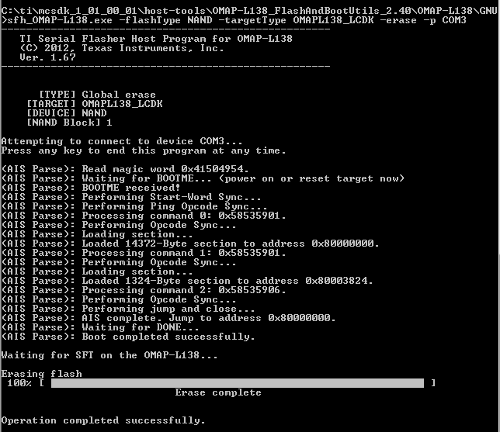
2. Type the below command to flash the u-boot binary to NAND flash.

>sfh_OMAP-L138.exe -flashType NAND -targetType OMAPL138_LCDK -flash_noubl u-boot

-omapl138-lcdk.out -p COM3

You will observe a screen like below

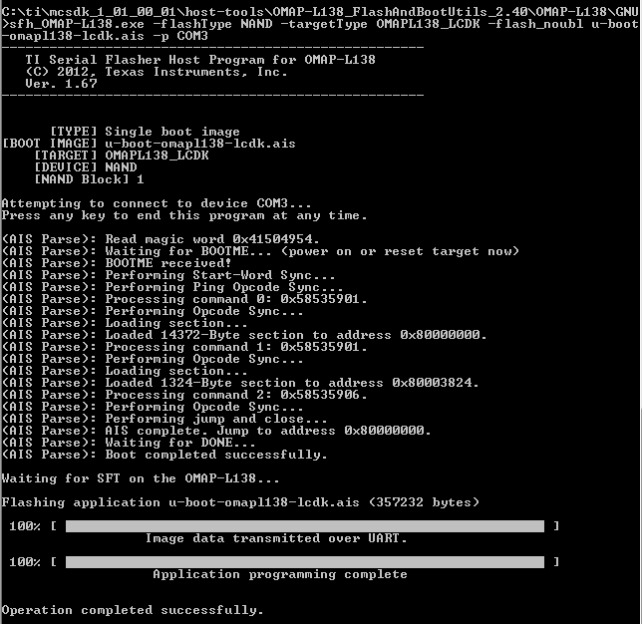

1. Change the DIP switch settings like below and do a reset. You will observe the u-boot messages and the u-boot prompt.

|  |  |  |  |  |  |  |  |  |
| --- | --- | --- | --- | --- | --- | --- | --- | --- |
| Pin# | 1 | 2 | 3 | 4 | 5 | 6 | 7 | 8 |
| Position | OFF | ON | ON | ON | OFF | OFF | OFF | OFF |

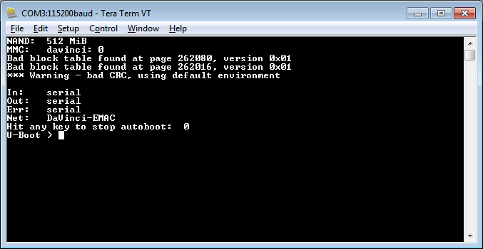

13.Great!!.. You are done the flashing of u-boot binary into NAND flash memory of OMAPL138 LCDK.