Read up on the following pipelines and functions for the aggregation framework and then

-give a quick explanation on what the function or pipeline does (The explanations for each function/stage does not have to be long, a few words should do the trick)

-**Simple** query example using the function or pipeline stage.

-Expected output of the query (Don’t make it very long give a quick overview on what the query did to the documents. A few words or one sentence should be fine)

Use the persons database we have used for previous examples for this assignment. As much as possible do not use the terms and definitions used by the documentation word for word for this assignment, as much as possible try to explain it using your own words.

Since this is a fairly long assignment, feel free to do this in groups of 5 members.

Deadline: Next meeting, If time is an issue, we can hold 30mins – 1hr next meeting to finish the assignment.

If any questions feel free to **EMAIL** me at : [prelalto@usc.edu.ph](mailto:prelalto@usc.edu.ph) or chat on FB:

<https://www.facebook.com/patrick.elalto/>

since di kaayo ko maka notice chats on Hangout

e.g $add = adds 2 numbers, $avg = gets the average values of a field

1. Pipelines
   1. $project

db.persons.aggregate([{$project:{_id:0,name:1,isActive:1,age:1}}])

* + - 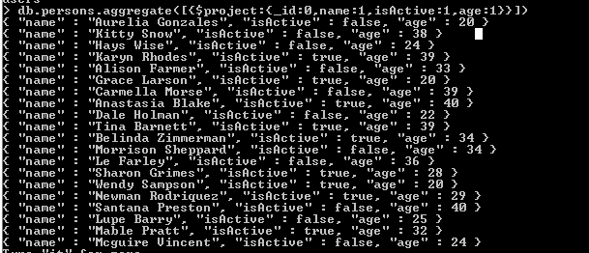
  1. $limit
  2. $skip

db.persons.aggregate([{$skip:2}])

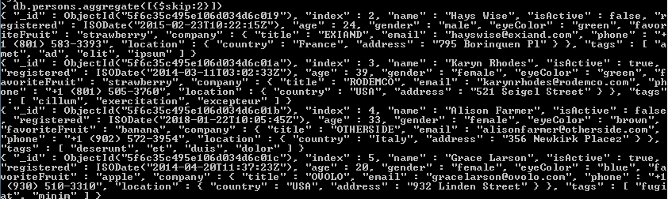

* 1. $out

1. $Group Functions
   1. $addToSet

db.persons.aggregate([{$match:{"age":{$gt:17}}},{$group:{_id:{age:"$age"},legal_age:{$addToSet:"$age"}}}])

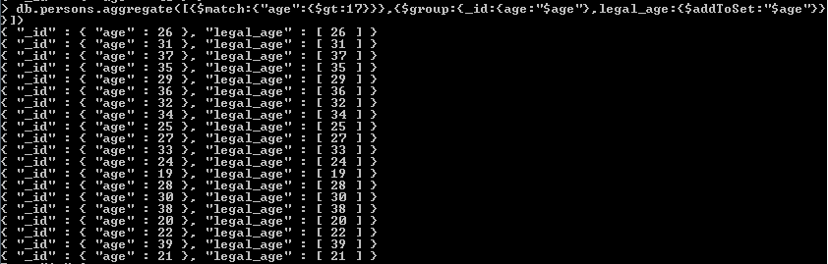

* 1. $first
  2. $last
  3. $max
  4. $min
  5. $avg
  6. $push

1. String Functions
   1. $concat

db.persons.aggregate([{$project:{_id:0,age:{$concat: ["$name"," - ",{$toString:"$age"}]}}}])

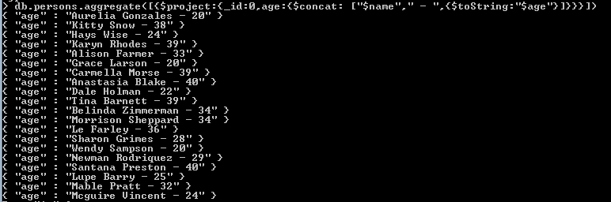

* 1. $strcasecmp
  2. $substr
  3. $toLower
  4. $toUpper

1. Arithmetic
   1. $add
   2. $divide
   3. $mod
   4. $multiply
   5. $subtract
2. Date Functions (No need for sample query, or explanation just give what the functions will return)
   1. $dayOfYear
   2. $dayOfMonth
   3. $dayOfWeek
   4. $year
   5. $month
   6. $week
3. Logical Functions
   1. $and
   2. $cmp
   3. $cond
   4. $eq
   5. $gt
   6. $gte
   7. $lt
   8. $lte
   9. $ifNull
   10. $ne
   11. $not
   12. $or
4. Set Operators
   1. $setEquals
   2. $setIntersection
   3. $setDifference
   4. $setUnion
   5. $setIsSubset
   6. $anyElementTrue
   7. $allElementsTrue