1. Display the number of movies a director has made. Display only the name of the Director and the count of his/her movies.

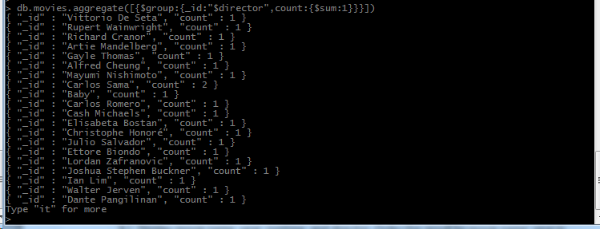

1. Number of Movies with a runtime greater than 120mins



1. Display the number of movies an actor has starred in. Display only the name of the Actor/Actress and the count of his/her movies.

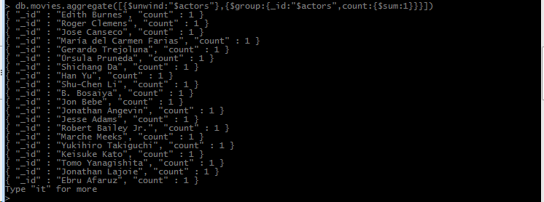

1. Display the number of Movies shown in a specific year. Display only the year and the count of movies.

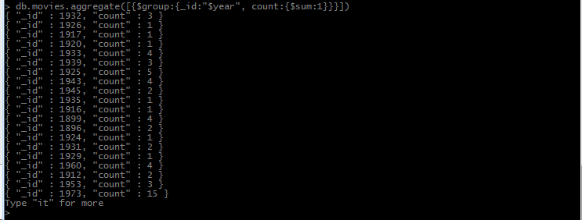

1. Display the Movie/Movies that meets the genres Adventure, Biography, Drama

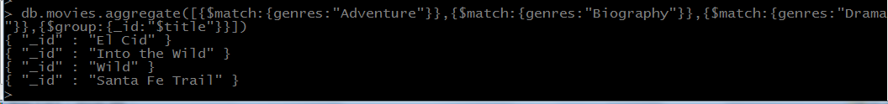

1. Display the number of movies per specific Genre.

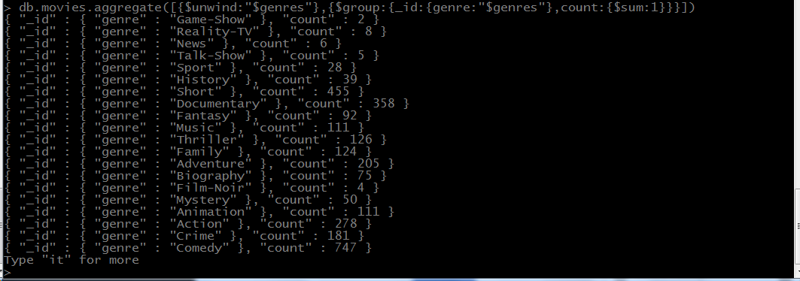

1. Updated all the movies with a rated “R” rating to rated “R-18”



1. Movies who starred actor “Hayden Christensen” and directed by “George Lucas” display only Movie Name, Year, and Runtime.

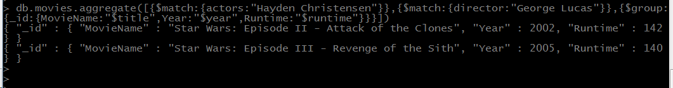

1. Display movie name, year, runtime, and director. Order the result by movie name, year in ascending order.

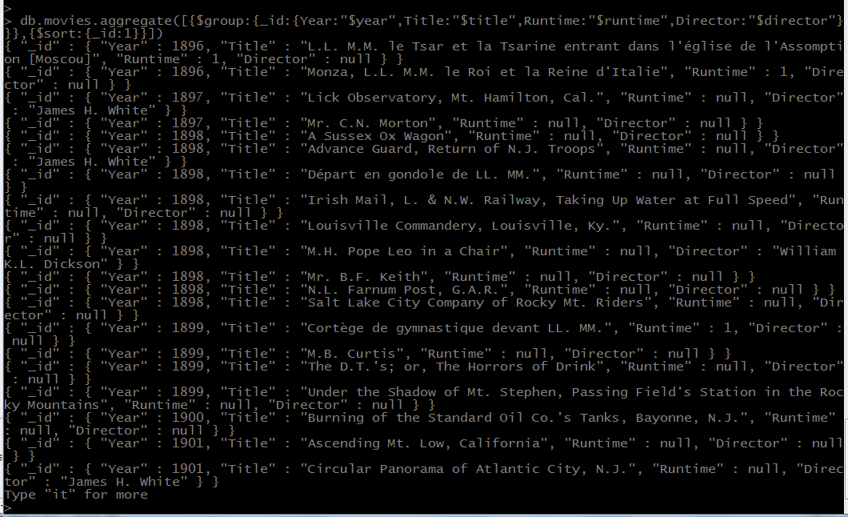

1. Display movies that includes “Wes Anderson” as a writer with a metacritic score greater than 80

https://lh3.googleusercontent.com/--h6c-PqNZco/X4gElrHVgRI/AAAAAAAAAPU/Ah70ICuSFJkaJZP___9gLWsCZznrx_YIQCK8BGAsYHg/s0/2020-10-15.png

1. Remove all movies without an imdb rating or votes or whose imdb ratings or votes values are null



1. Display only the movies that has all of the following:
   1. Imdb rating greater than 6
   2. Imdb votes greater than 5,000
   3. a tomato meter greater than 70
   4. a tomato rating greater than 5
   5. a tomato userRating greater than 3
   6. a tomato userReviews greater than 1,000
   7. a metacritic rating greater than 40

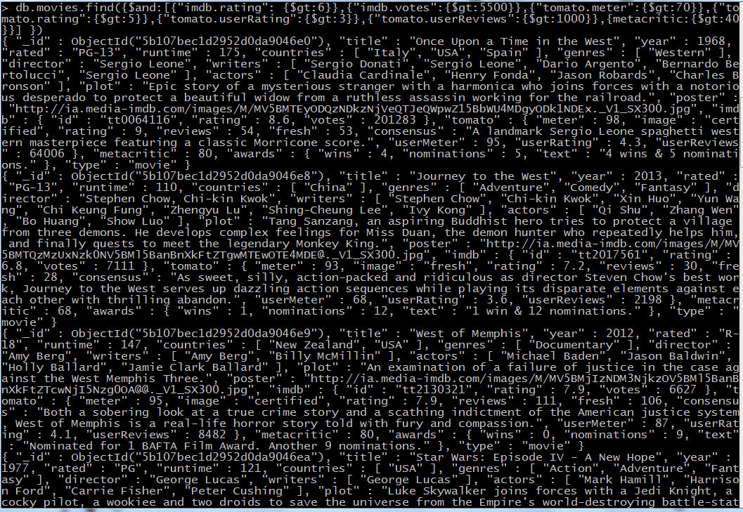

1. Display the number of movies found on #12

https://lh3.googleusercontent.com/-AKoHt8KTO7E/X4gL99IUGmI/AAAAAAAAAPo/yBfQKuROY-Eoxx-UP6KF4OCUcbN4Fe8HgCK8BGAsYHg/s0/2020-10-15.png

1. Display all the movies that were either nominated for or won an Oscar. Display the movie name ,year, and number of award wins and nominations.

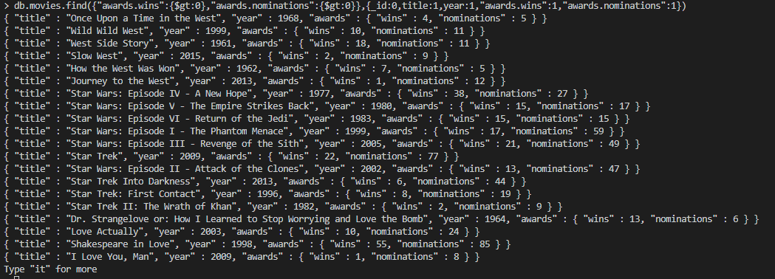

1. Search for information on the 2019 movie Parasite, and add it as a document to this collection.

Required:

Title, Year, rated, runtime, countries featured in the movie, genres, director, writers, actors, plot, and imdb{id: tt6751668 , rating:8.6, votes:491247}

If it is not required you can give it a null value.

The document added should follow the exact same format as other documents in the collection.

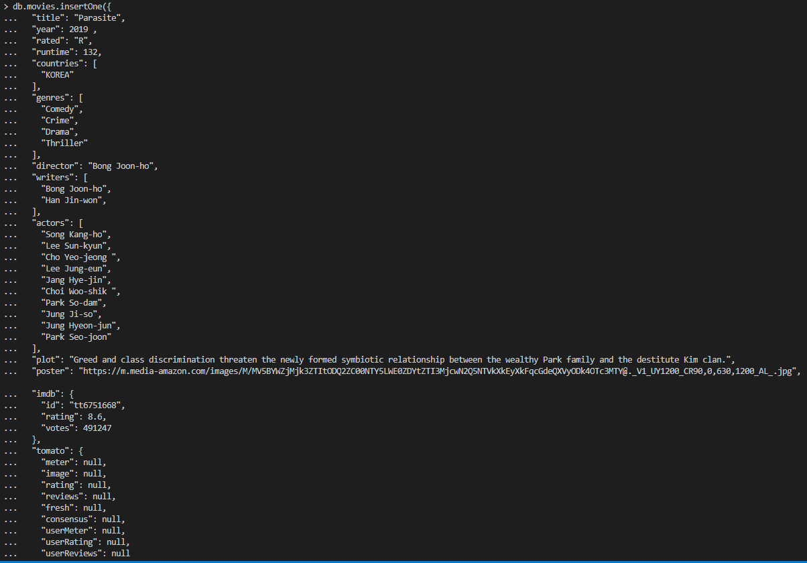

1. Display documents in a readable manner that were released after 1995 and whose name starts with the word “Star”. Sort by imdb ratings from descending order.

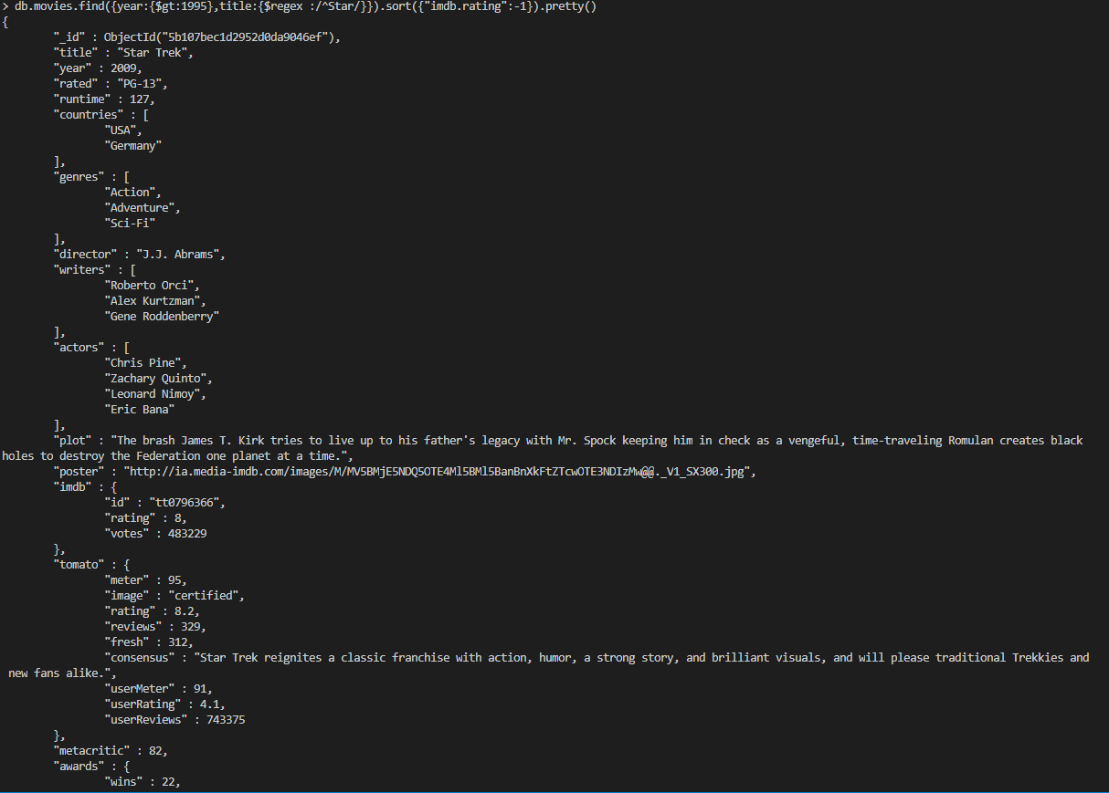

1. Display the Movie/Movies that contain the name “Anakin Skywalker” in the plot

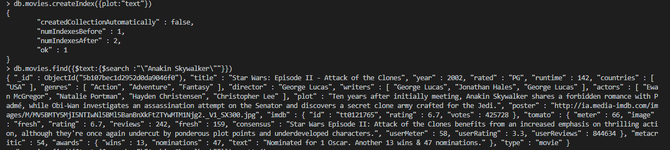

Bonus:

Guess/Find one of my favorite movies through the use of mongoDB queries!

It is a **comedy, drama** starring **Robin Williams** that has won one **Oscar** award