Name: Rhea May T. Ardiente Date: 10-01-2020

Sched:____________________

1. Enumeration

I.a. Give at least 5 advantages and 5 disadvantages of having a database integrated in your system/business.

Advantages:

* Reduce data Redundancy
* Improved Data Security
* Reduce data entry, storage, and retrieval cost
* Facilitated development of new apllications program
* Reduced updating errore and increased consistency

Disadvantages:

* Database Systems are difficult, time-consuming and complex to design
* Initial training required for all programmers and users
* Damage to database affects virtually all applications programs
* Substantial hadware and software start-ups costs
* Extensive conversion costs in moving form a file-based system to a database system.

1. ERD

II.a. Name every given cardinality (8pts)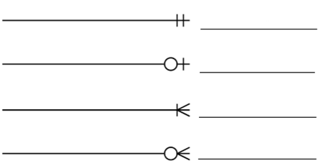

1. Mandatory One / One and only One (Mandatory)
2. Optional One / Zero or One (Optional)
3. Mandatory Many / One to Many (Mandatory)
4. Optional Many / Zero or Many (Optional)

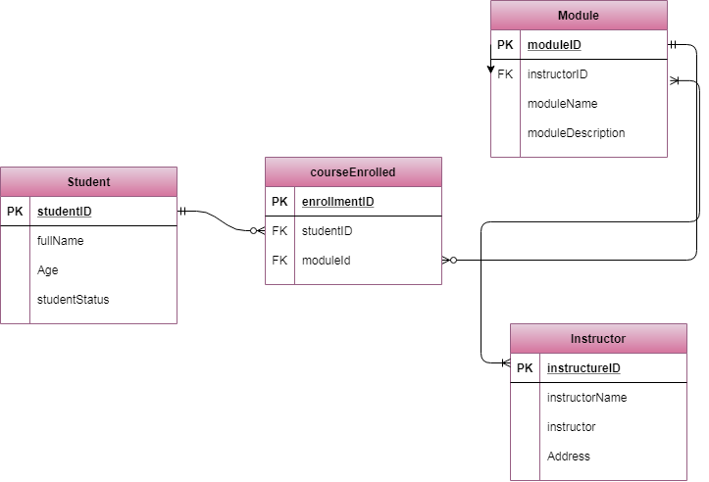II.b. Illustrate the ERD. Assuming USC asked you to design a data model for the enrollment module.

1. Normalization

Normalize the given table. (15 pts)

|  |  |  |  |
| --- | --- | --- | --- |
| Full name | Physical Address | Courses Handled | Masteral Degree |
| Patrick Elalto | Bldg 2, Room 24A, Banawa Residence | SD 205, IT 1102, IT 1101 | MSIT |
| Edrian Guanzon | B1 L1, Mapua St, Lungsod | SD 206, IT 1102 | MSCS |
| Gran Sabandal | Tabunok | SD 206, IT 1101, IT 3102 | MSCS |

**1NF:**

|  |  |  |  |
| --- | --- | --- | --- |
| Full Name | Physical Address | Courses Handled | Masteral Degree |
| Patrick Elalto | Bldg 2, Room 24A, Banawa Residence | SD 205 | MSIT |
| Patrick Elalto | Bldg 2, Room 24A, Banawa Residence | IT 1102 | MSIT |
| Patrick Elalto | Bldg 2, Room 24A, Banawa Residence | IT 1101 | MSIT |
| Edrian Guanzon | B1 L1, Mapua St, Lungsod | SD 206 | MSCS |
| Edrian Guanzon | B1 L1, Mapua St, Lungsod | IT 1102 | MSCS |
| Gran Sabandal | Tabunok | SD 206 | MSCS |
| Gran Sabandal | Tabunok | IT 1101 | MSCS |
| Gran Sabandal | Tabunok | IT 3102 | MSCS |

**2NF:**

|  |  |  |  |
| --- | --- | --- | --- |
| Mentor_Id | Full Name | Physical Address | Masteral Degree |
| M-1 | Patrick Elalto | Bldg 2, Room 24A, Banawa Residence | MSTI |
| M-2 | Edrian Guanzon | B1 L1, Mapua St, Lungsod | MSCS |
| M-3 | Gran Sabandal | Tabunok | MSCS |

|  |  |  |
| --- | --- | --- |
| Course_Id | CourseName | Mentor_Id |
| C-1 | SD 205 | M-1 |
| C-2 | SD 206 | M-2 |
| C-3 | IT 1102 | M-1, M-2 |
| C-4 | IT 1101 | M-1,M-3 |
| C-5 | IT 3102 | M-3 |

**3NF:**

|  |  |
| --- | --- |
| **masterDegree_id** | **Masteral Degree** |
| d-1 | MSTI |
| d-2 | MSCS |

1. SQL

IV.a. Write the sql queries.

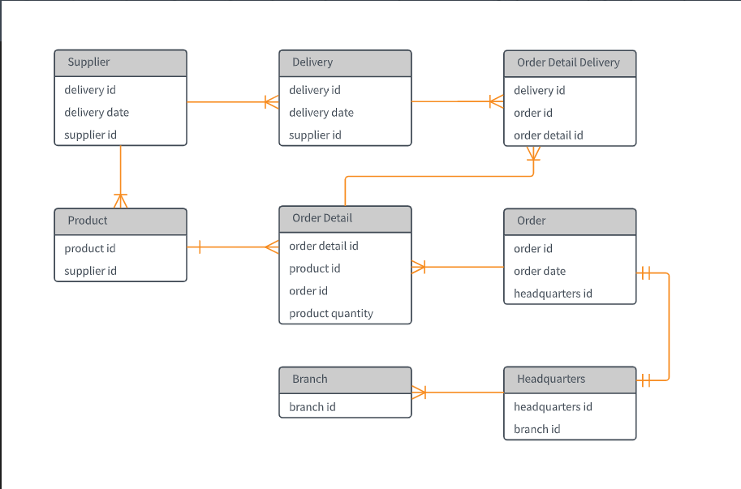

Refer to the diagram given.

1. The buyer bought two different items from different stores. Write the query that will add to the database.

____>>> U_________________________________________________________

_____________________________________________________________

1. Assuming the original date of delivery was moved from 9/11/20 to 9/22/20. Write the query that will change the delivery date. (note: mm/dd/yy)

>>>

1. The buyer changed her mind right after she checked out and decided to cancel her order. Write the query that will cancel her order.

>>>SELECT orderid FROM orders

WHERE NOT EXIST

(Select * from OrderDetail

Where orderid = orders.orderid

And cancelled = 1)

1. The supplies got delayed. The expected date of arrival was 10/10/20 but due to the delay, it was pushed further a month. Write the sql query that will change the arrival date. (note: mm/dd/yy)

>>> UPDATE Delivery

SET deliverydate = ’11-10-2020’

WHERE deliveryid =1

1. Assuming the store owner opened a new branch. Write the sql query that will add another branch in the database.

>>>

1. Perform a **left join** query with **Order Detail** and **Order Detail Delivery.**

>>>SELECT OderDetail.productid, OrderDetailDelivery.deliveryid

FROM OrderDetail

LEFT JOIN OrderDetailDelivery

ON OrderDetail.orderid = OrderDetailDelivery.orderid

ORDER BY OrderDetail.productid

1. Perform an **inner join** query with **Product** and Order **Detail**.

>>>SELECT Product.productid, OrderDetail.productquantity

FROM Product

INNER JOIN OrderDetail

ON Product.productid = OrderDetail.productid