Db.persons.aggregate([{$match:{“gender”:”male”}}, {$group:{_id:”$age”, count:{$sum:1}}}])

.aggregate([{},{},{}])

-Each one of these objects is going to represent a “stage”

* $match -> filters by a certain condition
* $group->groups the documents based on a certain criteria
* $project-> filters the fields in the document
* $sort->sorts in descending or ascending order, or possibly a custom sort
* $count->counts all the documents
* $limit->limits the documents returned by your query
* $skip->skips a certain amount or certain number of returned documents
* $out->Writes the output of the aggregation framework or the returned documents of the queries to another collection

-Going into each stage, an operation will be performed on the documents, and then it will create a new subset of documents based on the outputs.

-match: produces a subset of the passed documents based on a given criteria

{$match:{<query>}}

{$match:{“age”:{$gt:25}}}

-group: takes the subset of documents passed by the 1st stage, and then creates new documents, based on a certain format/syntax/condition

{$group:{_id:<expression>, <field1>: {<accumulator1>:<expression1>},<field2>:{<accumulator2>:<expression2>},…}}

_id= required

-Field=whatever you want to name the new field

-Accumulator=function on how to process or what to do with the data

-Expression=what to do inside the accumulator

{$group:{_id:”$age”, count:{$sum:1}}}])

Unwind

{

Name:Patrick,

Age:24,

Interests:[ Playing, Listening to Music, Working],

}

Unwind(

{

Name:Patrick,

Age:24,

Interests:[ Playing, Listening to Music, Working],

}

)

{

Name:Patrick,

Age:24,

Interests:Playing

//1

}

{

Name:Patrick,

Age:24,

Interests:Listening to Music

//2

}

{

Name:Patrick,

Age:24,

Interests:Working

//3

}

Using a MongoDB expression as a value for the field $sum:

db.persons.aggregate([{$match:{"age":{$gt:25}}},{$group:{_id:"$age", total:{$sum:{$add:["$age",5]}},count:{$sum:1}}}])

Using unwind to separate the array values of a document:

db.persons.aggregate([{$match:{"name":"Aurelia Gonzales"}},{$unwind:"$tags"}]).pretty()

Sorting the documents returned by the 2nd stage:

db.persons.aggregate([{$match:{"age":{$gt:25}}},{$group:{_id:"$age",count:{$sum:1}}},{$sort:{_id:1}}])

Reversing group and match:

db.persons.aggregate([{$group:{_id:"$age",count:{$sum:1}}},{$match:{"count":{$gt:5}}}

**Activities:**

1. Query to find all of the documents where isActive:false;



Result:



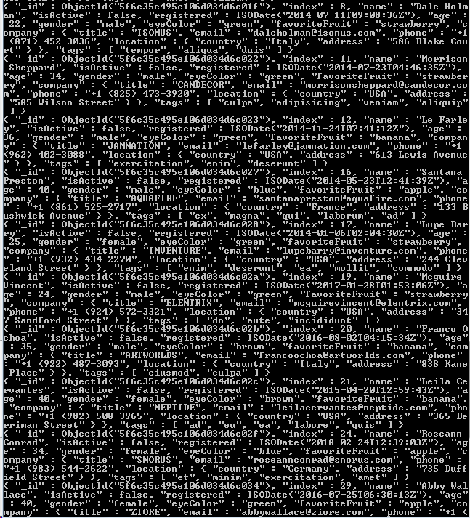



1. Query to find all of the documents where isActive:true;



RESULT:

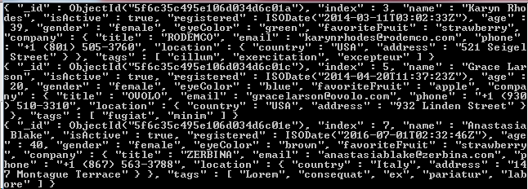

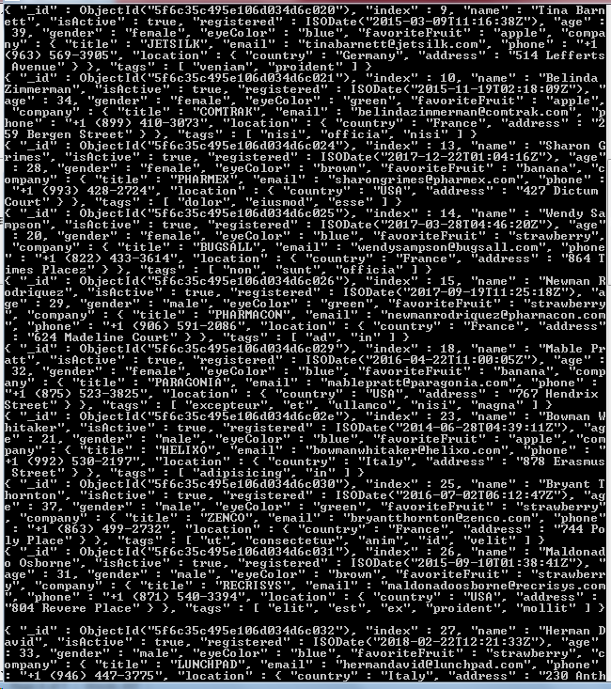

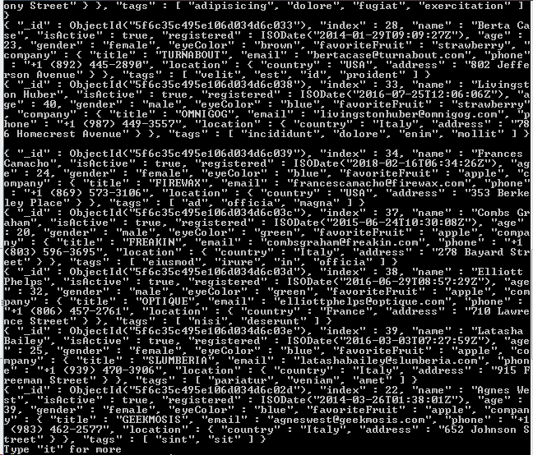

1. Query to find number of documents where isActive:true;

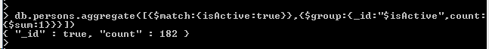

1. Query to find number of documents where isActive:false;



1. Query to create new documents showing the aggregate data of the isActive field

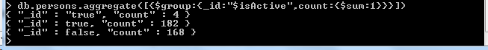

1. Query to create new documents showing the aggregate data of the isActive field and gender field

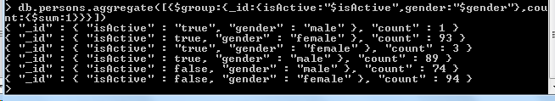

1. Query to create a new document showing the aggregate data of the isActive field and the age field, with the exception of anyone below the age of 35.

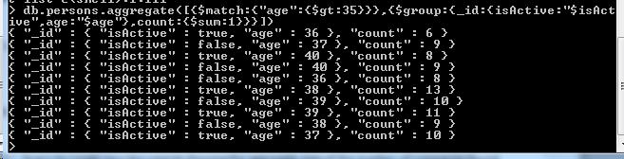

1. Sort the documents created in #7 in Ascending Order.

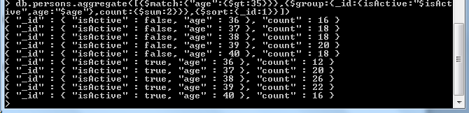

1. Query to create new documents showing the aggregate data of the number of companies found in a specific country. E.g USA: 5, Italy:10 , France: 15, etc.

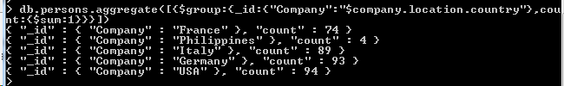

1. Query to create new documents showing the aggregate data of the number of documents associated to each specific tag. E.g ex:5, magna:10, enim: 10;

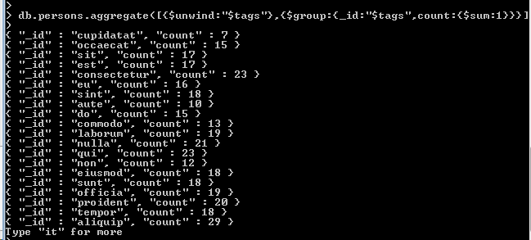

1. Query to sort the output of #10 in Descending Order

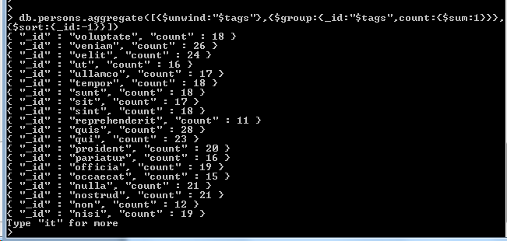

1. Query to create 2 new documents showing the average age of each gender.

e.g

{_id:female average:43};

{_id:male average:44};

