

**How it works:**

The ACGME Program scraper goes out to the [program search app](https://apps.acgme.org/ads/Public/Programs/Search) provided by ACGME.org and automatically inputs every specialty in their list as well as the state of Ohio to display all results in a list as displayed below:

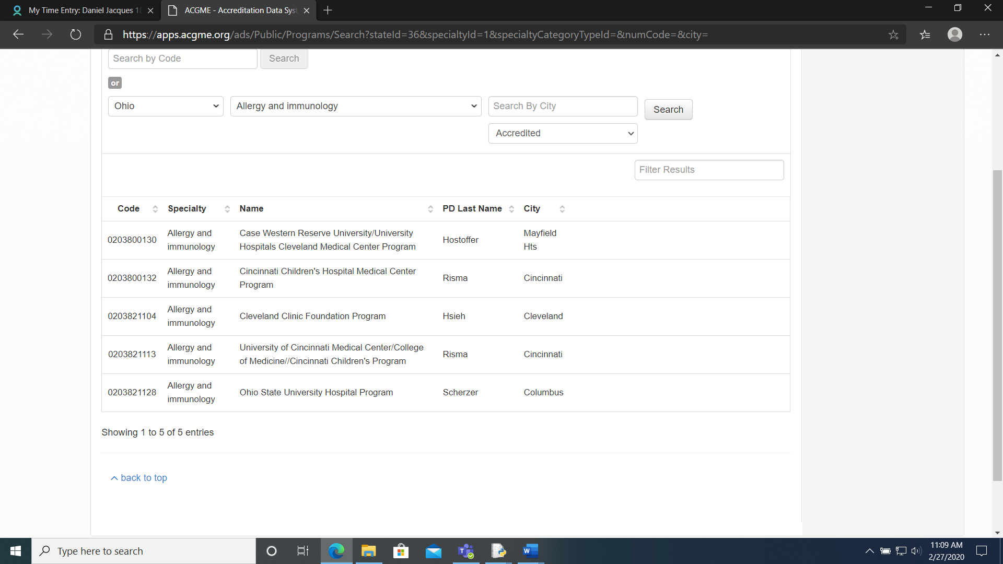

Each institution in the list is clicked on by the program and the information is instantly pulled from the webpage and compiled into an excel document for easy reading.

**Installing Python:**

The app requires the computer to have Python 3.7 installed. To install Python, go [here](https://www.python.org/ftp/python/3.7.6/python-3.7.6-amd64.exe). You will get a window that looks similar to this:

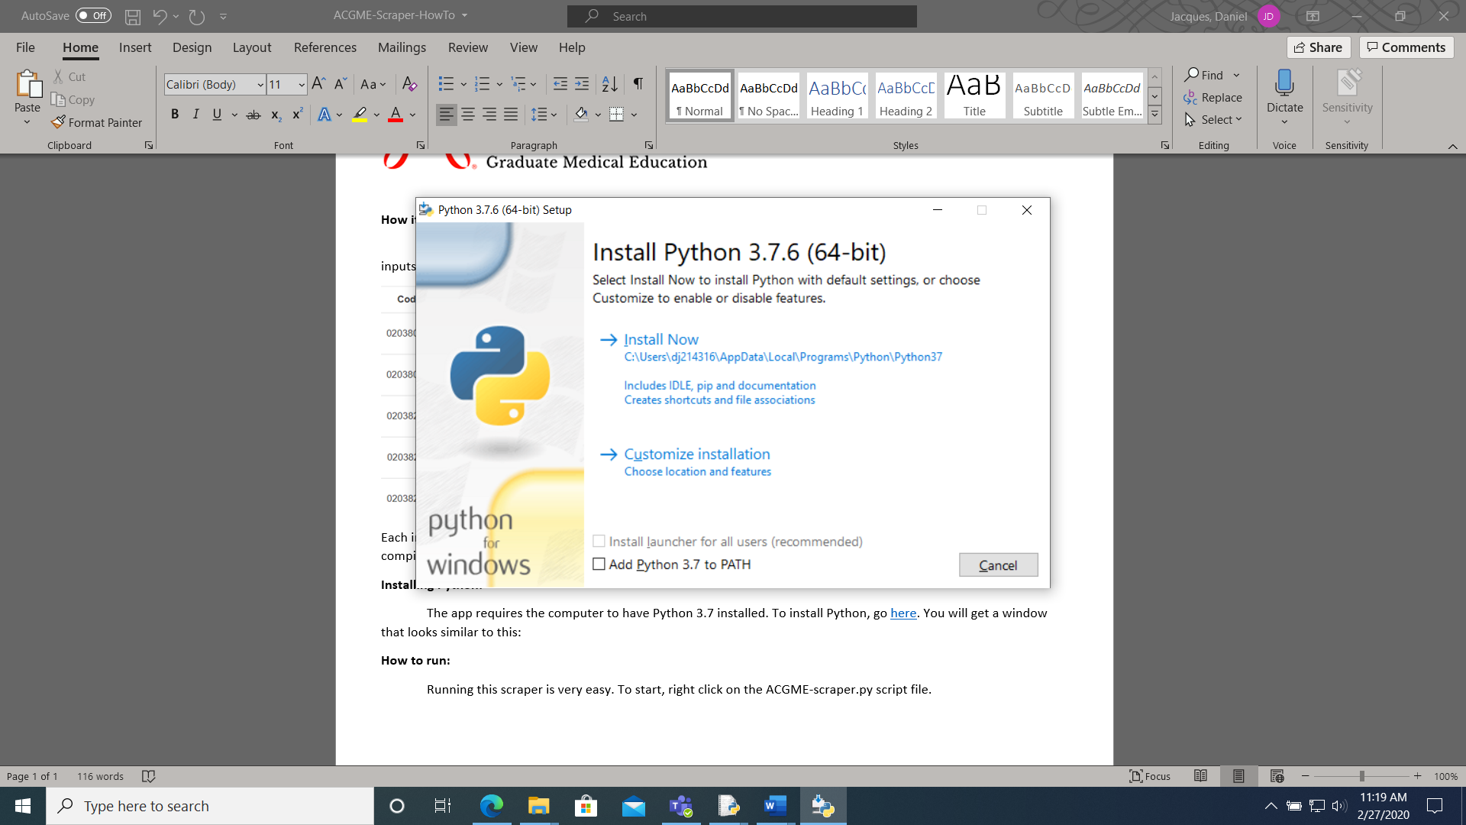

Ensure that you check the “Add Python 3.7 to PATH box, then click “Install now”.

**How to run:**

Running this app is very easy. To start, right click on the ACGME-scraper.py script file and choose “Edit with Idle 3.7.6”. You will get a window that looks like this:

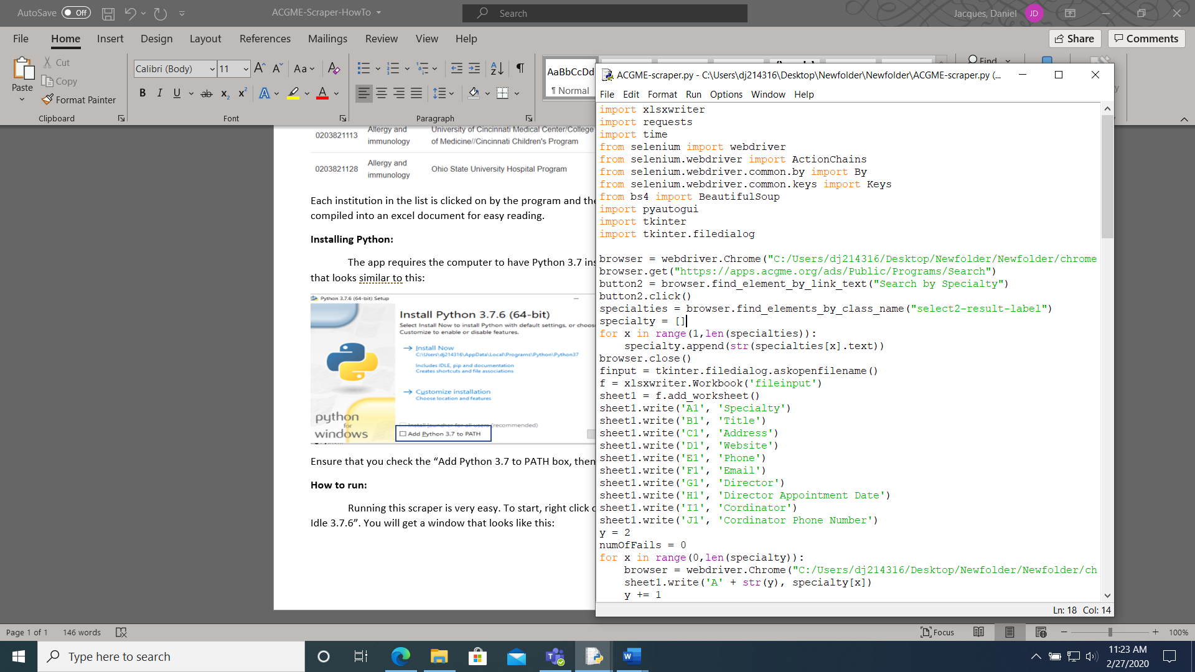

Click on “Run” at the top of the window, followed my “Run Module”. The program will now begin running. You will have a few windows pop up followed by a file selection screen window. This is normal. Select the excel file you would like to output to. The scraper will take a very long time to run (upwards of two hours) so it is best to let it run overnight or during time where you don’t need your computer. In the end, it is also normal to have a load of black windows similar to what you’ve been seeing it run with. **If it is stopped early, it will not save it’s data.**