Git 🡪** To work with Local Repository.  
**Git Hub🡪** To work with Remote Repository.  
  
**Pre Requisites :  
1)** Git Software Installation 🡪[https://git-scm.com/downloads/win](mailto:jagadeeshdesetti27@gmail.com?subject=Git%20Link) **2)** Create an account on Git Hub 🡪 <https://github.com/>

**

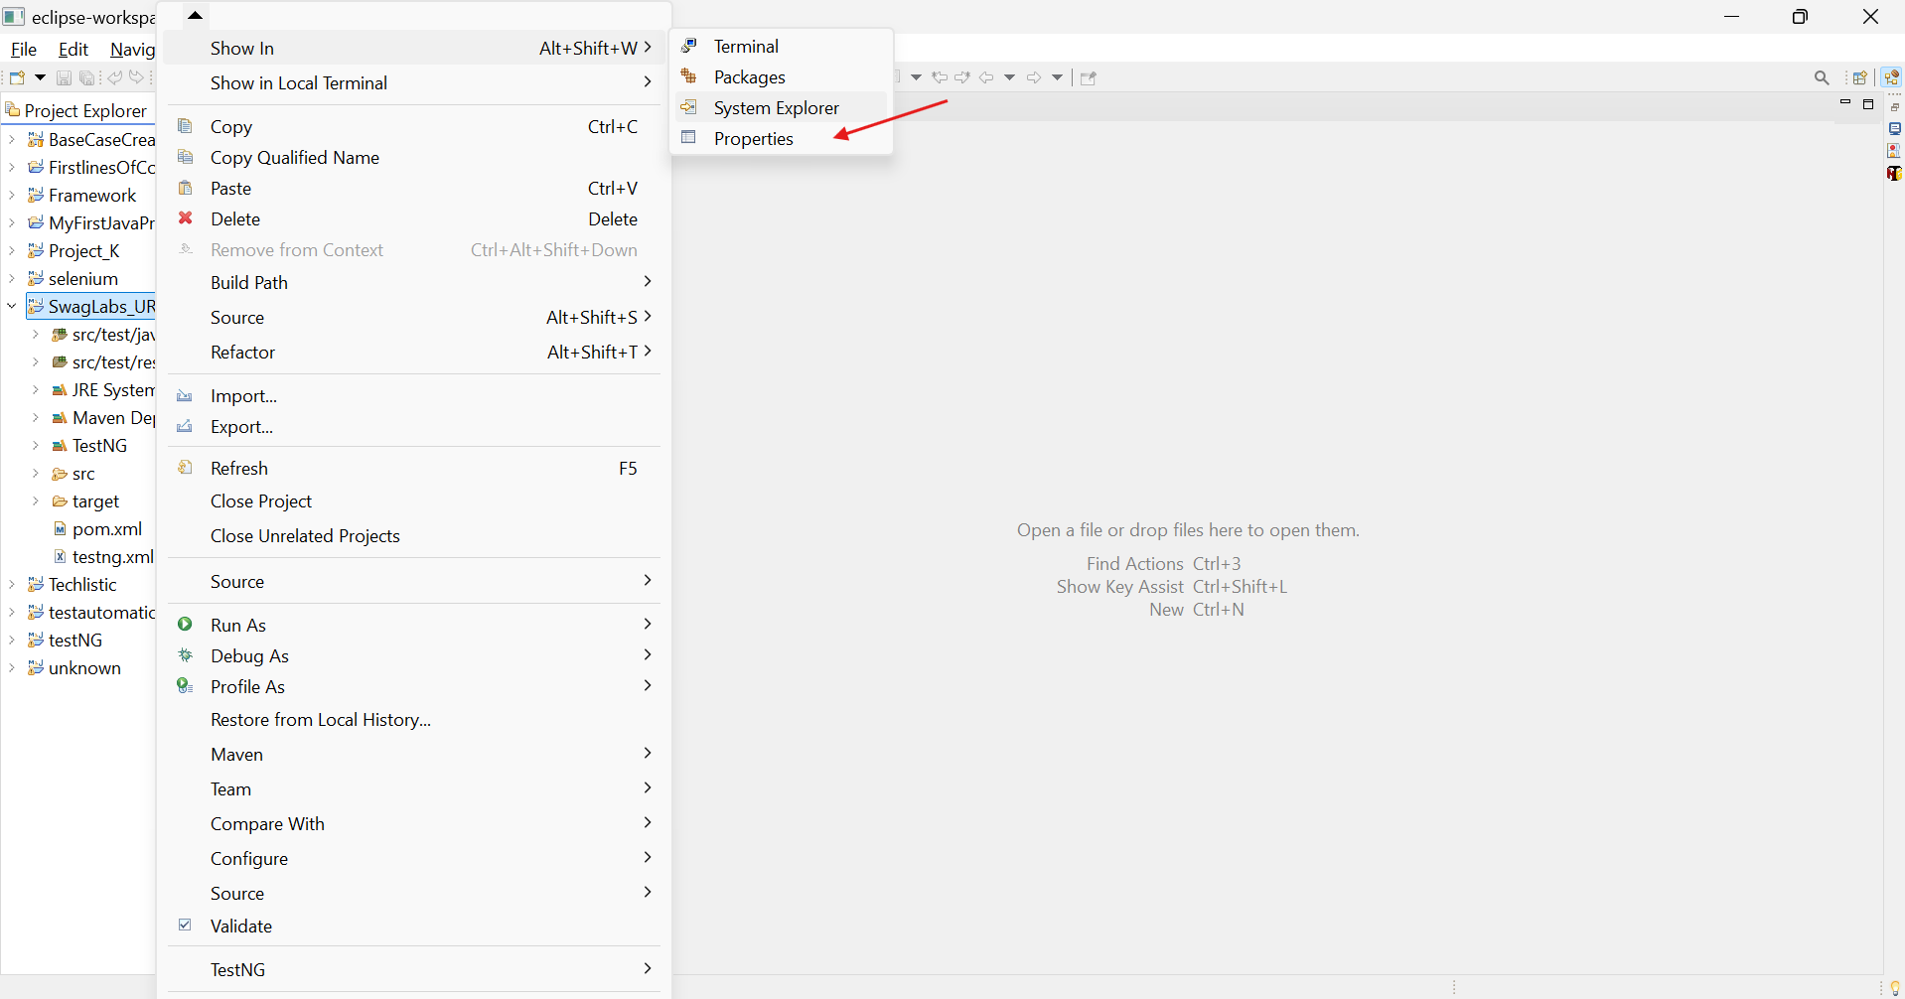

C:\Users\dejagadeesh\eclipse-workspace\SwagLabs_URL

1) To create new ‘Local Repository’ in Git.

**Adding files to the Staging Area** :-

1. git add -A
2. git add [File name]
3. git add *.xml
4. git add [Folder name]

5) To establish connection/Link between Local Repository & Remote Repository.

6) To push code into the remote Repository

**PUSHING CODE INTO ‘GITHUB’ (Code exists in the repository)**

New file is ‘Parallel.xml’ is added.

1) Adding the files/folders to Staging area

2) Committing the code to Local Repository

3) Pushing the code to Remote Repository

