Algorithme V_0

Table des matières
28/04/2023 19:49:22 2
29/04/2023 17:02:39 3
29/04/2023 19:45:06 3
30/04/2023 12:47:28 4
30/04/2023 17:45:34 4
02/05/2023 17:35:21 4
02/05/2023 17:49:03 6
02/05/2023 19:06:41 6
02/05/2023 19:30:12 8
02/05/2023 22:05:52 8
03/05/2023 11:59:38 10
03/05/2023 19:26:15 10
04/05/2023 18:29:55 11
05/05/2023 19:51:55 11
08/05/2023 20:23:28 12
08/05/2023 23:07:37 13
09/05/2023 20:22:07 14
10/05/2023 20:32:32 15
12/05/2023 12:14:44 15
12/05/2023 20:26:48 16
13/05/2023 16:45:48 17
13/05/2023 17:42:05 18
13/05/2023 20:50:29 18
14/05/2023 18:43:31 19
14/05/2023 19:58:36 19
14/05/2023 20:14:55 20
14/05/2023 22:29:38 21
14/05/2023 22:47:37 22
15/05/2023 12:10:36 23
15/05/2023 17:47:18 24
15/05/2023 20:15:22 25
16/05/2023 10:41:18 26
End 26

28/04/2023 19:49:22
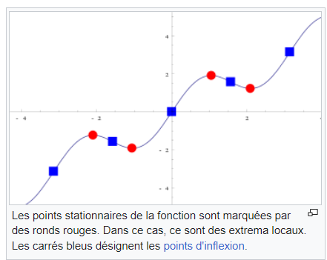

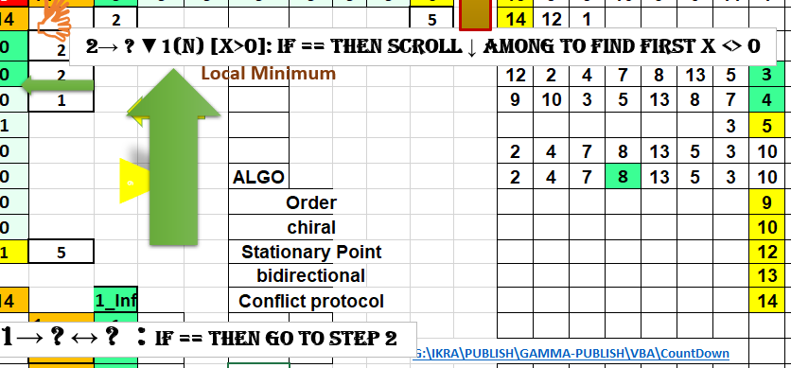

29/04/2023 17:02:39

https://youtu.be/qcEyUCLFJYM

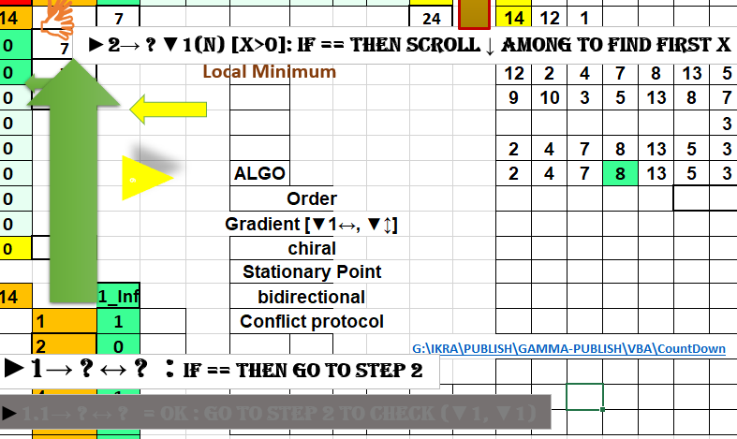

29/04/2023 19:45:06

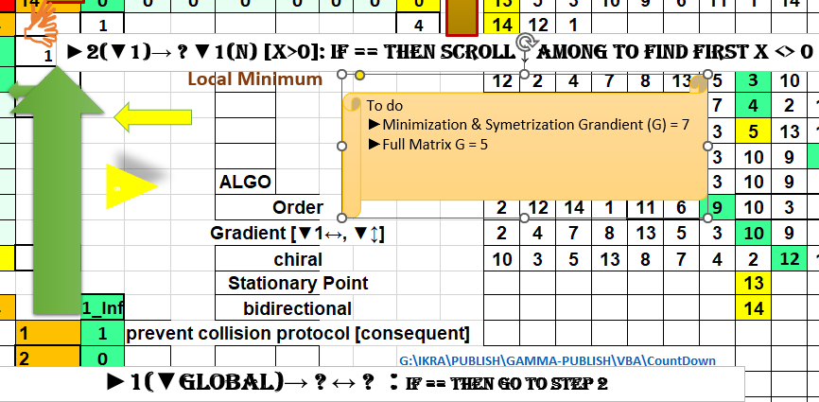

30/04/2023 12:47:28
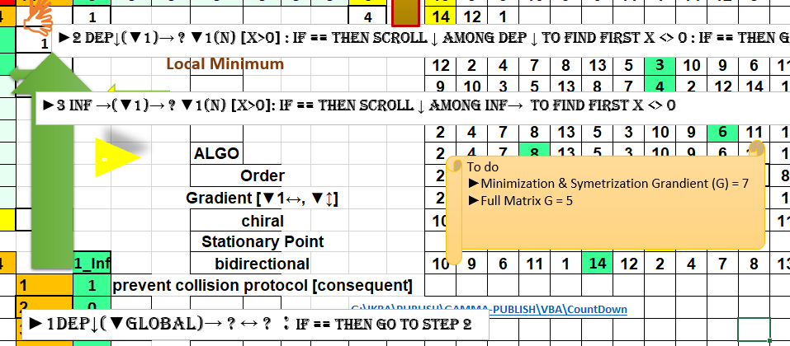

30/04/2023 17:45:34

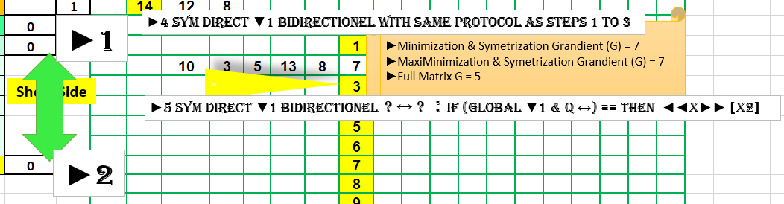

02/05/2023 17:35:21

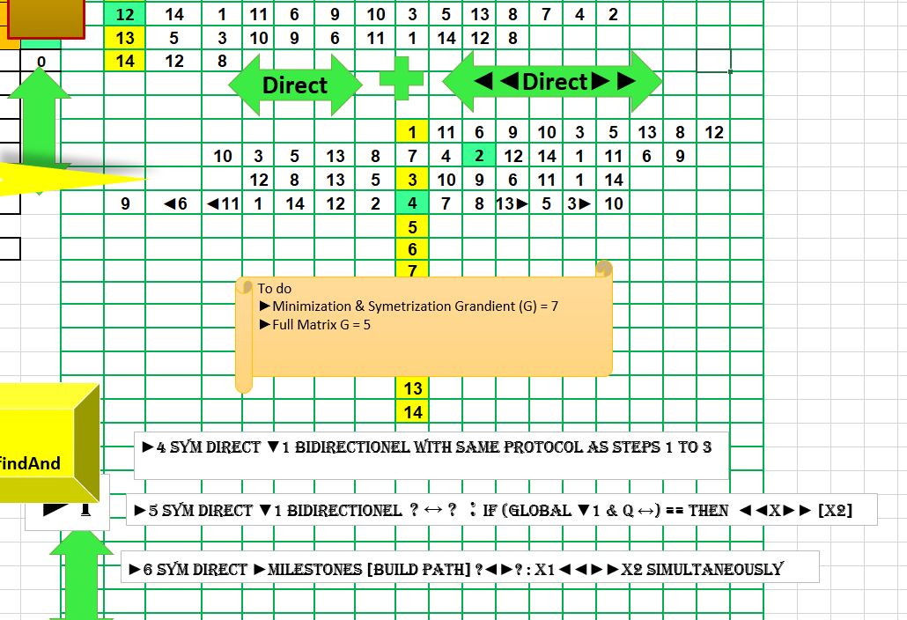

02/05/2023 17:49:03
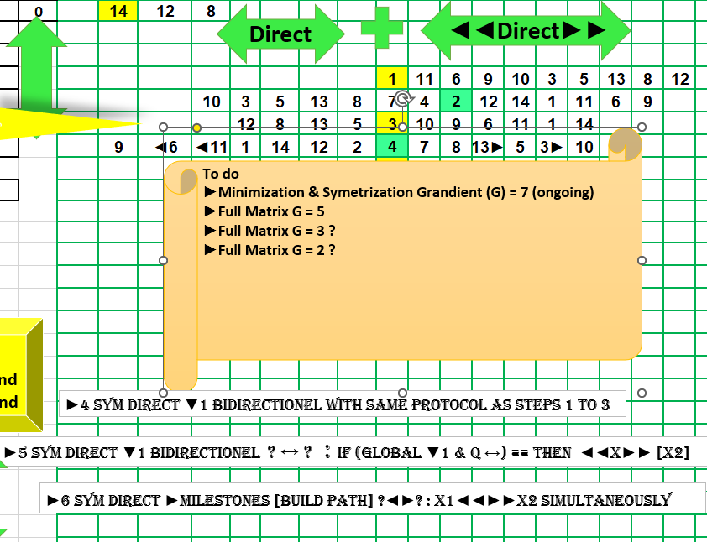

02/05/2023 19:06:41

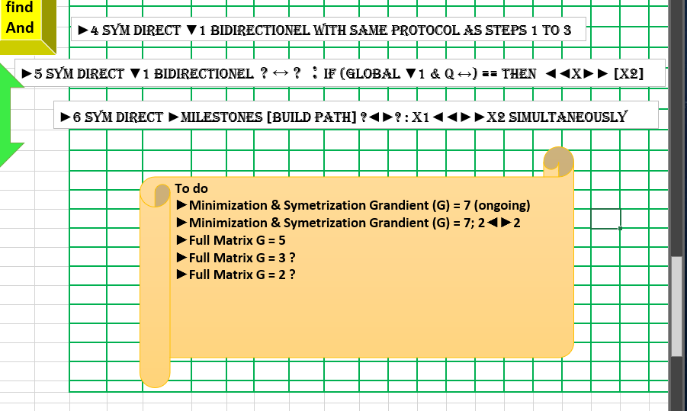

02/05/2023 19:30:12
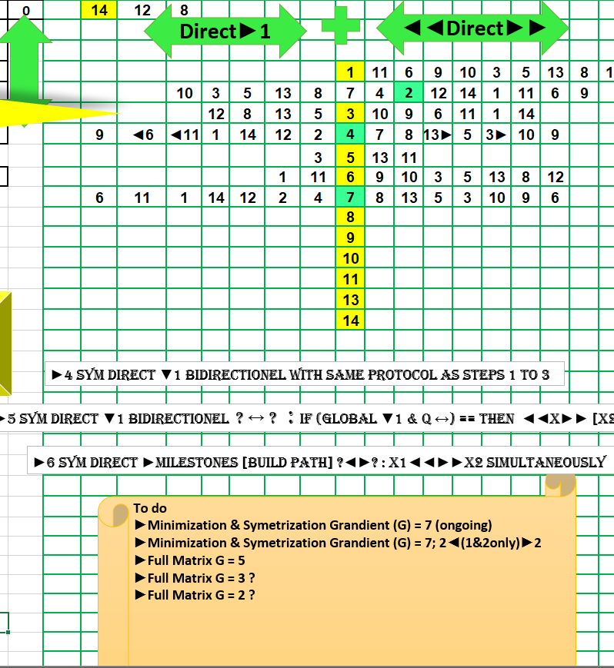

02/05/2023 22:05:52

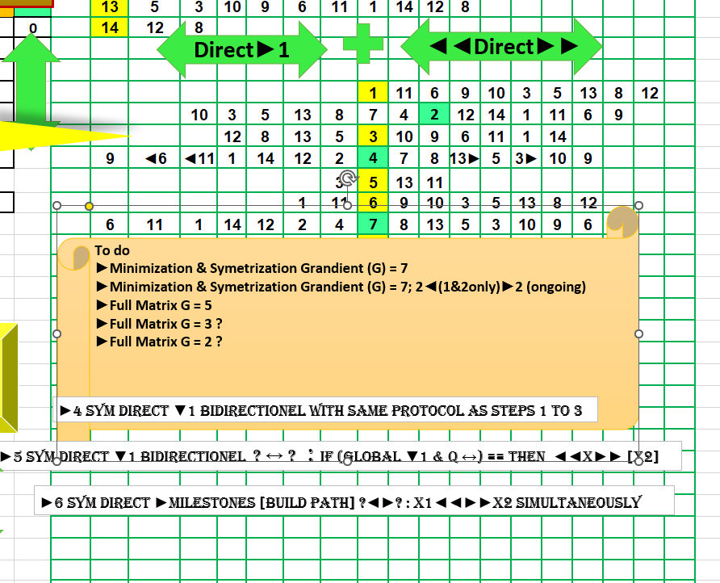

03/05/2023 11:59:38
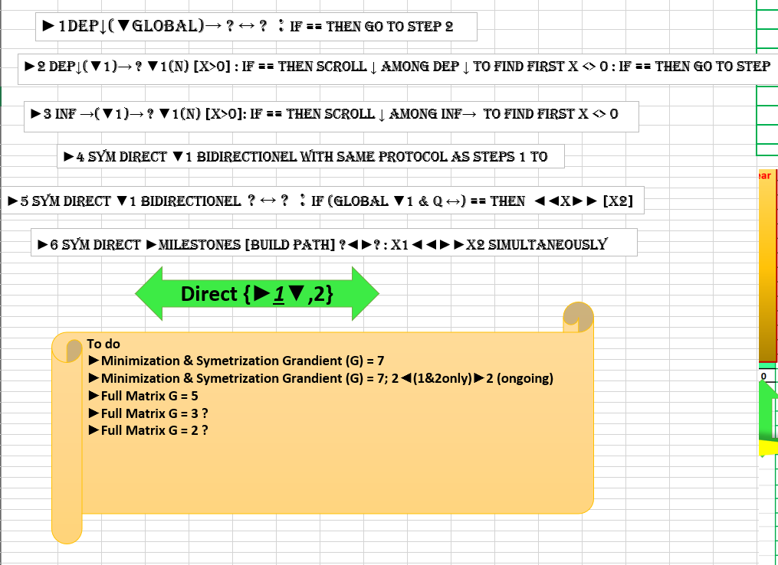

03/05/2023 19:26:15

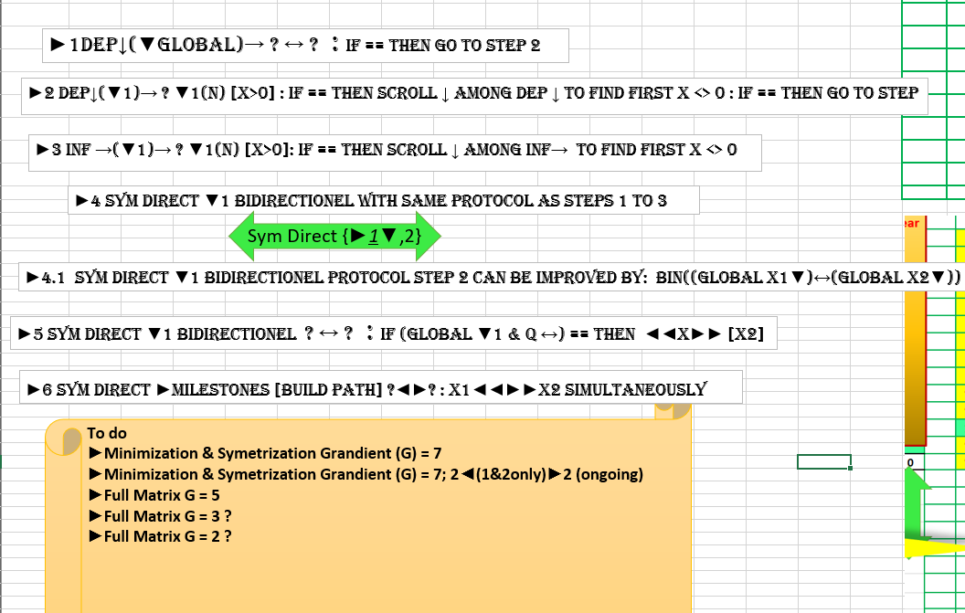

04/05/2023 18:29:55
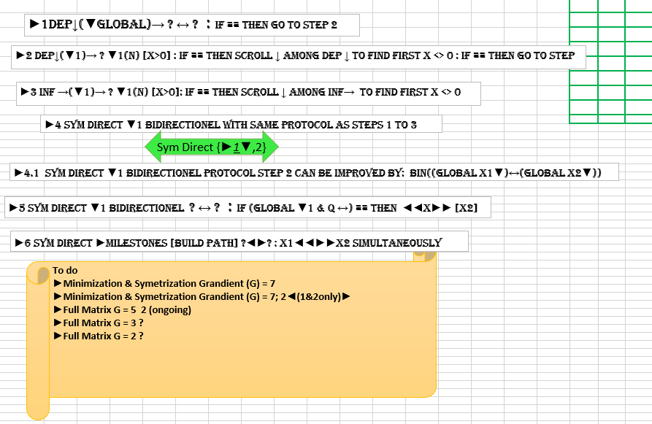

05/05/2023 19:51:55

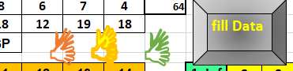

08/05/2023 20:23:28
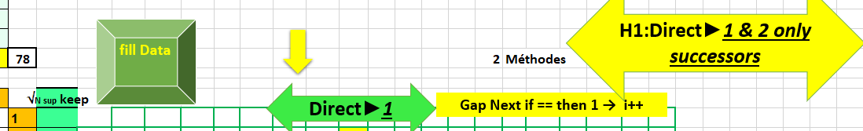
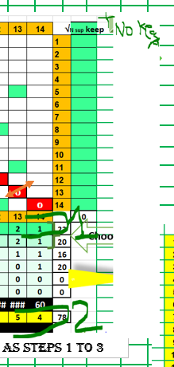
+ roadmap

08/05/2023 23:07:37
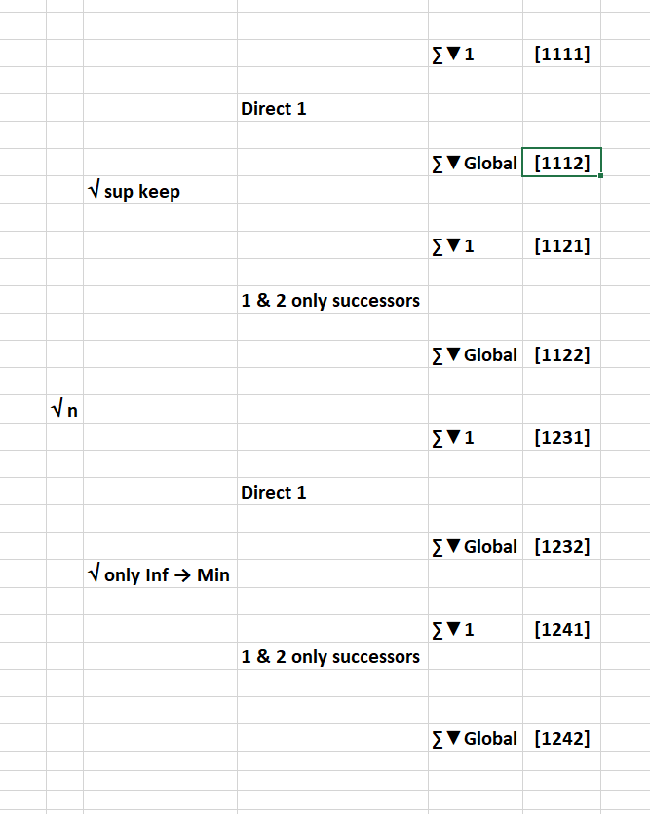

09/05/2023 20:22:07
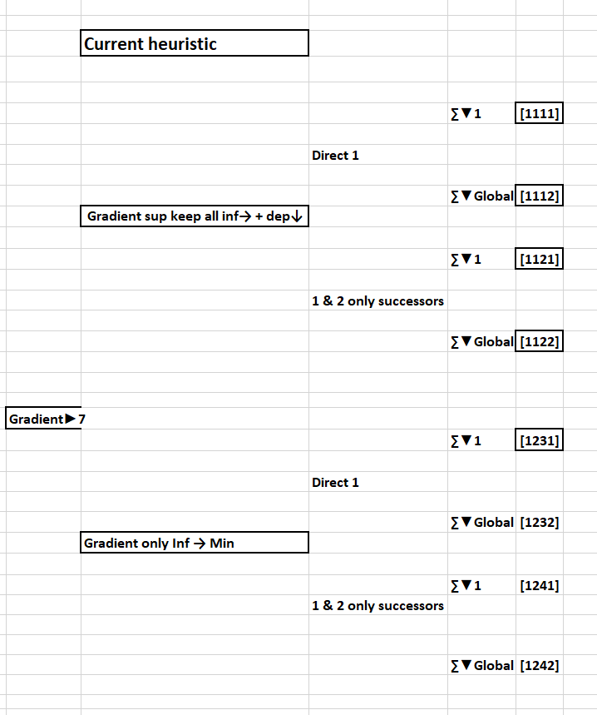

10/05/2023 20:32:32
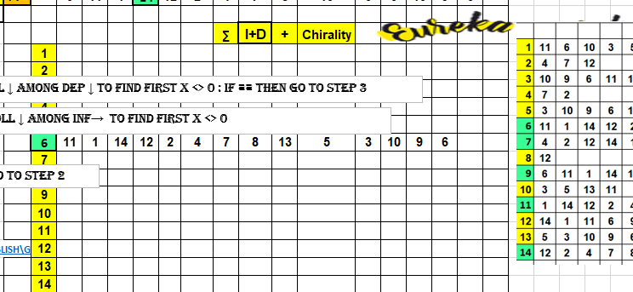

12/05/2023 12:14:44
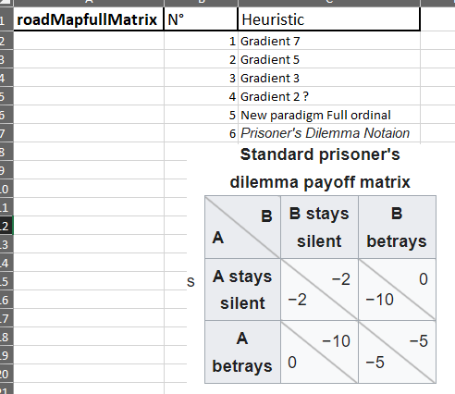

12/05/2023 20:26:48
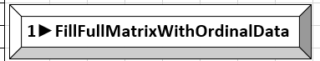
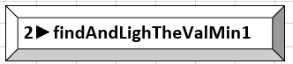

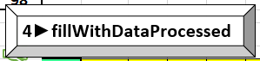

13/05/2023 16:45:48
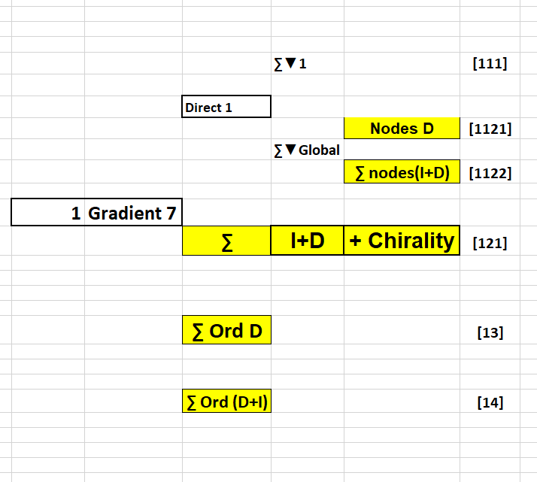

13/05/2023 17:42:05
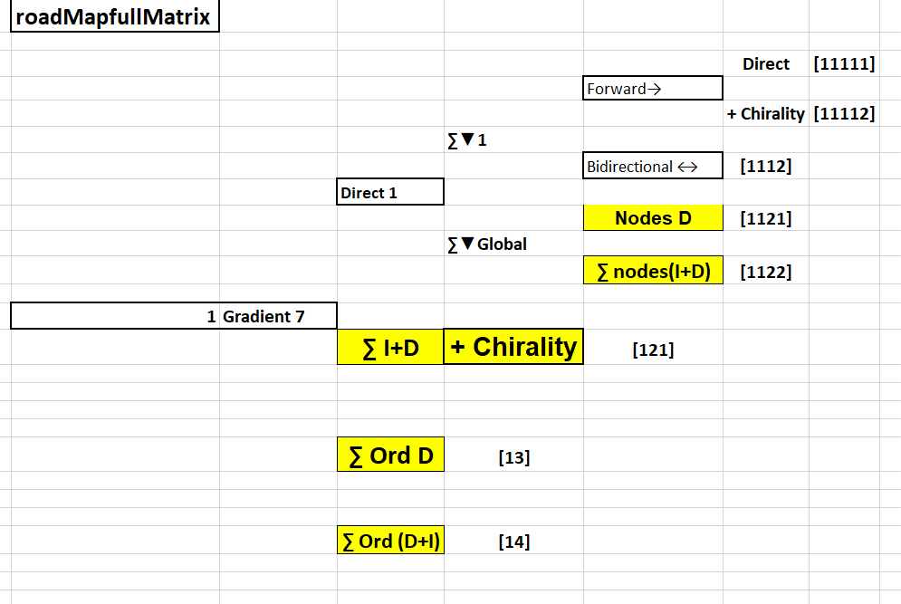

13/05/2023 20:50:29

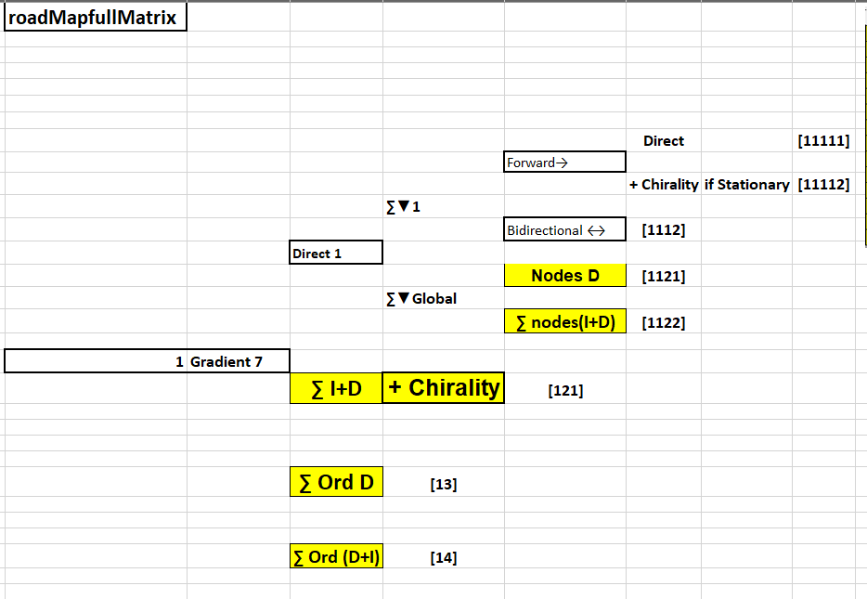

14/05/2023 18:43:31

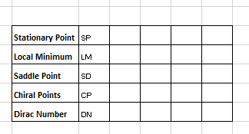

14/05/2023 19:58:36

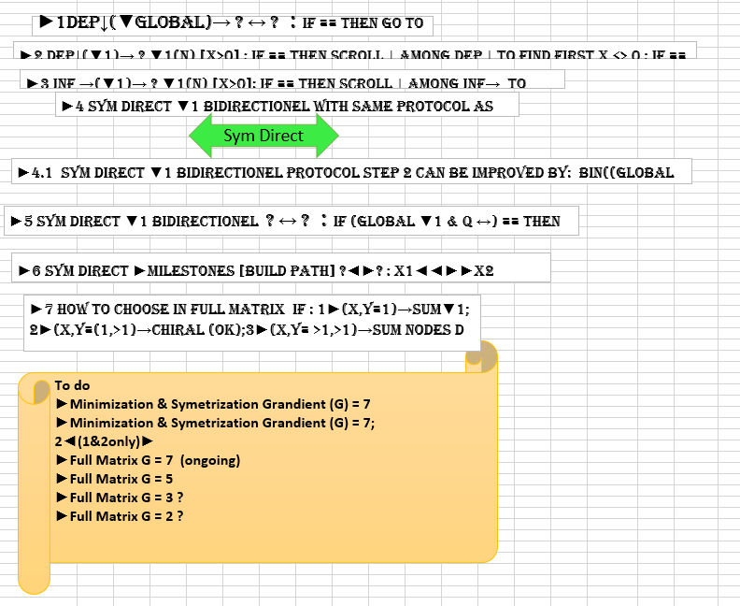

14/05/2023 20:14:55
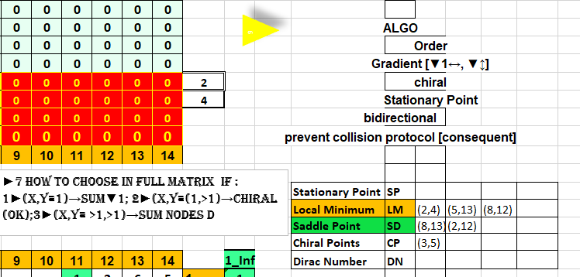

14/05/2023 22:29:38
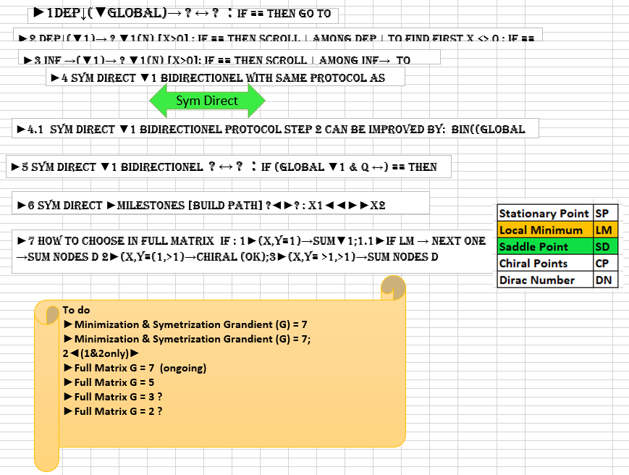

14/05/2023 22:47:37
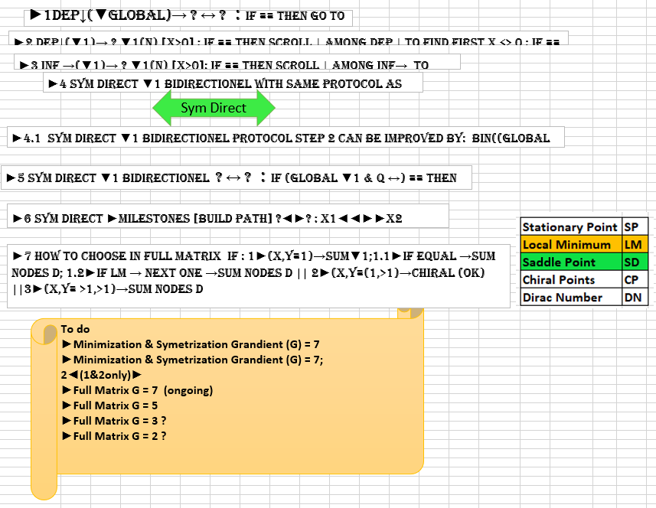

15/05/2023 12:10:36
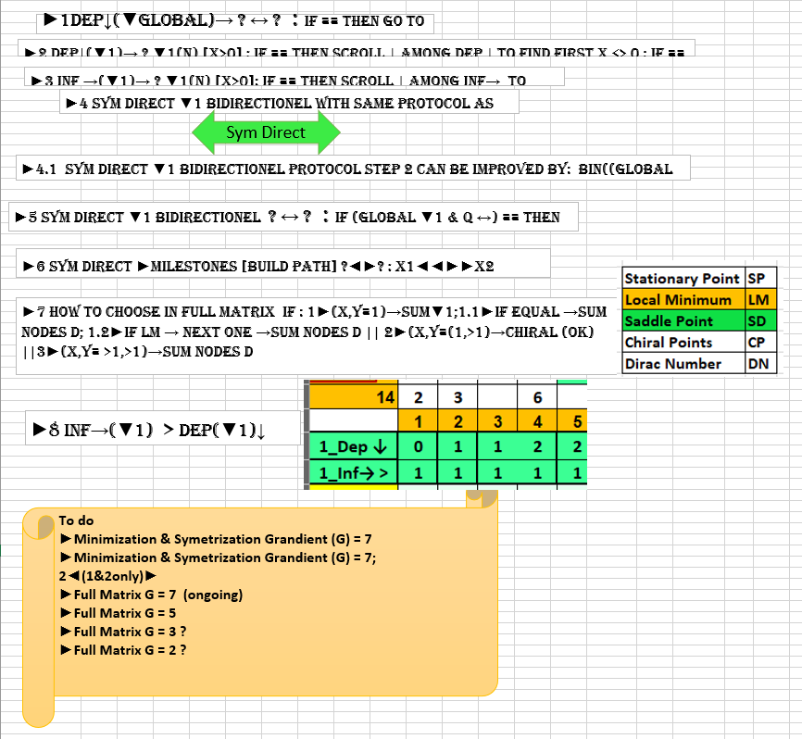

15/05/2023 17:47:18
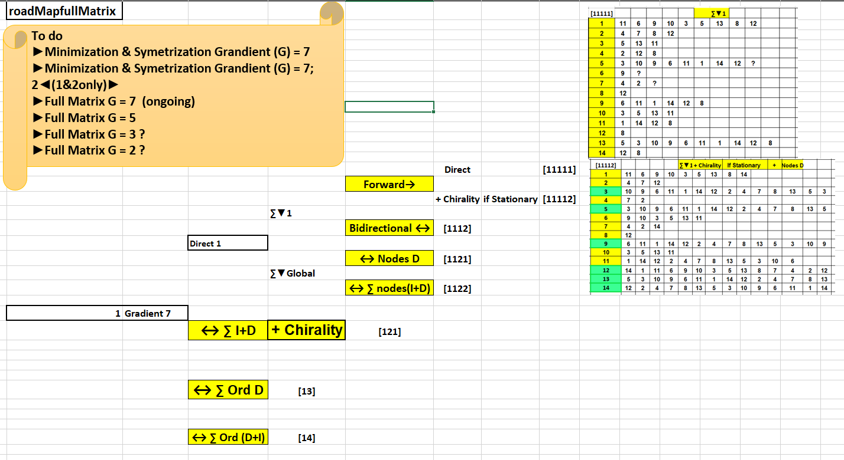

15/05/2023 20:15:22
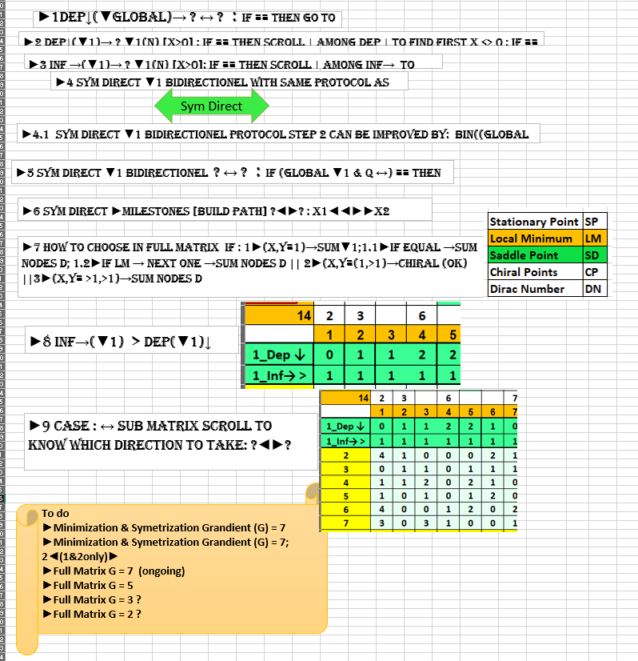

16/05/2023 10:41:18
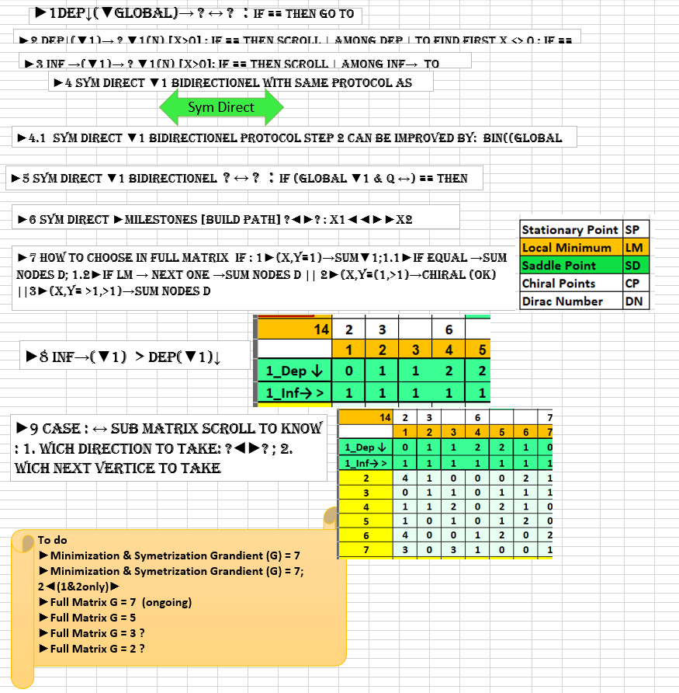

End

