Verbatim algorithmique

Table des matières
Vertex 9 2
Principe d'exclusion de Pauli 3
Pauli exclusion principle (PEP) 3
Eliminer 2p+1 ? 5
►V1 10
►V1 10
►V2 10
PEP 10
PEP 11
PEP 11
►V10 heuristique 11
Heuristique NPR 13
Algo start 13
Tsp_14 Node 1 13
Tsp_14 Edge 1→ ? 13
Min R (L2) 13
Min vertices: Go to k-NN 15
Go to Short side Sum Order ▼ 15
Go to Short side Sum Order ▼ 16
Tsp_14 Node 2 16
Tsp_14 Node 3 16
Variant 1 : Edge 13→? = Conflict 16
Variant 2 : Edge 13→? = Local Minimum 16
To be remake ! 16
Tsp_14 Node 4 16
Tsp_14 Node 5 17
Tsp_14 Node 6 18
Remake node 6 with L2/Mean 18
Tsp_14 Node 7 18
Tsp_14 Node 8 19
Tsp_14 Node 9 19
Tsp_14 Node 10 19
Tsp_14 Node 10_Chirality by x=1 20
Tsp_14 Node 11_Conflict protocol 20
Tsp_14 Node 12_Conflict protocol_BookedProtocol_Tchebychev 21
Tsp_14 Node 13_Conflict protocol_BookedProtocol 21
Tsp_14 Node 14_Conflict protocol_BookedProtocol_FullDuplex↔ 22
with polar coordinate Θ Vn, n >2 22
Tsp_14 Node 1_Conflict protocol_polar coordinat go short Side Order 23
=>Tsp_14 Node 1_Conflict protocol_polar coordinat ρ first 23
=>Tsp_14 Node 1_Conflict protocol_polar coordinate ρ first ONE SIDE 23
Tsp_14 Node 2_Conflict protocol_polar coordinate ρ first ONE SIDE 24
►►► 24
End 24

Vertex 9

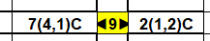

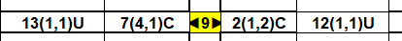

Principe d'exclusion de Pauli
: 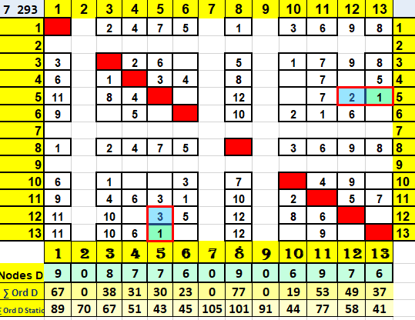

Pauli exclusion principle (PEP)
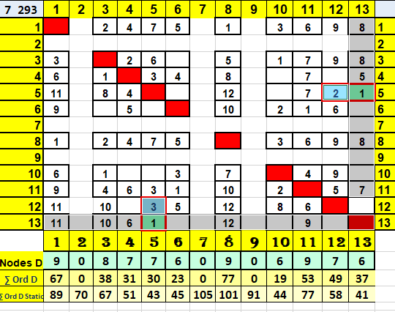
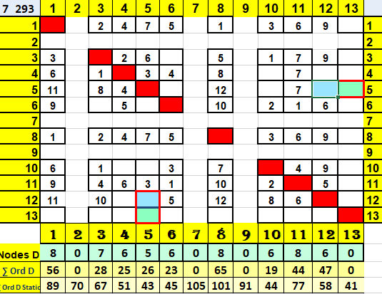

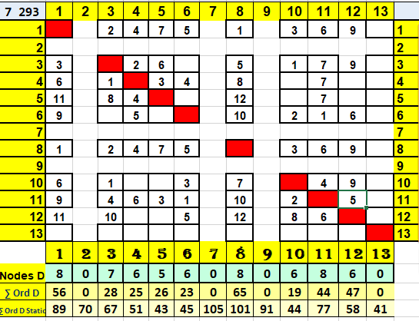

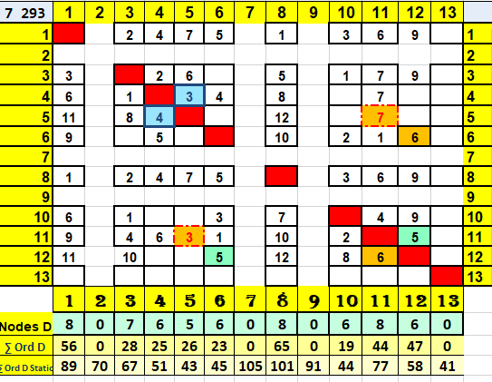

Eliminer 2p+1 ?
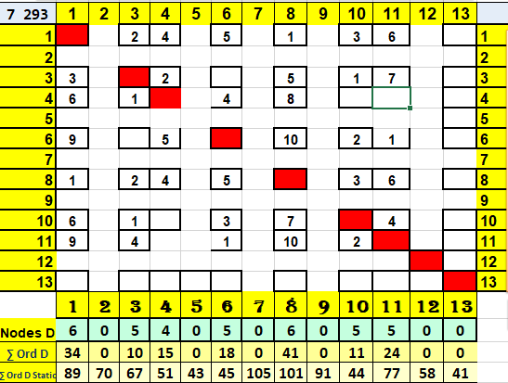
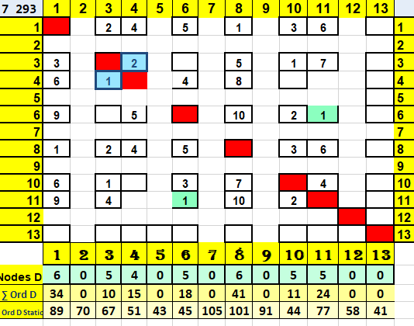

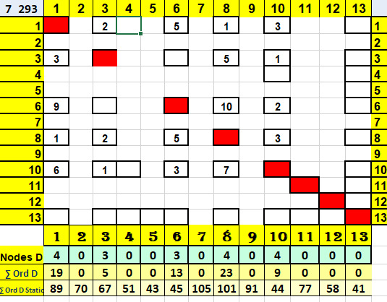
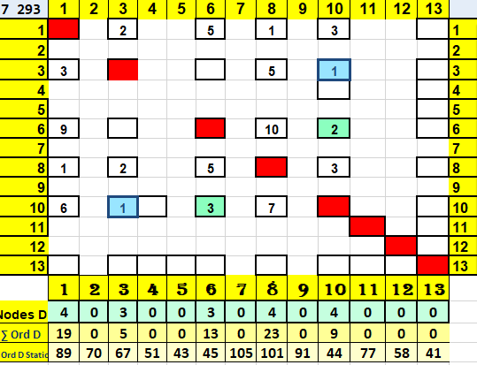

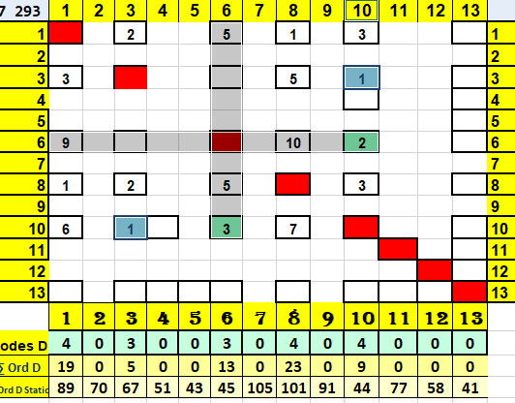
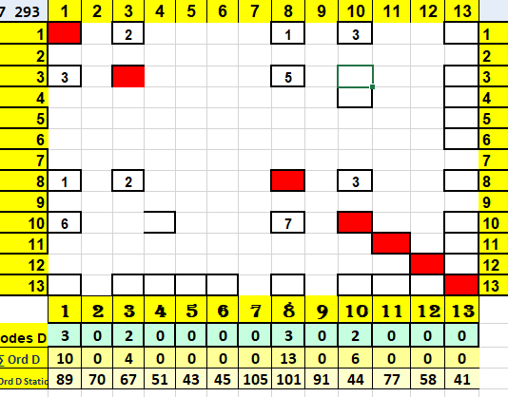

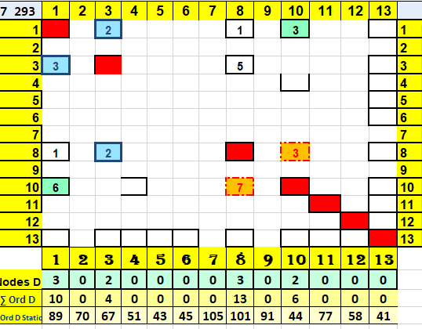
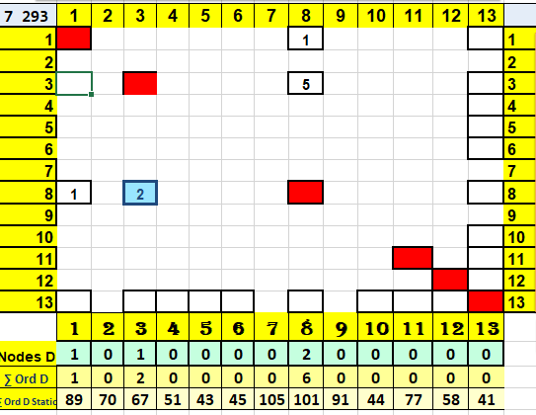

►V1
To do

►V1
To do

►V2

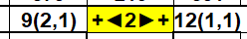

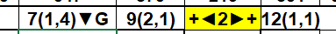

PEP

PEP

PEP

►V10 heuristique

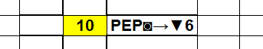

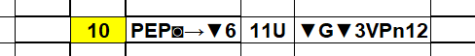

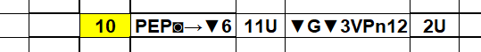

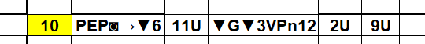

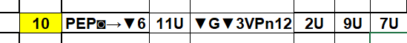

Heuristique NPR

- 28/07/2023 11:49:29
- No works !

Algo start
Start→ ▲vertices
Next → ↔ ▼ vertices
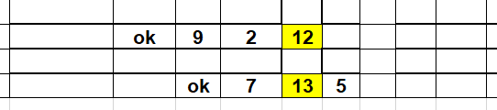

Tsp_14 Node 1

Tsp_14 Edge 1→ ?

Min R (L2)

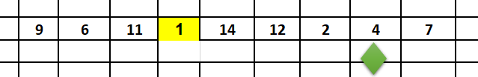

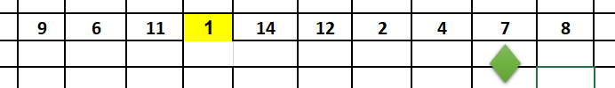

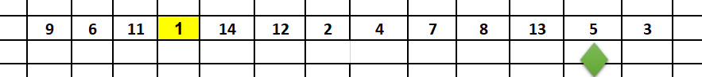

Min vertices: Go to k-NN

Go to Short side Sum Order ▼

Go to Short side Sum Order ▼

Tsp_14 Node 2

Tsp_14 Node 3

Variant 1 : Edge 13→? = Conflict

Variant 2 : Edge 13→? = Local Minimum

To be remake !

Tsp_14 Node 4

Tsp_14 Node 5

Tsp_14 Node 6

Remake node 6 with L2/Mean

Doesn’t work !

Tsp_14 Node 7

Tsp_14 Node 8

Tsp_14 Node 9

Tsp_14 Node 10

Tsp_14 Node 10_Chirality by x=1

Tsp_14 Node 11_Conflict protocol

Tsp_14 Node 12_Conflict protocol_BookedProtocol_Tchebychev

Tsp_14 Node 13_Conflict protocol_BookedProtocol

Tsp_14 Node 14_Conflict protocol_BookedProtocol_FullDuplex↔

with polar coordinate Θ Vn, n >2

Tsp_14 Node 1_Conflict protocol_polar coordinat go short Side Order

- => Tsp_14 Node 1_Conflict protocol_polar coordinat: ρ first (+ θ )

=>Tsp_14 Node 1_Conflict protocol_polar coordinat ρ first

= Tsp_14 Node 1_Conflict protocol_polar coordinat  first one side

=>Tsp_14 Node 1_Conflict protocol_polar coordinate ρ first ONE SIDE

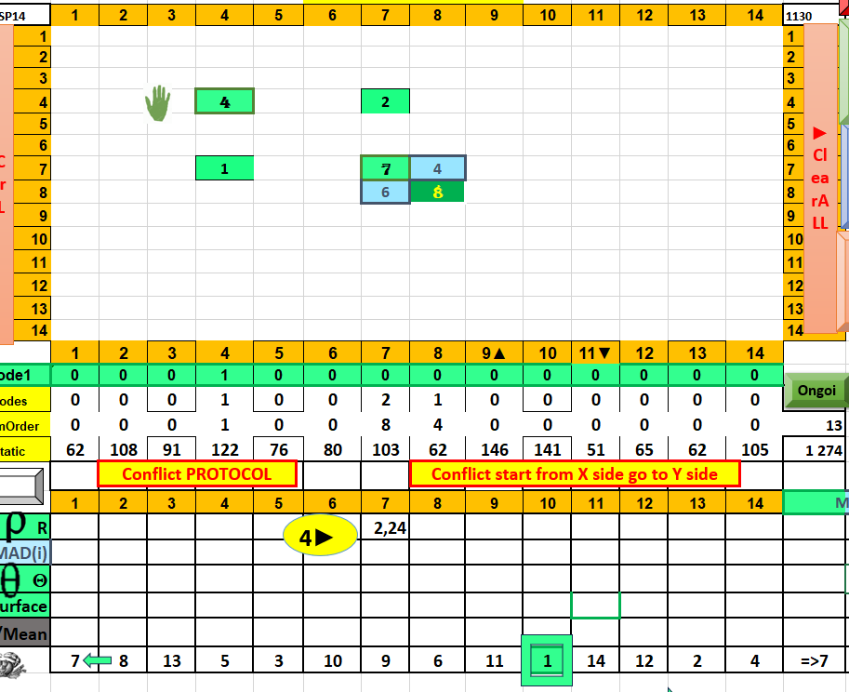

Tsp_14 Node 2_Conflict protocol_polar coordinate ρ first ONE SIDE

►►►

End
