A Study of IoT Protocols and Classification with Machine-2-Machine surveys, issues, and enabling technologies.

1st Sanket Chauhan
Faculty of Computer Applications
Marwadi University
Rajkot, India
sanketchauhanios@gmail.com
2nd Dr.Kalpesh Popat
Faculty of Computer Applications
Marwadi University
Rajkot, India
kalpesh.popat@marwadieducation.edu.in

Abstract—The Internet of Things (IoT) and machine-to-machine communication (M2M) should be the primary communication paradigm on the Internet of the future, with the rapid advancement of heterogeneous wireless technologies and their proliferation in connected objects for the environment, the Internet of Things (IoT) is a paradigm that is revolutionizing communication between people/objects. Communication between connected objects occurs through various communication modes, including machine-to-machine (M2M) and cloud machine (M2C). IoT / M2M devices should remain connected even if they frequently change network connection point due to mobility or simply change the connections in the overlapping radio coverage to achieve better connectivity. A secure initial device configuration for network access and network discovery. The device, monitoring, and remote control.
In the medical field, monitoring devices help to collect, exchange, and process patient health parameters and are used in open, unprotected environments in which they are exposed to various attacks. For this reason, it is important to ensure a high level of security and confidentiality. A first requirement to ensure this is authentication. It provides users with a range of simple programming interfaces that can be used to develop various IoT / M2M applications independent of the underlying network protocols. For each protocol, offer a security analysis and performance assessment, which we compare with existing proposals.

Keywords— Constrained, Internet of Things, Machine-to-Machine, Security, Standards, Scalability, Quality of service

Introduction
Communication between machines and machine takes place between machines with computing/communication resources without human intervention. Communication between humans is expanded to include human-machine or machine-machine communication. M2M uses machines to monitor certain events with sensors and to instruct activation. Recorded events are routed through wired or wireless networks to servers, which extract and process the information collected and automatically monitor and instruct other machines.[1] The network provides end-to-end connectivity between computers. Industrial surveillance and data acquisition systems (SCADA) introduced in the 1980s can be seen as the first forms of M2M. While M2M and SCADA focus on similar functions, SCADA consists of isolated systems based on proprietary technologies that make the solution expensive. SCADA started to open its proprietary protocols and publish its protocol specifications. It is moving from a proprietary system to standardized and inexpensive technologies. [21]

The appearance of M2M networks is very different from that of wired or derived wireless networks. The networks are made up of a large number of nodes because the subject involved in M2M is a machine or an object, or even everything that surrounds us. To be able to communicate with such a large number of objects (millions of billions), the cost must be low. Since most cars are battery powered, fuel efficiency is the most important aspect. Because the car discovers itself or its physical environment, traffic to the car is very low. However, the data is generated from a large number of objects, and because the period, quantity, and format of data generation are different, a large amount of data is generated. Although M2M communication can take place without human intervention, operational stability and endurance are also required. Many M2M research activities and solutions do not address some of the key application and service development challenges required to implement and deploy M2M services, as they focus on energy efficiency, wireless networks, and protocols.

Many M2M research and solutions activities do not address some of the main development issues of the applications and services needed to implement and deploy M2M services, as they focus on energy efficiency, networks, and networks. Wireless protocols M2M service platforms are a relatively new area of ​​interest. Provided a first analysis and comparison of the different M2M platforms. The authors compared the platform goals between people, objects, environments, and business systems based on their primary goal. They also compared how well the platforms met the requirements of the M2M platform they defined: standards-based, versatile, scalable, and IoT-oriented. Conversely, we looked at multiple platforms including those of, our targeted survey was the platform provider ecosystem, and functionality.

M2M APPLICATIONS AND CHARACTERISTICS

M2M Application Categorizing
M2M has various applications, with different features and functions. There are public applications such as environmental protection and ITS, as well as private applications such as home networking, resource management, and biological and medical applications. There are also location-based services that require localization techniques such as ITS and asset management. Some applications require mobile devices such as mobile robots. Finally, some portable devices have fewer energy efficiency restrictions because batteries are easy to charge.[1]
M2M nodes from low-level sensors, nodes to medium and high-level sensors. Their resources are too limited for support. They have basic functions such as data aggregation, automatic configuration, and energy-saving and apply to environmental monitoring applications. Low-level sensor assemblies are inexpensive and have low capacities. They are static, energy-efficient, and simple.
So, depending on the application, there can be M2M devices ranging from dummy and simple nodes to smart and powerful capacity nodes. Network technologies must be designed for different characteristics and applications.

Traffic attributes of M2M Applications
M2M devices generate a variety of traffic patterns, including periodic, event-based, and media streaming patterns, depending on their application. These different traffic patterns are generated by a huge number of nodes that have different patterns, generation periods, and generated quantities. This will create Big Data, which is a collection of data sets that are so large and complex that M2M traffic becomes difficult to manage.[2]

M2M and IoT Challenges
There are many factors to consider when implementing machine-to-machine (M2M) and Industrial Internet of Things (IoT) technologies, and every aspect must be carefully considered, from cost and power too long product life. - a cycle of calls and interference.[3]
Even companies that have a solid standard that is efficient and versatile enough for a variety of applications and infrastructure challenges continue to pursue this growing industry. Typically, higher data rates and larger ranges correspond to higher energy requirements. If the device is more complex in terms of the data that it can process and transmit, then it will be more limited in size. He will also be more receptive to the external environment. [4]

Low Power Or Data Speed
Pulse mode for data acquisition, control, and intercom in an attached device environment can be quite expensive in terms of performance. As per the result, the requirements of power for types of devices.[5] The power requirements for devices that transmit large amounts of data or constantly collect data from the environment vary widely. and rms do not have to be defined. Do not use abbreviations in the title or heads unless they are unavoidable. When the competitive characteristics of low power consumption, range, and data rates are critical, further research and development are needed to achieve a suitable wireless standard/protocol. [6]

High-level architecture
- Device domain: Consists of a collection of devices participating in running M2M applications. Some of these devices have special sensor technology such as body sensors, while others only record current values. Once the necessary data is collected, the M2M device transmits it across the network domain to a remote server. Please note that this domain is also called the M2M domain. [7]
- Scope: Contains servers that store data recorded by M2M devices or other network nodes. This real-time data is made available to legitimate users through various M2M applications that allow remote monitoring and control commands to be sent to M2M devices.
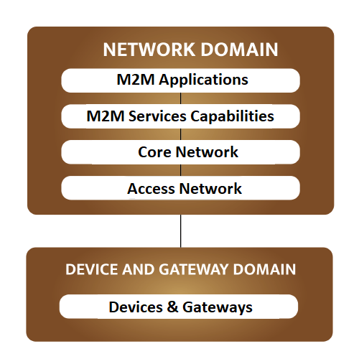
Fig. 1. M2M Network Architecture

ETSI M2M Terminal
It is a Service Capability Layer (SCL) that was developed for a REST-compatible architecture style. SCL plays an important role in the ETSIM2M architecture by providing functions that must be shared by several applications and making them available as functionality via a series of open interfaces (e.g. via APIs). By masking the complexity of the underlying networks, SCL simplifies application development and thus facilitates the development of new, network-independent services. The aim is also to enable the interoperability of M2M services and to facilitate the provision of vertical applications. Among the defined SCL levels there is a service capacity level called SEC (for security reasons) that regulates the initiation of the M2M service and the establishment of the key. [8]
In addition to the M2M architecture and associated interfaces, the ETSI standards body has also proposed a key hierarchy in which each set of M2M devices/gateways provided contains an M2M master key. [8] The root key can be provided to the M2M device or the gateway in three different ways. The first is to provide it in a secure environment during production or deployment, while the second key is derived from the access network credentials based on an authentication and key agreement (AKA) using either the 'Generic Boot Architecture (GBA), or Extensible Authentication Protocol (EAP).

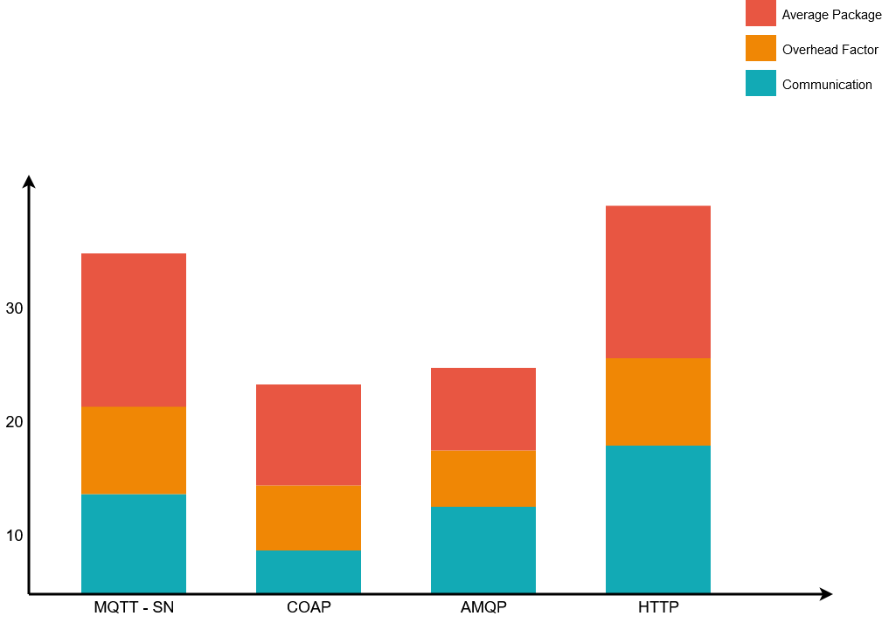

Fig. 2. M2M Communication Protocol Performance

M2M APPLICATION OVERVIEW.
Machine to Machine (M2M) is constantly evolving and covers more and more applications. The applications currently offered can be divided into five categories according to their area of application: automotive, e-health, smart metering, city automation, etc. the emergence of several automotive applications. [9]
It should be noted that the list of applications below is not exhaustive as more and more applications seem to meet the needs. Furthermore, in all these applications, communication is two-way. The M2M device not only monitors certain events but also receives information such as updates and application domain checks. [10] Even so, DL (downlink) traffic from the server to M2M devices is much less than UL (UpLink) traffic and typically consists of short control packets that are not sent to an M2M device or sent to a group of devices.

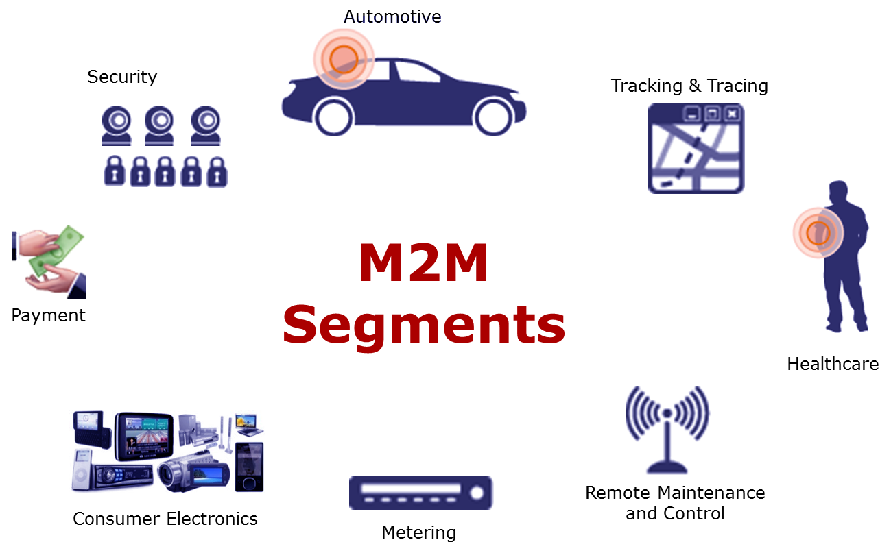

Fig. 3. M2M Applications

M2M APPS SECURITY ISSUES
Since M2M communication is based on the fusion of heterogeneous networks, they are exposed to all security threats of other network-based communication. Although M2M did not create any new threats, it amplified existing threats as, in the case of M2M, these threats not only result in financial loss but also pose a threat to human life. Like wireless sensor networks (WSNs), M2M devices are typically deployed inaccessible locations and are expected to operate over a longer period. Hence, various physical attacks can be carried out against the devices.
Besides, because the detected data is transmitted to a remote server over wireless or wired networks, M2M can be the subject of attacks that target the transmitted information. Attacks can also be carried out against the proper functioning of the system. In this section, we identify some of the main threats to M2M communications by dividing them into three categories based on the target entities, namely the M2M device itself, the correct functioning of the system, or the data being exchanged. These letters are known as physical, logical, and data attacks. It should be noted that for the remainder of this document we will mainly focus on the last two categories.

Physical attacks: Target the physical layer as well as hardware and software of M2M devices.
- Software Changes and Malware: Software changes can be made by an adversary or even by an attacker to change the proper functioning of the M2M device. Malicious users can do this to reduce the number of commissions they pay. Such inappropriate behavior can be seen, for example, when processing smart meters or ETL applications. These attacks can be performed even without physical access to the M2M device, as software updates can be performed wirelessly (OTA).

Logical attacks: These are aimed at the correct functioning of the system without making changes to the software of the device.
- Identity theft: Regarding M2M communications, an attacker can spoof the identity of a backend server, M2M device or gateway, etc. These attacks can lead to significant financial and human losses. For example, an opponent who succeeds in forging a smart meter identity may trick its owner into paying the opponent's tariffs. It is even worse to pretend to be a server because it can send the remote control to the appropriate M2M devices. In e-health applications, such an attack can pose a threat to people's lives. [10]
- Relay Attacks: An adversary can perform a relay attack to trick an entity into believing it is close to the sender or recipient. This attack can target the device, gateway, or network domain. For example, while the eToll application is being processed, a payment request may be sent to an on-board unit (OBU) of the vehicle and then the owner may be persuaded to pay additional costs for trips that he has never taken before. [10]

Attacks on data: target of information exchanged
- Attacks on privacy: Due to the ubiquity of M2M devices, attackers can invade users 'privacy by intercepting exchanged packets and connecting M2M devices or information to individuals while in transit, thus inferring users' habits and health, etc. If the device's MAC (Media Access Control) address is static, indicating, for example, that it is a heart monitor, the adversary knows that its owner has heart problems. Also, some applications such as Electronic Toll (PATD Insurance) (eToll), which sends location information to the service provider, pose a serious privacy risk as they allow the adversary or utility company to track the travel of the user. [11]

- Editing Data and Entering Incorrect Information: Data may be compromised during transmission or inactive on a device or application server. If we consider the case of eHealth or eCall applications, changing measurements or location information can put people's lives at risk. However, incorrect data entry can lead to financial losses in some applications. In the case of the eCall application, for example, emergency services would be called and would arrive at a place with no real need.

- Selective transmission/interception: An adversary can intercept some of the received packets and delay or delete them. Note that the effects of such a threat will depend on the contents of the shared packages. If the information stored is from a sensitive application like eCall, the impact of such a threat can be significant. Usually, such attacks are carried out against the underlying infrastructure.

M2M FEATURES AND IMPORTANT CHALLENGES
Resisting the security threats listed above is not an easy task due to the diverse challenges and issues facing M2M communications and devices. Indeed, the uniqueness of M2M networks, which generally comprise thousands of devices, are left unattended and are expected to function for several years, makes their security a challenging task. Under these challenges.
- Extensible: A major concern in M2M communication is scalability. In fact, as the number of devices increases, the data generated, as well as network traffic, will increase, causing scalability issues. For example, consider the case where several devices attempt network authentication at the same time. Since current mobile technologies are not designed to handle such a large number of devices, this is likely to cause network congestion. [12] On the other hand, some applications (for example city automation) integrate a large number of M2M devices that secure their communications using the same key. In the case of a shared key, a scalable key management scheme is required which allows you to configure/update the shared key after membership changes (joining/leaving devices). In contrast, paired keys require the storage of a large number of keys.
- Device discrepancy: The processing and power supply capabilities of the device vary widely, from devices with very limited resources such as sensors to more powerful devices. The designed security mechanisms must therefore take into account the properties of the various devices.
- Inadequate resources: Most M2M devices suffer from resource limitations (power, storage, and computers) as they should be inexpensive. These limitations make both computational power and efficiency fundamental characteristics of any system designed to protect M2M communications. [21] [22] Therefore, the use of asymmetric cryptography is not always possible unless lightweight and efficient cryptographic schemes are suggested. The use of light symmetric cryptography is more interesting. However, this poses the problem of scalability.
- Low frequency: Given the scarcity of bandwidth and the expected number of M2M devices, the additional effort associated with mechanisms for key generation and authentication, for example, should be minimized.
- Multiple contributors: There can be two or more stakeholders with different access rights in the same application. [13] Hence, a particular data subject should not be able to read the data for which they are not authorized.
- Durability: M2M devices are sometimes used in inaccessible areas where fault-tolerant security mechanisms are required. In other cases, malicious individuals can easily access M2M devices. Therefore, for some applications, the Fraud Resistance Material is recommended.

M2M Application | Communication | Privacy | Obstruction | Energy consumption
Home Automation | Many to One (* to 1) | Low | Low | High
Smart Health Service | Many to One (* to 1) | High | High | High
Smart Grid | Many to One (* to 1) | High | High | Low
Smart City | One to Many (1 to *) | Low | High | High
Vending Machine | One to Many (1 to *) | High | Low | Low
Traffic Monitoring | Many to One (* to 1) | Low | High | High
Telemetry | Many to One (* to 1) | High | Low | Low
TABLE 1. M2M Application Characteristics and Analysis

It is evident that the characteristics and requirements of M2M applications make designing a security scheme a difficult task. It is not possible to provide a suitable solution for all applications, as these have different properties and requirements as shown in the table. Note that the availability of the application and the integrity of the data exchanged are always required. Privacy is also important, except for city and balloon automation apps. Also, almost all devices suffer from limited computing resources. It should also be noted that the functions of the app vary considerably depending on the scenario. For example, think of smart metering apps. This is because water and gas meters are subject to energy restrictions, while smart electricity meters are not because they are connected to the grid.

M2M SECURITY COMPOUNDS
To avoid the threats to which M2M communications may be exposed, several security services must be guaranteed. Among these services, we note authentication, which aims not only to ensure that the data does indeed come from a certain entity, but also avoids representation, confidentiality which prevents the reading of packets exchanged by interceptors, integrity, which manages devices and packets sent for tampering, the readiness to protect against DoS attacks and, last but not least, non-rejection to ensure that an entity cannot refuse to send a packet through the following.
So far, there have been several proposals to ensure M2M communication, developed not only by science and industry but also by standardization organizations such as the OneM2Mglobal initiative and ETSI, as discussed in Section II. It is also possible to optimize solutions for wireless sensor networks (WSN), ad hoc vehicle networks (VANET), etc. Meets M2M specifications. [14] Only the most important solutions that have been specially developed for M2M communication are discussed below. The security services provided and the limits of each proposal are indicated. It should be noted that

most of the solutions in the literature dealt with authentication and privacy issues, while a few dealt with privacy. Before discussing the various proposals to provide one or more of the required security services, we need to consider key management, the cornerstone of implementing secure communications.

Key Solutions
Whether it's authentication, confidentiality, integrity, or even data protection, it's all about the use of keys. Thus, the overall security and reliability of communication depend on the security of these keys. Therefore, an adequate key management mechanism is needed. The latter takes care of generating, storing, exchanging, and updating the required keys. Key management is especially important when it comes to shared keys, [16] [17] especially in group communication. Indeed, these keys must be updated every time a device joins or leaves a group to guarantee both forward and backward secrecy. Also, to improve security, all keys used must have a limited lifespan and must be refreshed over time. Then, in this subsection, we will look at the existing M2M key management schemes and highlight the contributions and limitations of each.

Substantiation Solutions
In terms of authentication, we can refer to entity authentication or data source authentication, which refers to two different security services. This is because entity authentication allows communicating parties to verify whether another entity is what it claims to be, while data source authentication, as the name suggests, ensures that a message comes from a given entity. Most of the documents dealing with the authentication problem in the case of M2M communication dealt with object authentication.

Secrecy Solutions
Many M2M applications process fairly confidential information related to personal data or location data, as is the case with Smart Health or PAYD. Therefore, keeping user information private is critical to the massive deployment of M2M applications. Therefore, this section explains the existing solutions aimed at maintaining user anonymity and privacy for the application to work properly.

Entirety Solutions
During M2M communication, data and device integrity must be ensured. Because the devices are deployed inaccessible locations, adversaries or malicious users can access them and perform any kind of physical attack. To ensure data reliability, four algorithms are used: Choose-Median, Choose-Most, and Choose-Nearest, and Trust-Based Improvement. [15] During M2M communication, however, different devices should not monitor the same parameters/events. So this solution isn't really useful.

Consultation
As mentioned earlier, some of the above solutions have serious security vulnerabilities, while others are robust but fail to take into account the different capabilities of M2M devices. At first glance, we can easily see that most of the suggestions are robust and can also be applied to mobile devices and time-sensitive applications. However, none of the proposals meet all of the characteristics, and each of them has its advantages and disadvantages. [20] In addition, there are only a few solutions that support different communication modes or exploit the heterogeneity of devices.

conclusion
In this article, we have briefly introduced the M2M architecture, as well as most of the widely used M2M applications, before delving into the challenges and threats associated with interoperability with M2M communications. Although the M2M environment is subject to the same security threats as other networks, this is not the case.
The sensitivity of the information processed between machines makes these attacks less dangerous, as they can lead to significant financial losses for utilities and customers. We also discussed the existing solutions to protect M2M communications. Indeed, these proposals mainly focused on key management, object authentication, and confidentiality issues, while accessibility was not taken into account and remained an open research topic. [18] [19] Also, the problem of group key management, which can be the key to scalable and secure multicast communication, has not been resolved. It would be easy to collect different types of user data. By using data mining techniques, this information can be used to provide useful information, such as a person's habits or health. While this data may be of interest to many companies, it can prevent the mass adoption of M2M applications because it violates user privacy. Therefore, it is imperative to come up with new systems that will not only protect the collected data but also protect user privacy.

References

- Arshdeep Bahga, Vijay Madisetti, “Internet of Things: A Hands-on Approach”, ISBN 978-0996025515, 2014.
- S.B.Kale, K.Varpe, R.Chotave, K.Borse, and P.H. Khairnar, “The Development of Village (Smart Sustainable Village for Community)”, International Journal of Advanced Research in Science and Engineering, vol. 6, no. 3 pp. 767-771, March 2017.
- S.Bhasin, T.Choudhry, S. C. Gupta and P. Kumar, “Smart City Implementation Model Based on IoT”, International Conference on Big Data Analytics And Computational Intelligence (ICBDAC), 2017.
- K. Chong and H. Sung., “Prediction of Road Safety Using Road/Traffic Big Data”, Proceedings of the International Conference on Semantic Web Business and Innovation (SWBI2015), ISBN: 978-1-941968-19-2 SDIWC pp. 23-27, 2015.
- N.Dlodlo, O.Gcaba, and A. Smith, “Internet of Things Technologies in Smart Cities”, 2016 IST-Africa Week Conference, IEEE Explore, ISBN 978-1-9058-2455-7, August 2016.
- A.Giyenko, Y. I. Cho, “Intelligent UAV in Smart Cities using IoT”, 2016 16th International Conference on Control, Automation and Systems (ICCAS), October 2016.
- R. R. Harmon, E. Castro-Leon and S.Bidhe, “Smart Cities and the Internet of Things”, 2015 Portland International Conference on Management of Engineering and Technology (PICMET), 2015.
- J.Byun, S.Kim, J.Sa, Y.Shin, and J.Kim, “Smart City Implementation Models Based on IoT Technology”, 2016 Advanced Science and Technology Letters vol., 2016.
- S.Saha, A.Majumdar, “Datacenter temperature monitoring with ESP8266 based Wireless Sensor Network and cloud-based dashboard with the real-time alert system”, Devices for Integrated Circuit (DevIC), 2017.
- A.Medvedev, P.Fedchenkov, A.Zaslavsky, T. Anagnostopoulos, and S.Khoruzhnikov, “Waste Management as an IoT-Enabled Service in Smart Cities”, 2015 International Conference on Next Generation Wired/Wireless Networking, 2015.
- D.Minoli, K.Sohraby and B.Occhiogrosso, “IoT Considerations, Requirements, and Architectures for Smart Buildings—Energy Optimization and Next-Generation Building Management Systems”, 2017 IEEE Internet of Things Journal, vol. 4, no 1, Feb. 2017.
- F. J. Lin, Y. Ren, and E. Cerritos, “A feasibility study on developing IoT/M2M applications over ETSI M2M architecture,” Proc. Int. Conf. Parallel Distrib. Syst. - ICPADS, pp. 558–563, 2013.

- Y. Gao, Z. Qin, Z. Feng, Q. Zhang, O. Holland, and M. Dohler, “Scalable and Reliable IoT Enabled by Dynamic Spectrum Management for M2M in LTE-A,” IEEE Internet Things J., vol. 3, no. 6, pp. 1135–1145, 2016.
- C. Hongsong, F. Zhongchuan, and Z. Dongyan, “Security and trust research in M2M system,” Proc. 2011 IEEE Int. Conf. Veh. Electron. Safety, ICVES 2011, no. 20090460245, pp. 286–290, 2011.
- M. Alam, R. H. Nielsen, and N. R. Prasad, “The evolution of M2M into IoT,” 2013 1st Int. Black Sea Conf. Commun. Networking, BlackSeaCom 2013, pp. 112–115, 2013.
- Yan Zhang, Rong Yu, Shengli Xie, Wenqing Yao, Yang Xiao, and M. Guizani, “Home M2M networks: Architectures, standards, and QoS improvement,” IEEE Common. Mag., vol. 49, no. 4, pp. 44–52, 2011.
- D. B. Seo, C. S. Jeong, Y. B. Jeon, and K. H. Lee, “Cloud infrastructure for ubiquitous M2M and IoT environment mobile application,” Cluster Comput., vol. 18, no. 2, pp. 599–608, 2015.
- R. Ratasuk, B. Vejlgaard, N. Mangalvedhe, and A. Ghosh, “NB-IoT system for M2M communication,” 2016 IEEE Wirel. Commun. Netw. Conf. Work. WCNCW 2016, no. Wd5g, pp. 428–432, 2016.
- P. H. Su, C. S. Shih, J. Y. J. Hsu, K. J. Lin, and Y. C. Wang, “Decentralized fault tolerance mechanism for intelligent IoT/M2M middleware,” 2014 IEEE World Forum Internet Things, WF-IoT 2014, pp. 45–50, 2014.
- H. Li, D. Seed, B. Flynn, C. Mladin, and R. Di Girolamo, “Enabling Semantics in an M2M/IoT Service Delivery Platform,” Proc. - 2016 IEEE 10th Int. Conf. Semant. Comput. ICSC 2016, pp. 206–213, 2016.
- https://docplayer.net/10512765-Cps-communications-dr-bheemarjuna-reddy-tamma-iit-hyderabad.html
- https://ipwithease.com/internet-of-things-vs-machine-to-machine-iot-vs-m2m/

