The important role of industry data connectivity platforms in M2M and IoT application capabilities
Sanket Chauhan¹, Dr.Kalpesh Popat²

¹ Faculty of Computer Application, Marwadi University, Rajkot, Gujarat, India

² Faculty of Computer Application, Marwadi University, Rajkot, Gujarat, India

Abstract

In today's world of technology, IoT is working on various applications and M2M communication protocols, with many different sensors and platforms developed with different innovative ranges and many different services. We are developing to suit the current need, and applications include monitoring solutions, construction sites, surveillance systems, smart homes, and industrial segments. For industrial units, we can introduce new sensors and industrial segments in a new form by using the M2M Communications with a separate IoT system to suit the existing needs of the people.

A range of platforms will be important in this endeavor, including planning to connect and operate the current state installer and measurement devices accordingly and the M2M protocol. Different systems are installed from time to time to connect different devices. To meet the current industry requirement we can manage the different defense and machine tool devices and ensure that the corresponding reporting and troubleshooting devices can be used as further support for necessary use. Providing connectivity to industrial units and using other technologies with other alternative platforms, machine tools, and planning solutions could prove to be critical for us in the future. M2M and IoT related applications and we will help people to establish new custom-related units for the coming generation by providing the necessary data collections and alternative analysis on it.

Keywords: Devices transferring data, Connectivity Platform, M2M and IoT Solutions, Automotive industry, Emergence of the IoT
1. Introduction
In today's vertical industries it is very important to provide necessary services related to the M2M protocol and its resources. It can be compared to a complex solution for developing and designing industrial units and their segments. With the help of that solution, efficiency can be increased and the current limitation is that in very few cases its connectivity support which platform can adapt to different technologies. It takes a lot of effort and a little bit of integrated information to create an application to meet the current needs, with which one can spend a lot of effort and money at different times. But once that application is created, we can easily integrate its industrial units. Connectivity and support platforms usually lead to purpose-built solutions with limited full use or even integration of separate features. [1][2]

We have looked at the connection development of M2M and IoT related applications. Have become the preferred approach for the emerging range of application platforms. The devices expect development similar to the connectivity support platform and these combinations allow you to manage more scale and protocol on fewer platforms. The connectivity of multi-technology devices and their platform-related information to work with different protocols. Multiple building and real-time data collection are ready to manage its compromise functions. We can use cloud computing protocols and various platforms to exchange information about devices. Allows protocol management to collect relevant information on existing complex industrial units. [3]

M2M and solutions in IoT applications are becoming more and more common and diverse. Existing connections have to deal with more traffic and events. The result-oriented M2M and IoT applications are different and can be spread across a growing range of short-distance networks and ideally connectivity technology that may require more capacity. [4]
The devices connected to it and its solutions will become increasingly common and varied in the context of M2M and IoT applications. Existing IoT and M2M applications are facing more traffic and event loads.

2. Devices to Networks and Platforms

We are at a turning point right now. This is because the market between machines has become very fragmented over the last year, varying vertically, corporately, and geographically. Recently, along with technological advances, many efforts have been made to promote standardization, openness, and simplicity. The result is that standards are set and platforms built on top of those standards. This article discusses Ericsson's device connection platform, which gives an operator access to key features needed to manage M2M business connections, including device management, subscription management, and self-service. It also presents examples of different business models and applications with deployment scenarios.

2.1 Data Collection

The data produced by the industrial units are analyzed by connecting them to separate units to provide a distinct place. In the world of IoT traditionally different physical systems and model providers regarding M2M and IoT applications with future generations. Will be done so that the security of devices or items that can be changed can become a standard with data collection and the analysis behind it.
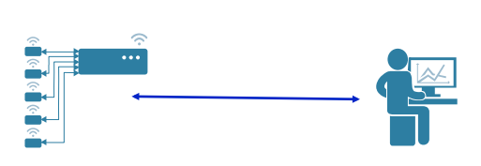

Fig. 1 Sensor Analytics and Development of Smart Devices

Businesses that rely on IoT devices need to reassess key aspects of their operations secure IoT operations.
Device credential storage: In this changing world of IoT and M2M devices and the data generated with them must provide its storage. So that the incoming credentials must be stored on special chips with the highest value safe place for it in device storage.
Exchange of communications with external service providers: Users' credentials that are authenticated in encrypted format with additional hardware monitors are exchanged across different networks, and the operating systems are more likely to be hacked so the operator's profile is temporarily exposed and their credentials.
2.2 Data Communication
Data Communication serves as a model that can be more useful for IoT applications and machine-to-machine communications with connected devices providing trusted other records by communicating with clients and servers of information round the clock. Integration between recorded data and model selling can also take advantage of a central platform. Through machine-to-machine applications, we humans can collect data for a more useful industrial unit that can be useful solutions for future generations and for current research. Devices connected to the industrial segment correspond to each other by exchanging data. The data communication technique can be a very beneficial solution as we can use the newly adapted industrial plant on the existing supernatural segment from the data we have received. As more and more devices connect to IoT networks and machine-to-machine applications, network operators will reach the point where they cannot handle all data traffic, resulting in delays to businesses and industrial units and their operations, as well as their connections and Illegal surveillance and data retrieval and the operation of the disclosed machine may increase and experience vulnerabilities.

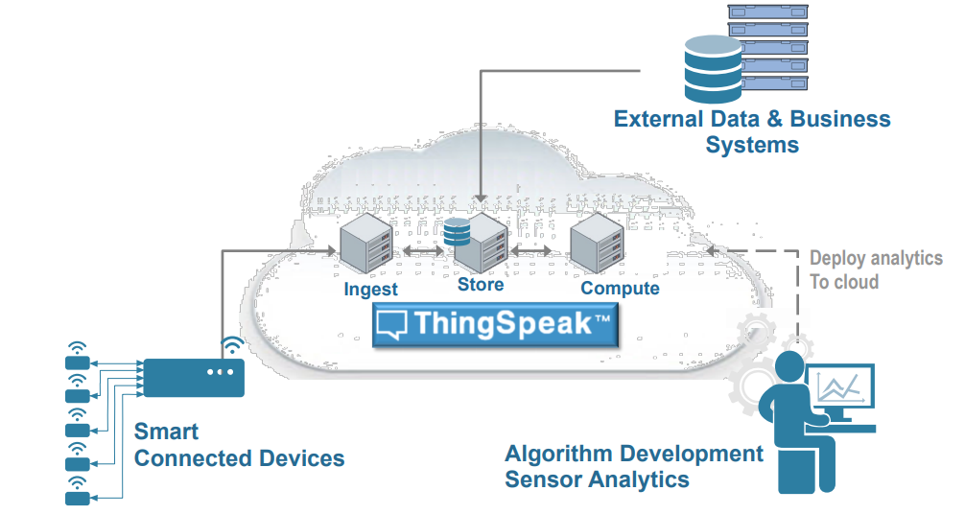

Fig. 2 Thing Speak for Small Scale Deployment

2.3 Strengthen the data management platform
In this case, the acquis communication is an important factor in the implementation of the IoT operational program, and the real benefits of this approach have been realized in the context of data and data on this platform. As soon as the platform is imported, the platform must be recycled and processed. The platform is designed to be inverted, and IoT reverse charging is limited to the current infrared type. Data access control is based on data transmission, IoT output platform is based on data integration, validation, and data validation.

Centralized Device Management: We can easily communicate with it on business issues by installing devices for communication on the cloud. That can be connected via a wireless network and we can authorize its operation by remote control, [5] and also communicate with the communications industrial segment. We will also be secured with device management which can be installed on the dynamic of this device and its site installed in the central location. All this will be based on the company-defined results.

High-performance data management: With the highest capacity data communication technology we can use the data encryption technologies of industrial units as well as a wide range of data storage transport distribution facilities in which you can ensure the integrity and confidentiality of all your assets.

Enhanced Administration and Security: We can use existing cloud computing techniques for administration and security. This enables us to protect the data of businesses and industrial units and their devices and applications on a separate platform from the threat of cybersecurity. We can also control when employees log in with all sorts of access and role-based permissions with authorized session identification and timeout management. [6][7]

Flexible Application Development: We have a variety of platforms available for application development in which we can use his dashboard to create his web and mobile applications. That can be used to deliver connectivity features and data to his devices whose enterprise system and cloud-based big data analytics for collecting data techniques innovations.

M2M Application | Communication | Privacy | Obstruction | Energy consumption
Home Automation | Many to One (* to 1) | Low | Low | High
Smart Health Service | Many to One (* to 1) | High | High | High
Smart Grid | Many to One (* to 1) | High | High | Low
Smart City | One to Many (1 to *) | Low | High | High
Vending Machine | One to Many (1 to *) | High | Low | Low
Traffic Monitoring | Many to One (* to 1) | Low | High | High
Telemetry | Many to One (* to 1) | High | Low | Low

Table 1: M2M Application Characteristics and Analysis
3. Data transfer with MQTT
We can use the secure data connection technique using the MQTT protocol. Establish an MQTT broker connection on TCP on all devices connected to the platform. Calls the subscriber between the clients for data exchange and the subscriber transmits the information to the server connected to it. There are currently several cloud platforms available to use this technique. In my current research, I have used the Things peak Platform. With the help of this platform, we can visualize all the information of various devices connected to industrial units. This platform is open source for which no license is required. The data transfer can be done easily with the help of the algorithm that I have created for the current research.

The MQTT protocol is attached to a node at a central location. Devices connected to data communication provide data in the form of visualization by interacting with related topics. The first subscriber technique used to link any resource is to deliver further information and its central node. With the help of this existing platform, the exchange of messages from the MQTT protocol is very fast and secure.

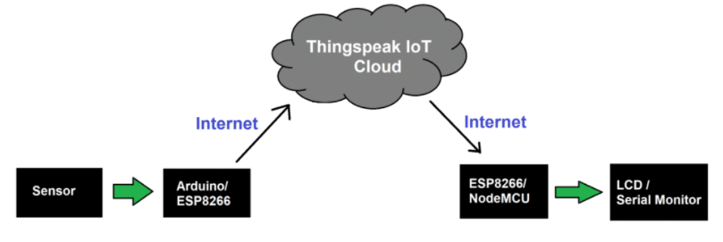

Fig. 3 Reading Data from Thing speak Block Diagram

3.1 Topic and Quality of Service (QoS)
MQTT protocol for data communication can be more useful to connect existing industrial segments and send messages to its subscribed clients. MQTT and its collateral service provide quality service. Messages are sent based on network presence. Information related to the MQTT protocol can provide more data to different devices. The level of communication and messages can be duplicated. Connected devices can exchange information with the help of cloud computing. Messages are sent only once for communication with the client so that we can add preventable devices to industrial units in its list. We have various protocols available for data communication but the MQTT protocol is beneficial for machine-to-machine communication.

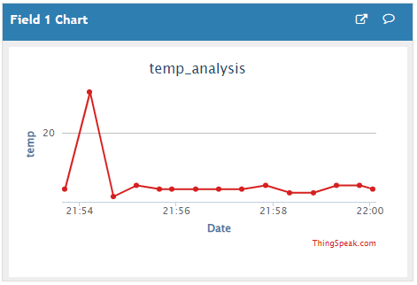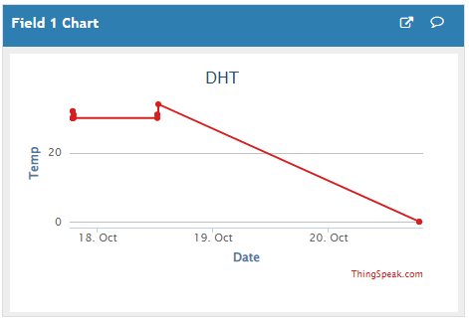
Fig. 4 Temp. Result Field 1 Fig. 5 DHT Result Field 1

The graph above displays temperature analysis and humidity data using the MQTT protocol connected to a cloud platform. The python language library has been used in research here for this data communication technique, PAHO library with MQTT protocol is used for data communications. The connectivity of the devices to each other is done by developing an algorithm using Python language. Using the MQTT protocol we can use Python language or Advanced-C language which we can use for data communication.
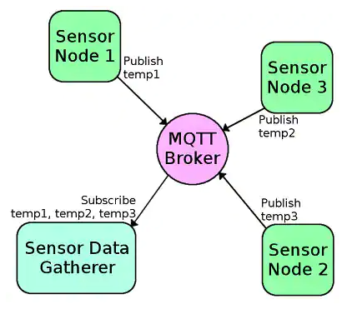
Fig. 6 MQTT Broker Integration
An integrated server that supports MQTT version 3.1.1 can act as an MQTT client that publishes content to an MQTT server and an MQTT client that subscribes to topics on the MQTT server. Specific:
The integrated server can publish MQTT messages to the MQTT server using the service pub.MQTT: integrated publication.
The integration server can register themes by creating an MQTT activation. The MQTT trigger receives messages that are posted to the topic on the MQTT server, and then calls an activation service to process the messages.
The built-in server alias uses MQTT connections to connect to the MQTT server. The call is required on the pub.MQTT service: publish MQTT alias links to publish the message to the MQTT server. Similarly, MQTT activation specifies the MQTT connection alias, which it uses to identify the MQTT server from which it retrieves messages and from which activation activates a subscription.

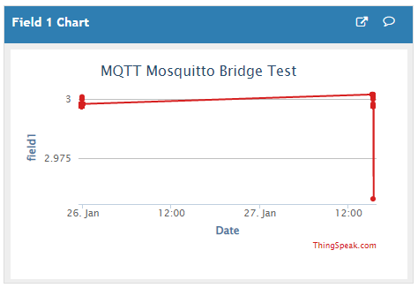
Fig. 7 MQTT Broker Result

4. Conclusion
Since the HTTP protocol requires a connection to be established whenever the connection overhead increases, this is not required for the MQTT protocol. Data sent using HTTP protocol is reliable because it is synchronous, but MQTT is not reliable in all situations. MQTT is an asynchronous protocol. The time it takes to send data using the MQTT protocol is fast compared to the HTTP protocol, which is useful for low-power IoT devices.

References

[1] Z. M. Fadlullah, M. M. Fouda, N. Kato, A. Takeuchi, N. Iwasaki, and Y. Nozaki, “Toward intelligent machine-to-machine communications in smart grid,” IEEE Commun. Mag., vol. 49, no. 4, pp. 60–65, 2011.

[2] Yan Zhang, Rong Yu, Shengli Xie, Wenqing Yao, Yang Xiao, and M. Guizani, “Home M2M networks: Architectures, standards, and QoS improvement,” IEEE Commun. Mag., vol. 49, no. 4, pp. 44–52, 2011.

[3] D. B. Seo, C. S. Jeong, Y. B. Jeon, and K. H. Lee, “Cloud infrastructure for ubiquitous M2M and IoT environment mobile application,” Cluster Comput., vol. 18, no. 2, pp. 599–608, 2015.

[4] R. Ratasuk, B. Vejlgaard, N. Mangalvedhe, and A. Ghosh, “NB-IoT system for M2M communication,” 2016 IEEE Wirel. Commun. Netw. Conf. Work. WCNCW 2016, no. Wd5g, pp. 428–432, 2016.

[5] H. Li, D. Seed, B. Flynn, C. Mladin, and R. Di Girolamo, “Enabling Semantics in an M2M/IoT Service Delivery Platform,” Proc. - 2016 IEEE 10th Int. Conf. Semant. Comput. ICSC 2016, pp. 206–213, 2016.

[6] Barros, J., Rodrighues, M.R.D., 2006. Secrecy Capacity of Wireless Channels, In: Proceeding of the IEEE International Symposium on Information Theory (ISIT 2006), Seattle, WA, 9-14 July 2006.

[7] Korner, C.I., Korner, J., 2002. Broadcast channels with confidential messages. IEEE Trans. Inf. Theory 24 (3), 339-348.

[8] Wyner, A.D., 1975. The wire-tap channel. Bell Syst. Tech. J. 54, 1355-1387.

[9] Fleisch, E., 2010. What is the internet of things? An economic perspective. Econom. Manage. Financ. Markets 2, 125-157.

[10] Floerkemeier, C., Roduner, C., Lampe, M., 2007. RFID application development with the academic middleware platform. IEEE Syst. J. 1 (2), 82-94.

[11] He, W., Xu, L., 2012. Integration of distributed enterprise applications: a survey. Hendricks, K.B., Singhal, V.R., Stratman, J.K., 2007. The impact of enterprise systems on corporate performance: A study of erp, scm, and crm system implementations. J. Operat. Manage. 25 (1), 65-82.

[12] Hepp, M., Siorpaes, K., Bachlechner, D., 2007. Harvesting wiki consensus: using Wikipedia entries as vocabulary for knowledge management. IEEE Internet Compute. 11 (5), 54-65.

[13] Hernandez-Castro, J.C., Tapiador, J.M.E., Peris-Lopez, P., Li, T., Quisquater, J.-J., 2013. Cryptanalysis of the sasi ultra-light weight rfid authentication protocol. arxiv.

[14] Sharma, P. and Padole, D.V., 2017, March. Design and implementation soil analyser using IoT. In 2017 International Conference on Innovations in Information, Embedded and Communication Systems (ICIIECS) (pp. 1-5). IEEE.

[15] Ciuffoletti, A., 2017. OCCI-IOT: an API to deploy and operate an IoT infrastructure. IEEE Internet of Things Journal, 4(5), pp.1341-1348.

[16] Mois, G., Folea, S. and Sanislav, T., 2017. Analysis of three IoT-based wireless sensors for environmental monitoring. IEEE Transactions on Instrumentation and Measurement, 66(8), pp.2056-2064.

[17] Xu, Y., Mahendran, V., Guo, W. and Radhakrishnan, S., 2017, January. Fairness in fog networks: Achieving fair throughput performance in MQTT-based IoTs. In Consumer Communications & Networking Conference (CCNC), 2017 14th IEEE Annual (pp. 191-196). IEEE.

Sanket Chauhan is a Ph.D. scholar of Marwadi University, Rajkot, Gujarat. He obtained his Master’s degree in Computer Application at CHARUSAT University, Changa. He is currently a Technical Trainer / Corporate Trainer / Developer. He has taken a 150+ seminar/webinar and workshop on iOS Application Development, Python, IoT, and Digital Marketing across Gujarat colleges and universities. He is a member of the Computer Society of India. Right now, He is an Apple Authorized Trainer.

Dr.Kalpesh Popat is currently working as Associate Professor at Marwadi University, Rajkot, Gujarat. He obtained his Master’s degree in Computer Application from IGNOU in 2003. He is a member of the Computer Society of India. He has published 30+ Paper in International Journal. His research area is mobile computing.

