
full time Enterprise Application Architecture
John Burns

December 19, 2016
Institute of technology tallaght
Franklin Belinga x00113837

Host Machine

Fedora (64 bit) was used as the Operating System provided by this module.

It was configured in the following format
• Base Memory of 5131 MB
• Processor 2 CPU
• Execution Cap 100 %
Hard disk was SATA Port 1 with the following
• Format was Normal(VMDK)
• Virtual size: 19.25 GB
• Actual size: 9.73 GB
Which was dynamically allocated storage.
The loadtest.C ran on the single CPU provided, in the runtest.sh it will only run on a single processor even if the machine is using a multi-core processor.

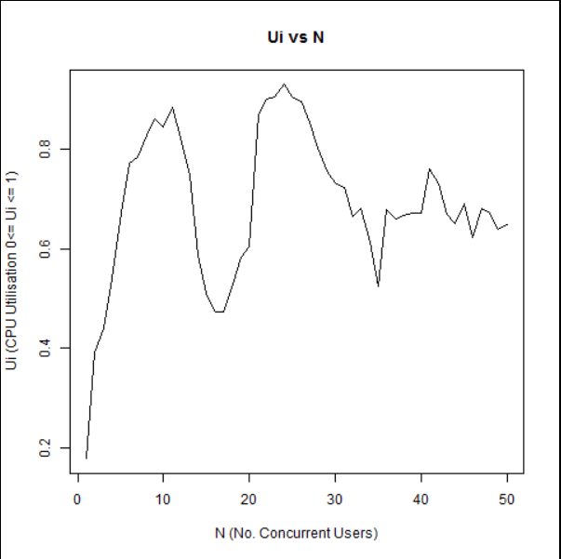

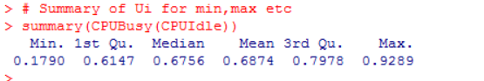
The Utilisation of the CPU is the busy time of the CPU. It can be in the form of a percentage or in the form 0.0 < ui < 1.0
This means that the utilisation of the resource must be between value of 0.0 and 1.0 but can never be greater than 1.0 or less than 0.0. To calculate ui: [(100 – idle) / 100]
As the number of concurrent users increases, Ui increases in the same fashion until all resources are used up. At the point, there is no more elevation in the UI even if more concurrent user joined the graph.

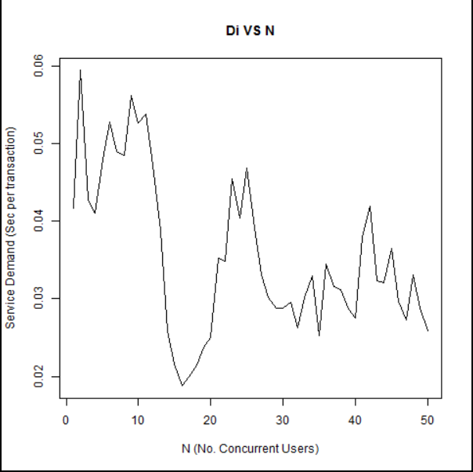

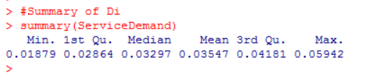
Service Demand is a measure of how much time in seconds one transaction requires of a specific resource, Di = Ui / Xo

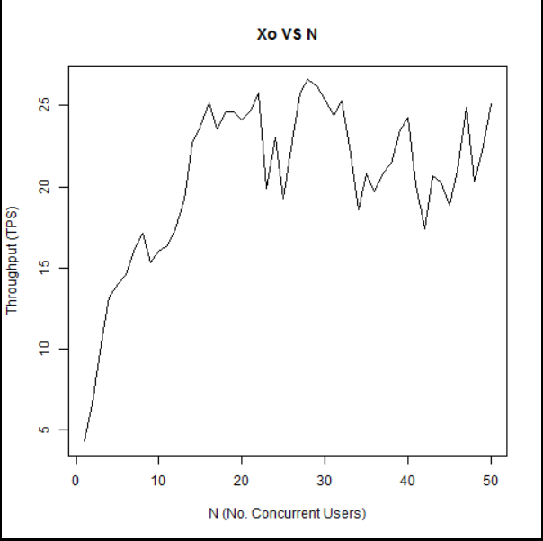
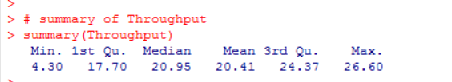
The system throughput represents the amount of transactions per second that the system can accomplish. It is calculated: throughput = Number of Transactions / Time, where Time is the length of the observation period.
The system has a Max throughput of 26.60 tps, which means this system no matter what value N is, the throughput saturates at 26.60 transactions per second.
The mean average of is 20.41 tps, which means on average the system can deal with 20.41 transactions per second, which depending on the value of N is good if N is low but if N if high like 50, a delay for the users of the system.
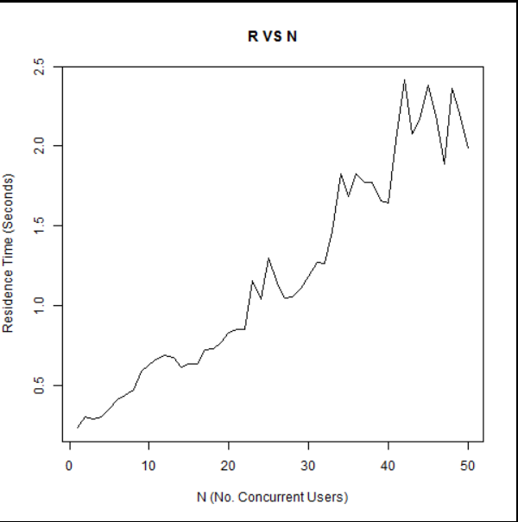

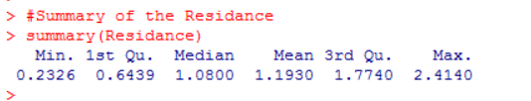
Response time is time taken for a request to be answered by the system. It is almost a linear progression (straight Line) as N increases. When N is approx. 25 to 27 there is a surge in the response time, this could be caused by the processing of transaction which were larger transactions or that there was an increase in the utilisation of the CPU that caused this.
Also it could be said that as the response time is dependent on both the number of concurrent users and the utilisation of the CPU, so if either of these increase or decrease, so too will the response time.

