

Subscribe to DeepL Pro to edit this document.  
Visit [www.DeepL.com/pro](https://www.deepl.com/pro?cta=edit-document) for more information.

Table of Contents

Home 2

Header 2

Heroes 2

Overview services 3

Overview 1 3

Overview 2 3

Overview 3 3

Overview 4 4

Overview 5 4

Overview 6 4

Testimonials (3) 5

Footer 5

Donate ($) or become a member 5

Introductory text 5

Form 6

News list / current events 7

News page 11

List of services offered 12

Congress 12

Association 13

CCR 14

Board tenant 16

Newsletters 17

Newsletters 18

Practical guides 18

Conference booklet 25

Memories 27

Search 28

Service page 28

Team 29

About us 30

History 31

Contact us 42

Frequently asked questions (FAQ) 43

Error 404 43

# Home

[https://flhlmq.com/fr]

## Header

Fédération des locataires d'habitations à loyer modique du Québec (Quebec federation of low-income housing tenants)

The voice of low-income housing tenants

## Heroes

*To be created

## Service overview

### Overview 1

Send an email to support Alexis!

OMH refuses SHQ funds to help a young Down's syndrome patient at the end of his life.

### Overview 2

"I live in a low-income housing scheme, and that's a blessing in disguise".

Chantal Daneau's testimony in favor of new low-income housing.

### Overview 3

Petition for quality low-cost housing

The FLHLMQ hopes to collect 10,000 signatures.

### Overview 4

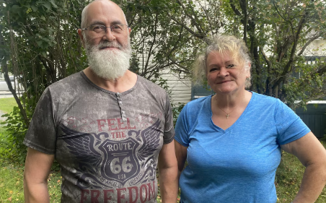

The contempt has gone on long enough!

The Office d'habitation du lac Abitibi needs to change its attitude.

### Overview 5

Groundbreaking ceremony for Unitaînés in Rimouski

Boards must not depend on others to fulfill their mission.

### Overview 6

Community safety in a Montreal low-income housing project

Tenants are not alone!

### Testimonials (3)

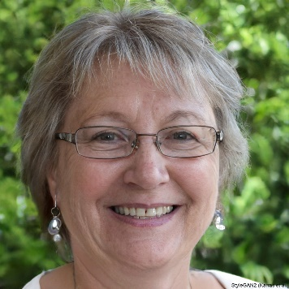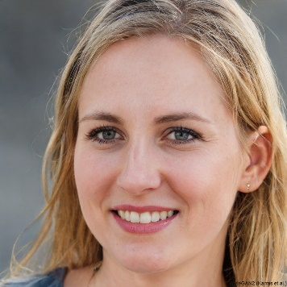*To be created

### Footer

Please contact us:

info@flhlmq.com

1-800-566-9662

Facebook: [https://www.facebook.com/flhlmq/]

Youtube: [https://www.youtube.com/@robertpilon547]

# Donate ($) or become a member

[https://flhlmq.com/fr/publication/adhesion-et-abonnement]

## Introductory text

Membership and subscription

Why become a member of the FLHLMQ?

Nearly 300 tenant associations and Residents' Consultative Committees (RCCs) renew their membership in the FLHLMQ every year. It's thanks to you that the federation can speak with a strong voice to the governments of Quebec and Ottawa to ensure that they take care of our housing. The strength you give us by being a member of our federation has enabled us in recent years to advance the cause of low-income housing in a number of ways:

Obtaining a rent freeze and free use of laundry rooms for May to October 2020 due to containment;

Tenant association subsidy increased from $17 to $26;

Increase from $400 to $500 in the amount granted to tenants in the event of a compulsory housing transfer;

Lower rents for families receiving child support;

Free training available to all Quebec tenants, via Internet on zoom, every Wednesday.

By paying your dues to become a member of the FLHLMQ, you enable us to be representative of tenants throughout Quebec and to stay in touch with you to help you at all times. In the case of CCRs, you can ask your office to pay your FLHLMQ dues.

Use this form to become a member or renew your membership.

Rates** for

25 per year for associations and CCRs with 40 units or less;

50 per year for associations and CCRs with 41 to 100 units.

75 per year for associations and CCRs with more than 100 units.

Make out a cheque to the FLHLMQ and send it with your form to our offices at:

FLHLMQ, 2520 Lionel-Groulx Ave., Suite 202, Montréal, QC, H3J 1J8

** Arrangements can be made to modulate the membership fee for very small associations, with 10 units or less.

## Form

**FLHLMQ membership form**

Together, we're stronger! Join the movement!

**Identification of your association**

Name of association :

1st contact person :

Title (president, secretary, etc.) :

Address:

City: Postal code :

Tel: E-mail :

2nd contact person :

Title (president, secretary, etc.) :

Address:

City: Postal code :

Tel: E-mail :

**Type and number of units represented by your association**

Number of housing units for the elderly :

Number of family units :

Number of units for disabled people :

**Annual subscription**

☒ Association and/or CCR* bringing together

40 units or less :

25 / year

☐ Association and/or CCR* bringing together

41 to 100 units :

50 / year

☒ Association and/or CCR* bringing together

101 dwellings and more :

75 / year

# List of news / current events

[https://flhlmq.com/fr/actualit%C3%A9]

News

*See home page for image

Send an email to support Alexis!

September 17, 2024

OMH refuses SHQ funds to help a young Down's syndrome patient at the end of his life.

*See home page for image

"I live in a low-income housing scheme, and that's a blessing in disguise".

September 16, 2024

Chantal Daneau's testimony in favor of new low-income housing.

*See home page for image

Petition for quality low-cost housing

September 11, 2024

The FLHLMQ hopes to collect 10,000 signatures.

*See home page for image

The contempt has gone on long enough!

September 11, 2024

The Office d'habitation du lac Abitibi needs to change its attitude.

*See home page for image

Groundbreaking ceremony for Unitaînés in Rimouski

September 10, 2024

Boards must not depend on others to fulfill their mission.

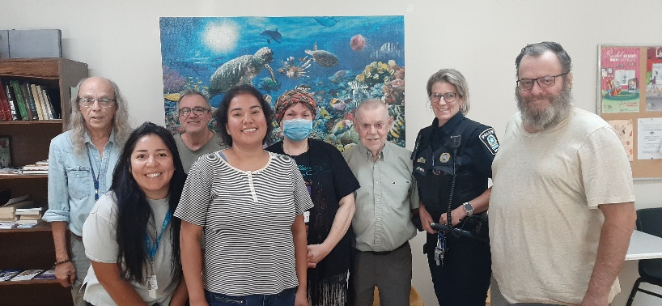

Community safety in a Montreal low-income housing project

September 5, 2024

Tenants are not alone!

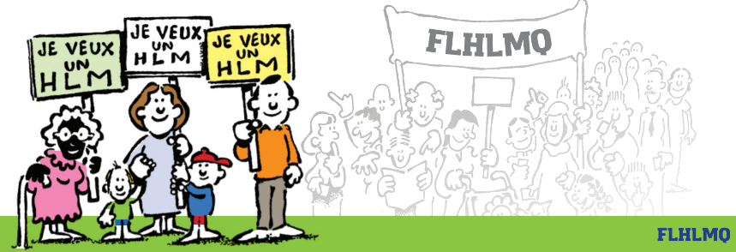

September 15 demonstration in Quebec City

September 4, 2024

We're marching behind the banner "Je veux un HLM" ("I want low-cost housing")!

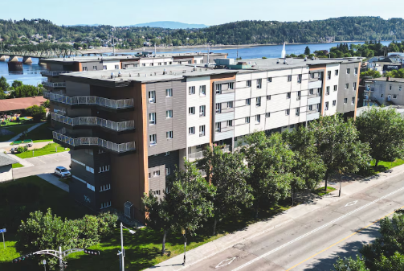

Record demand for low-cost housing in Saguenay

September 3, 2024

The list explodes from 200-300 to 454 people waiting.

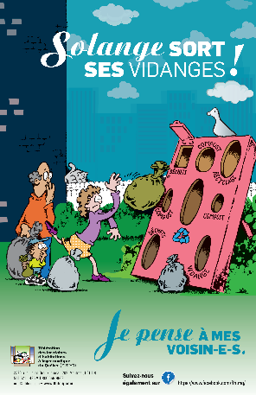

Solange takes out her garbage!

September 3, 2024

Humorous poster on waste management.

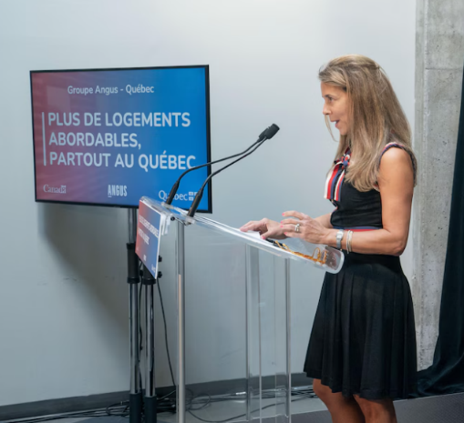

A new fast lane for developers

August 30, 2024

Housing associations must be involved.

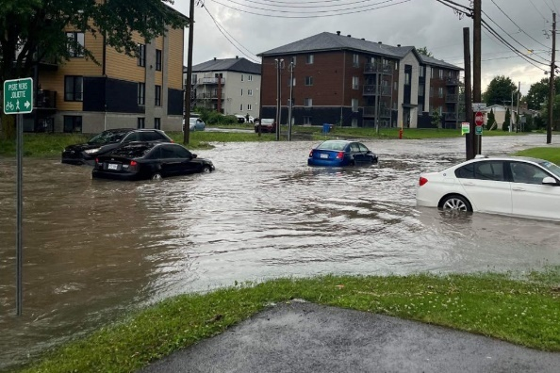

Flooding in Lanaudière

August 27, 2024

The SHQ looks after its tenants.

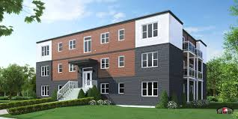

Prefabricated low-cost housing?

August 27, 2024

A golden opportunity for the boards.



A strategy that limits the number of future social housing units to 4%.

August 22, 2024

Pitiful targets for low-income households.

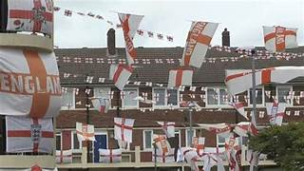

A radical building plan in England

August 21, 2024

Ten times better than Quebec!



Demonstrate in Quebec City on September 14 and 15

August 20, 2024

The FLHLMQ will be present to demand HLMs.

# News page

[https://flhlmq.com/fr/article/je-vis-dans-un-hlm-et-ca-cest-une-chance-que-jai]

"I live in a low-income housing scheme, and that's a blessing in disguise".

Submitted by Rédaction on Mon 16/09/2024 - 16:28

Image

solei;

The FLHLMQ was present at the 1,300-strong demonstration in favor of social housing that took place in front of the National Assembly in Quebec City on September 15.

A member of our Board of Directors, Chantal Daneau, even made the front page of Le Soleil newspaper and a Radio-Canada report when she said: "I live in a HLM and that's how lucky I am. There are about 34,000 households that would like to have the same chance as me.

At this rally organized by FRAPRU, 450 people signed the POUR DES HLM DE QUALITÉ petition, which all associations and CCRs will receive by mail during the week of September 16.

Read the article in Le Soleil:

[https://www.lesoleil.com/actualites/actualites-locales/la-capitale/2024/09/15/la-chance-dhabiter-dans-un-hlm-5L4SZKQNHZADTEKTRYCSCWKI5M/]

# List of services

## Congress

[https://flhlmq.com/fr/vie-democratique]

democratic life

The FLHLMQ is a voluntary association of some 300 free and independent tenants' associations and CCRs. A great deal of effort goes into ensuring a strong and democratic associative life. In addition to meetings of the federation's Board of Directors, which brings together representatives from all regions of Quebec, there are regular regional meetings to enable exchanges between tenants and/or association Board members.

Congress

The congress, usually held every June, is a crucial moment in the life of the association. Over 200 delegates come together to exchange views, vote on the federation's major orientations and elect the Board of Directors. Each association and CCR can submit proposals, which are discussed and voted on by the delegates. It is on the basis of the proposals adopted that the work of the federation, and in particular that of the Board and the work team, will be articulated for the coming year.

Each convention also provides an opportunity for exchanges between delegates and key government ministers - municipal affairs, employment and solidarity, Secrétariat aux aînés - or SHQ representatives.

Regional caucuses take advantage of the convention to choose their representatives on the FLHLMQ Board of Directors.

[Activity Report June 16, 2021]

[Activity report to June 30, 2020]

[Conference book June 14-15, 2019]

[Congress booklet June 8-9, 2018]

[Conference book June 9-10, 2017]

[Congress booklet June 10-11, 2016]

[Congress booklet June 5-6, 2015]

[Conference book June 13-14, 2014]

[Conference book June 7-8, 2013]

[Conference book June 14-15, 2012]

[Conference proceedings June 10-11, 2011]

[Conference proceedings June 4-5, 2010]

[Cahier de congrès 13-14 juin 2009]

[Conference book May 16-17, 2008].

[Conference book June 15-16, 2007].

## Association

[https://flhlmq.com/fr/votre-association-de-locataires]

Your tenants' association

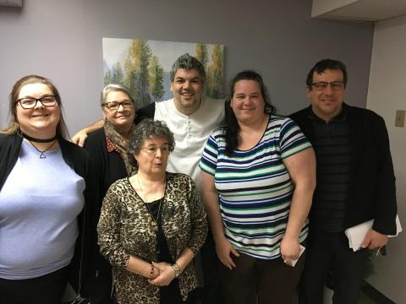

association

A tenants' association is a group of tenants from one or more low-cost housing projects. The association is set up by tenants for tenants. The association is managed like an NPO and must have its own board of directors, sometimes called a committee. The association works to improve tenants' well-being and quality of life. It is an autonomous body that decides how it will be organized and what activities it will carry out.

There are nearly 400 HLM tenants' associations across Quebec. Most of these associations are members of the FLHLMQ. The law of the Société d'habitation du Québec (SHQ) obliges all OMHs to recognize any association bringing together the tenants of their buildings, on condition that the association respects certain rules of foundation and operation that can be found in [Directive sur la participation des locataires].

FLHLMQ's role

The SHQ recognizes the FLHLMQ's right to hold meetings for tenants in order to set up tenant associations or ensure their democratic operation. Upon written request from the FLHLMQ, the OMH must allow such meetings to be held.

The FLHLMQ has published two guides to help tenants set up an association. They are available for download.

[Avoir une association: un plus pour les locataires de HLM], PDF version, 8 pages

[Ensemble pour agir], 2015 edition, PDF version, 103 p.

Training video on setting up and running a tenants' association

[View the first block] and the [powerpoint presentation].

[View the second block] and the [powerpoint presentation].

[View the third block] and the [powerpoint presentation].

## JRC

[https://flhlmq.com/fr/simpliquer-au-ccr]

Getting involved at CCR

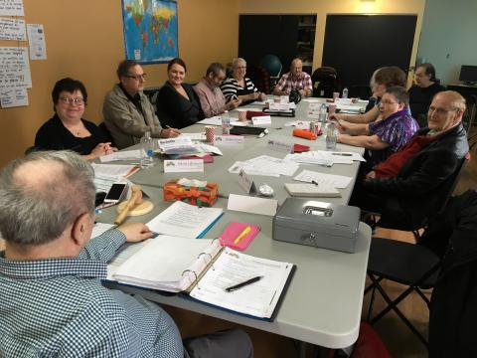

ccr quebec

A Residents' Consultative Committee (CCR) is a body that enables HLM tenants to participate in the management of their building and make recommendations to OMH management on all issues that affect them. A CCR is composed exclusively of tenants designated by their associations. All offices are obliged to have one, and must support it.

A cost estimate is a plus!

The participation of tenants in the management and community life of our offices is a PLUS that has not diminished over the years. On the contrary, the experience acquired in many offices shows just how rich it can be. This participation is a fundamental element in meeting the challenges facing low-income housing today and in the future. Whether it's maintaining the quality of our housing, ensuring a harmonious living environment or developing resources to help people stay in their own homes or reintegrate into society, tenant collaboration is essential.

Since April 2002, the SHQ Act has required each of Quebec's housing offices to set up a CCR. Beyond the law, experience shows that the CCR is a valuable tool in the management of an office. More than half of all housing offices have set one up.

In the case of large offices, the Act also provides for the creation of sector committees to discuss more specifically direct services to residents and their complaints.

The SHQ has mandated the FLHLMQ to provide the support needed to set up CCRs. Don't hesitate to call on its services to set up or support your CCR.

Find out more about how CCR works:

[How to set up your Residents' Advisory Committee (RAC)], 2016 edition, pdf version, 8 p.

[Residents' advisory committees], PDF version, 64 pages

## Board tenant

[https://flhlmq.com/fr/etre-au-ca-de-lomh]

Being on the OMH Board of Directors

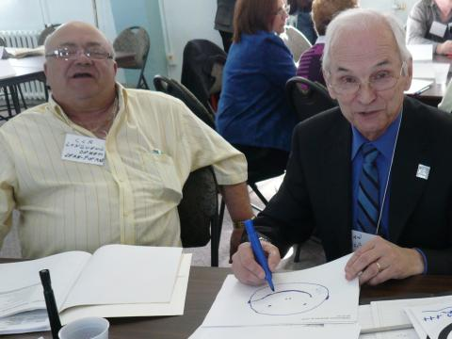

oh longueuil

The SHQ Act stipulates that the Board of Directors (BOD) of a housing office is made up of a fixed number of directors, ranging from five to fifteen. It is made up of persons designated by the municipalities, two persons appointed by the Minister of Municipal Affairs as socio-economic representatives, and two or three tenant representatives elected by the members of the Residents' Advisory Committee from among all tenants with a lease with the office.

The role of the manager

The Director is not a member of the Board of Directors. As the office's principal employee, he or she attends Board meetings to pass on information and report on management. He or she has observer status on the Board.

Directors have equal rights

All directors have equal rights. This means that whether you are a tenant, elected municipal official or socio-economic representative, you are equally entitled to :

To be elected to the position of Chairman, Vice-Chairman, Secretary or Treasurer of the Board of Directors. There is nothing to prevent a tenant from being elected to the position of President of the Board or to an officer position on the Board;

To require the Director to report to the Board of Directors on a regular basis;

Formulate proposals which, if supported, will be discussed and put to the vote;

Get all the information you need to make informed decisions, including access to all documents;

In the event of serious disagreement, to record dissent in the minutes;

In the event of non-compliance with the Code of Ethics, to complain to the Chairman of the Board of Directors of the office and to the President and Chief Executive Officer of the SHQ, who is responsible for enforcing the Code.

The FLHLMQ has produced a guide for tenants on the Board of Directors. You can download it here.

[Enter director code], PDF version, 44 pages

## Bulletins

[https://flhlmq.com/fr/bulletin-de-la-flhlmq-1]

FLHLMQ Newsletter

The FLHLMQ Bulletin is published two to four times a year, and contains a gold mine of useful information for tenant associations and CCRs. It talks about the latest developments in low-cost housing, important issues on which the FLHLMQ is working, actions and campaigns underway to improve the quality of life in low-cost housing, and much more.

Subscribe

All member groups of the federation receive the Bulletin, but you can subscribe for two years by completing and sending us the subscription form with a cheque for $15 for individuals and $30 for organizations.

You can consult the bulletins online, or type in a keyword that will take you to the information you need.

[Bulletin - March 2024]

[Newsletter - September 2023]

[Newsletter - October 2022]

[Bulletin - May 2022]

[Newsletter - December 2021]

[Newsletter - February 2021]

[Newsletter - December 2019]

[Newsletter - July 2019]

[Newsletter * Year 2018]

[Newsletter * Year 2017]

[Newsletter * Year 2016]

[Newsletter * Year 2015]

[Newsletter * Year 2014]

[Newsletter * Year 2013]

[Bulletin * Year 2012]

[Bulletin * Year 2011]

[Bulletin * Year 2010]

[Bulletin * Year 2009]

[Bulletin * Year 2008]

[Bulletin * Year 2007]

[Bulletin * Year 2006]

[Bulletin * Year 2005]

[Bulletin * Year 2004]

[Bulletin * Year 2003]

[Bulletin * Year 2002]

[Newsletter * Animal feature]

## Newsletters

[https://flhlmq.com/fr/infolettre]

Newsletter

Subscribe to our newsletter

Link

Subscribe to our newsletter!

2024

03/07/2024 - [FLHLMQ Newsletter 275 - July 3, 2024]

## Practical guides

[https://flhlmq.com/fr/guides-pratiques]

Practical guides

Our humorous posters for good neighborliness

AFF BRUIT.pdf

AFF FIDO.pdf

Document

AFF LAVAGE.Pdf

Three fact sheets explaining the role and operation of the Residents' Advisory Committee (RAC)

Document

Sheet 1A - Participation bodies.pdf

Document

Sheet 1B - Costing.pdf

Document

Sheet 5 Partnerships.pdf

Nine factsheets to get your association up and running

Sheet 2.A - Tenant Associations_0.Pdf

Sheet 2B - Tenant Committees_2.Pdf

Fiche 2C - Se Donner Un Exécutif_0.Pdf

Fiche 2D - Keys To Success_1.Pdf

Sheet 4A - Annual Activity Report_0.Pdf

Sheet 6 Annual General Meeting Final_0.Pdf

Sheet 4B - Annual Financial Report.Pdf

Sheet 4C - Annual Action Plan.Pdf

Sheet 4D - Annual budget forecast.Pdf

How do you set up a Residents' Advisory Committee (RAC)?

Guide produced as part of the consolidation of small municipal offices. It includes :

The usefulness of the Residents' Advisory Committee (RAC)

The JRC work plan

Financing ACC activities

The partnership between the board and its ACC

How to set up your Residents' Advisory Committee (RAC), 2016 edition, pdf version, 8 p.

Ensemble pour agir. Le guide des associations de locataires des offices d'habitation du Québec, 2015 edition.

These include :

how to set up an association;

how to organize elections;

how to manage an association's finances;

the rights and duties of members;

practical tips for organizing activities.

Ensemble pour agir, 2015 edition, PDF version, 103 p.

Checklists to support the work of tenants' associations

To help tenants who are members of the board of directors of their association or office to fully understand their role and responsibilities, or to quickly learn how to prepare a program of activities or organize an annual general meeting, the FLHLMQ has prepared practical fact sheets. They contain useful, easy-to-consult information.

Chairman's role

Role of a vice-president

Role of a secretary

Role of the treasurer

Role of an administrator

Role of the tenant on the selection committee

Representing tenants on the Board of Directors

Prepare an activity report

Organize an Annual General Meeting

Prepare a program of activities

Getting renovations done in our building

Role of a community organizer

Having pets

All documents are in PDF format.

Green low-cost housing for better living

A special edition of the Bulletin highlighting concrete actions taken by tenants and OMHs to protect the environment. Ideas to remember and implement:

green renovations

recycling

greening and gardening

public transport

The Bulletin, issue 70, PDF, four-page tabloid

Does your office have good local bylaws when it comes to allocating HLMs?

This guide presents:

models of compulsory or optional local bylaws that offices must adopt in addition to the allocation bylaws in force since September 1, 2011;

applicants' right to refuse housing;

the role of the selection committee.

Does your office have good local bylaws when it comes to allocating HLMs?, PDF version, 8 pages

How does HLM allocation work?

This guide presents:

the rules that boards must follow;

their different local room for maneuver;

the rights of applicants and tenants.

How HLM allocation works, PDF version, 6 pages

Having an association: a plus for low-income housing tenants

These include

the rules for setting up an association;

resources available to tenants;

model minutes;

a poster inviting tenants to a first meeting.

Avoir une association: un plus pour les locataires de HLM, PDF version, 8 pages

Sample poster for the Foundation Meeting, PDF version

Associations' experience in family projects

Families on the move across Québec

The ABCs of low-income housing tenants' rights

Are you in conflict with your office?

Do you know your rights?

Do you know how your rent was calculated?

Are you allowed to install a satellite dish?

L'ABC des droits des loctaires de HLM is the ideal tool for learning about your rights and improving your life in low-income housing. Some fifty simple, concise factsheets will give you the answers you're looking for!

The ABCs of HLM tenants' rights , PDF version, 52 pages

Residents' Advisory Committees: A guide to help RACs function properly

It covers three aspects:

how a CCR works;

tenant representatives on the board of directors of a housing office;

improving OMH services.

Residents' advisory committees, PDF version, 64 pages

Guide to acting on the board of directors of a housing office

It provides simple, precise answers on topics such as the following:

who are the directors on the Boards;

the obligation for the two tenants elected to the Board of Directors to also sit on the CCR;

duties to be respected and rights to be asserted;

how to make a positive contribution to the Board;

what to do when the code is not respected.

Enter the Directors' Code, PDF version, 44 pages

Guide to electing tenants to the board of directors of an office

He explains, among other things:

the composition of the OMH Board of Directors;

the role and responsibilities of the Board of Directors;

the place of tenants;

the election of a tenant representative to the selection committee.

Guide for the election of tenant representatives to the Board of Directors, PDF version, 12 pages

Guide to consulting tenants on renovations

Documents so that tenants, in association or not, can organize themselves and give their opinions on the work to be planned:

PDF version of the tenant consultation form,

Table of possible improvements, PDF version

Living safely in our low-income housing

A feeling of insecurity is very much present in our low-income housing, as evidenced by a survey conducted by the FLHLMQ in 2010 among 200 tenants from 32 cities in Quebec.

The FLHLMQ has produced a number of tools to help tenants' associations analyze and solve the security problems they face:

A guide to analyzing safety-related problems

guide to conducting a safety meeting in low-income housing, PDF version, 12 pages

A poster inviting you to discuss safety

A neighbor watching over you

A guide to self-monitoring for senior tenants, PDF version, 12 pages

Document

A neighbor watching over you.pdf

A good neighbor charter to agree on rules for living together

Good neighbor charter

Anti-bullying posters in community halls and on swings

Document

HLM-intimidation-posters-print.pdf

Aging in peace in our low-income housing

leaflet on elder abuse, PDF version, 4 pages

## Conference booklet

[https://flhlmq.com/fr/autres-documents#cahier-de-congres]

other documents

Conference booklet

Every year, the FLHLMQ prepares a brochure for its convention, outlining the issues, work and achievements of the federation. They generally include a portrait of the Board of Directors, financial statements and proposals to be voted on at the convention. They are the memory of the FLHLMQ.

Activity report 23-24.pdf - June 14, 2024

Cahier du congrès 2023 - June 16-17, 2023

Cahier de congrès 2022, June 10-11, 2022

Activity report June 16, 2021

Activity report to June 30, 2020

Conference book June 14-15, 2019

Cahier de congrès June 8-9, 2018

Cahier de congrès June 9-10, 2017

Cahier de congrès June 10-11, 2016

Cahier de congrès June 5-6, 2015

Cahier de congrès June 13-14, 2014

Cahier de congrès June 7-8, 2013

Cahier de congrès June 14-15, 2012

Cahier de congrès June 10-11, 2011

Cahier de congrès June 4-5, 2010

Cahier de congrès June 13-14, 2009

Cahier de congrès May 16-17, 2008

Cahier de congrès June 15-16, 2007

Study documents on low-income housing in Quebec

Les associations de locataires en milieu HLM et leurs effets sur celui-ci dans les régions de l'Estrie et de Montréal, Paul Morin, 2008, CLSC de Sherbrooke, 87 p.

Habiter en HLM - Impacts - Le résumé and Habiter en HLM - Impacts - L'enquête, MORIN, Paul, Xavier LELOUP, Evelyne BAILLERGEAU and Jacques CAILLOUETTE, 2010, Université de Sherbrooke and INRS-UCS, 300p.

Documents produced by SHQ

SHQ complaint procedure

Canadian and Quebec governments invest in social housing, June 2012.

## Memories

[https://flhlmq.com/fr/autres-documents#memoires-et-communiques]

Briefs and press releases

Des Éclaireurs_web.Pdf, avis au MSSS sur le soutien communautaire apporté par les locataires, 2024.

Document

Memoire prebudgétaire 2024-2025.pdf

Observations of the FLHLMQ on the consolidation of housing offices in Quebec, submitted in December 2020.

FLHLMQ brief on bill no. 67, tabled in November 2020 and addition of amendments.

FLHLMQ brief submitted as part of the study of Bill 155 amending various legislative provisions concerning the municipal sector and the Société d'habitation du Québec, December 2017

FLHLMQ submission to the consultation on a new approach to housing intervention organized by the Quebec government, December 2016

Pour mettre fin à l'éparpillement des ressources et offrir de meilleurs services aux locataires dans les HLM du Québec, FLHLMQ brief on Bill 83 amending various legislative provisions in municipal matters concerning, in particular, political financing, January 2016

FLHLMQ submission to the Solidarity and Social Inclusion public consultation, January 2016

Deux propositions majeures pour améliorer la performance des HLM, brief submitted to the Commission de révision permanente des programmes, September 2014.

Budget bachand: Quebec throws the ball back to Ottawa, March 2012

Le gouvernement du Québec fait des heureux chez les locataires de HLM, press release, March 2006

Une proposition globale pour rendre les HLM encore plus utiles socialement, press release, winter 2006

Cadre national sur le soutien communautaire en logement social, letter to the Minister of Municipal Affairs, December 2005

100 million campaign to renovate low-income housing, press release, November 2005

La santé de la population passe avant la santé de l'industrie pharmaceutique, brief on the draft drug policy, submitted to the Commission des affaires sociales of the Quebec National Assembly, February 2005.

Projet de loi 57 sur l'aide aux personnes et aux familles, brief presented to the members of the Commission des affaires sociales of the Quebec National Assembly, November 2004.

Comment les associations de locataires contribuent-elles au renouveau du logement public, presentation at the housing conference Avoir un toit au Québec et en Outaouais, Université du Québec en Outaouais, March 2004

Quatre grands chantiers pour développer les HLM du Québec, brief presented as part of the pre-budget consultations of the Ministère des Finances du Québec, February 2004

Workshops on multiethnic cohabitation, Réflexions, April 2000

## Search

[https://flhlmq.com/fr/autres-documents#documents-etude]

Search

Étude sur les efforts requis pour gérer les offices d'habitation de moins de 100 logements, SHQ

La participation des locataires en milieu HLM, HLM research team, Université de Sherbrooke

Evaluation report on the public non-profit housing program (HLM public) - regular component, SHQ

# Service page

[https://flhlmq.com/fr/simpliquer-au-ccr]

Getting involved at CCR

Image

ccr quebec

A Residents' Consultative Committee (CCR) is a body that enables HLM tenants to participate in the management of their building and make recommendations to OMH management on all issues that affect them. A CCR is composed exclusively of tenants designated by their associations. All offices are obliged to have one, and must support it.

A cost estimate is a plus!

The participation of tenants in the management and community life of our offices is a PLUS that has not diminished over the years. On the contrary, the experience acquired in many offices shows just how rich it can be. This participation is a fundamental element in meeting the challenges facing low-income housing today and in the future. Whether it's maintaining the quality of our housing, ensuring a harmonious living environment or developing resources to help people stay in their own homes or reintegrate into society, tenant collaboration is essential.

Since April 2002, the SHQ Act has required each of Quebec's housing offices to set up a CCR. Beyond the law, experience shows that the CCR is an invaluable tool in the management of an office. More than half of all housing offices have set one up.

In the case of large offices, the Act also provides for the creation of sector committees to discuss more specifically direct services to residents and their complaints.

The SHQ has mandated the FLHLMQ to provide the support needed to set up CCRs. Don't hesitate to call on its services to set up or support your CCR.

Find out more about how CCR works:

[How to set up your Residents' Advisory Committee (RAC)], 2016 edition, pdf version, 8 p.

[Residents' advisory committees], PDF version, 64 pages

# Team

[https://flhlmq.com/fr/equipe-de-la-flhlmq]

FLHLMQ Team

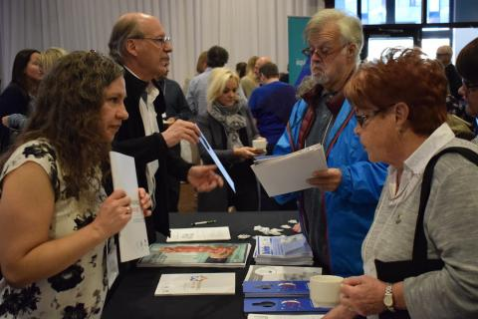

kiosk

The FLHLMQ office has four employees:

Robert Pilon, community organizer - robert.pilon@flhlmq.com



Élisabeth Pham, Administrative Manager - elisabeth.pham@flhlmq.com



Patricia Viannay, Coordinator - patricia.viannay@flhlmq.com



Anik Leroux, community organizer - [anik.leroux@flhlmq.com](mailto:anik.leroux@flhlmq.com)

# About us

[https://flhlmq.com/fr/presentation-de-la-flhlmq]

Introducing the FLHLMQ

Founded in 1993, the Fédération des locataires d'habitations à loyer modique du Québec (FLHLMQ) brings together over 300 HLM tenants' associations and Residents' Consultative Committees (CCR) across Quebec.

The FLHLMQ's mission is :

promote and defend tenants' interests and work to improve their quality of life;

support the work of local tenants' associations;

promote tenant involvement and empowerment in low-income housing;

represent tenants in political and administrative bodies.

The FLHLMQ is governed by a board of 18 tenants representing the various regions of Quebec. They are elected for a two-year term at the FLHLMQ convention. Each is responsible for liaising with the associations and CCRs in his or her region, as well as organizing FLHLMQ regional activities.

If you'd like to know more about how the FLHLMQ operates democratically, you can consult our by-laws.

Document

FLHLMQ GENERAL BYLAWS- 2021.pdf

The FLHLMQ employs 4 people: Robert Pilon, Élisabeth Pham, Patricia Viannay and Anik Leroux. The federation's offices are located in Montreal.

## History

[https://flhlmq.com/fr/les-25-ans-de-notre-federation-historique-de-la-flhlmq]

25 years of our federation (FLHLMQ history)

To mark its 25th anniversary, the FLHLMQ has published a weekly series of short articles on its history. Thanks to André Giroux for writing these articles.

-1-

In Quebec, low-cost housing really came into being in the '70s to accommodate citizens evicted from their homes to make way for the major revitalization projects of the time. Examples include the demolitions caused by the construction of Highway 40 through Trois-Rivières, the Radio-Canada building in Montreal and Place du Portage on Hull Island, as well as the closure of villages in central Gaspésie. To avoid protests, all those displaced were invited to live in beautiful new HLMs at very low rents. The first HLMs were thus built from a diversity of populations, ensuring the right to housing for all.

In the '80s, as social policies tightened, governments in Quebec decided to restrict access to low-cost housing to only the most disadvantaged populations. Changes to rent-setting regulations and housing allocation rules gradually drove out working-class households. As a result, between 1978 and 1989, the proportion of tenants declaring an earned income fell from 20% to 7%. To drive a further nail into the concept of social housing accessible to all, Brian Mulroney's Conservative government announced in 1993 that the federal government was unilaterally withdrawing from the construction of new low-cost housing. The country's social housing shortage had just begun.

It was in this context that the Front d'action populaire en réaménagement urbain (FRAPRU) had the good idea, in 1993, of encouraging eight HLM tenants' associations to create the Fédération des locataires d'habitations à loyer modique du Québec (FLHLMQ). Funnily enough, the only FRAPRU employee to vote against the project went on to become FLHLMQ coordinator, a position he has held for 25 years.

From the outset, the main objective driving the Federation has been democracy. In some offices, such as those of Montreal, Quebec City and Trois-Rivières, the creation of tenants' associations was supported, while in other cities they were forbidden. It was therefore necessary to gain recognition for the right of HLM tenants to form associations, to give them a voice when dealing with OMH managers.

Soon, other issues were added to the Federation's battles to make tenants feel at home in an HLM. From small, day-to-day battles, such as the right to own pets or simply to choose the paint color of one's unit, to larger battles to prevent rents from rising, obtain budgets for building renovation or prevent the privatization of HLMs.

Over the next few weeks, we'll be taking you through the events and issues that have marked the Federation's 25-year history, taking stock of what we've achieved and what lies ahead for the next few years.

Photo: Members of the FLHLMQ Board of Directors in 1995.

-2-

Battles for democracy

As early as 1993, the first challenge facing the Fédération des locataires d'habitations à loyer modique du Québec (FLHLMQ) was the need to obtain recognition of the right to form a tenants' association. The theme of the first convention, held in 1995, was "A greater place for tenants". This theme reflected the spirit of the times particularly well.

We felt that some HLM administrators - fortunately not all, but there were several of them - acted as if tenants were less than nothing," recalls Robert Pilon, Federation coordinator from the outset. Their management was paternalistic at best, authoritarian at worst. It reflected the fact that HLM tenants saw themselves as failures: failures in employment, in relationships, in school, in leisure and in consumption."

Hence the theme of the first congress, to make the case that low-income housing tenants are full-fledged citizens capable of taking charge of their lives in low-income housing.

The battle for democracy involved the right to be informed, consulted and to form associations. The reality was that in Longueuil, Chicoutimi and Bromont, management refused to recognize tenants' associations. At the time, in practice, recognition of associations was at the discretion of local leaders, who decided whether to accept them, with the funding and availability of premises that this implied, tolerate them or reject them.

Some boards, like Montreal's, accepted recreation committees per building, but didn't want them to get together to negotiate. This was the most progressive practice at the time. Many offices boasted that they didn't have tenants' associations, and made it clear that they didn't want them, on the pretext that they would create trouble.

In Bromont, some wonderful women tenants, including Isabelle Marrisal, who would later become president of the FLHLMQ, had received letters from lawyers stating that they had to leave on the following July 1 because they had tried to set up an association.

In Longueuil, courageous women fought for seven years to create a tenants' association. The OMH refused to recognize it under Mayor Claude Gladu.

The Federation's first victory came in April 1998, when it tabled a 30,000-strong petition for recognition of the right of association in low-rent housing and held the largest demonstration of low-rent housing tenants - over 700 - in front of the National Assembly and the congress of the Regroupement des offices d'habitation du Québec. In June 1998, the SHQ issued a directive requiring OMHs to recognize, fund and consult tenants' associations. At the time, Federation president Claude Gelderblom of Rivière-du-loup enthusiastically declared that this gain represented a "veritable quiet revolution for low-cost housing". There were two reasons for this:

Giving tenants the chance to become actively involved in the management of their building will improve the quality of services and contribute to a more positive image of public housing in the eyes of both politicians and the general public;

This commitment on the part of tenants gives them the opportunity to enhance their self-esteem and regain their dignity.

Despite this initial gain, tenants are finding out the hard way that offices are ignoring the administrative directive because it does not have the force of law. The FLHLMQ is therefore going back on the offensive to ensure that tenants' right of association is enshrined in the law of the Société d'habitation du Québec.

In April 2002, the SHQ Act was amended to include two new rights for HLM tenants: the obligation for offices to recognize all associations that comply with SHQ directives, and the obligation for all offices to create a Residents' Consultative Committee (CCR). According to the Federation's president at the time, Jean-Marie Doyon of Rock-Forest, "the introduction of advisory committees will give us the chance to change the face of low-cost housing".

Over the next fifteen years, these achievements led to the creation of dozens of Residents' Advisory Committees (RACs) across Quebec. Many CCRs are very proud of what they have achieved since then. On the other hand, more than half of all offices have never set up a CCR.

According to Élisabeth Pham, who has been with the FLHLMQ since 2003, "this shows us that it was much easier to get a legislative change than to get a real change of attitude in the field. It's a daily battle. Even today, many active people are afraid of reprisals: fear of losing their housing, of displeasing administrators."

These fears are based on concrete facts: threats of being moved to a smaller place or to a neighborhood the tenant doesn't like.

The balance of power still exists. In a 2011 survey by the Société d'habitation du Québec (SHQ), 49% of office managers were opposed to tenant associations. However, low-cost housing is a world where 70% of tenants are single women, while the majority of managers are still men.

So it's always a huge challenge for people excluded from everything to learn how to occupy the democratic spaces that are the fruit of their struggles.

That's why the Federation remains very much on the ground to support tenants who want to organize.

On the photo: Claude Gelderblom, president of the FLHLMQ, in 1998, before the National Assembly.

-3-

The battle to get workers back into low-income housing

By the time the Federation was founded in 1993, it was clear to all residents that low-cost housing had become a very difficult environment in which to live. This was because, in the early '80s, the Quebec government had changed the rules in two ways:

By abolishing the Rogers scale, which set rent on a scale of 16% to 25% of the main household income, and replacing it with rent set at 25% of the two main incomes, with no ceiling.

By restricting allocation rules through a weighting system designed to prioritize only the poorest, effectively excluding households working for even the minimum wage.

As a result, vast housing complexes of 200 to 400 units were now home to just three or four working households. Poverty ghettos were created, making it harder to raise a family than in the '70s and '80s. One researcher, Paul Morin, coined the term "social trap" to indicate that it was also becoming more difficult to escape.

In 1993, the then Minister of Municipal Affairs, Claude Ryan, wanted to go one step further by considering all family incomes, including those of children. The outcry was such that it was the mobilization of tenants to maintain the rent of HLMs that enabled the Front d'action populaire en réaménagement urbain (FRAPRU) to create the Fédération. This battle led to a partial victory: the setting of a lump sum for young people aged 18 to 24 living with their parents. Only at the age of 25 does the percentage rise to 25% of their income.

Two significant gains

In the early 2000s, under the presidency of Isabelle Marissal of Bromont, the Federation organized several demonstrations and press conferences in major Quebec cities to demonstrate that, because of rent policies, it was not advantageous to work for a low wage while living in low-income housing. The Federation obtained from the Minister responsible for Housing, Louise Harel, an amendment to the regulations to obtain protected rent. This means that the rent for people who start working will gradually increase, enabling them to stay in a HLM for longer. Tenants of housing cooperatives and housing owned by non-profit organizations (NPOs) also benefited from this measure. The Fédération's objective was to develop a certain mix in HLMs.

It was also with the aim of increasing social diversity that in 2011, after 19 years of tenacious representations, the Fédération obtained an amendment to the HLM allocation regulations to take into account the length of time the application had been in existence. It was no longer just the poorest of the poor who could access a HLM. People with a wide range of backgrounds came together, creating a more pleasant living environment.

In 2011, the SHQ promised a study in 2016 on the impact of this measure on social diversity. We're still waiting for it in 2018.

Two setbacks avoided

When Lucien Bouchard became Premier of Quebec in the aftermath of the 1995 referendum, he launched the fight for zero deficit. With this obsession in mind, his government came within a hair's breadth of transferring responsibility for low-income housing to the municipalities, without the corresponding budgets. This would have been a royal road to privatization. In Ontario, for example, under Mike Harris's common-sense revolution, the transfer to municipalities led to the sale of low-income housing to the private market. In Quebec, it was the Federation's public outcry, in alliance with FRAPRU, that made the government back down.

Subsequently, Rémi Trudel and the PQ announced plans to reduce the rent in low-rent housing to 30% of income over five years, at a rate of 1% per year. Through their mobilization, including a petition delivered to all MPs, HLM tenants succeeded in having this measure rejected, whereas almost everywhere else in Canada, this proportion has been 30% for nearly twenty years.

-4-

Battles for renovation!

When Jean Charest came to power in 2003, the total budget allocated to HLMs was $50 million per year to renovate and maintain 63,000 HLMs. The first decision of the new Minister responsible for Housing, Jean-Marc Fournier, was to reduce this budget to $30 million.

There wasn't a city, not a single HLM, where tenants managed to get their old carpets or kitchen hoods replaced, let alone their 30-year-old kitchens or bathrooms renovated. Zero renovation, except for emergencies or the refurbishment required for re-rental. In fact, the SHQ has estimated that the accumulated maintenance deficit for the renovation of all HLM housing in Quebec is close to $4 billion.

Under the chairmanship of Nicole Sirois, from the Eastern Townships, the Federation initiated a petition that has gathered nearly 54,000 signatures. The document calls on the Liberals to increase the sums allocated to HLM renovation to $100 million a year. One hundred and ten MNAs rose in turn at the National Assembly to read the contents of the petition submitted by the low-income housing tenant associations in their ridings. Many MNAs from all parties were sympathetic to our cause, but Minister Fournier remained intractable.

2007 - 2008 saw the worst global economic crisis since the Great Depression of the '30s. Canada fared slightly better than other countries thanks to an infrastructure program created by the federal government at the same time.

To everyone's surprise, in December 2007, Jean-Marc Fournier's replacement, Nathalie Normandeau, invited FLHLMQ representatives to a press conference in a low-cost housing project next to our offices in Montreal's Little Burgundy district. She announces a 15-year renovation program for low-income housing: this federal-provincial program, worth $260 million a year, is indexed. In 2017, it amounted to $360 million. In ten years, three billion dollars were invested in HLM renovation. According to the SHQ, we are 79% advanced in HLM renovation work.

FLHLMQ coordinator Robert Pilon remembers that in the photo taken with the Minister, he couldn't smile because it looked too good to be true.

This is, in his words, "a historic victory that guarantees the survival of low-income housing because of the money invested. These are proportionally higher investments than in schools, for example. However, there are still a multitude of local battles to be fought to ensure that this money is spent on the real needs of tenants."

-5-

Battles at the Quebec National Assembly

Over the past 25 years, the FLHLMQ has repeatedly defended the cause of low-cost housing before Quebec's MNAs. Here's a brief overview of the sometimes courageous or visionary positions we've taken following debates at congress.

March 4, 1995 - Let's run the risk of independence if the project is worth it! FLHLMQ presentation to the Commission des aînées et aînés sur l'avenir du Québec.

December 1, 2000 - Mergers can promote the management and development of social housing for disadvantaged populations in large cities. FLHLMQ presentation to the Commission de l'aménagement du territoire on Bill 70.

October 24, 2002 - Pour une gestion moderne et transparente des HLM afin de favoriser la participation des locataires. FLHLMQ presentation to the Commission sur l'aménagement du territoire on Bill 49.

February 6, 2004 - Four major projects to develop low-income housing in Quebec. Presentation as part of the Ministère des Finances du Québec's pre-budget consultations.

February 14, 2005 - The health of the population comes before the health of the pharmaceutical industry. FLHLMQ presentation to the Social Affairs Commission.

March 2013 - Work that is changing the face of low-income housing. FLHLMQ presentation to the Quebec Ministry of Finance.

January 20, 2016 - To put an end to the scattering of resources and offer better services to HLM tenants in Quebec. FLHLMQ presentation to the Minister of Municipal Affairs.

January 2016 - A proposal to reduce poverty in low-income housing - Transferring maintenance to tenants. Presentation as part of the Solidarity and Social Inclusion public consultation.

2016-2017 - More than 300 tenants took part in the consultation tour organized by MNA Norbert Morin and the SHQ on a new approach to housing intervention in some 20 cities across Quebec.

Each time, it was a rich but demanding experience for successive FLHLMQ Board members to speak at the National Assembly with all its decorum.

-6-

The referendum battle

From the very first months of its existence in 1993, the Fédération des locataires d'habitations à loyer modique du Québec (FLHLMQ) has been preoccupied with the issue of animals in low-cost housing. At the time, two Longueuil residents, Fleurette Trottier and Denise Blanchard, were fighting in court to keep their dogs and cats, respectively. After losing before the Régie du logement, Ms Trottier appealed and won her case before the Court of Quebec on technical grounds.

In solidarity with their struggle, the Fédération asked the Société d'habitation du Québec (SHQ) to force OMHs to allow pets in HLMs. Although the Association des OMH du Québec (now called the Regroupement des offices d'habitations du Québec) recommended tolerance among its members at the time, only a few dozen cities, including Montreal and Quebec City, allowed pets.

It would take five years, and many pathetic cases of evicted tenants, notably that of Ezzy the cat in the Superior Court, before in 1998 the FLHLMQ persuaded the Minister of Municipal Affairs, Louise Harel, to give tenants the decision-making power to decide whether or not to allow the presence of animals. "The idea of giving tenants the power to hold a referendum on animals appealed to the Minister, who was very familiar with the issue of referendums, having experienced two unfortunate ones at close quarters," says Robert Pilon, coordinator of the FLHLMQ.

The adoption, in 2002, of an amendment to the Act respecting the Société d'habitation du Québec (SHQ), which obliges housing associations to set up Residents' Advisory Committees (RACs), led the SHQ to amend its Guide to the Management of Social Housing to give RACs the mandate to "provide, in collaboration with the housing association, for a secret ballot mechanism to enable tenants to vote on the presence of animals in low-rental housing. In addition, "if a majority of tenants are in favor of the presence of animals in HLMs, the office will not be able to prohibit it in a general way, and will have to issue guidelines to this effect and integrate them into the building bylaws (...)".

"The question of animals is the only issue on which tenants have obtained real decision-making power, but unfortunately it is still little known or sometimes hidden from residents," points out Robert Pilon. Since 2002, some fifty tenant associations have organized a referendum on animals. The FLHLMQ recommends the following wording for the referendum, to which it suggests a YES vote:

Would you agree to

1. that OMH authorize the presence of animals by requiring tenants to comply with the following conditions: A CAT, PROVIDED THAT IT IS OPERATED, DEGROOVED AND KEEPED INSIDE THE DWELLING; or A DOG, PROVIDED THAT IT DOES NOT FLAKE, IS ALWAYS LEASHED OUTSIDE AND THE EXCREMENT IS PICKED UP.

2. that the office intervene firmly against tenants who do not comply with these new rules. Please check your choice: YES___ NO___

To date, more than half of the 443 OMHs, including the one in Longueuil, allow cats or dogs. So things have changed in Longueuil since 1993 when it comes to the right to own an animal. In many other cities too!

Photo: Demonstration in front of Longueuil City Hall in 1994, organized by the FLHLMQ.

-7-

Monik Desjardins joined the Fédération des locataires d'habitations à loyer modique du Québec (FLHLMQ) in 1994, a year after it was founded. She became a member of the Board of Directors, representing the HLM des Hirondelles, which she had joined in 1989. It was the start of a long experience that continues to this day in 2018.

One of Monik's most memorable experiences was meeting Jean Campeau, then PQ MP for Crémazie, in April 1998. Prior to his election, he had co-chaired the Bélanger-Campeau Commission on Quebec's political and constitutional future. He also served as Minister of Finance and Revenue (1994 - 1995) in Jacques Parizeau's government.

During her meeting with Jean Campeau, Monik acted as spokesperson for the seven tenants' associations in the Ahuntsic district, representing 600 households. She handed the MP a petition containing 500 names. The petition called on the government to retain ownership of the HLMs rather than transferring them to the municipalities, not to increase their rents to 30% of their incomes, as was increasingly the case in English-speaking Canada, to encourage low-income working households, and to adopt regulations promoting tenant participation in the management of their buildings. Over the years, the signatories won their cause, thanks to a petition that received 50,000 names in Quebec.

"Mr. Campeau was the only MNA to join us at the 700-strong demonstration the Federation organized in front of the Quebec National Assembly," points out Monik Desjardins.

The following year, at the Federation's third congress, she became secretary of the organization and vice-president of the Montreal OMH. "I used to think I was just a b.s., but I've gained in self-confidence since I've been in low-cost housing," she told Josée Boileau, a journalist with Le Devoir, a few years later.

One of the events that gave Monik confidence was her intervention before the parliamentary commission on the possibility of merging housing associations, as proposed by the Federation in 2001.

The mayor of Sainte-Foy, Andrée Boucher, came before us," recalls Monik. Federation coordinator Robert Pilon suggested I take inspiration from her. When it was my turn to speak, Louise Harel, then a PQ minister, congratulated me on being the first tenant to sit on the executive committee of an OMH. Liberal MP Fatima Houda-Pepin also congratulated me, even though I disagreed with her. I still remember it, 17 years later.

A disagreement with the Montreal OMH, which had refused to follow up on a decision taken at a tenants' assembly, led Monik to resign from her elected position.

She returned to the Federation ten years later, in 2012, for at least two days a week, as a volunteer. She's the one who answers the phone and gives you her valuable advice, the fruit of her vast experience.

It's thanks to Monik and the two thousand volunteers involved in Quebec's low-income housing tenant associations that the FLHLMQ has been in existence for 25 years.

# Contact us

[https://flhlmq.com/fr/nous-joindre]

Contact us

To contact the Fédération des locataires d'habitations à loyer modique du Québec (FLHLMQ).

- by phone: (514) 521-1485 or 1-(800)566-9662

- by fax: (514) 521-6444

- by post :

2520 Lionel-Groulx Ave., local 202

Montreal, Quebec

H3J 1J8

- by e-mail :

info@flhlmq.com- WEB site :

flhlmq.com

- on Facebook :

- Robert Pilon

Community organizer

- Patricia Viannay

Coordinator

- Élisabeth Pham

Administrative Manager

-Anik Leroux

Community organizer

# Frequently asked questions (FAQ)

[]

COMING SOON

# Error 404

Page not found

The requested page could not be found.