**Gameplay Game Design Document. Djem Thijs SD2A**

Story 🪐:

You were flying peacefully in your spaceship. Until the motor started to make loud noises. You did not know what was going on so u decided to make a emergency landing on a unknown planet. You landed with a big smack and your spaceship was not able fly anymore. You see in the distance a friendly creature, they walk up to you and ask you what just happened. Lucky for you that you can understand him. You explained that you needed to make a emergency landing because of the loud noise of your spaceship. You are now asking if the creature can fix your spaceship. The creature says yes, but in return you must collect 20 gems that are hidden inside of the caves of this planet. The creature says that he is to scared to go inside of the caves because there are obstacles that will stop you if your trying to get a gem. The creature also gives you a strange gun that can shoot a glowing vine that can stick on the walls of a cliff. He says “This will help you platform through the caves. I will fix your spaceship if u get all the gems. Deal ?”

You accept the deal. Now you are going on an ADVENTURE !

Gameplay 🎮 :

I am going to make a 3d, third person platformer where you go inside of a long cliff on a different planet with obstacles that come out of ceiling and try to stop you. First you have to walk to a cliff on the planet.

You have 3 different areas where you can find different levels: The main zone, the iceberg zone and the volcano zone. You can choose were to go first but only in the iceberg and volcano zone, there are hazards.

In the volcano zone there are flying magma rocks. If they hit you you will be knocked back a couple of meters. You have a mechanic that allows you to see them before the fall on the ground but I will discus That later.

In the iceberg zone there are small and slippery paths. In that zone there are also holes that you can fall into. If that happens you respawn on the place were you just fell and move on.

Once your in a level you have a objective. The objective is to get a gem that is on 75% in the level without falling down or getting hit/shot. You are in a different universe where you have a special gun that will shoot a glowing vine to the ceiling so u can move forward like spiderman Right before you shoot your glowing vine and swing further. You can find shiny capsules in a level and use the to shoot faster (consumable). You have a rectangle on the sealing and a blue dot(Were you will shoot). You have a couple of seconds to shoot in that rectangle and position your swing. The reason for that is because you want to avoid the obstacles the obstacles are different in each zone you are in. You have a mechanic that allows you to see obstacles before they will activate. The hard part about this game is if u are to late with shooting the vine you will fall down and die. And if you shoot to far to the side of the rectangle you will smack against the walls of the cliff and also fall down. If u die u restart the level. If you complete a level you will move one the next one and hope that you will find a gem for the creature.

Target audience 🎯:

* Hardcore gamers, because You need to have a lot of time, skill, and patients I other to play this game.
* People that like to explore and collect rare objects.
* Platformer enjoyers that like to challenge themselves.
* 12+ because there is violence when you enter a cave. But it doesn’t have blood or something like that. Probably a couple of particles.

☆ USP ☆:

The mechanic where you can see the weapons/obstacles before you position yourself in the swing, and before the weapons/obstacles are even there to stop you.

Concept Art:

MDA: Mechanics:

* You can walk around the planet like in Mario galaxy to go in specific caves.
* You can not leave the planet until your spaceship is made.
* You can choose the level you want to play.
* In the volcano zone you can see the place were the magma block is going to land before it happens.
* In the volcano zone ff you get hit by a magma rock you move a couple meters back.
* In the iceberg zone if you walk on ice, your speed slowly becomes faster.
* In the iceberg zone there are holes were you can fall into.
* if you fall into a hole you respawn and your speed resets on the place you fell down.
* If your to slow on ice you freeze for a couple of seconds
* If you are standing next to a cave you can go in and play the level.
* The level will slow down a little bit if you can shoot
* The rectangle only appears if you falling down after a swing.
* You can only shoot your vine if there is a rectangle on the sealing.
* You can only shoot in the rectangle.
* You shoot your vine on the blue dot in the rectangle.
* You can not move all the way to the right on the next shot if your all the way to the left, and the other way as well.
* If your to late with shooting your vine you fall down and restart the level.
* If you shot your vine. You will swing forward in that direction.
* If you smack yourself on the side of the cliff. You fall down and restart the level.
* If you hit a 1 capsule for your gun you can shoot 1 faster vine
* If you use a faster vine you can shoot everywhere and go faster.
* You can see obstacles before you position yourself in the swing, and before the weapons/obstacles are even there to stop you.
* If you get hit by a the main obstacles you fall down and restart the level.
* If you get hit by the iceberg zone obstacles your speed reduces and it takes more swings to get to the end of the level. And if you get hit 5 times you fall down and restart the level.
* If you get hit by the volcano obstacles you will have less time to shoot. (It stacks)
* There is a 100% chance you will find a gem when your on 75% of the level.
* If you get a gem your volcano/iceberg debuffs will go away and the level will get harder until the end (In the main zone it will only get harder because you don’t have debuffs). The amount of gems you will collect are shown in the menu.
* If there is not a gem in a cave there will not be one. Even if your restart the same level.
* If you make it to the end of a level you will go back to the cave you jumped into.
* You can talk to the creature when your standing next to him.
* If your talking to him and you don’t have all the 20 gems he will say to you that you need to find more of them.
* If you talk to the creature and you have all the gems, he will fix your spaceship
* If the creature is fixing your spaceship you will get a cut Cene to were its finished.
* If you go back into your fixed spaceship you will thank the creature and leave this planet.

Dynamics:

* You can Walk to a random cave and play the level.
* You can dodge the magma rocks by reacting on time.
* It will be harder for you to get on track when the floor is ice.
* You need to move at a consistent speed to not get frozen.
* You can Go in cave to collect a gem
* You can shoot your vine on the sealing before you fall down and restart the level.
* You can position yourself perfectly so you don’t have to worry about not reaching a side on the next shot.
* You can position yourself before you shoot.
* You can doge the main obstacles (Red) to not restart the level.
* You can doge the volcano/iceberg obstacles (orange, Light Blue) to prevent debuffs.
* You can use the faster vine if u have one in other to go faster and shoot everywhere in the rectangle.
* You can collect a gem. But you leave it there is no purpose of completing the level anymore.
* You can talk to the creature at any time when your standing next to him.

Aesthetics:

* Challenging.
* Discovery.
* Fantasy

Challenging mostly because your trying to complete a level in a cliff. (Overcoming an obstacle) And trying to doge obstacles and collect the gem. And after collecting a gem the game becomes harder witch is also a challenge for most people.

Discovery because you on a unknown planet as a Alien. And the creature tells you that you need to collect gems in caves. You have no idea what will happen if your close to the volcano/iceberg zone. You will only find it out when your there.

Fantasy because there are a lot of different mechanics/items in this game that don’t exist in real live. That give you the joy of still using them in game.

Formal Elements:

Players:

* Player vs the obstacles
* Player Uses his gun to platform

Premises:

* Fantasy
* Platformer
* Explore the planet

Objectives:

* Collecting 20 gems
* Let the creature repair your spaceship
* Explore all zones on the map

Resources:

* Speed/Momentum
* A gun in other to platform
* An ability in other to see obstacles before they will stop you
* Gems
* A capsule in other to shoot a faster vine
* A button on your gun that shoots a faster vine

Rules:

* The player is not effected by gravity when walking on the planet.
* The player can not go to a level in the volcano/iceberg zone without passing the obstacles
* The player can only shoot when there is a rectangle on the sealing
* The player can only shoot in the rectangle
* If the player dies he restarts the level
* The player can only shoot a faster vine If he has a capsule
* If the player swings to slow he falls down and restarts the level
* You need to collect 20 gems before you complete the game

Conflicts:

* Walls
* Swords
* Guns
* Ray guns
* Flamethrower
* Ice potions

Outcome

* Collect all the 20 gems in the cliffs, talk to the creature, get a cut scene were he makes your space ship, you thank the creature and the creature thanks you and you go back to into space in you home (your spaceship)

Test questions:

* Was it clear how to enter a level on the map ?
* Do the debuffs make sense in the gameplay ?
* Were the levels to long or short ?
* Is the game to hard to play?
* Did you enjoy the different Zones of obstacles and levels?
* Did you have fun playing ?

Inspirations:

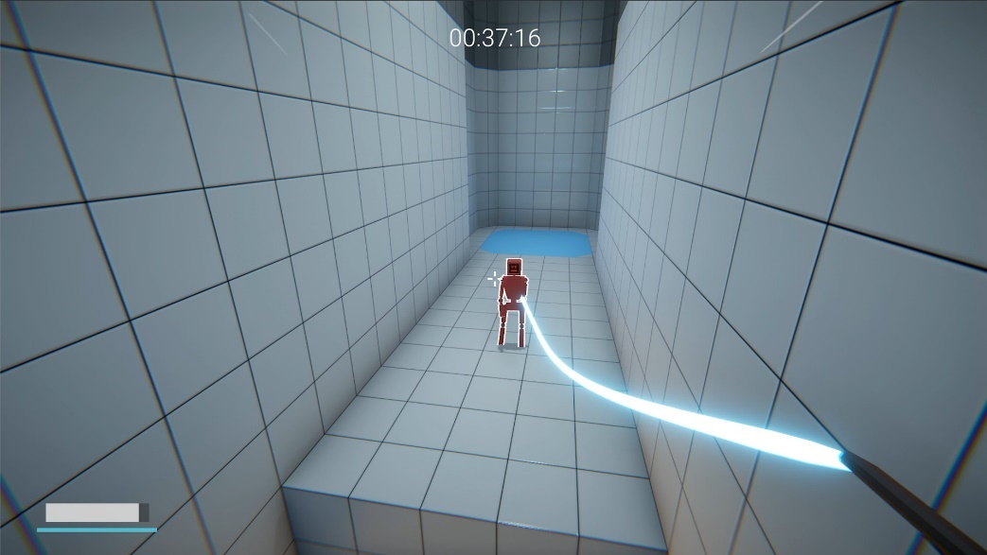

Karlson.

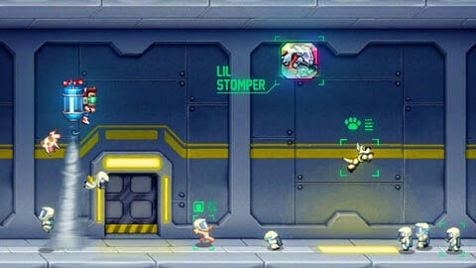

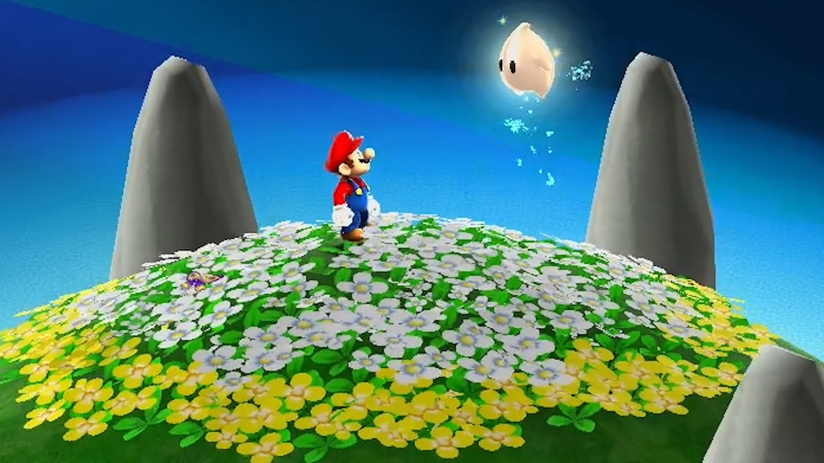Jet pack Joyride.

Mario Galaxy.