Template based on the Centers for Medicare & Medicaid Services, Information Security & Privacy Management’s Assessment

**Security Assessment Report**

Version N.0

January 1, 1900

Table of Contents

1. Summary 3

1. Assessment Scope 3

2. Summary of Findings 3

3. Summary of Recommendations 4

2. Goals, Findings, and Recommendations 4

1. Assessment Goals 4

2. Detailed Findings 5

3. Recommendations 5

3. Methodology for the Security Control Assessment 5

4. Figures and Code 7

4.1.1 Process flow of System (this one just describes the process for requesting) 7

4.1.2 Other figure of code 7

5. Works Cited 7

# Summary

Executive Summary:

The overall goal was to strengthen the security of the bitmap converter to ensure it didn’t break due to user input.

## Assessment Scope

What tools, platforms, OSes, Browsers, and software (including your own) was tested or used in testing?

CLion was used to fix and debug the code and was tested on multiple Windows 10 devices. A major limitation is not testing the code on multiple OSes since the code must be built to work.

## Summary of Findings

Of the findings discovered during our assessment, 0 were considered High risks, 2 Moderate risks, 0 Low, and 0 Informational risks. The SWOT used for planning the assessment are broken down as shown in Figure 2.

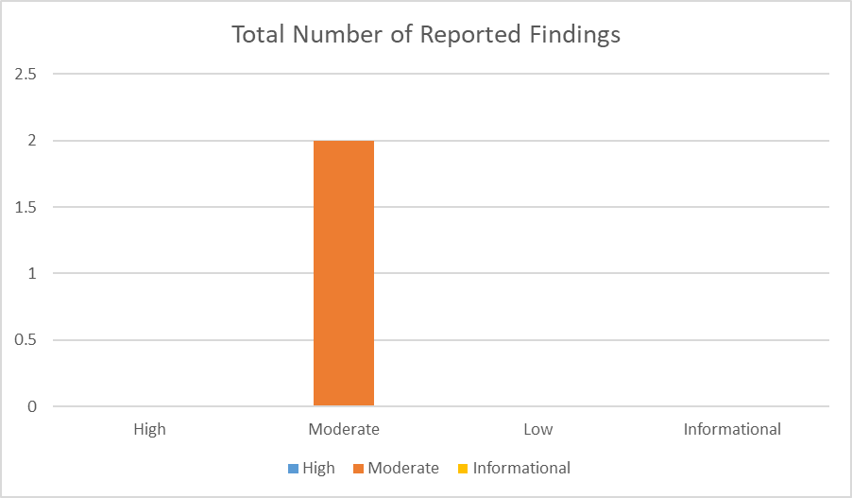

Figure 1. Findings by Risk Level

Explain above and link to full table of explanation of top risks like Figure 3.

Figure 2. SWOT

Explain which issues were used from above SWOT (which are addressed in this assessment).

## Summary of Recommendations

# Goals, Findings, and Recommendations

## Assessment Goals

The purpose of this assessment was to do the following:

* Ensure that the program only reads and writes when it is required
* Determine if the application was securely maintained
* Reduce redundancy in the code
* Allocated memory is freed once the task is done

## Detailed Findings

Ensure each vulnerability is thoroughly explained, specific risks to the continued operations are identified, and the impact of each Threat or Weakness is analyzed as a business case. Ensure these are linked to Table 1 when describing the Risk Value. This is not the fixes – it’s the description of the problems found. The fixes go in the next section (for ease of lookup using TOC) - build this off your checklist, SWOT, and risk assessments.

## Recommendations

Here’s where your fixes go (ensure you reference Table 2 for your ease of fix evaluation and explain why it matches that category).

# Methodology for the Security Control Assessment

**3.1.1 Risk Level Assessment (delete this text: you don’t have to change 3.1.1)**

Each Business Risk has been assigned a Risk Level value of High, Moderate, or Low. The rating is, in actuality, an assessment of the priority with which each Business Risk will be viewed. The definitions in Table 1 apply to risk level assessment values (based on probability and severity of risk). While Table 2 describes the estimation values used for a risk’s “ease-of-fix”.

Table - Risk Values

| Rating | Definition of Risk Rating |
| --- | --- |
| High Risk | Exploitation of the technical or procedural vulnerability will cause substantial harm to the business processes. Significant political, financial, and legal damage is likely to result |
| Moderate Risk | Exploitation of the technical or procedural vulnerability will significantly impact the confidentiality, integrity and/or availability of the system, or data. Exploitation of the vulnerability may cause moderate financial loss or public embarrassment to organization. |
| Low Risk | Exploitation of the technical or procedural vulnerability will cause minimal impact to operations. The confidentiality, integrity and availability of sensitive information are not at risk of compromise. Exploitation of the vulnerability may cause slight financial loss or public embarrassment |
| Informational | An “Informational” finding, is a risk that has been identified during this assessment which is reassigned to another Major Application (MA) or General Support System (GSS). As these already exist or are handled by a different department, the informational finding will simply be noted as it is not the responsibility of this group to create a Corrective Action Plan. |
| Observations | An observation risk will need to be “watched” as it may arise as a result of various changes raising it to a higher risk category. However, until and unless the change happens it remains a low risk. |

Table - Ease of Fix Definitions

| Rating | Definition of Risk Rating |
| --- | --- |
| Easy | The corrective action(s) can be completed quickly with minimal resources, and without causing disruption to the system or data |
| Moderately Difficult | Remediation efforts will likely cause a noticeable service disruption   * A vendor patch or major configuration change may be required to close the vulnerability * An upgrade to a different version of the software may be required to address the impact severity * The system may require a reconfiguration to mitigate the threat exposure * Corrective action may require construction or significant alterations to the manner in which business is undertaken |
| Very Difficult | The high risk of substantial service disruption makes it impractical to complete the corrective action for mission critical systems without careful scheduling   * An obscure, hard-to-find vendor patch may be required to close the vulnerability * Significant, time-consuming configuration changes may be required to address the threat exposure or impact severity * Corrective action requires major construction or redesign of an entire business process |
| No Known Fix | No known solution to the problem currently exists. The Risk may require the Business Owner to:   * Discontinue use of the software or protocol * Isolate the information system within the enterprise, thereby eliminating reliance on the system   In some cases, the vulnerability is due to a design-level flaw that cannot be resolved through the application of vendor patches or the reconfiguration of the system. If the system is critical and must be used to support on-going business functions, no less than quarterly monitoring shall be conducted by the Business Owner, and reviewed by IS Management, to validate that security incidents have not occurred |

**3.1.2 Tests and Analyses**

This was completed using <list and describe any type of testing you performed here>.

**3.1.3 Tools**

This was completed using <list and describe any tools used for testing (include Linux Command Line commands>.

# Figures and Code

Insert any pictures here (including of major code issues or code that was used as a tool – can just screenshot and add link to github). This section must include at least 4 figures or code portions:

### Process or Data flow of System (this one just describes the process for requesting), use-cases, security checklist, graphs, etc.

Describe the process flow here.

### Other figure of code

HERE

# Works Cited

**There are no sources in the current document.**