SafeSteps Core Logic Testing and Version Control Report
Desta Jomma
University of the People
MSIT 5910-01 · MSIT Capstone Project
October 2026
This report documents the working SafeSteps prototype, its core logic and test evidence, and the Git practices used to manage project milestones. The implementation demonstrates the project objective of making cybersecurity awareness practice measurable and safe for a small-business setting. It also identifies the limits of the current prototype so that test results are interpreted within their scope.

Part A: Core Logic Implementation and Output Validation
SafeSteps is a local prototype for small businesses to teach employees how to recognize suspicious email, practice safe reporting, and let managers review privacy-conscious cohort summaries. Its main objective is to turn awareness into a short learning cycle: read a lesson, answer questions, practice on a synthetic message, and receive feedback. The prototype supports that objective through employee, manager, and administrator views backed by SQLite. The design keeps the exercise safe: it sends no email, uses no active links, and never asks for or stores credentials. This is consistent with the project’s documented emphasis on learning, data minimization, and role-based access control (Merritt et al., 2024; OWASP Foundation, 2021).
The core assessment algorithm compares each selected option with the answer key and returns the number correct. Before scoring, it rejects an incomplete response or any option outside the three permitted choices. The web route stores only the resulting score and total, then provides feedback; it does not persist the learner’s answer text. Related validation helpers restrict scenario scheduling to the allowlist and simulation events to ‘reported’ or ‘clicked.’ These boundaries support the system objective by making practice measurable while preventing arbitrary campaign types or credential-like event labels from entering the database. Passwords are transformed with salted PBKDF2-HMAC-SHA256 and checked with constant-time comparison. Database initialization seeds synthetic demo accounts and is safe to repeat without duplicating them.
The implementation is a modular monolith: identity and policy, learning, assessment, simulation events, reporting, and audit records are separate logical responsibilities within one small Python application. This keeps local setup simple while preserving module boundaries for maintenance and testing. The screenshots below pair the actual scoring and validation code with the successful unit-test output. The tests show that all three correct answers score 3, incorrect selections score 0, malformed answer sets are rejected, and allowlists reject unsupported values. In the browser demonstration, the same saved score appears in the learner view, while the manager view exposes only aggregated cohort counts. This design follows software engineering guidance to connect requirements with verifiable behavior and maintainable modules (Summers, 2020).
One implementation challenge was balancing useful demonstration data with privacy. A small cohort can make individual performance identifiable, so the manager summary requires at least five synthetic participants and displays totals rather than individual results. A second challenge was making the scoring and validation decisions independently verifiable: the initial request-handling code combined parsing, validation, and database writes in one route. I extracted small helpers for scoring and allowlist checks, then added tests around valid and invalid inputs. This improved clarity and makes later changes less likely to affect unrelated request-handling behavior. The prototype remains an academic local demonstration, not a production service; HTTPS, deployment-managed secrets, multifactor authentication, retention controls, and security review remain necessary before production use.
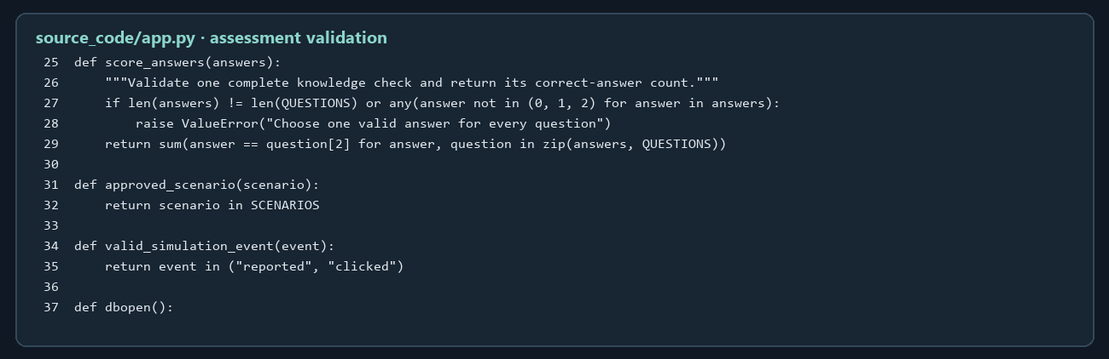
Figure 1. Assessment scoring and input validation from the implemented application.
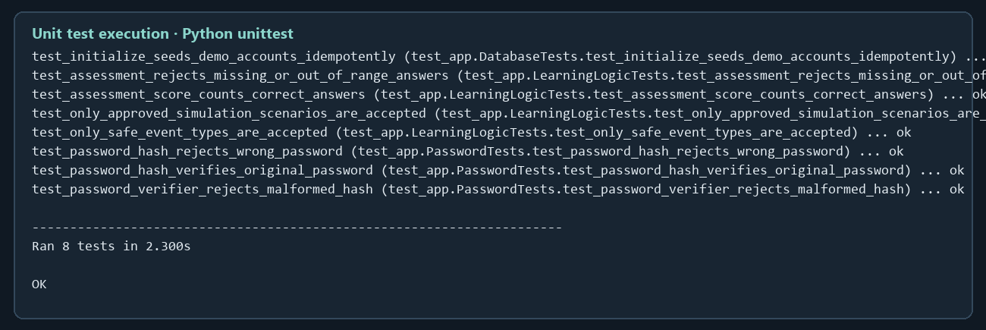
Figure 2. Actual unittest output showing all eight unit tests passing.

Part B: Unit Testing of Functional Modules
I used Python’s built-in unittest framework to run eight unit tests. This is primarily white-box unit testing because the tests exercise named helpers and database initialization directly, with expected paths derived from the implementation. The assertions also have black-box characteristics: each gives an input and checks an externally meaningful result, such as accepting an approved scenario or rejecting a malformed password hash. Coverage includes password success, wrong-password rejection and malformed-hash rejection; full and invalid assessment responses; approved and unapproved scenarios; permitted and disallowed event labels; and repeatable database seeding. The captured console output records eight passing tests and an overall ‘OK’ result.
Testing exposed the absence of a test suite and highlighted that invalid assessment choices needed a clear, reusable rule. I added a scoring helper that raises a validation error unless all three answers are within the allowed range. The HTTP handler translates that failure into a client error and does not write an assessment. Tests also verify that the database initializer can run twice without adding duplicate seeded users. No failures remained in the final run. These results establish correctness for the covered module behaviors; they do not establish end-to-end usability, production security, or resilience under load. A later integration test should exercise complete HTTP sessions, role restrictions, CSRF checks, and report aggregation against an isolated database.
Unit tests can be grouped by purpose. Positive or happy-path tests verify expected behavior for valid inputs. Negative or boundary tests check invalid, missing, extreme, or unauthorized inputs. State and persistence tests confirm that records are created consistently and repeat operations do not corrupt or duplicate state. White-box tests use knowledge of internal units and branches; black-box tests assess behavior through defined inputs and outputs without depending on internal structure. Regression tests preserve previously fixed behavior when code changes. Unit testing improves reliability by finding defects near their source, documents module contracts through executable examples, and allows developers to change one component with less risk to others. Small, isolated modules also make failures easier to diagnose and encourage development in parallel, while integration and acceptance tests remain necessary to verify that modules work together (Summers, 2020).

Part C: Version Control Management
The project repository is Cybersecurity Awareness and Phishing Simulation System. Its README describes a Git branching model with main for reviewed, submission-ready milestones, development for integration, and short-lived feature branches for focused work. This keeps experimental changes separate until they are reviewed and ready to promote. The current local checkout is on development; the published repository has main and development branches. The Git history records architecture and documentation milestones, and the public repository URL is functional in the project documentation. Anyone evaluating access should confirm visibility through the link using their own GitHub session if the repository’s permission settings change.
Milestone tags and releases provide named, stable references to important repository states. The intended sequence is an initial-development milestone, a testing-complete milestone, and a final release after the implementation and report are reviewed. Annotated tags identify the milestone and its purpose, while a GitHub release can attach a summary and downloadable source snapshot. These records help an instructor compare the code and report to a specific state, trace later fixes, and distinguish a tested milestone from ongoing work. Tags should be created on committed content, then pushed to GitHub so branches, tags, and releases are visible to reviewers. The project uses concise commit messages describing one change at a time, consistent with its README workflow.
Version control supports more than backup: it makes changes reviewable and ties source code, tests, and documentation to an evolving project history. Feature branches reduce interference between independent tasks; integration on development exposes conflicts before stable promotion. Tags and releases make milestone monitoring easier because a reviewer can return to the exact state used for a demonstration or evaluation. For this assignment, the relevant evidence is the repository link, named milestone references, branch roles, and the test record. Together these practices support reproducibility and controlled change, while the unit tests provide a repeatable quality check at each milestone.

References
Cybersecurity and Infrastructure Security Agency. (n.d.). Small and medium-sized business resources. https://www.cisa.gov/small-and-medium-sized-business-resources
Merritt, M., Hansche, S., Ellis, B., Nethery Snyder, J., Sanchez-Cherry, K., & Walden, D. (2024). Building a cybersecurity and privacy learning program (NIST Special Publication 800-50 Rev. 1). National Institute of Standards and Technology. https://doi.org/10.6028/NIST.SP.800-50r1
OWASP Foundation. (2025). OWASP Top 10. https://owasp.org/Top10/
Summers, B. L. (2020). Effective methods for software engineering. Auerbach Publications. https://www.routledge.com/Effective-Methods-for-Software-Engineering/Summers/p/book/9781032474359

