Desta Jomma

SafeSteps Capstone Project Report Chapters Four to Six
MSIT 5910-01 - AY2027-T1

SafeSteps Capstone Project Report Chapters Four to Six
This report presents implementation results, system integration, measured performance, deployment planning, and conclusions for SafeSteps, a cybersecurity awareness learning prototype. The main finding is that its core workflow is integrated and functionally validated in a local synthetic environment: a learner can sign in, complete a short lesson and assessment, record a safe practice action, and receive feedback, while managers see privacy-conscious cohort aggregates and administrators inspect audit activity. Local response measurements are promising but do not establish production capacity or training effectiveness. The system is best treated as an instructional prototype and a basis for a controlled pilot after operational and security work.

Chapter Four Results

4.1 Project Context and Evaluation Questions
The capstone addressed a practical training problem: small organizations need repeatable ways to teach people to evaluate suspicious electronic messages without exposing real users to harmful campaigns or collecting credentials. SafeSteps translates that goal into an integrated learning flow. Evaluation asked whether the modules formed a working application, whether core decisions and state changes matched expectations, whether local page delivery was responsive in a bounded trial, and whether the interface communicated its safety purpose clearly. These questions distinguish software correctness from educational effect. The prototype can show that a request is handled and a score is saved; it cannot show that a learner will behave differently later at work. That distinction sets the scope for every result reported here.
The system is implemented as a modular monolith in one Python source file, with functions for assessment scoring, allowlist validation, password hashing, database initialization, session access, and role-specific page rendering. HTTP routing and HTML generation live in a request-handler class, and SQLite provides persistent tables for users, sessions, lesson completion, assessments, campaigns, simulation events, and audit actions. This arrangement limits operational complexity for a student project while keeping conceptual responsibilities visible. It does not create independent UI, API, and database services. The report therefore describes one deployable application with a local relational data store rather than overstating the architecture.
The primary roles are employee, manager, and administrator. Employees receive a learning plan, a three-question knowledge check, and a sample suspicious message with safe report or simulated-click actions. Managers can schedule one of three allowlisted practice scenarios for the cohort and see aggregate completion, score, report, and click counts. Administrators see account counts by role and recent security-related events. The application includes synthetic accounts and cohort records so the demonstration can show each view without importing real employee data or contacting an email system. No external identity provider, email service, or third-party API is connected. That constrained environment is a deliberate safety boundary and an important limitation.

4.2 Core Algorithm and Validation Results
The assessment algorithm receives a list of selected integer indexes, rejects input unless the list has exactly the same number of entries as the questions, and rejects any value outside the supported indexes. For valid input it compares each response with its answer key and counts equal pairs. Centralizing this invariant means every request path follows the same rule: one valid response per question. It prevents invalid input from being silently scored as a low result and makes correctness cases easy to test. The expected answer vector [1, 0, 2] produces three correct answers, while an incorrect vector [0, 2, 1] produces zero. Missing answers and an unsupported answer such as 3 raise a validation error that the request route converts into a client error.
Figure 4.1. Core score function and allowlist predicates from source_code/app.py.
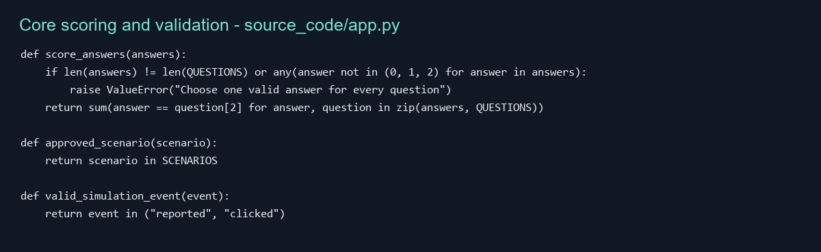
The score then moves through an integrated request path. The employee submits a form with the session-specific CSRF value and three selected answers. The handler parses the form, resolves the active user from a hashed session identifier, confirms employee role, checks the CSRF token using constant-time comparison, validates choices, calls the scoring helper, and inserts score and total using parameterized SQL. A separate audit row records the submission. The handler commits the transaction and redirects to a page that displays the result. A follow-up database query verified that the row held score 3 and total 3 for the sample input. This path joins browser input, role and session controls, business logic, persistence, and output feedback.
Figure 4.2. Authenticated HTTP handler linking assessment logic and SQLite persistence.
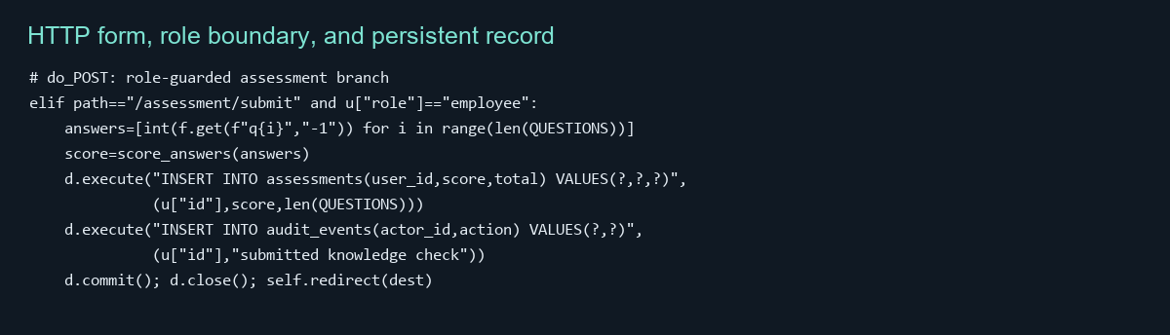
Figure 4.3. Local route sequence and database verification for one synthetic learner.
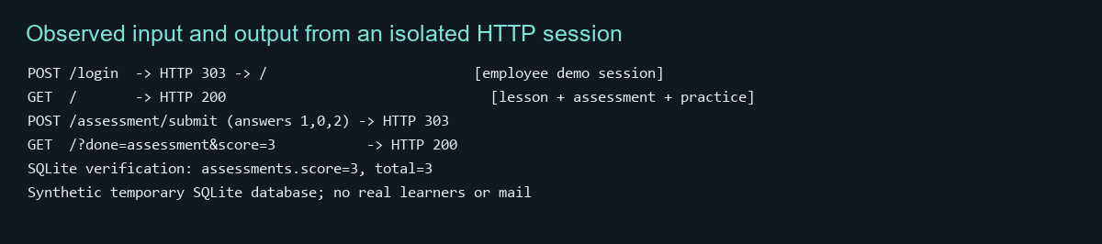
Scenario and event validation use explicit allowlists. Managers may choose shared file, password reset, or invoice scenarios; arbitrary values are rejected. Employee simulation actions are constrained to “reported” or “clicked.” The application stores only an action category and timestamp for this practice path, not message contents or typed credentials. Principal database writes use parameterized statements, and output strings are HTML-escaped before inclusion. These safeguards reduce common input handling errors in this prototype, but source inspection is not a penetration test. The current Content Security Policy permits inline styling, and the built-in HTTP server lacks production hardening; a security review should precede network deployment.

4.3 Module Integration
The browser interface and backend connect through form posts. A rendered page includes a form whose action names a route, embeds a CSRF token as a hidden input, and supplies radio or select values. The browser sends the request. The handler routes the path, resolves the user role, validates the token, applies the domain function, interacts with SQLite, and returns a redirect or error view. Redirect-after-post prevents accidental duplicate submission when a user refreshes and allows the interface to show a concise confirmation. Although the assignment invites API examples, SafeSteps uses an internal HTTP route contract rather than a JSON REST interface; describing a separate public API would misstate the implementation. The route contract is nevertheless a concrete example of inter-module communication.
Database access is direct. The application opens a SQLite connection on demand, enables foreign-key enforcement, executes statements, commits state changes, and closes the handle within each request path. The schema links sessions and learning records to users, and campaigns to their creator. This connection pattern is understandable for a local, low-volume demonstration. Concurrency, schema migration, backup, and multi-process behavior require deliberate treatment before a larger pilot. A managed database and a data access layer would better support multiple application instances and central backup policies. The local database file path is a configuration limitation because it is not exposed as an environment setting.
Role communication is enforced on the server instead of relying only on hidden links. An employee session cannot use a manager path by manipulating a URL, because the handler checks role and returns an access-denied response. The manager dashboard uses aggregate queries and suppresses reporting below five cohort participants. The administrator page has its own route guard. Sign-in establishes an unpredictable cookie value but stores only its SHA-256 digest in the session table. The cookie uses HttpOnly and SameSite=Strict attributes and expires after two hours; state-changing forms include a CSRF token. These features show how authentication, authorization, presentation, and persistence cooperate, although the system has no centralized identity provider or account recovery feature.

4.4 Unit-Level and Integration Verification
The unit suite uses Python unittest and contains eight tests. Password cases verify that the original password matches its salted PBKDF2 digest, a wrong password does not match, and a malformed saved digest returns false instead of raising an unhandled exception. Learning logic tests verify perfect and zero scores, reject missing or out-of-range answers, accept only named scenarios, and permit only the defined simulation event types. The database test redirects the path to a temporary directory, runs initialization twice, and checks that seven seeded accounts remain without duplication. The observed suite completes successfully with eight tests passing. These results show coverage of specific logic, not complete coverage of the program.
This is primarily white-box testing because cases invoke named internal helpers and target their validation branches. Some assertions resemble black-box testing because they express external outcomes, such as an invalid assessment being rejected, rather than inspecting private state. Test execution is evidence for these cases, but the repository does not include a coverage instrumentation report; no line or branch percentage is claimed. The next useful verification layer is handler-level integration tests with an isolated database. They should prove successful employee sign-in, failed sign-in, CSRF failure, denied cross-role requests, manager scheduling, and audit persistence. This would test the edges where unit-tested helpers meet HTTP parsing and database writes.
Testing has several forms. A unit test checks a small function or class in isolation; an integration test verifies that related elements exchange data correctly; system testing exercises the assembled application; acceptance testing checks stakeholder tasks; regression testing repeats prior checks after a change. Tests can also be categorized by method: black-box tests focus on input-output contracts, while white-box tests are informed by implementation and branches. SafeSteps has helper-level verification and a manual HTTP workflow probe, but no automated browser acceptance suite, sustained load test against a production server, independent security test, or learner-outcome trial. Unit testing improves reliability by checking local assumptions before defects spread, supports modular development through focused contracts, and provides executable documentation of allowed answer and event values.

4.5 Performance Evaluation
Performance testing focused on the employee landing page because it exercises session resolution, SQLite reads, HTML generation, and response delivery in one route. The application ran on loopback with a temporary database initialized with synthetic seed records. The benchmark warmed the page with ten calls, then measured 100 sequential GET requests. It next measured 200 requests using eight worker threads. Each request carried an authenticated synthetic employee cookie, so the workload exercised the learning page rather than redirecting unauthenticated requests to sign-in. A monotonic high-resolution timer measured durations. All 300 measured requests returned HTTP 200.
Figure 4.4. Captured output of the isolated local performance run.
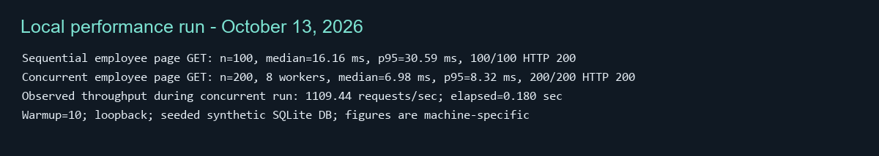
Figure 4.5. Sequential and concurrent page latency using measured local values.
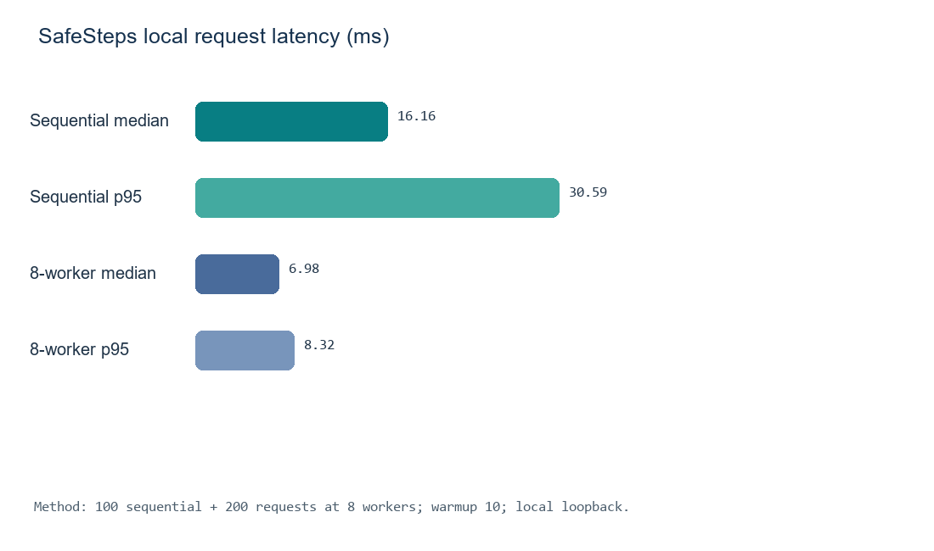
Summary of quantitative and functional results
Table 1
Metric | Workload and sample | Result | Interpretation
Sequential latency | 100 GET after 10 warmups | Median 16.16 ms; p95 30.59 ms | Local responsiveness
Concurrent latency | 200 GET; 8 workers | Median 6.98 ms; p95 8.32 ms | No errors in short burst
Successful responses | All measured GETs | 300 of 300 HTTP 200 | Completed test requests
Throughput | 200 requests in 0.180 sec | 1,109.44 requests/sec | Local burst only
Assessment output | One valid submission | 3/3 persisted | Sample functional correctness
Earlier project requirements set p95 at or below two seconds for lesson and assessment reads, five seconds for aggregate reports, under 50 sessions. The measured single-page p95 is beneath the read target, but the workload did not use 50 independent sessions and did not benchmark manager aggregates. Thus, the result is “local page-read target met for this limited workload; full capacity target unverified.” A repeatable evaluation should record OS, Python runtime, processor, memory, workload mix, and database state; generate virtual users with realistic pacing; run for several minutes; report p50/p95/p99, error rate, memory, and report latency; and repeat runs. Wells (2025) recommends combining quality indicators rather than relying on a single metric; for this project, the interpretation must likewise balance speed, correctness, and user experience.
A second quantitative outcome is assessment correctness: the valid input vector produced a stored 3/3 score, while unit cases for correct and incorrect vectors returned 3 and 0. The full test suite passed 8/8. These values describe verification results, not phishing prediction accuracy or learning efficacy. SafeSteps does not contain a trained classifier, so calling its score “model accuracy” would be incorrect. Future learning outcomes could include knowledge change, course completion, safe reporting, and delayed retention, measured with defined samples and consent. NIST SP 800-50 Rev. 1 recommends lifecycle evaluation and continual improvement of cybersecurity learning programs (Merritt et al., 2024).

4.6 Qualitative Usability Review
A heuristic inspection reviewed the actual employee page and source strings for clarity, task flow, feedback, safety, and visible accessibility cues. This is qualitative evidence from expert inspection, not observations from recruited users. The page opens with “Welcome to your learning plan,” describes what the user will do, and organizes content into learning, knowledge check, and controlled practice. Headings, fieldsets, legends, labels, buttons, and confirmation messages create a reasonably clear structure. The practice section presents a synthetic sender and no real link, followed by report and simulated-click choices. Feedback after reporting says that no email was sent. This helps distinguish rehearsal from live message handling.
Figure 4.6. Employee interface content transcribed from the running application; heuristic inspection.
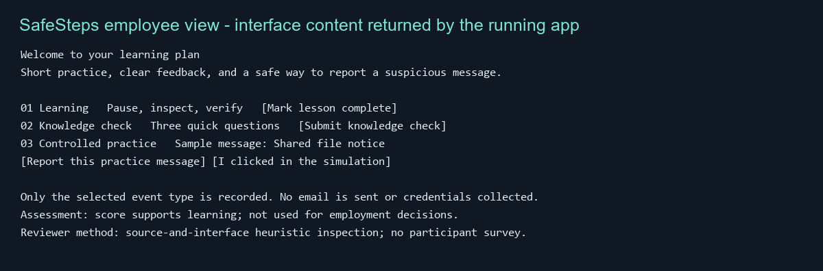
Privacy wording adds to the safety framing. The page explains that the score supports learning and is not used for employment decisions; the practice module says only the event type is recorded and no credentials are collected. The manager page explains aggregate reporting and the minimum cohort size. These statements align with a design that avoids shame-based training and minimizes collected data. They should still be validated with users: technically correct words can fail to reassure someone if their placement or organizational context creates concern. Experience measures such as clarity, confidence, usefulness, perceived privacy, and satisfaction can surface issues that response time cannot (LaunchNotes, 2023; Wells, 2025).
The review found improvement opportunities. The complete knowledge check is one long form, which may create scrolling on a phone. The simulated-click option may feel judgmental unless it is paired with reassuring educational feedback. Keyboard and screen-reader review should verify that fieldsets and legends are announced in order, focus indicators remain visible, error messages connect to relevant controls, and confirmation feedback can be found. Responsive styles exist at a breakpoint but have not been tested on real devices. Success and warning states include explanatory text as well as color, but contrast should still be checked against accessibility criteria.
The qualitative record therefore uses a small heuristic checklist: purpose stated, three-stage flow visible, action labels explicit, result feedback immediate, safety boundary stated, and assistive/device accessibility verified. Five items are supported by source and interface inspection; accessibility across devices and assistive technology remains unverified. This is not a standardized usability score and must not be presented as a user satisfaction percentage. A later study should ask representative users to complete tasks, observe confusion, and collect post-task clarity and confidence ratings. LaunchNotes (2023) offers a useful distinction between numeric indicators and experience-centered evidence, but its blog is a secondary explainer, not a validated usability method.

4.7 Results Summary
Taken together, results demonstrate an integrated prototype with a coherent user journey, tested core functions, persistent storage, role-specific interfaces, and a brief local performance evaluation. The assessment rejects invalid choices, computes a result, saves it, and displays feedback. The manager view summarizes synthetic cohort records, and the administrator view lists role and audit information. Eight unit tests pass; 300 measured local page requests returned success. The employee interface communicates its safety boundary and offers clear practice choices. Each result supports a limited conclusion tied to its method. The benchmark supports a local response observation; the review supports a visible-content assessment. Neither alone establishes production readiness or educational effectiveness.

Chapter Five Discussion

5.1 Interpretation in Relation to Project Objectives
The main objective was to connect learning content, decision practice, results, and role-based visibility in one prototype. Integration succeeded against this objective. A learner action flows through the web handler to a validated operation and persistent record, then returns as visible feedback. A manager can schedule only approved local practice scenarios and receives cohort-level output. An administrator can review synthetic roles and audit history. These capabilities create a functional artifact that can be demonstrated and extended. The system also avoids live mail and credential collection, an important boundary for a project involving simulated phishing behaviors.
The objective of improving awareness is only partially addressed. The software offers instruction and a short knowledge check, but evidence does not show lasting behavior change. Three questions assess immediate recall, not real-world decisions under pressure. A simulated message records a choice but is never delivered to inboxes, so the prototype cannot measure behavior during real work. NIST SP 800-50 Rev. 1 frames a learning program as a lifecycle with design, development, implementation, evaluation, and improvement, aligned with organizational audiences and objectives (Merritt et al., 2024). SafeSteps implements an interaction and basic outcome collection; a training owner must still define learning goals, cadence, audience differences, accessibility, and an ethical evaluation plan.
Peer-reviewed work has examined the role of training and feedback around phishing behavior. Kumaraguru et al. (2009) studied embedded training approaches and user responses to phishing messages. SafeSteps shares the broad design idea of pairing examples with feedback at a decision point, but it does not reproduce that study or its results. Its sample message is static and local; participants are not exposed to adversarial messages in normal email. The comparison is conceptual: both illustrate an educational intervention near a decision, while only a controlled study could establish effect or retention for this implementation.

5.2 Software Quality Metrics and Interpretation
The local response numbers appear strong relative to the two-second page-read target, but the scope is narrow. A benchmark must represent the system and workload of interest. Loopback testing excludes enterprise network latency and infrastructure. ThreadingHTTPServer is one local process; the measurement omitted TLS, load balancing, production logging, a managed database, and simultaneous login cost. It tested one employee page, not manager reports or larger data volume. The short 0.180-second sample helps detect gross errors but cannot stand in for a sustained capacity test. The current finding is useful as an initial baseline against which a later repeatable staging run can be compared.
The results table combines latency, successful responses, throughput, and functional correctness so that one attractive number does not represent overall quality. Wells (2025) describes quality across code, delivery, reliability, and experience rather than one simplistic count. Here, quantitative measures are objective within the test harness but still depend on sample, environment, and method. Qualitative inspection contributes context about whether the interface explains why a score is saved and what a simulated click means. LaunchNotes (2023) likewise distinguishes numeric measurement from experience-centered evidence. These measures complement one another: latency indicates how quickly a page returned, whereas usability review asks whether a user can understand and safely complete the task.
Requirements set a page-read p95 threshold of two seconds and a manager-report p95 threshold of five seconds with 50 concurrent sessions. This run recorded employee-page p95 values of 30.59 ms sequentially and 8.32 ms under a short eight-worker workload. That suggests the tested route is lightweight at the observed load, but cannot prove the 50-session requirement because the test lacked the defined session count, duration, and realistic pacing. It also cannot prove report performance because the manager route was excluded. A future evaluation should define workload before testing, repeat runs, collect host and process resource use, and choose an acceptable error threshold. A documented threshold makes a future pass or fail meaningful rather than selecting the most favorable observed number after the fact.

5.3 Qualitative Evaluation and Experience
The clearest usability feature is a direct task sequence. Employees see the lesson, knowledge check, and controlled practice message without searching through a complex navigation structure. Descriptive button labels and feedback states explain what action was recorded. A manager sees aggregate results and a scenario scheduler, while an administrator sees role counts and audit activity. Role-specific pages reduce irrelevant actions and clarify responsibility. These choices support a small application where employee learning and manager oversight are distinct tasks.
The limits of the review matter. No user study tested whether learners understand “verify through a known, separate channel,” whether the message looks plausible, whether the click option discourages participation, or whether the privacy notice is trusted. The heuristic review reflects the evaluator’s assumptions and does not capture variation in language, technical familiarity, disability, culture, or workplace power. LaunchNotes provides terminology for comparing qualitative and quantitative metrics, but as a vendor blog it is not a methodological standard. Direct user research should guide design decisions before the system expands.
The next qualitative evaluation should recruit representative employees and managers, with informed consent and synthetic accounts in staging. Participants can complete learning and manager tasks while moderators observe errors, hesitation, requests for clarification, and misinterpretations. A post-task form can ask about clarity, confidence, privacy, and usefulness, and invite written comments. The study should avoid collecting performance information tied to employment and explain how observations will be used. A later design could compare pre- and post-instruction decisions and include delayed follow-up for retention, subject to ethical and organizational review. This staged approach offers a better basis for improvement than launching a realistic campaign immediately.

5.4 Deployment Options and Selected Strategy
Three deployment approaches were considered. A local classroom demonstration is least complex and matches the current localhost binding, synthetic database, and no-email scope. An on-premise server offers organizational control and network proximity but requires secure operations, TLS, backups, patching, identity management, and monitoring. A cloud-hosted container provides repeatable packaging and managed infrastructure but requires data-residency, access, secret, cost, and service configuration decisions. For a future limited pilot, this report recommends a containerized application on one controlled or managed host, behind a supported production server and TLS proxy, with a managed database and no outbound email at the initial stage.
Docker Compose can define services, networks, volumes, and environment settings in versioned YAML and can be used across development, staging, and production with overrides. Docker documentation describes production changes to ports, environment variables, logging, restart policy, and deployment by rebuilding and recreating services (Docker, n.d.). This can make a small pilot repeatable. It does not by itself secure the host, validate image provenance, protect secrets, back up a database, or provide monitoring. Python documentation specifically warns that http.server is not recommended for production because it implements only basic security checks (Python Software Foundation, n.d.). The development server must not be exposed directly to the public internet.
The selected rollout is staged. First, developers run tests on a feature branch. Next, a reviewed build is deployed to staging with synthetic data and a configuration that mirrors the planned pilot. An authorized pilot group then uses the application without external mail. Operators review logs, health, database storage, accessibility, and user feedback before widening access. Blue-green rollout can reduce downtime when two environments are available; canary rollout limits exposure to a fraction of users; rolling deployment replaces instances gradually. ByteByteGo (2023) summarizes these strategies, and Sumo Logic (n.d.) explains moving tested software into operation and monitoring it. For a single-instance app, a controlled staged pilot with a tested rollback is proportionate; advanced rolling or canary methods only make sense with multiple instances and operational telemetry.
A release record should include tagged source, build identifier, configuration, schema version, migration steps, operator instructions, release notes, and rollback procedure. A v1.0.0 tag should mean the project met a defined acceptance bar, not merely that coding ended. That record could include unit and route test results, supported runtime, known limits, and explicit absence of mail integration. Summers (2020) emphasizes disciplined software engineering, while Bennett (2024) and the SNS Institutions OOSE video explain baselines and controlled change as configuration management practices. These secondary instructional sources are complemented by the actual versioned repository and secure-development lifecycle guidance.

5.5 Configuration Management and Setup
Configuration management improves reliability when environments can be recreated and differences are explicit. The project README describes startup and test commands, while Git tracks source and documentation. However, host, port, database path, demo accounts, and security constants are fixed in code. The repository has no lockfile because it uses only Python’s standard library, and it contains no Dockerfile or Compose file. The first deployment improvement should be validated external configuration with safe local defaults and no unsafe production defaults. Configuration should be reviewed as code and recorded with each release so an operator can connect an observed behavior to the values used to start the service.
Current prerequisites are Python 3.11 or newer, a supported desktop or server OS, and a writable directory for SQLite. There are no third-party Python dependencies. Developers can clone the repository, run “python -m unittest discover -s tests -v,” run “python source_code/app.py,” then visit the localhost sign-in page. The test suite uses a temporary database in its initialization test, but running the application initializes a database file beside the source. Operators should not use real personal data in this prototype and should preserve synthetic demo accounts only in local demonstrations. If a pilot records learner actions, retention and access decisions must be established before collection begins.
Recommended future settings include APP_ENV, APP_HOST, APP_PORT, APP_DB_PATH or DATABASE_URL, SESSION_TTL_SECONDS, and LOG_LEVEL. The current implementation generates unpredictable session and CSRF tokens using Python’s secure random source and stores only a hash of the session token; future deployment still needs explicit secret and key lifecycle decisions. Secrets must never be checked into Git or put in a public Compose file. Startup should validate missing configuration, production cookies should use Secure behind HTTPS, demo credentials should be removed, network binding restricted, and debug details withheld from responses.
A future container build should pin its base image, use a non-root account, add a health check, keep application code read-only where practical, and mount persistent database storage. Staging might be started using “docker compose -f compose.yaml -f compose.staging.yaml up --build -d,” and inspected with “docker compose ps” and “docker compose logs.” A production override could supply secrets, restart policy, and TLS proxy routing. Docker guidance explains that production configuration often differs from development and can be layered over a base Compose definition (Docker, n.d.). These commands are planning examples: there are no container artifacts in the current repository, so they are not commands verified against the existing project.

5.6 Documentation, Limitations, and Risks
Brown (2025) describes documentation as a way to support shared understanding and maintenance. Brown’s later guide focuses specifically on software documentation types and practices (Brown, 2026).
The main technical limitation is the Python development server and local SQLite file. Python documentation cautions that http.server is not appropriate for production, so any network deployment requires a supported server and security review. SQLite fits a local demonstration, but concurrent writes, backups, multi-instance access, and recovery need attention as scale grows. Password hashing uses a substantial PBKDF2 work factor, but account lifecycle is minimal: demo accounts are seeded, passwords appear on the sign-in page, and there is no reset process or enterprise login. These properties make the application suitable only for a controlled demo with synthetic users.
The central evaluation limitation is absence of learner outcome data. Seeded dashboard values are synthetic. The benchmark uses loopback and does not validate a sustained 50-session requirement. The qualitative review includes no participants. Eight unit tests cover selected logic, but there is no formal coverage report, static analysis, browser automation, accessibility audit, independent security assessment, or deployment rehearsal. The artifact should not be presented as a verified phishing defense product, production SaaS application, or proof that employees became safer because of the project. Stating this boundary protects the integrity of the technical findings.
Source authority varies. NIST SP 800-50 Rev. 1 and SP 800-218 are government publications directly relevant to learning-program evaluation and secure development. Python and Docker documentation are primary sources for server and deployment claims. Kumaraguru et al. is peer-reviewed research on phishing instruction. Summers is the course reading and provides broad engineering methods. LaunchNotes, Helpjuice, Guru99, LinearB, Sumo Logic, and ByteByteGo are accessible industry sources that offer practical summaries, not controlled experiments or standards. The report uses them as supplements and relies on primary sources for technical constraints and guidance. This balance follows the assignment’s requirement to use multiple relevant sources while considering authority and purpose.

5.7 Recommendations for Future Research and Development
The immediate engineering recommendation is route-level automated testing. A fixture should allocate a temporary database and start an ephemeral server. Tests should cover successful and failed login, session expiration, CSRF rejection, role denial, lesson completion, valid and invalid assessment form, allowed and disallowed events, manager scheduling, minimum cohort behavior, and audit persistence. Assertions should verify status, redirects, headers, database state, and error output. A coverage tool can then expose untested branches, but coverage should guide test selection rather than become a vanity target. These tests will make integration safer and create a stronger functional baseline than helper-only tests.
The next performance study should run in staging with realistic sessions. A test could ramp to 50 active sessions, hold for ten minutes, and include representative proportions of page reads, assessment posts, manager dashboard queries, and sign-ins. It should run from a separate client host over TLS and collect p50/p95/p99, throughput, status codes, CPU, memory, and per-route timing. Several repetitions can reveal variance. Manager reports should use cohort sizes relevant to intended use. If a service objective is missed, profiling can identify whether template generation, password hashing, SQL indexes, or database locks dominate before the team changes architecture.
Educational evaluation should start with a formative study rather than a high-stakes field exercise. Participants can review plain-language content, answer questions, choose an action for a clearly synthetic message, and explain what data they believe is saved. Researchers can observe completion, wrong turns, time, confidence, and privacy perception. The team can revise content, then conduct pre/post knowledge and delayed retention checks. Comparison groups may be useful but require careful ethics review and fairness. NIST encourages ongoing evaluation and improvement of learning programs, supporting this staged approach (Merritt et al., 2024).
Release practice should keep main releasable, use an integration branch, and create focused short-lived feature branches. Reviewers should require tests and configuration review before merge. Tags should follow a documented convention: major for incompatible behavior, minor for backwards-compatible features, and patch for fixes. A release includes a changelog, migrations, runtime version, source tag, image digest, and known limits. A candidate should be verified in staging before promotion. If a release causes failures, operators need a rollback path and preserved data. Version control then provides coordination and auditability rather than merely an off-site copy.

Chapter Six Conclusion

6.1 Main Findings
This capstone integrated a cybersecurity awareness workflow into a local web application. Employees can review a lesson, submit a three-question assessment, and choose report or simulated-click practice for a clearly marked message. Managers can schedule approved local scenarios and view cohort aggregates; administrators can review roles and audit events. The application connects browser forms, HTTP routes, validated logic, session and role checks, SQLite persistence, and feedback pages. It uses synthetic data and sends no email. The result is a cohesive prototype that demonstrates integration and can support further work.
Evidence includes eight passing unittest cases and an observed assessment submission in which the correct answer set produced a persisted 3/3 score. Performance evidence includes 100 sequential and 200 concurrent local page requests, all HTTP 200. Sequential p95 was 30.59 milliseconds; eight-worker p95 was 8.32 milliseconds. Local throughput was 1,109.44 requests per second during a 0.180-second burst. Heuristic review found a visible three-step flow, explanatory labels, immediate feedback, and safety language. Each result supports a limited conclusion tied to its sample. None proves production readiness or long-term learning effect.

6.2 Contributions and Lessons Learned
The project contributes an inspectable example of connecting learning content, practice, assessment, and reporting without launching an actual phishing campaign. It makes the relationship among UI, application logic, roles, and data concrete and testable. It also shows why privacy and interpretation matter: scores and event records can be sensitive, so a system should explain that metrics support learning rather than discipline. This artifact provides a starting point for a more complete pilot while making clear that a classroom prototype is not a production service.
A central lesson is that integration requires validating each action at the server boundary, not merely presenting a polished form. The handler resolves identity, enforces role, verifies CSRF, validates values, calls scoring or allowlist logic, persists only needed data, and returns meaningful feedback. Reusable helpers made core cases testable. Another lesson is that seeded records help demonstrate dashboards but must be labeled synthetic so they are not treated as user evidence. SafeSteps labels the data and prototype status in the interface.
Measurement introduced a separate challenge: plausible numbers are easy to overstate. A short localhost benchmark showed low response times but omitted network and operational factors. It cannot verify 50 concurrent sessions. Likewise, interface source inspection cannot establish usability across user groups. Reporting the limits improved the work by separating observation, interpretation, and recommendation. Future evaluation should preserve that distinction and document sample, configuration, and workload before drawing conclusions.
Deployment planning exposed the gap between a local app and a reliable service. SQLite and the development server are useful for class demonstration, while an organizational pilot requires supported serving, TLS, external configuration, secret handling, backups, account lifecycle, monitoring, tests, and rollback. Compose can make deployment more repeatable but does not solve these responsibilities. Tags and release notes should identify exactly what was tested and which limitations remain. The report provides a path toward a governed pilot without implying that it already exists.

6.3 Final Conclusion and Next Improvements
SafeSteps met its immediate capstone objective: assemble a functioning local learning prototype and document its integration, core logic, unit verification, limited performance findings, heuristic interface review, and deployment plan. Its strongest result is the demonstrated flow from user input through role-aware processing and persistence to visible feedback. Evidence is sufficient to support supervised development, but not long-term behavior change, sustained capacity, production readiness, or accessibility for all users.
Next steps are route-level tests, validated configuration, removal of development credentials before hosting, replacement of the development server, realistic performance measurement, accessibility work with assistive technology, and independent privacy and security review. A formative learner study should test comprehension and trust before considering more realistic simulations. Future versions should use group learning indicators and multiple evaluation methods rather than treating scores or clicks as individual performance judgments. These improvements can move the project from a classroom demonstration toward a carefully governed pilot whose operations and educational value are both measured.

References
Bennett, L. (2024, August 13). Software configuration management in software engineering. Guru99. https://www.guru99.com/software-configuration-management-tutorial.html
ByteByteGo. (2023, June 6). Top 5 most-used deployment strategies [Video]. YouTube. https://www.youtube.com/watch?v=AWVTKBUnoIg
Brown, J. (2025, December 2). Technical documentation: Purpose and best practices. Helpjuice. https://helpjuice.com/blog/technical-documentation
Brown, J. (2026, April 16). Knowledge software documentation best practices [with examples]. Helpjuice. https://helpjuice.com/blog/software-documentation
Docker. (n.d.). Use Compose in production. Docker Docs. https://docs.docker.com/compose/how-tos/production/
Kumaraguru, P., Sheng, S., Acquisti, A., Cranor, L. F., & Hong, J. (2009). Teaching Johnny not to fall for phish. ACM Transactions on Internet Technology, 10(2), Article 7. https://doi.org/10.1145/1572532.1572536
LaunchNotes. (2023, September 1). Qualitative metrics vs quantitative metrics: A comparison. https://www.launchnotes.com/blog/qualitative-vs-quantitative-metrics-a-comprehensive-comparison
Merritt, M., Hansche, S., Ellis, B., Sanchez-Cherry, K., Snyder, J. N., & Walden, D. (2024). Building a cybersecurity and privacy learning program (NIST SP 800-50 Rev. 1). NIST. https://doi.org/10.6028/NIST.SP.800-50r1
Python Software Foundation. (n.d.). http.server — HTTP servers. Python documentation. https://docs.python.org/3/library/http.server.html
SNS Institutions. (n.d.). Software configuration management | OOSE [Video]. YouTube. https://www.youtube.com/results?search_query=Software+configuration+management+OOSE+SNS+Institutions
Souppaya, M., Scarfone, K., & Dodson, D. (2022). Secure software development framework version 1.1 (NIST SP 800-218). NIST. https://doi.org/10.6028/NIST.SP.800-218
Summers, B. L. (2020). Effective methods for software engineering. Auerbach Publishers, Incorporated.
Sumo Logic. (n.d.). What is software deployment? https://www.sumologic.com/glossary/software-development/
Wells, J. (2025, April 16). Top 12 software quality metrics to measure and why. LinearB. https://linearb.io/blog/software-quality-metrics

