Desta Jomma
SafeSteps System Integration Evaluation and Deployment Plan
MSIT 5910-01 - AY2027-T1

SafeSteps System Integration Evaluation and Deployment Plan
This report evaluates SafeSteps, a local cybersecurity learning prototype that combines short lessons, a knowledge check, controlled message-reporting practice, manager summaries, and administrator audit views. The system meets its integration objective as a functioning modular monolith with a Python HTTP interface and SQLite persistence. Local measurements show responsive delivery in a small synthetic test, while source inspection identifies limits that must be addressed before organizational use.

Part A: System Integration & Feature Completion
The project objective is to give a small organization a safe place to teach and rehearse basic suspicious-message decisions. Its components are integrated in one Python application: the browser sends form-encoded HTTP requests; the handler checks session, role, and CSRF state; learning logic validates answers and allowed actions; SQLite stores completions, scores, schedules, event types, and audit records; and the response returns a tailored HTML page. This is a modular monolith, not separate UI, API, and database services. The lifecycle view is consistent with cybersecurity learning guidance that connects instruction, evaluation, and continued improvement (Merritt et al., 2024).
A representative input is the employee knowledge check with answers 1, 0, and 2. The scoring function checks the expected number and range of answers, compares them with the three answer keys, and returns three correct. The POST route binds the result to the authenticated employee, inserts score and total into the assessment table, writes an audit event, and redirects to a success view. The page displays “Score: 3 / 3.” This request-response path demonstrates validation, application logic, relational persistence, and visible output. Incomplete or invalid answers are rejected, and role checks prevent an employee from scheduling a manager scenario.
Figure 1. Core scoring and allowlist helpers from the application source.
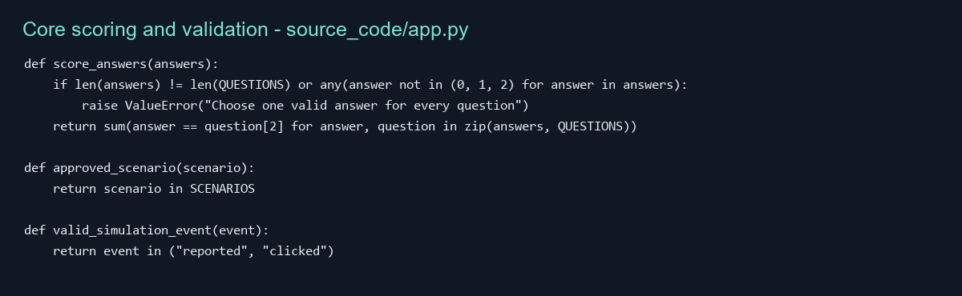
Figure 2. The employee HTTP handler stores the assessment and audit event in SQLite.
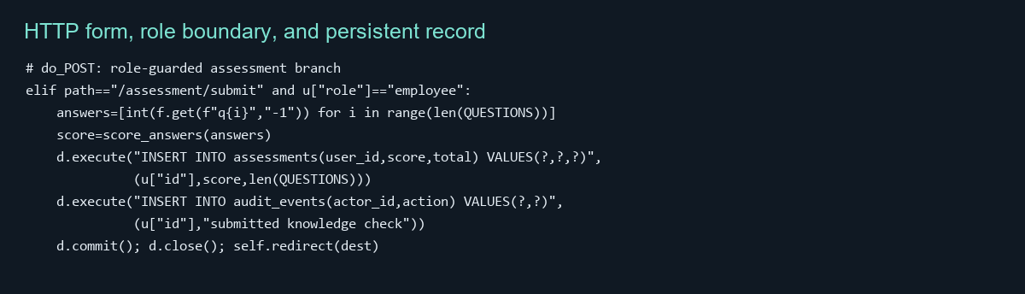
Figure 3. Output trace and database verification from an isolated synthetic session.
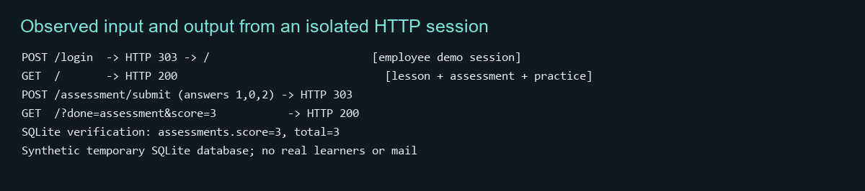
The employee view includes a lesson, three questions, and two explicit practice choices. The manager view queries cohort totals and permits only allowlisted scenarios; reporting is suppressed below five participants. The administrator view lists role counts and recent audit actions. Security-related controls include a hashed session token, HttpOnly and SameSite cookie attributes, CSRF token validation, parameterized SQL, salted PBKDF2-HMAC-SHA256 password hashes, HTML escaping, and response headers. These features support a local prototype but are not a production security assessment. Python warns that its built-in http.server implements only basic security checks and is not recommended for production (Python Software Foundation, n.d.).
Integration challenges included preventing direct HTTP submissions from bypassing the UI’s allowed values and keeping manager reporting useful without exposing an individual learner list. The implementation centralizes assessment, scenario, and event validation in reusable helpers and checks roles in the server handler. The dashboard returns cohort aggregates and withholds output below five participants. Seeded synthetic records allow the dashboard to render during demonstration while clearly representing fictional data. This improves repeatability and privacy, but means the dashboard cannot support conclusions about actual learner outcomes.

Part B: System Evaluation & Metrics Reporting
Performance was measured against the local app using a temporary synthetic SQLite database. After ten warmup requests, 100 sequential employee-page GET requests and 200 GET requests across eight worker threads were timed. Every measured response returned HTTP 200. Sequential median latency was 16.16 milliseconds and p95 was 30.59 ms. The concurrent median was 6.98 ms, p95 was 8.32 ms, and throughput was 1,109.44 requests per second over 0.180 seconds. These are loopback microbenchmark observations, not production service guarantees. The short local workload and hot cache make the peak throughput unsuitable for extrapolation.
Figure 4. Local benchmark results; machine-specific measurements.
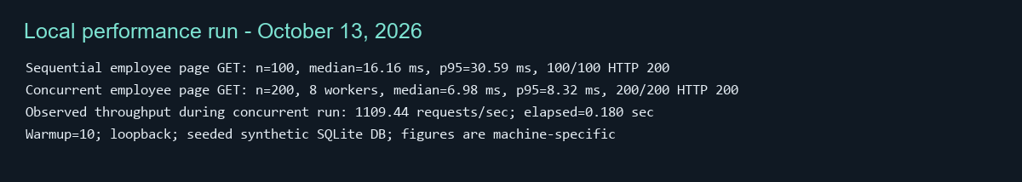
Local system evaluation results
Table 1
Measure | Observed result | Interpretation
Sequential GET | 100/100 success; median 16.16 ms; p95 30.59 ms | Responsive local request path
Concurrent GET | 200/200 success; 8 workers; p95 8.32 ms | No errors in the short burst
Throughput | 1,109.44 requests/sec for 0.180 sec | Local burst rate, not capacity guarantee
Assessment correctness | 3/3 persisted for inputs 1,0,2 | End-to-end logic and storage agreed
Figure 5. Measured response latency; lower bars indicate shorter requests.
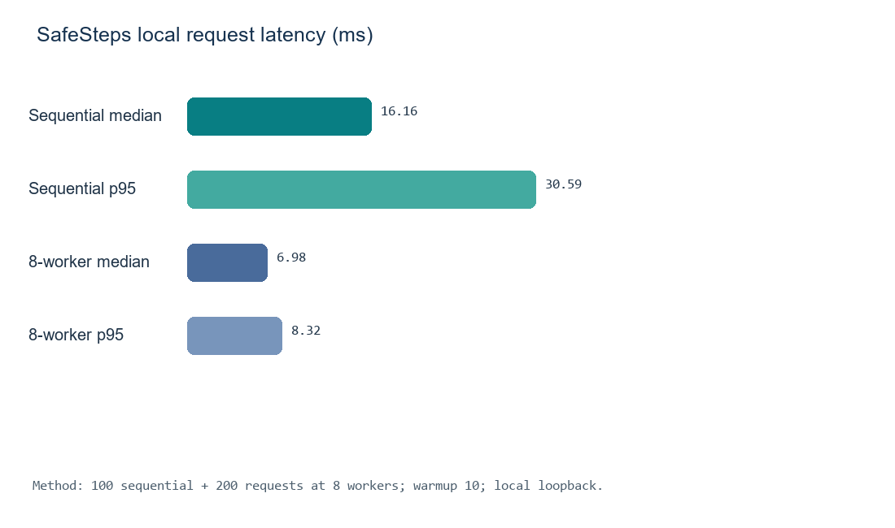
The earlier design target is p95 lesson or assessment reads at or below two seconds and aggregate reports at or below five seconds with 50 concurrent sessions. The measured page p95 is below the first target, but this benchmark did not run aggregate reports or a sustained 50-session workload. Those requirements remain unverified. Reporting sample size, workload, and environment matters because one number cannot establish general system quality (Wells, 2025).
The qualitative evaluation was a heuristic review of the actual interface and source text, not a user survey. The page explains three sequential actions, uses descriptive headings and labeled controls, provides immediate feedback, distinguishes synthetic practice from real email, and says scores are not used for employment decisions. These are positive clarity and safety cues. The question form is long, and mobile layout, keyboard-only use, screen-reader behavior, and comprehension have not been tested with representative users. Qualitative metrics describe perceptions and context; quantitative metrics describe counts and timings, and the two types complement each other (LaunchNotes, 2023).
Figure 6. Key text returned by the running employee view; heuristic inspection only.
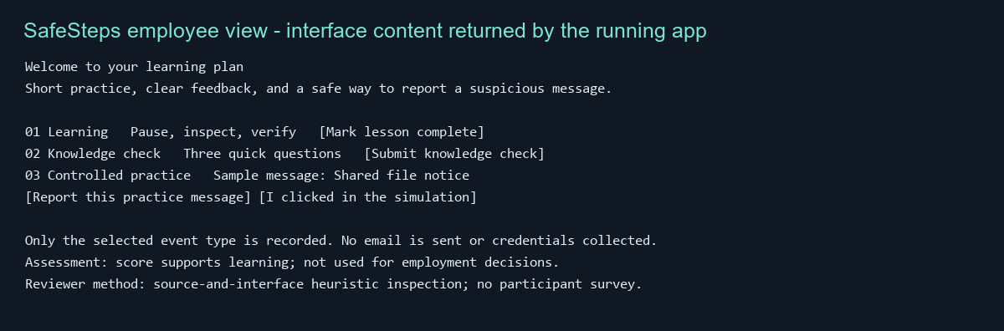
Unit tests use Python unittest. Eight cases passed. Tests cover password verification and malformed hashes, assessment scoring and invalid input, scenario and event allowlists, and idempotent database seeding. The testing is mainly white-box because cases target internal helpers and branches; assertions also check black-box outcomes such as rejection of an invalid assessment. Execution is coverage evidence for these cases, but no line-coverage percentage was collected. A follow-up should add HTTP route tests for CSRF rejection, authorization boundaries, form errors, and SQL persistence. The suite surfaced the need to reject malformed hashes safely and preserve database seed idempotence. Unit testing improves reliability by catching local regressions early, supports modular development through small contracts, and acts as executable documentation. Other test levels include integration tests between modules, system tests of the assembled application, acceptance tests against user tasks, and regression tests after changes.

Part C: Deployment & Configuration Planning Overview
Local deployment is selected for the current prototype because it is simple to inspect and has no live email integration or external service dependency. It binds to 127.0.0.1:8000 and stores a SQLite file beside the source. For a future limited pilot, the recommended approach is a container on a controlled or managed host behind a supported production application server and TLS proxy, with managed database, backups, monitoring, and organizational identity. Docker Compose can provide repeatable single-host staging; Docker documents environment-specific overrides and rebuilding services for releases (Docker, n.d.). Direct public exposure of the development server is not recommended.
Configuration management improves repeatability by versioning code, runtime assumptions, schema changes, deployment settings, and release notes together. Development work should use short-lived feature branches merged to an integration branch after review and tests; stable release candidates are promoted to main. Tags such as v1.0.0 identify reviewed source snapshots. A release record should include configuration, migration instructions, known limits, and rollback steps. Course methods and SCM summaries describe baselines and change control as ways to keep system state explainable (Summers, 2020; Bennett, 2024; SNS Institutions, n.d.).
Current prerequisites are Python 3.11 or newer, a supported Windows, macOS, or Linux system, and SQLite, which is included with Python. Run “python -m unittest discover -s tests -v,” then “python source_code/app.py,” and open http://127.0.0.1:8000/login. Demo credentials are shown on the local sign-in page. Host, port, database path, seed accounts, and password work factor are presently hard-coded; no environment variables exist yet. Brown (2025) emphasizes clear technical documentation; Brown (2026) discusses software-specific documentation types and practices. A future deployment should externalize APP_HOST, APP_PORT, APP_DB_PATH, SESSION_TTL_SECONDS, and secret settings, and separate demo seeding from production initialization. After adding a Dockerfile and Compose definition, a planned build command would be “docker compose up --build -d”; those files are not yet implemented, so this is a proposed setup command.
A deployment checklist should document the runtime version, exposed port, database volume, environment settings, health check, logs, backup and recovery, and responsible operator. Secrets should be injected through a protected environment or secret manager and excluded from Git. A release should run unit and route tests, migrate a staging database copy, verify health and TLS, and preserve a rollback point. Deployment strategies include rolling replacement, blue-green, canary, and feature toggles (ByteByteGo, 2023); for this small system, a staged pilot and tested rollback are proportionate. Sumo Logic (n.d.) similarly frames deployment as a release into operation followed by monitoring. These steps are recommendations, not completed production work.

References
Bennett, L. (2024, August 13). Software configuration management in software engineering. Guru99. https://www.guru99.com/software-configuration-management-tutorial.html
ByteByteGo. (2023, June 6). Top 5 most-used deployment strategies [Video]. YouTube. https://www.youtube.com/watch?v=AWVTKBUnoIg
Brown, J. (2025, December 2). Technical documentation: Purpose and best practices. Helpjuice. https://helpjuice.com/blog/technical-documentation
Brown, J. (2026, April 16). Knowledge software documentation best practices [with examples]. Helpjuice. https://helpjuice.com/blog/software-documentation
Docker. (n.d.). Use Compose in production. Docker Docs. https://docs.docker.com/compose/how-tos/production/
Kumaraguru, P., Sheng, S., Acquisti, A., Cranor, L. F., & Hong, J. (2009). Teaching Johnny not to fall for phish. ACM Transactions on Internet Technology, 10(2), Article 7. https://doi.org/10.1145/1572532.1572536
LaunchNotes. (2023, September 1). Qualitative metrics vs quantitative metrics: A comparison. https://www.launchnotes.com/blog/qualitative-vs-quantitative-metrics-a-comprehensive-comparison
Merritt, M., Hansche, S., Ellis, B., Sanchez-Cherry, K., Snyder, J. N., & Walden, D. (2024). Building a cybersecurity and privacy learning program (NIST SP 800-50 Rev. 1). NIST. https://doi.org/10.6028/NIST.SP.800-50r1
Python Software Foundation. (n.d.). http.server — HTTP servers. Python documentation. https://docs.python.org/3/library/http.server.html
SNS Institutions. (n.d.). Software configuration management | OOSE [Video]. YouTube. https://www.youtube.com/results?search_query=Software+configuration+management+OOSE+SNS+Institutions
Souppaya, M., Scarfone, K., & Dodson, D. (2022). Secure software development framework version 1.1 (NIST SP 800-218). NIST. https://doi.org/10.6028/NIST.SP.800-218
Summers, B. L. (2020). Effective methods for software engineering. Auerbach Publishers, Incorporated.
Sumo Logic. (n.d.). What is software deployment? https://www.sumologic.com/glossary/software-development/
Wells, J. (2025, April 16). Top 12 software quality metrics to measure and why. LinearB. https://linearb.io/blog/software-quality-metrics

