System Architecture, Requirements, Module Design, and Version Control
Cybersecurity Awareness and Phishing Simulation System for Small Businesses
Desta Jomma
University of the People
MSIT 5910-01 - AY2027-T1
MSIT Capstone Project
September 2026

1. System Architecture Blueprint and Module Design
The proposed capstone project is a Cybersecurity Awareness and Phishing Simulation System for small businesses. The system is designed to help a small organization provide structured cybersecurity education, conduct controlled phishing simulations, measure employee awareness, and provide management with useful aggregate information. The architecture uses a layered design consisting of presentation, application, security, and data responsibilities. This approach separates user-interface functions from business logic and data storage, which improves maintainability and makes security controls easier to apply consistently. Software architecture patterns provide reusable structures for recurring design problems, while requirements and configuration management provide a foundation for controlled development (Davies, 2024; Summers, 2020; Walker, 2022).
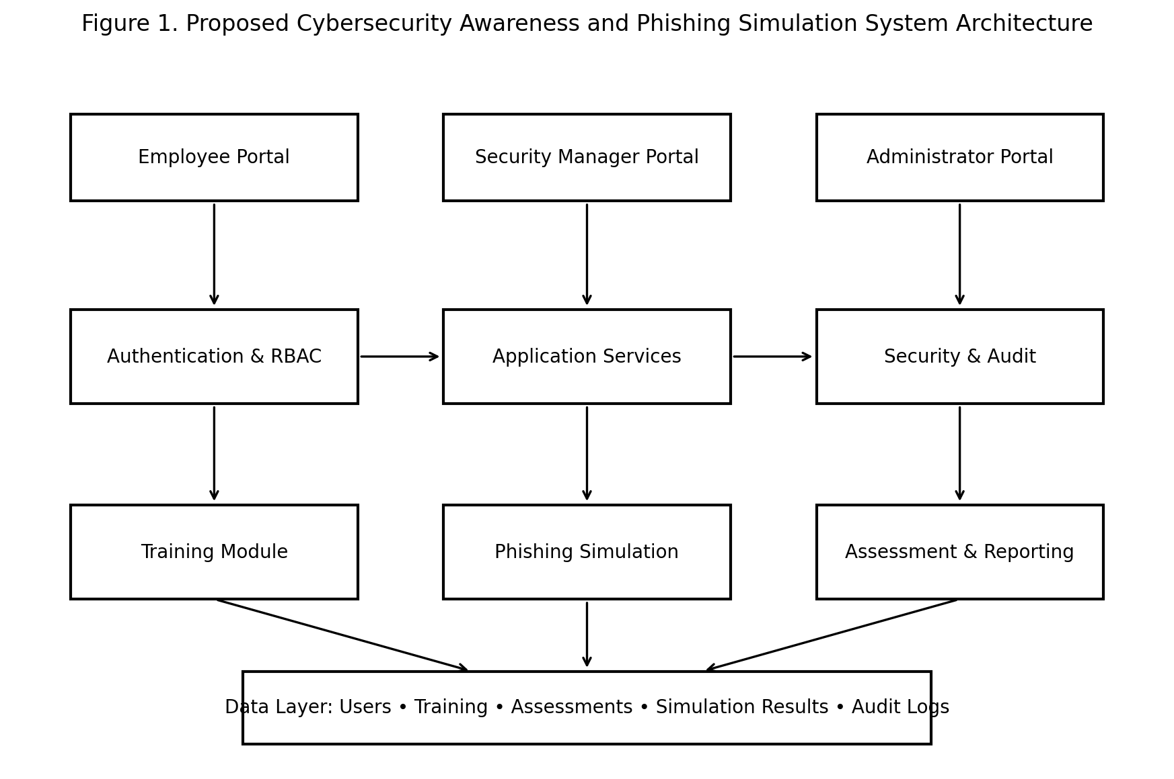
Figure 1. Proposed system architecture.
The presentation layer contains separate employee, security-manager, and administrator portals. Employees can access assigned training, assessments, simulations, and their own progress. Managers can configure approved awareness activities and review authorized reports. Administrators can manage accounts, roles, security settings, training content, and audit information. The application layer contains the training, phishing simulation, assessment, reporting, and content-management services. The security layer provides authentication, role-based access control (RBAC), session management, and audit logging. The data layer stores only information required by the system, including user records, training progress, assessment results, simulation events, and audit records. The design follows the principle that authorization must be enforced on the server and not only through hidden interface options (OWASP Foundation, 2021).

Module-Wise Functional Specifications
Module | Inputs | Outputs | Methodology
Authentication and RBAC | Username, password, MFA factor, requested resource | Authenticated session, role, authorization decision | Secure password hashing, MFA, session management, server-side authorization
Training | Course, lesson, employee identity | Progress, completion status, knowledge-check results | Modular lessons, progress tracking, feedback
Phishing Simulation | Approved scenario, recipient group, schedule | Delivery, interaction, report, and feedback events | Controlled simulation templates; no real credentials collected
Assessment | Questions and employee responses | Scores, topic-level feedback, completion record | Pre/post assessments and consistent scoring
Reporting | Training, assessment, and simulation records | Aggregate dashboards and authorized reports | Aggregation, filtering, trend analysis
Security and Audit | Login, access, configuration, and privileged actions | Protected audit records and alerts | Structured logging, access checks, integrity and retention controls
Data Layer | Application records | Persistent system data | Database controls, encryption, backups, retention policies
These modules are intentionally separated so that changes to one function do not require changes to the entire system. For example, new training topics can be added without changing the authentication service, and new reporting metrics can be developed without changing the employee interface. The modular approach also supports testing because each service can be evaluated against its own functional and security requirements (Letaw, 2024).

Functional Requirements
ID | Requirement
FR1 | The system shall authenticate users and assign access according to role.
FR2 | The system shall provide cybersecurity awareness lessons covering phishing, passwords, MFA, social engineering, and safe browsing.
FR3 | The system shall administer pre-training and post-training assessments.
FR4 | The system shall allow authorized managers to configure controlled phishing simulations.
FR5 | The system shall record simulation outcomes such as interaction and reporting events without collecting unnecessary personal information.
FR6 | The system shall provide immediate educational feedback after a simulation interaction.
FR7 | The system shall provide dashboards showing training completion, reporting behavior, and awareness trends.
FR8 | The system shall restrict sensitive records using server-side RBAC.
FR9 | The system shall maintain audit logs for authentication, administrative changes, and security-relevant actions.
FR10 | The system shall allow authorized administrators to update training content and simulation scenarios.
The functional requirements translate the project purpose into testable system behavior. For example, FR4 can be tested by verifying that an authorized manager can create a simulation while an employee cannot. FR8 can be tested by attempting to access another employee's results and confirming that the server rejects the request. FR9 can be tested by generating login and administrative events and verifying that they appear in the protected audit trail. This approach connects requirements to later verification and validation activities, an important software-engineering practice (Summers, 2020).

Non-Functional Requirements
NFR Area | Design Decision
Security | Use secure authentication, MFA for privileged access, least privilege, encrypted communication, secure password storage, input validation, and audit logging.
Privacy | Collect only information necessary for awareness training and evaluation; minimize individual-level reporting and apply retention limits.
Usability | Use simple navigation, plain-language instructions, clear feedback, and interfaces appropriate for employees with different technical backgrounds.
Performance | Common training, assessment, and dashboard operations should provide responsive interaction for the expected small-business workload.
Reliability | Training completion, assessment, and simulation records should be persisted consistently and protected through backup procedures.
Scalability | The system should support additional employees and training content without major architectural redesign.
Maintainability | Modules, training content, and simulation templates should be independently maintainable and documented.
Accessibility | Use readable text, clear labels, logical navigation, and understandable messages.
The non-functional requirements influence architecture decisions even when users do not directly see them. Security affects authentication, authorization, session management, logging, and database design. Privacy affects what data is collected and how long it is retained. Usability affects the structure of training and feedback. Reliability affects database persistence and backup procedures. These requirements are therefore treated as design constraints rather than optional enhancements.

2. Version Control and Collaboration
The project will use Git and GitHub as the version-control platform. The repository will organize source code, documentation, diagrams, tests, and configuration files into clearly labeled folders. Git will record the history of development so that changes to code and documentation can be traced to individual commits. This is particularly important for a capstone because the system requirements, architecture, implementation, and technical report will evolve during development. Software configuration management helps ensure that the correct version of code and documentation is identified at each project milestone (Summers, 2020).
Repository Area | Purpose
src/ | Application source code organized by authentication, training, simulation, assessment, reporting, and security modules.
docs/ | Requirements, system design, technical report drafts, test plans, and user documentation.
diagrams/ | Architecture, workflow, database, and UML diagrams.
tests/ | Functional, security, usability, and integration test materials.
README.md | Project purpose, setup instructions, architecture summary, repository workflow, and contribution guidance.
The primary branches will be main and development. The main branch will contain stable versions that are appropriate for formal submission. The development branch will contain active integration work. Feature branches can be created for individual tasks and merged into development after testing. At major milestones, development can be merged into main. This structure separates stable work from ongoing development and makes it easier to identify the version used for evaluation.
Commit messages will describe meaningful changes clearly. Examples include “Create employee authentication module,” “Add phishing simulation workflow,” “Implement role-based dashboard,” “Add audit logging,” and “Update architecture diagram.” Pull requests and issue records can be used to document review and correction. The same version-control process will apply to documentation and design files so that the final technical report, diagrams, and implementation remain traceable to the project history. Letaw (2024) emphasizes teamwork, requirements, design, and sustainable development practices, while Davies (2024) discusses design documentation and collaborative software development. These practices support the proposed Git workflow.

Repository Information
Repository location: Local Git repository in the assignment workspace. No GitHub or GitLab remote URL has been configured.
Suggested branch structure: main → stable submission; development → active integration; feature/* → individual module development.

References
Davies, S. (2024). Blueprints: Creating, describing, and implementing designs for larger-scale software projects (Version 2.5). University of Mary Washington. https://open.umn.edu/opentextbooks/textbooks/blueprints-creating-describing-and-implementing-designs-for-larger-scale-software-projects-davis
Letaw, L. (2024). Handbook of software engineering methods (2nd ed.). Oregon State University. https://open.oregonstate.education/setextbook/
OWASP Foundation. (2021). OWASP Top 10: 2021. https://owasp.org/Top10/
Summers, B. L. (2020). Effective methods for software engineering. Auerbach Publications. https://www.routledge.com/Effective-Methods-for-Software-Engineering/Summers/p/book/9781032474359
Walker, V. (2022, March 16). 14 software architecture design patterns to know. Red Hat. https://www.redhat.com/en/blog/14-software-architecture-patterns

