RateMyPlace 🏠

User Documentation

Software Engineering CS4320

https://github.com/Djhyv2/RateMyPlace.git

Group 13: Connor Fitzmaurice, Dustin Hengel, Mercy Housh, Madison Williams, Bradley Worthen

**Login/Create an Account**

Users can choose Register button to create a new account or they can enter their username and password if they are already registered and then click the Login button.

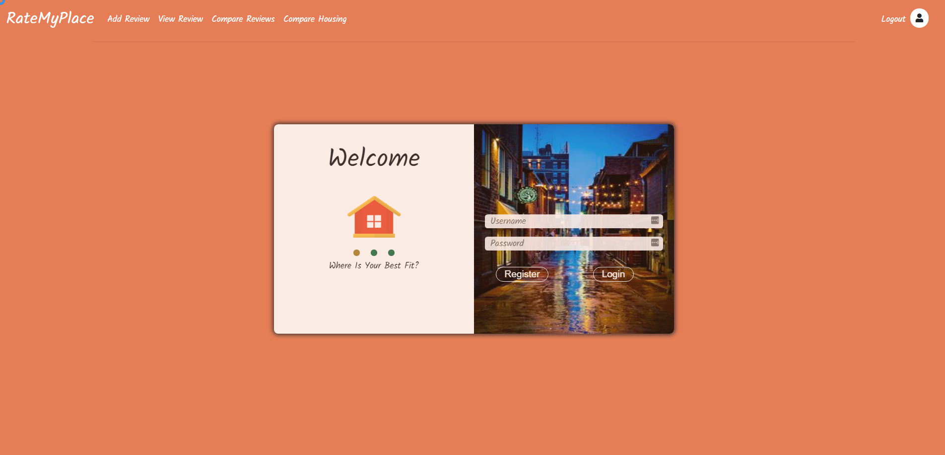

The user can use the navigation bar to select if they want to add a review, view reviews, compare reviews on a single housing complex or compare housing complexes.

**Adding a New Review**

1. User must click the Add New Review Button on the navigation bar or from user profile
   1. User selects name of housing complex
   2. User selects star ratings for overall rating, noise rating, safety rating and maintenance rating
   3. User inputs monthly rent and utilities cost, as well as distance from campus
   4. User inputs pros and cons comments (if applicable/desired)
   5. User inputs lease start and end date
   6. User selects checkboxes for apartment amenities including: study space, shuttle, wifi, furnished, tv,trash service, gym, parking, pets
   7. User inputs parking fee, pet fees and misc fees (if applicable)
   8. User presses the submit review button

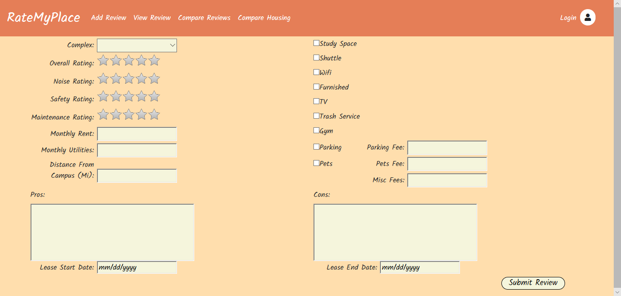

**Viewing Reviews**

1. User will click on View Review button and a list of all reviews will be displayed.

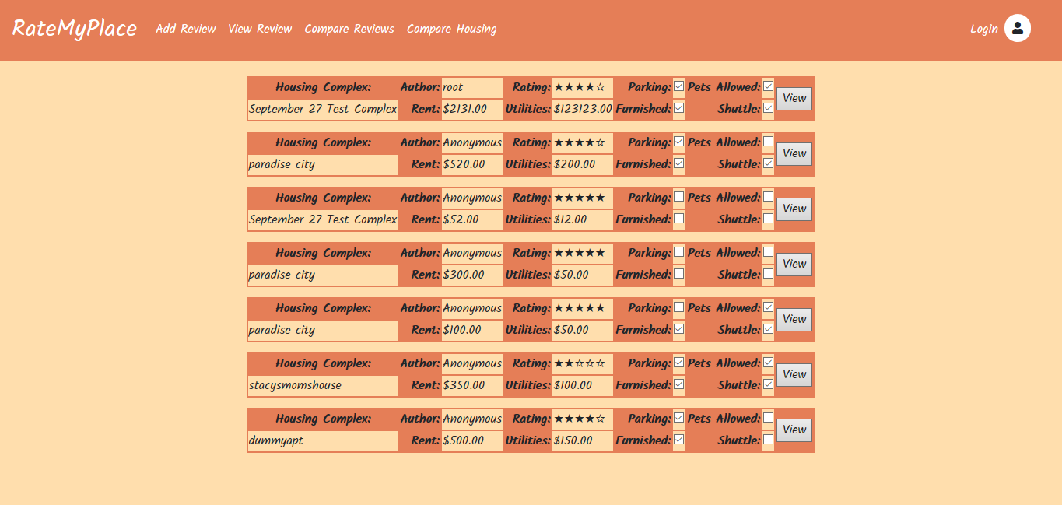

1. There will be a specific page that lists all of the reviews that are stored in the database - one is able to scroll through this list and press the View button adjacent to the record they want more information about.
2. Further information will be displayed including:
   * 1. Name of housing complex
     2. Overall rating
     3. Amenities that are available
     4. Cost of rent
     5. Cost of utilities
     6. Either the name of the author who submitted the review, or if the user was not logged in, “Anonymous” will be shown in place of an author name

**Comparing Housing Complexes**

1. User must click on the Compare Housing Complexes tab in the navigation bar and user will be taken to a page that displays all housing complexes where the user can select which complexes they want to compare and then select the compare button.

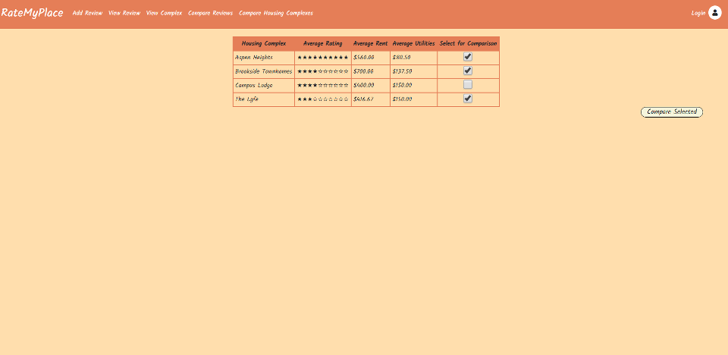

1. User will be taken to the following page where data from the selected complexes will be displayed side by side for easy comparison.

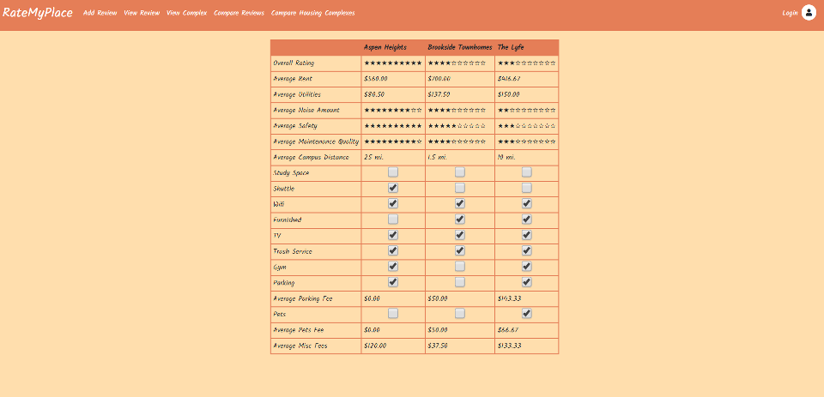

**Comparing Multiple Reviews About a Specified Housing Complex**

1. User must click on the Compare Reviews tab in the navigation bar and user will be taken to a page that displays a list of complexes and reviews made with a checkbox column to choose which reviews they'd like to compare

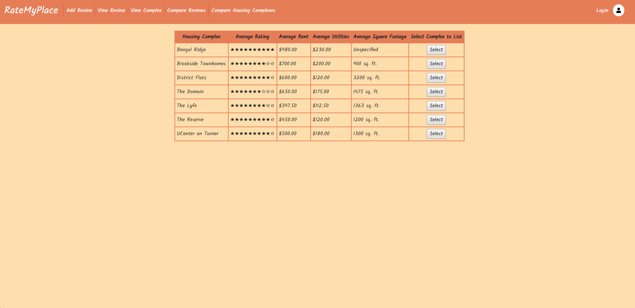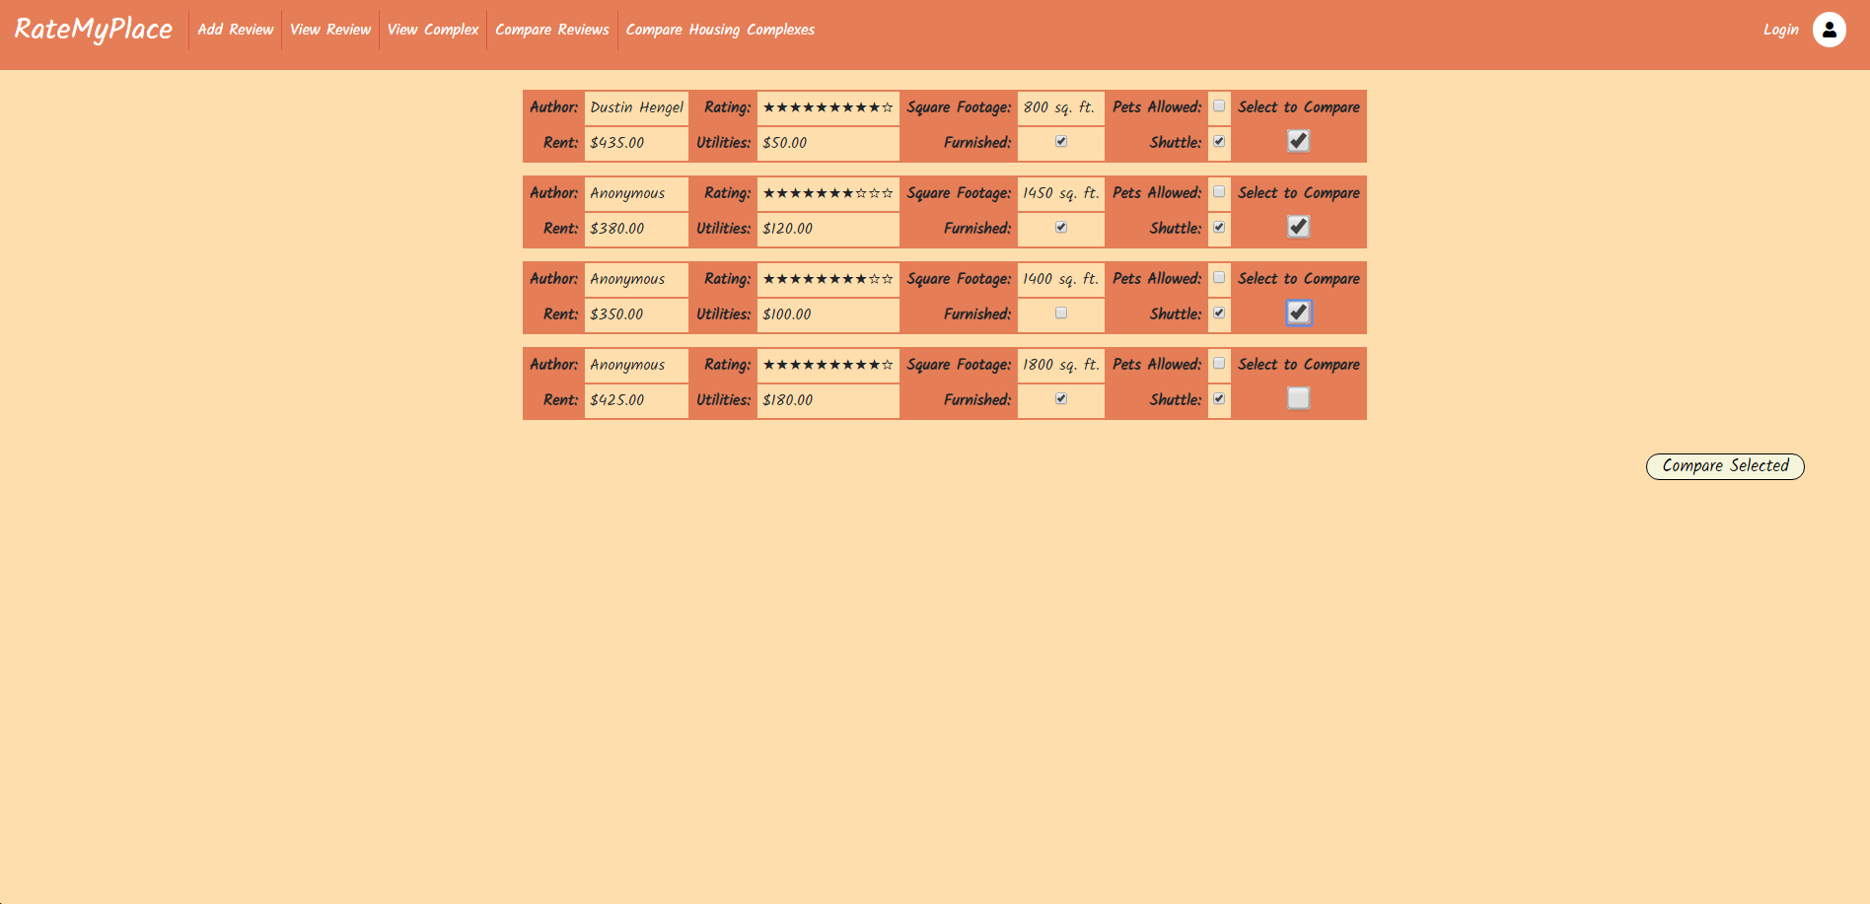

1. Once the user selects reviews and clicks the compare reviews button they will see the following screen that compares selected reviews side by side

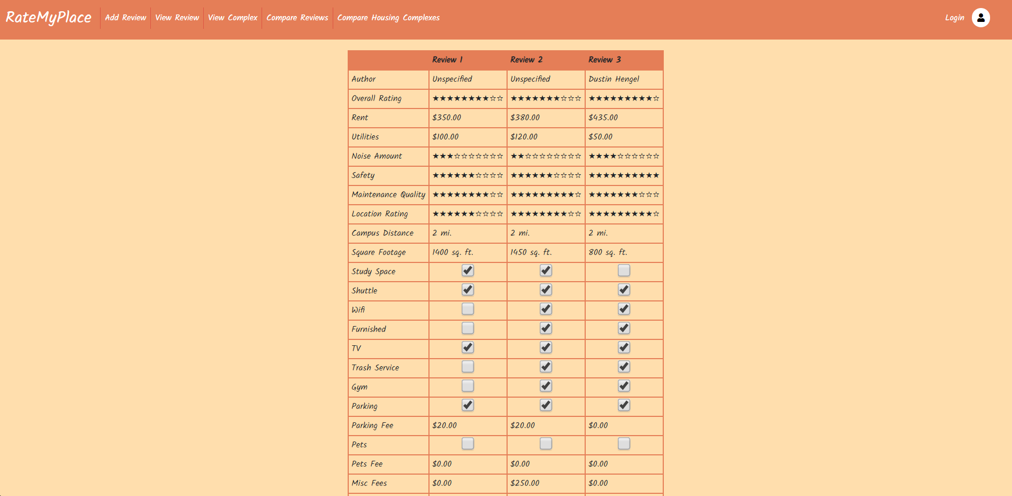

**Viewing Aggregated Details of a Single Housing Complex**

1. The User must select the View Complex tab in the navigation bar and user will be taken to a page that displays a list of housing complexes from which they can select a complex.

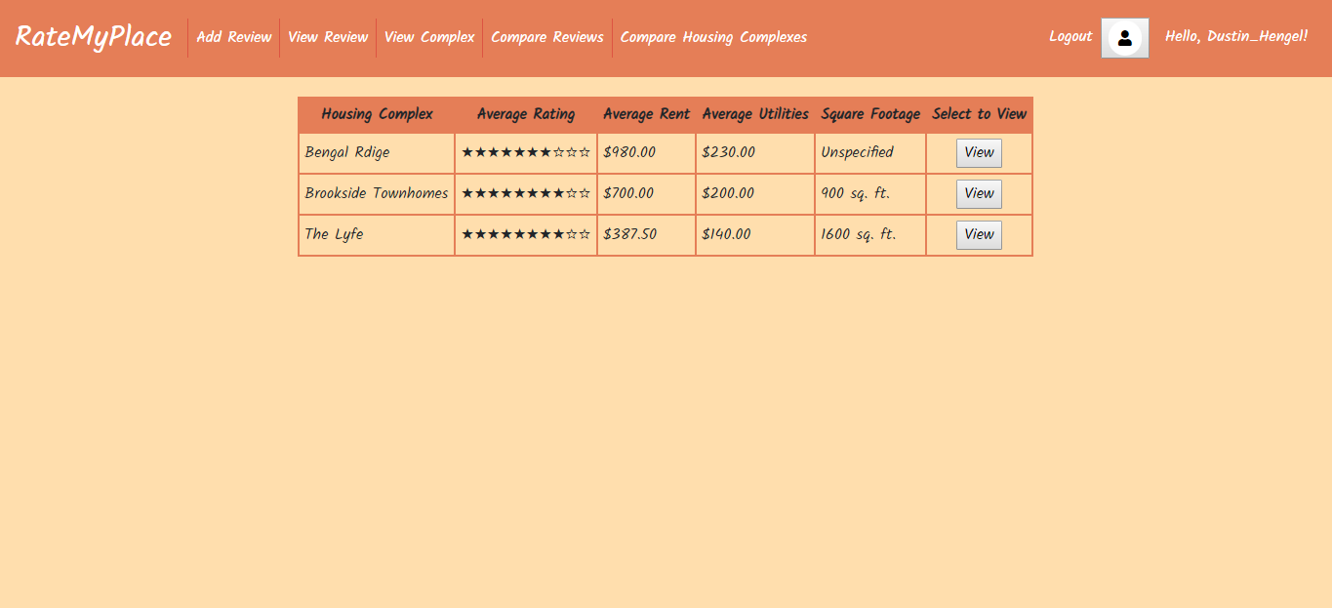

1. Once the user selects a housing complex they will be able to view the aggregated data for that complex.

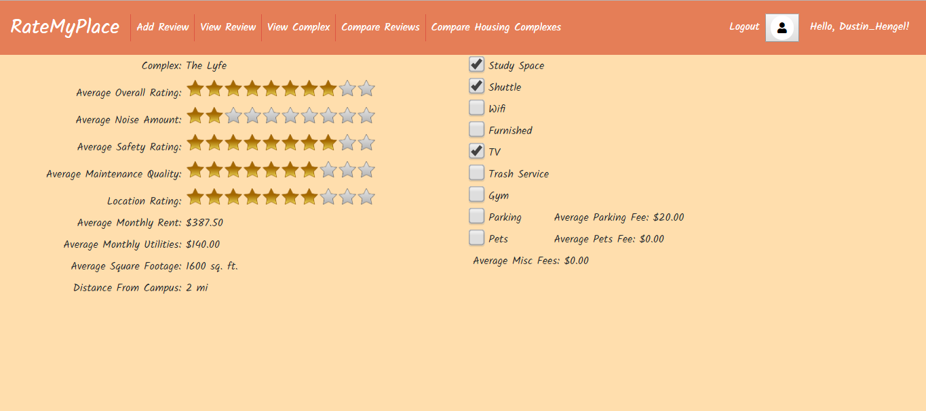

**View Own Reviews**

1. This screen is accessible by click on the user icon or your username in the top right corner. It displays a list of all reviews made by the current user and provides a page to manage them. The user can either edit, delete, or view their own review as they wish. As this page’s contents is based on the logged in user, it is one of the few features of the site not available to guest users.

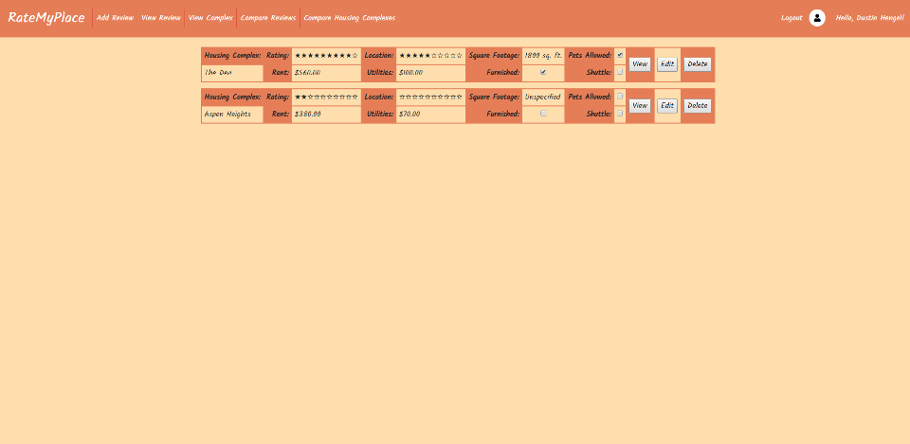

**Editing or Deleting a Review Created by a Registered User**

1. From the View Own Reviews screen pictured above users are able to edit or delete a review they have posted.
2. If the user chooses the delete option on a review that they have posted they will see the following screen asking them to confirm that they do want to delete the review and then if they choose yes the review will be deleted.

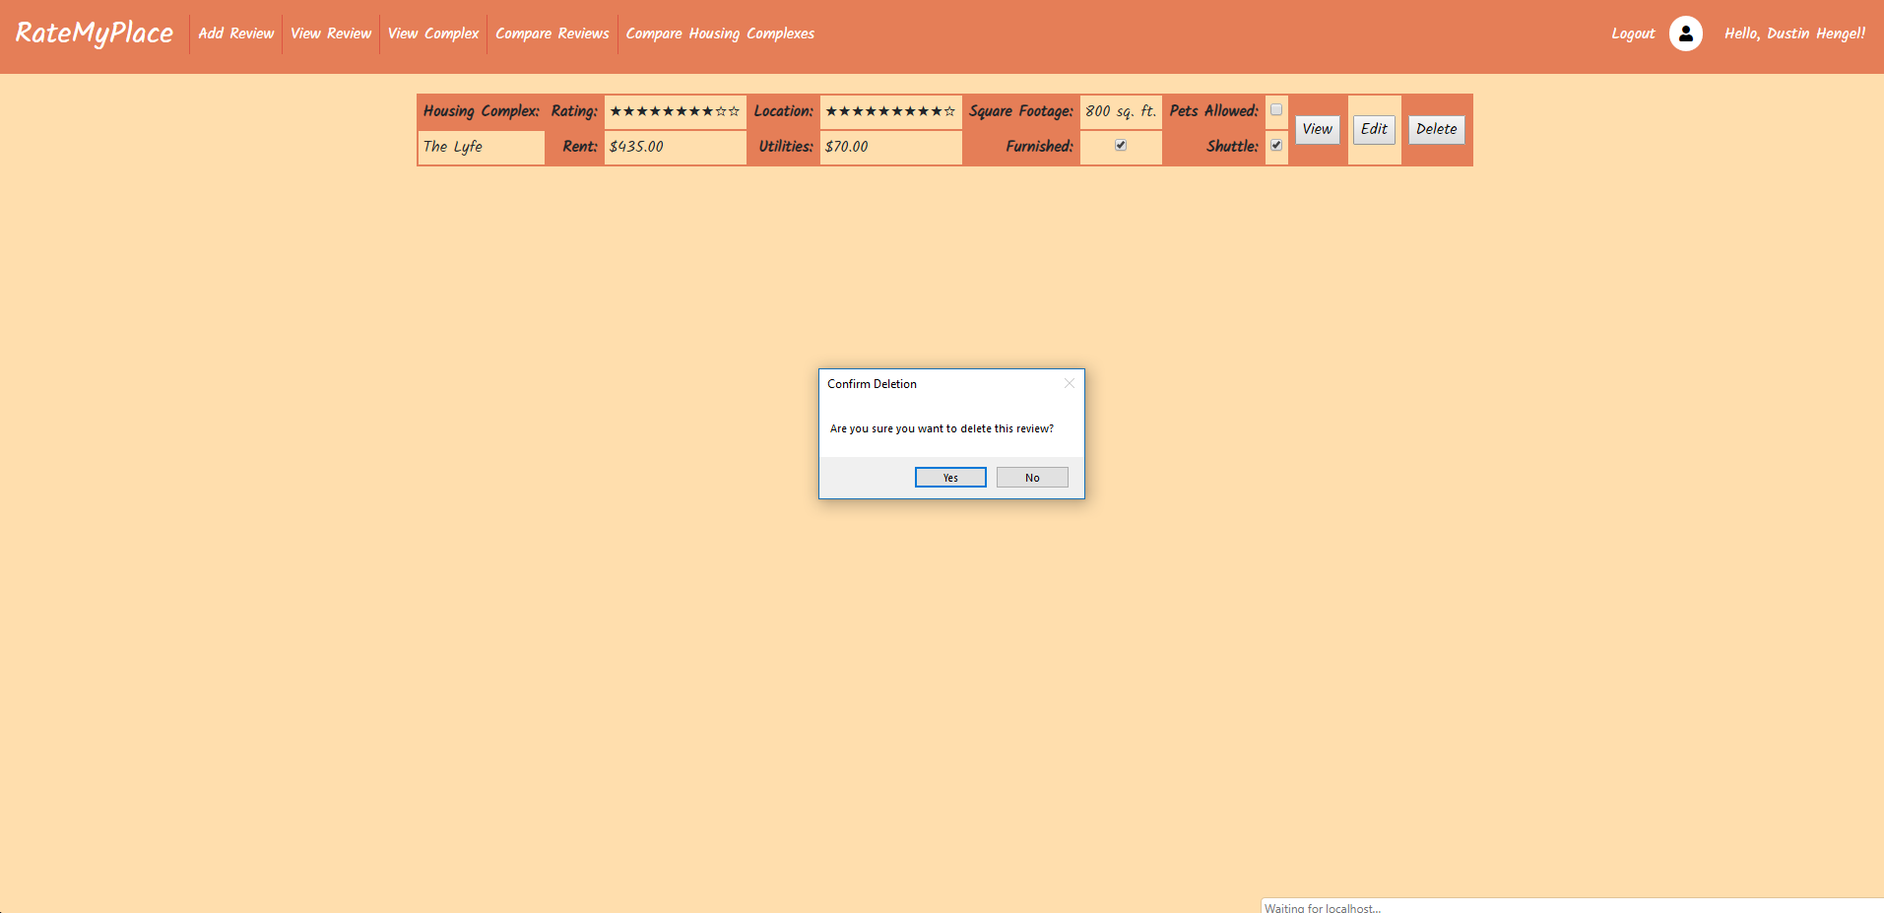

3) If the user selects Edit Review form the View Own Reviews screen they will see the following screen that is similar to the Add Review form but it is filled with the data they submitted when they made their review, giving them the option to change the data that they previously entered and change their review. Once the user is finished altering their review they can press the Edit Review button to save their changes. 