Pitch Deck 2: Agri Market-Linkage & Data Service
Founder Profile Fit: Technical deployer + prompt-driven operator; suitable for rapid MVP execution and relationship-led selling.

1) Opportunity Summary
Problem: Smallholder producers and cooperatives often lack reliable demand visibility and consistent buyer access.
Solution: A lightweight USSD/WhatsApp intake + dashboard to aggregate produce availability, forecast supply windows, and match verified buyers.
Primary Customers: Cooperatives, produce aggregators, food processors, and institutional buyers.

2) Strategic Partnership Map
- Farmer cooperatives and sector agronomists for onboarding
- Input suppliers and NGOs for sponsored analytics
- Logistics operators for fulfillment and traceability

3) Business Model
Pricing: Coop subscription: 180,000 RWF/month. Buyer analytics report: 250,000 RWF/report. Transaction facilitation fee: 1.5%.

4) Operating Assumptions (24-Month Plan)
- Start with 5 cooperatives and 2 reports/month in Month 1
- Cooperatives grow by +1 monthly; reports grow to 4/month by Year 2 midpoint
- Facilitated monthly GMV starts at 15,000,000 RWF and grows 5% monthly

5) Financial Projection (Clear Summary)
Metric | Value
Year 1 Revenue | 48,180,000 RWF
Year 1 Gross Profit (58%) | 27,944,000 RWF
Year 1 Operating Cost | 15,960,000 RWF
Year 1 Net Profit | 11,984,000 RWF
Year 2 Revenue | 74,460,000 RWF
Year 2 Gross Profit (58%) | 43,187,000 RWF
Year 2 Operating Cost | 19,800,000 RWF
Year 2 Net Profit | 23,387,000 RWF

6) Process Diagram (Mermaid Rendered to PNG)
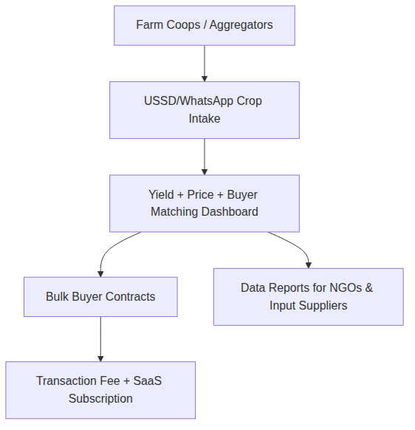

7) Risk Controls & Next 30 Days
• Sign 3 pilot partners and 5 paying customers before scaling spend.
• Collect weekly unit-economics dashboard (CAC, payback period, churn).
• Build referral loops through institution and ecosystem partnerships.

8) Source & Validation Note
Real-time data note (generated 2026-04-18): Direct access to Rwanda statistics endpoints was blocked in this sandbox. Numbers below are operator assumptions for planning and should be validated with current data from NISR, BNR, RURA, and RDB before pitching investors.

