Pitch Deck 3: Student Housing & RentTech Network
Founder Profile Fit: Technical deployer + prompt-driven operator; suitable for rapid MVP execution and relationship-led selling.

1) Opportunity Summary
Problem: Students struggle to find trusted housing quickly, while landlords have vacancy and payment-tracking inefficiencies.
Solution: A verified listing + matching + rent-reminder and payment workflow platform focused on university catchment zones.
Primary Customers: University students, private hostel owners, and small landlord portfolios.

2) Strategic Partnership Map
- Universities/student guilds for trusted onboarding channels
- ISPs and furniture providers for move-in bundles
- Fintech/payment providers for recurring collection rails

3) Business Model
Pricing: Placement commission: 40,000 RWF per signed tenant. Landlord SaaS: 35,000 RWF/property/month.

4) Operating Assumptions (24-Month Plan)
- Month 1: 30 placements and 20 subscribed properties
- Placements grow by +4/month; properties grow by +5/month
- Gross margin: 62%; fixed cost starts at 1,200,000 RWF/month

5) Financial Projection (Clear Summary)
Metric | Value
Year 1 Revenue | 39,720,000 RWF
Year 1 Gross Profit (62%) | 24,626,000 RWF
Year 1 Operating Cost | 14,940,000 RWF
Year 1 Net Profit | 9,686,000 RWF
Year 2 Revenue | 63,600,000 RWF
Year 2 Gross Profit (62%) | 39,432,000 RWF
Year 2 Operating Cost | 18,360,000 RWF
Year 2 Net Profit | 21,072,000 RWF

6) Process Diagram (Mermaid Rendered to PNG)
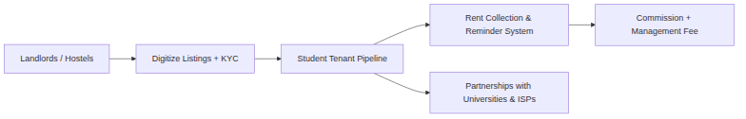

7) Risk Controls & Next 30 Days
• Sign 3 pilot partners and 5 paying customers before scaling spend.
• Collect weekly unit-economics dashboard (CAC, payback period, churn).
• Build referral loops through institution and ecosystem partnerships.

8) Source & Validation Note
Real-time data note (generated 2026-04-18): Direct access to Rwanda statistics endpoints was blocked in this sandbox. Numbers below are operator assumptions for planning and should be validated with current data from NISR, BNR, RURA, and RDB before pitching investors.

