Pitch Deck 2 V2: Agri Market-Linkage & Intelligence Platform
Version objective: This V2 is an investment-grade upgrade oriented to a defined 24-month final destination.

1) Investment Thesis
Create a trusted transaction and data layer connecting producer groups to buyers with predictable quality and delivery.

2) Problem Severity & Why Now
Demand fragmentation and weak market signaling create pricing inefficiency and post-harvest losses.

3) Offer Architecture
Coop SaaS, buyer intelligence reports, and transaction facilitation with reliability scoring.

4) Go-to-Market Wedge (First 100 Customers)
Launch with concentrated crop corridors and anchor buyers to prove repeatability before geographic scale.

5) Partnerships Flywheel
Better data improves match quality; better matches increase GMV; rising GMV attracts more buyers and coops.

6) 24-Month Financial Engine (Scenario View)
Metric | Target
Downside Year 2 Revenue | 56,000,000 RWF
Base Year 2 Revenue | 81,000,000 RWF
Upside Year 2 Revenue | 108,000,000 RWF
Target Gross Margin | 60%
Target EBITDA Margin (Month 24) | 28%

7) Final Destination (Month 24)
FINAL DESTINATION: By Month 24, become the most trusted agri matching and transaction intelligence node in target provinces with predictable monthly GMV.

8) Milestone Ladder
- Day 0-90: 5 coop pilots, 3 anchor buyers, first repeat transaction cycles
- Month 4-12: 25 coops onboarded, reliability scoring operational, SLA performance above 90%
- Month 13-24: province replication, integrated finance partnerships, strong recurring data-report revenue

9) KPI Command Center
- Lead-to-customer conversion (%)
- Monthly recurring revenue (RWF)
- Gross margin (%)
- CAC payback period (months)
- Customer retention / churn
- Contribution margin per customer
- On-time payment rate (%)
- Partner-sourced revenue share (%)

10) Risks, Kill-Criteria, and Mitigations
- Risk: inconsistent supply quality. Mitigation: standardized grading and QA checkpoints.
- Risk: buyer trust gap. Mitigation: contract templates and transparent performance scorecards.
- Kill criterion: no repeat monthly buyer cohort by Month 9.

11) Final Destination Diagram (Mermaid PNG)
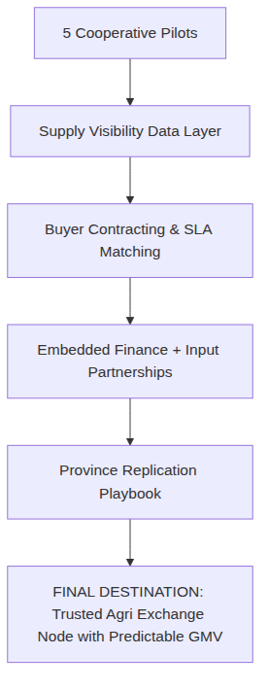

12) Source & Validation
Validation note (2026-04-18): Where live statistics were not retrievable in-session, figures are explicit planning assumptions. Verify current indicators with NISR, BNR, RURA, and RDB before investor distribution.

