**Business template:**

**Recruitment Agency**

**CONTENTS:**

1. BUSINESS DESCRIPTION........................................................................................2

1.1 Business background........................................................................................2

1.2 Problems. Current Situation..........................................................................2

1.3 Benefits from implementing a database. Project Vision.......................3

2. MODEL DESCRIPTION..............................................................................................4

2.1 Definitions & Acronyms ..................................................................................4

2.2 Logical Scheme..................................................................................................6

2.3 Objects.................................................................................................................7

1. **BUSINESS DESCRIPTION**

**1.1 Business background:**

Recruitment agency is a professional staffing agency that specializes in delivering personalized recruitment solutions to businesses across various industries. Our expert recruiters provide targeted staffing solutions for all roles, from executive to entry-level positions. Whether you need temporary staffing solutions or direct-hire recruitment, we have the expertise to help you build a successful team. Contact us today to learn more.

**1.2 Problems. Current Situation:**

Candidate Shortage: In a competitive job market, finding qualified candidates for open positions can be challenging. Recruitment agencies may struggle to attract and retain top talent, particularly for specialized roles or in industries with high demand for certain skills.

Client Demands: Clients may have high expectations for the quality and speed of candidate delivery, which can put pressure on the recruitment agency to perform. Balancing client demands with the need to source and screen quality candidates can be a delicate balance.

Economic Conditions: Economic conditions, such as a recession or job market instability, can impact the recruitment industry. Clients may have fewer job openings to fill, which can impact the agency's revenue and ability to operate.

Technology Changes: Recruitment agencies must stay up-to-date with the latest technology to remain competitive. Failure to adopt new tools and techniques can put them at a disadvantage and impact their ability to attract clients and candidates.

Legal Compliance: Recruitment agencies must comply with a range of legal regulations, such as anti-discrimination laws and data privacy regulations. Failure to comply with these regulations can result in legal action, loss of business, and reputational damage.

**1.3 Benefits from implementing a database. Project Vision:**

Improved Efficiency: With a database system, recruiters can easily store, organize, and search for candidate information, which can save time and improve overall efficiency. This can allow recruiters to focus on higher-value tasks, such as building relationships with clients and candidates.

Enhanced Candidate Screening: A database system can allow recruiters to easily screen and filter candidates based on specific criteria, such as job experience, education, and skills. This can help to ensure that only the most qualified candidates are presented to clients, which can improve client satisfaction and increase the likelihood of successful placements.

Increased Candidate Engagement: With a database system, recruiters can easily track candidate communication and engagement, including email correspondence, phone calls, and interviews. This can help to build stronger relationships with candidates and improve the candidate experience, which can help to attract and retain top talent.

Data Analytics: A database system can provide recruiters with valuable insights and data analytics, such as candidate sourcing, recruitment metrics, and placement success rates. This can help recruiters to identify trends and areas for improvement, which can lead to better recruitment strategies and more successful placements.

Scalability: A database system can provide a scalable solution for managing candidate and client information, allowing recruitment agencies to grow and expand their business without having to worry about storage and organization issues. This can help to improve operational efficiency and reduce overhead costs.

**2. MODEL DESCRIPTION**

**2.1 Definitions:**

Customer - The customers of a recruitment agency are businesses or organizations that are seeking to fill open positions with qualified candidates, as well as existing clients who are working with the agency to provide ongoing staffing solutions.

Worker - A worker hired within an agency for a customer is a job candidate who has been placed in a temporary or permanent position by the recruitment agency, and is contracted to work for the customer business or organization.

Position - A position is a specific job opening that a customer business or organization is seeking to fill through a recruitment agency. The agency works to identify qualified candidates for the position and presents a shortlist of potential hires to the customer for consideration. Once a candidate is selected, the agency assists in the onboarding process and may provide ongoing support to ensure a successful placement.

Requirements - Job requirements are the skills, experience, education, and other qualifications that a candidate must possess in order to be considered for a particular position. A recruitment agency works with the customer business or organization to determine the job requirements for each position and uses this information to identify and screen potential candidates. The agency may also provide guidance to the customer on how to refine or adjust job requirements in order to attract a larger pool of qualified candidates.

Skill - A skill is a specific ability or proficiency that a candidate possesses and that is relevant to a particular position.

Education - The highest level of worker education with a major.

Branch - An agency branch is a physical location of a recruitment agency that operates in a specific geographic area.

Employee - Person hired directly by employment agency. To perform the job in agency.

Payroll - Payroll involves managing payments to placed workers and employees, including taxes and deductions.

Tax_code - A tax code is a unique set of numbers and letters used by employers and payroll providers to calculate the amount of tax to be deducted from an employee's earnings.

Deduction - Any other deductions from salary.

**2.2 Logical Scheme**

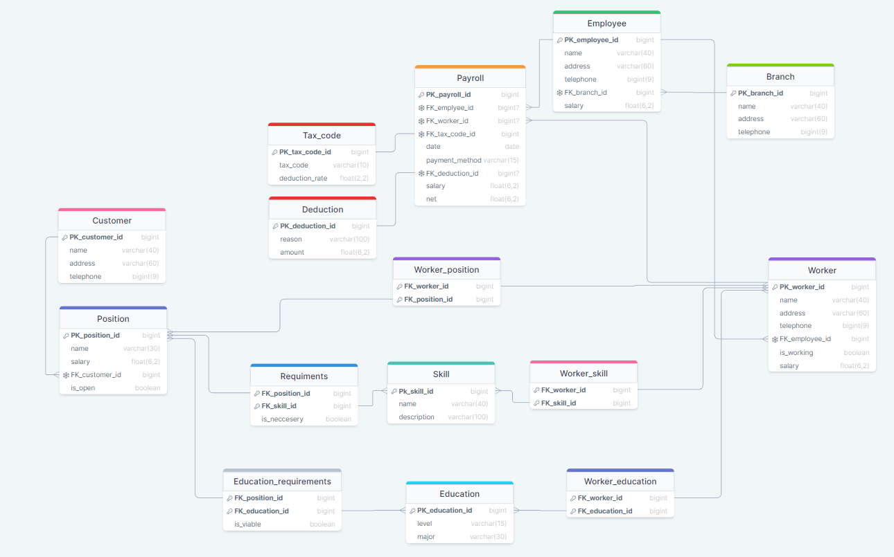

**2.3 Objects**

**Customer**: Customers of agency.

| Customer | PK_customer_id | Key for customer table | Integer |
| --- | --- | --- | --- |
| name | Name of customer | text |
| address | Address of customer | text |
| telephone | Telephone to the customer | Integer(9) |

Example:

| Customer | 0 | Company ABC | Fictional street 34, 34-155 Fictional city, Country | 123456789 |
| --- | --- | --- | --- | --- |
| 1 | ZKH Holding | Fictional street 324, 14-155 Fictional city, Country | 234567890 |

Customer table is connected with one - many relation with position table. Since one customer can have multiple open positions.

**Position** : Table related to open and filled positions.

| Position | PK_position_id | Key for position table | Integer |
| --- | --- | --- | --- |
| name | Name of a position | Text |
| salary | monthly salary for given position | float(6,2) |
| FK_customer_id | ID of customer who posted position | integer |
| is_open | Is there a worker already sign for a position | boolean |

Example:

| Position | 0 | Data Engineer | 3000 | 0 | True |
| --- | --- | --- | --- | --- | --- |
| 1 | Data Analyst | 2800 | 0 | False |

Position table have three many - many relationships through bridge tables:

- with worker through worker position, since one worker could have few positions, and sometimes we will need few workers for a certain position.

- with skill through requirements and with education through education requirements for same reason.

**Requirements:** Bridge table for job skill requirements.

The primary key for this table is a combination of FK_position_id and FK_skill_id.

| Requirements | FK_position_id | ID for position | integer |
| --- | --- | --- | --- |
| FK_skill_id | ID for skill | integer |
| is_neccesary | Information if skill is necessary for given position | boolean |

Example:

| Requirements | 1 | 1 | True |
| --- | --- | --- | --- |
| 1 | 2 | True |
| 13 | 4 | False |

**Education Requirements:** Bridge table for job educational requirements.

The primary key for this table is a combination of FK_position_id and FK_education_id.

| Education_requirements | FK_position_id | ID for position | integer |
| --- | --- | --- | --- |
| FK_educationl_id | ID for education | integer |
| is_viable | Information if education is viable for given position | boolean |

Example:

| Education_requirements | 1 | 1 | True |
| --- | --- | --- | --- |
| 1 | 2 | True |
| 13 | 4 | False |

**Worker position:** Bridge table used for storing positions for workers.

The primary key for this table is a combination of FK_worker_id and FK_position_id.

| Worker_position | FK_worker_id | ID for worker | integer |
| --- | --- | --- | --- |
| FK_position_id | ID for position | integer |

Example:

| Worker_position | 1 | 1 |
| --- | --- | --- |
| 1 | 2 |
| 13 | 4 |

Skill Table and Education table are also connected with Worker table through bridge tables to store information about worker's skills and education.

**Worker skill:** Bridge table used for storing skills of workers.

The primary key for this table is a combination of FK_worker_id and FK_skill_id.

| Worker_skill | FK_worker_id | ID for worker | integer |
| --- | --- | --- | --- |
| FK_skill_id | ID for skill | integer |

Example:

| Worker_skill | 1 | 1 |
| --- | --- | --- |
| 1 | 2 |
| 13 | 4 |

**Worker education:** Bridge table used for storing education of workers.

The primary key for this table is a combination of FK_worker_id and FK_education_id.

| Worker_education | FK_worker_id | ID for worker | integer |
| --- | --- | --- | --- |
| FK_education_id | ID for education | integer |

Example:

| Worker_education | 1 | 1 |
| --- | --- | --- |
| 1 | 2 |
| 13 | 4 |

**Skill:** Table of possible skills with descriptions.

| Skill | PK_skill_id | Key for skill | integer |
| --- | --- | --- | --- |
| name | Name of a skill | text |
| description | Description of a skill | text |

Example:

| Skill | 0 | Python | Knowledge of python language |
| --- | --- | --- | --- |
| 1 | Data Analysis | Knowledge of data analysis |
| 2 | HTML | Knowledge of HTML language |

**Education:** Table of possible skills with descriptions.

| Education | PK_educationl_id | Key for education | integer |
| --- | --- | --- | --- |
| level | Level of education | text |
| major | Major subject | text |

Example:

| Education | 0 | Bachelor | Computer Science |
| --- | --- | --- | --- |
| 1 | Master | Computer Science |
| 2 | Doctor | Computer Science |

**Worker:** Table used for storing information about workers (peoples hired by agency to work for external customers).

| Worker | PK_worker_id | Key for worker table | integer |
| --- | --- | --- | --- |
| name | Full name of worker | text |
| address | Address of a worker | text |
| telephone | Telephone to a worker | integer(9) |
| FK_employee_id | ID of employee of agency assigned to take care of particular worker | integer |
| is_working | Boolean information if worker performing work at the moment | bool |
| salary | Total monthly gross salary of worker | float |

| Worker | 0 | Henry Ford | Fictional street 34, 34-155 Fictional city, Country | 789456123 | 111 | True | 5215.25 |
| --- | --- | --- | --- | --- | --- | --- | --- |
| 1 | Adam Smith | Fictional street 34, 34-155 Fictional city, Country | 789123456 | 111 | False | 0 |

Worker table is connected furthermore with many-to-one relationship with Employee table, since one employee of agency could manage multiple workers and also connected with one-to-many relationship with payroll table since each worker gets paycheck every month.

**Employee:** Table used for storing information about employees of agency.

| Employee | PK_employee_id | A key for employee table | integer |
| --- | --- | --- | --- |
| name | Name of employee | text |
| address | Address of employee | text |
| telephone | Telephone to employee | integer(9) |
| FK_branch_id | A key for a branch employee is working in | integer |
| salary | Gross monthly salary of an employee | float |

| Employee | 1 | Adam Wesley | Fictional street 34, 34-155 Fictional city, Country | 789456123 | 13 | 6265.00 |
| --- | --- | --- | --- | --- | --- | --- |
| 2 | Michel Scoot | Fictional street 344 34-155 Fictional city, Country | 789456123 | 1 | 2777.85 |

Employee table is connected furthermore with branch table with many-to-one relationship since many employees can work in the same branch as well as with payroll table.

**Branch:** Table used for storing information about branch.

| Branch | PK_branch_id | A key for branch | integer |
| --- | --- | --- | --- |
| name | Name of a branch | text |
| address | Address of a branch | text |
| telephone | Telephone to a branch | integer(9) |

| Branch | 13 | Warsaw Branch | Owocowa 13, 34-244 Warsaw, Poland | 888999777 |
| --- | --- | --- | --- | --- |
| 14 | London Branch | Kings Street 1, 101020 London, Poland | 111222333 |

**Payroll:** Table used for storing information about monthly pay-checks for workers and employees.

| Payroll | Pk_payroll_id | A key for payroll table | integer |
| --- | --- | --- | --- |
| FK_employee_id | A key for employee table | integer or null |
| FK_worker_id | A key for worker table | integer or null |
| FK_tax_code | A key for tax code table | integer |
| date | A date of pay check | date |
| FK_deduction_id | A key for deduction table | integer or null |
| salary | salary of an employee or a worker | float |
| net | Net salary of employee | float |

| Payroll | 12 | 12 | Null | 1 | 2023-02-28 | null | 5600,00 | 4300,24 |
| --- | --- | --- | --- | --- | --- | --- | --- | --- |
| 13 | Null | 199 | 4 | 2023-02-28 | 1 | 6200.00 | 4566,11 |

Payroll table is also connected with tax code table and deduction table to determine net salary of employee or a worker.

**Tax code:** Table used for storing tax_codes.

| Tax_code | PK_tax_code_id | A key for tax_code table | integer |
| --- | --- | --- | --- |
| tax_code | Tax code | text |
| deduction_rate | Tax rate | float |

| Tax_code | 1 | L-0001 | 0,19 |
| --- | --- | --- | --- |
| 2 | BR-245 | 0,45 |

**Deduction:** Table used for storing any other deductions like vacation etc.

| Deduction | PK_deduction_id | A key for Deduction table | integer |
| --- | --- | --- | --- |
| reason | Reason of deduction | text |
| amount | Sum that will be deducted from salary | float |

| Deduction | 1 | Fine | 100,00 |
| --- | --- | --- | --- |
| 2 | Holiday | 150,00 |