Practical scientific writing
  - Laboratory Work No. 1
NONOGA Djintoba
February 11, 2026

Purpose of the work
To become familiar with the LateX language.

Laboratory Work 1
To work with Overleaf (online), you need an account. Here’s how to create one. 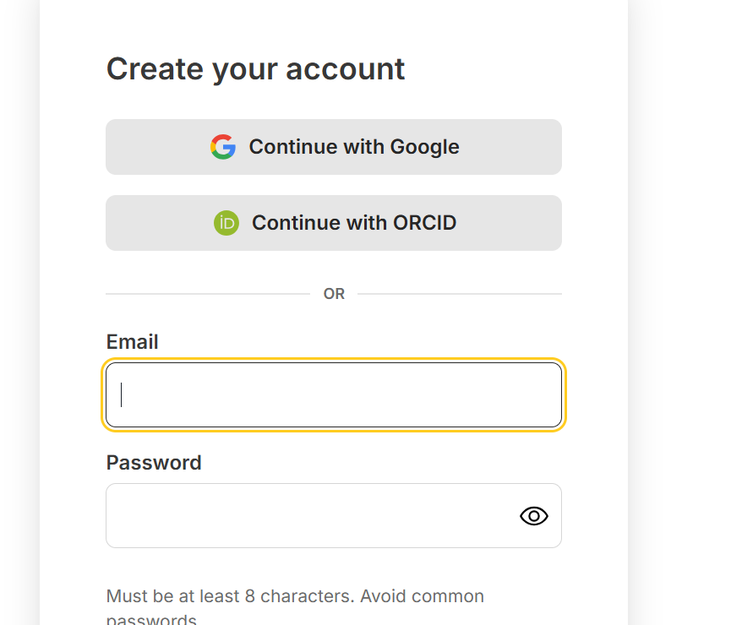
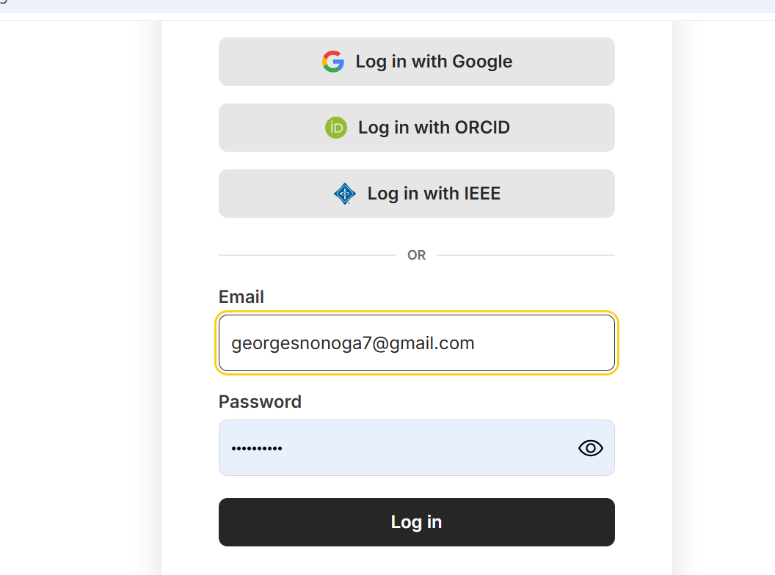
alt text
First document LateX on overleaf 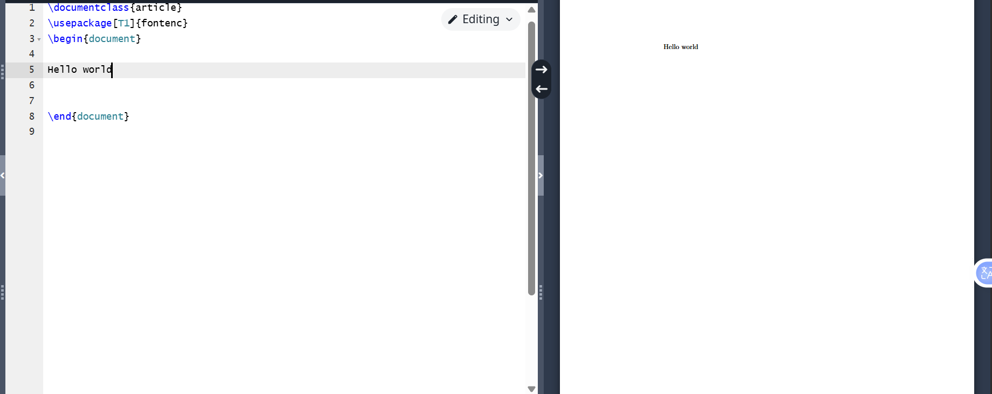

Conclusions
Conclusions
I have become familiar with the LaTeX language.

