Practical scientific writing
  - Laboratory Work No. 3
NONOGA Djintoba
February 09, 2026

Objective of the Work
To become familiar with the LaTeX language and continue studying its capabilities.

Task
- Launch several different programs, study a new package for working with graphics and new language commands.

Execution of Laboratory Work
Start working with a new package. To add graphics from an external source to LaTeX, we use the graphicx package, which adds the ’ includegraphics command to LaTeX.
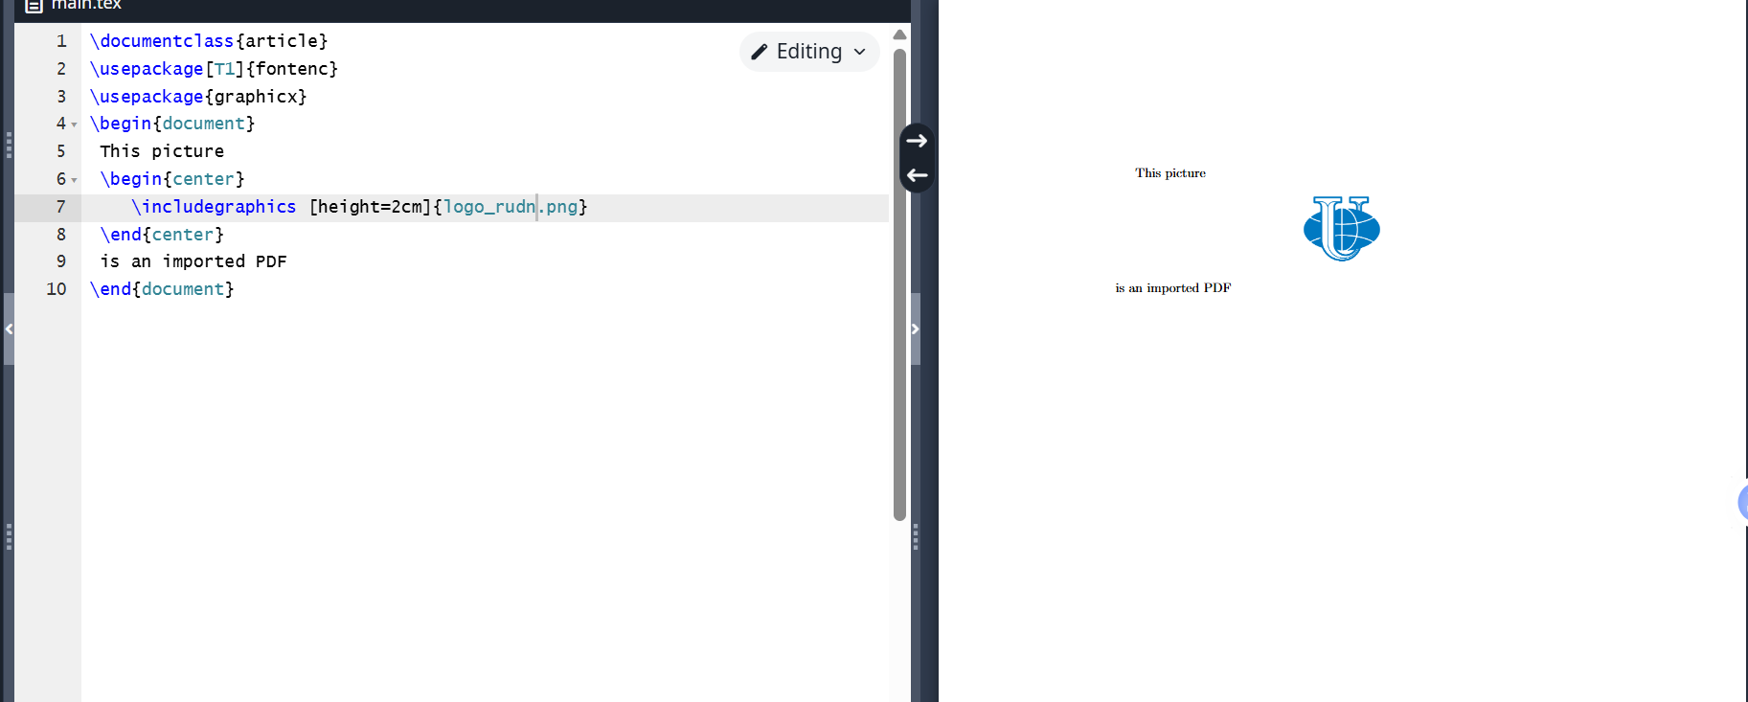
Program 1
Try changing the image’s height and width. LaTeX automatically scales the image to preserve its aspect ratio.
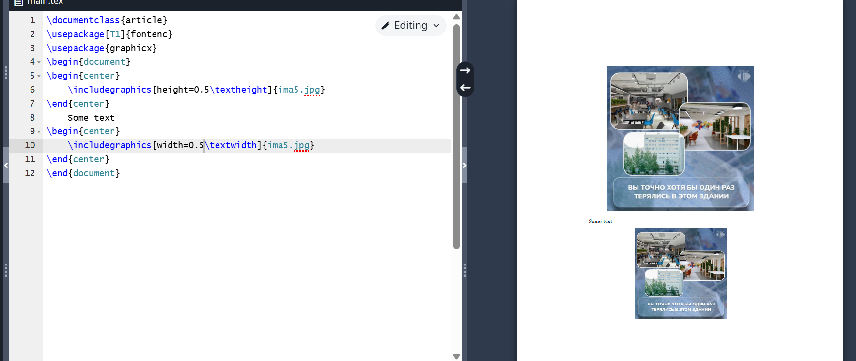
Program 2
We can not only change the width and height of the image but also crop it and rotate it at various angles.
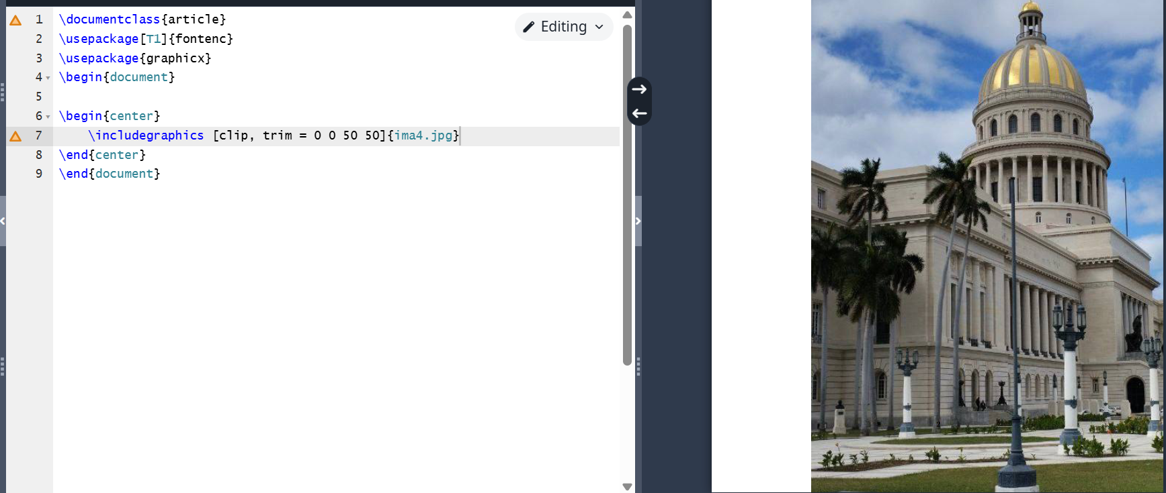
Program 3
Graphical elements can be moved to another place in the document. This is called a floating element. Let’s try implementing this in a program.
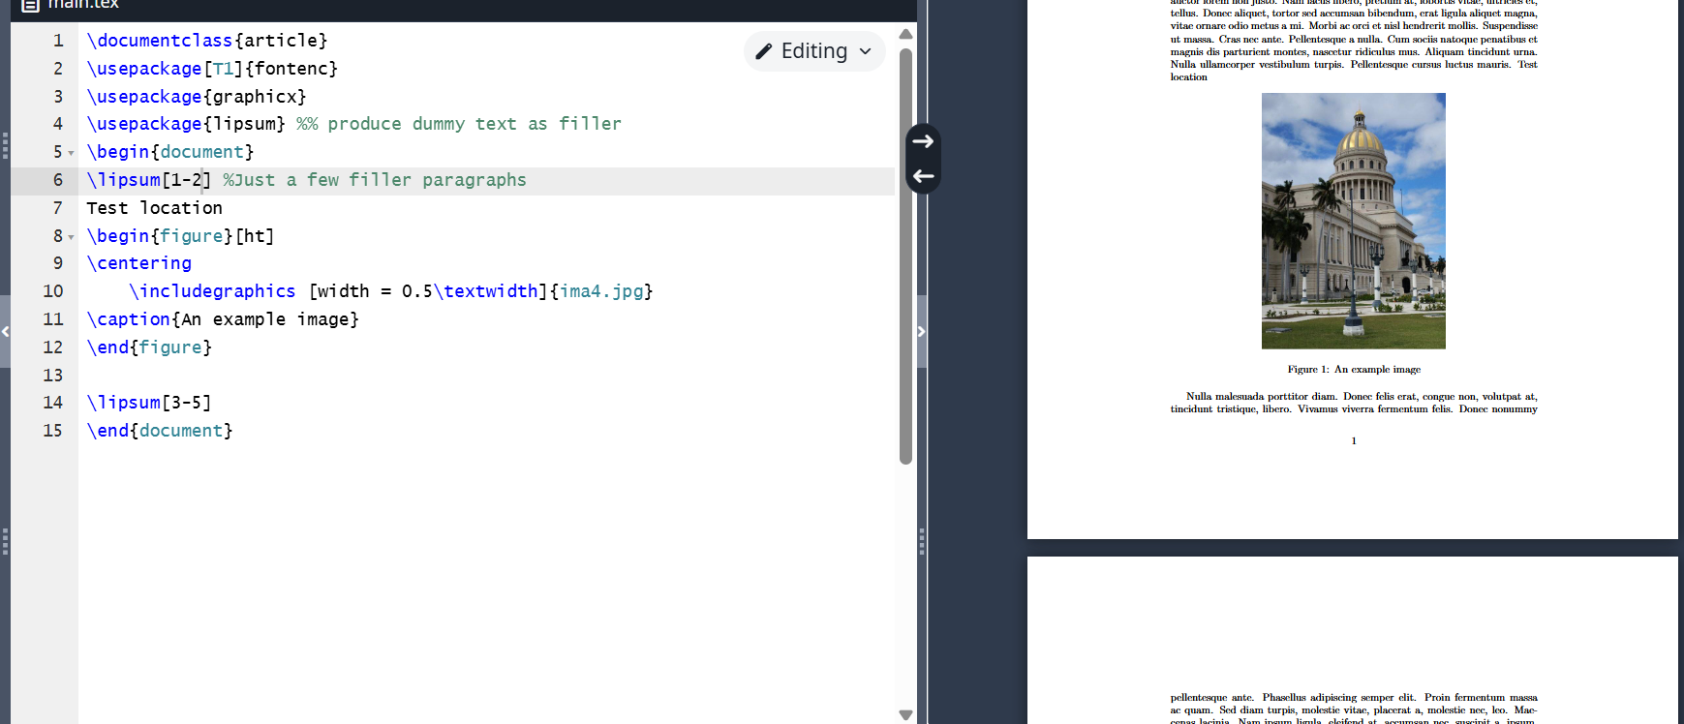
Program 4
Often, it is required for a figure to appear in the output exactly where it is placed in the input data. The float package allows this to be done using the H option.
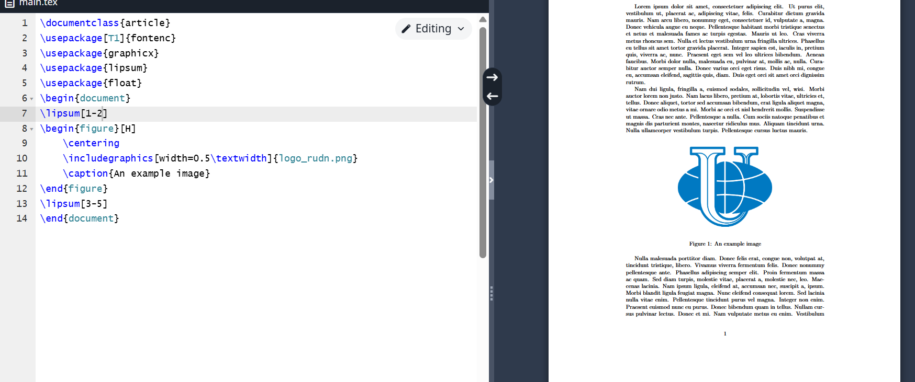
Program 5
If we need several environments, this can be done using the trivfloat package. It provides a single command trivfloat for creating new types of floating environments.
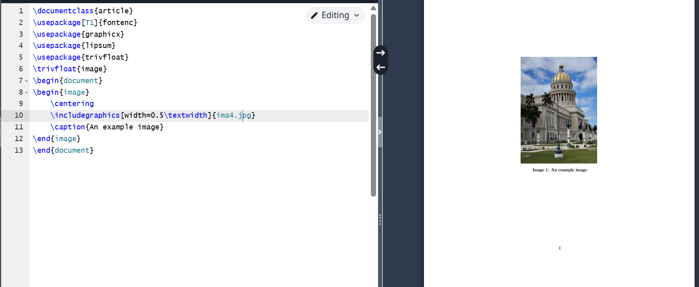
Program 6
For LaTeX to remember a place in the document, it needs to be marked and then referenced from other places.
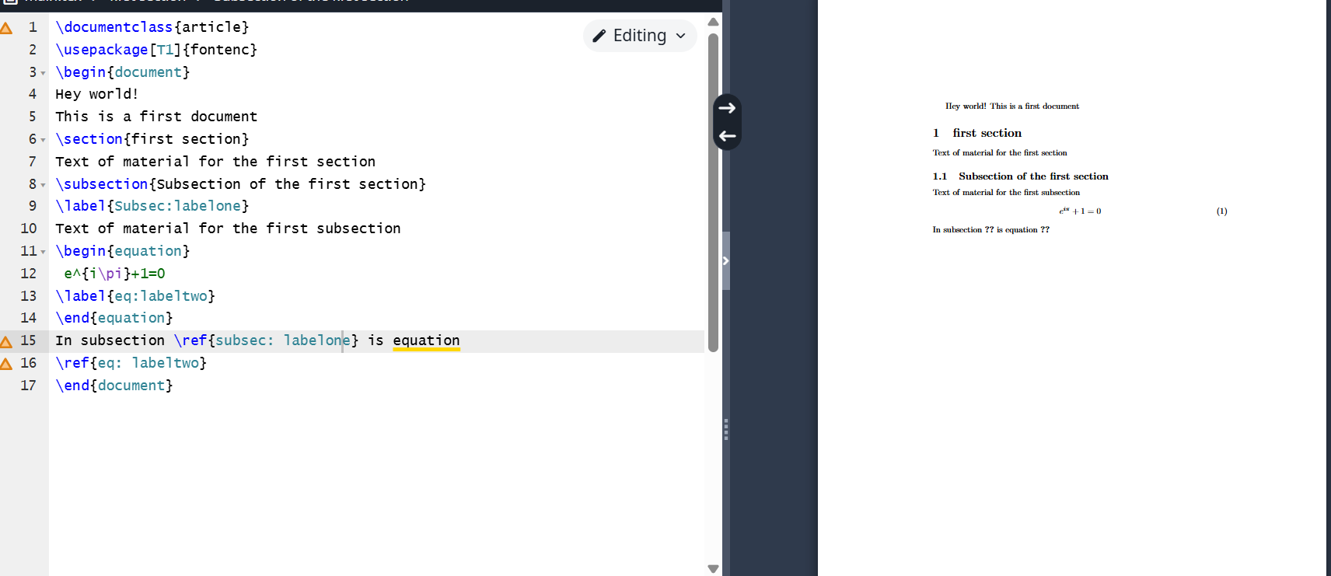
Program 7
Turn cross-references into hyperlinks using the hyperref package. It should be noted that if we place a reference outside of a chapter, it will neither display nor function.
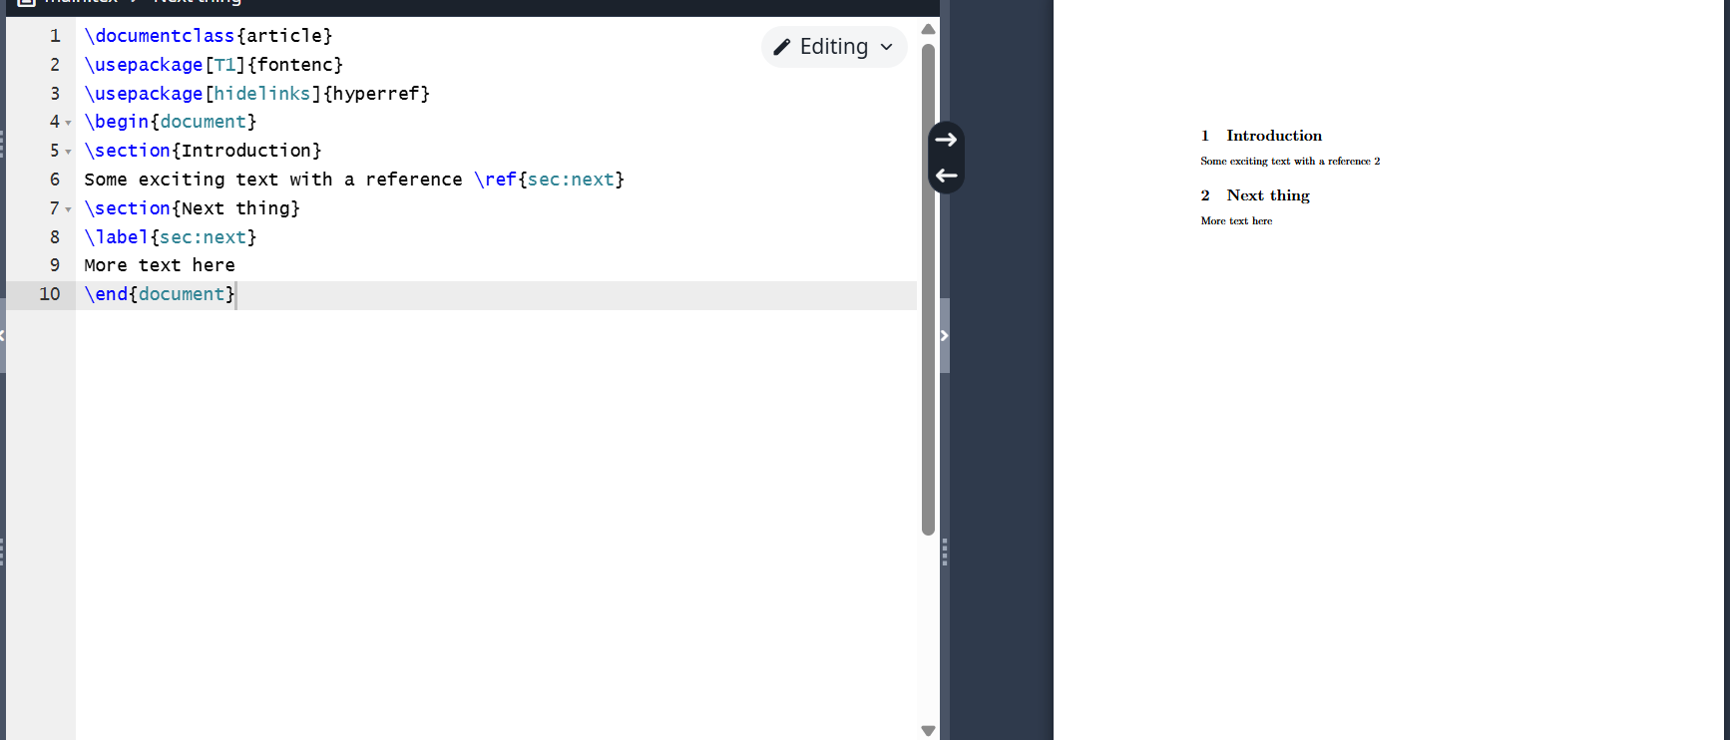
Program 8
The programs work correctly.

Conclusions
I became familiar with the LaTeX language and continued studying its capabilities.

