Practical scientific writing
  - Laboratory Work No. 6
NONOGA Djintoba
February 11, 2026

Purpose of the work
To become familiar with the LaTeX language and further explore its capabilities.

Task
- Launch several different programs, learn a new presentation package and new language commands.

Completing the lab
Let’s get started with a new package. In LaTeX, you can create presentations using the beamer document class. To create slides, you can use the frame environment with the slide title as the only argument.
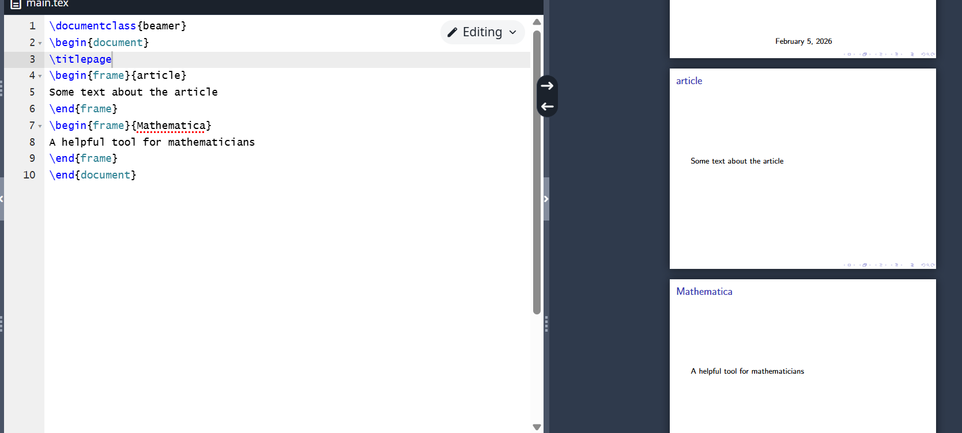
Program 1
To organize information in a presentation, you can use boxes, columns, lists, and bulleted lists.
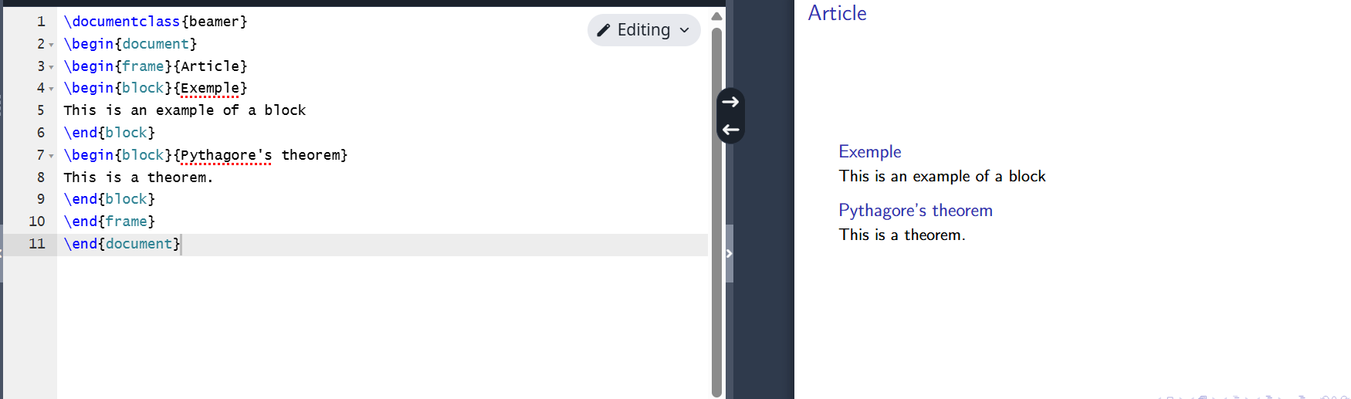
Program 2
To make slide elements appear one after another, use pause. This command can be placed almost anywhere in the code.
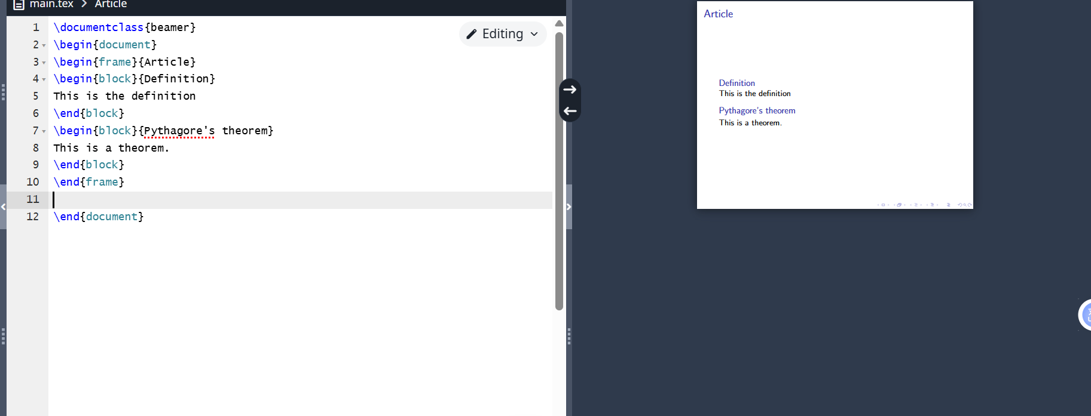
Program 3
or in a list.
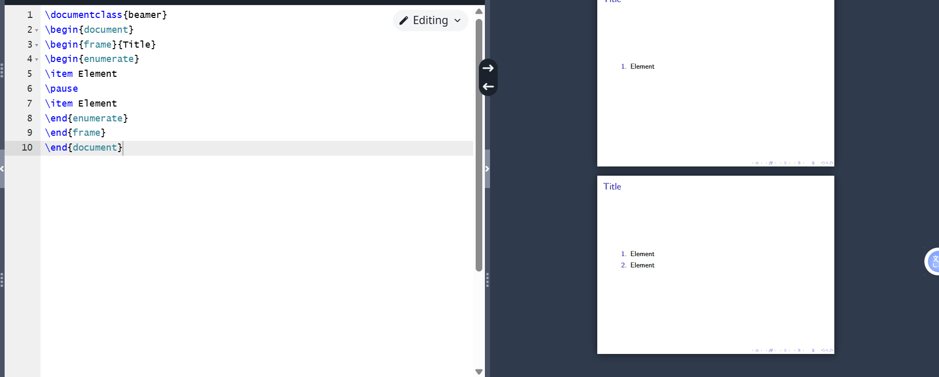
Program 4
The uncover command allows you to precisely control when each section of a slide is displayed. This command is more flexible than the pause command. Below is an example of using the uncover command.
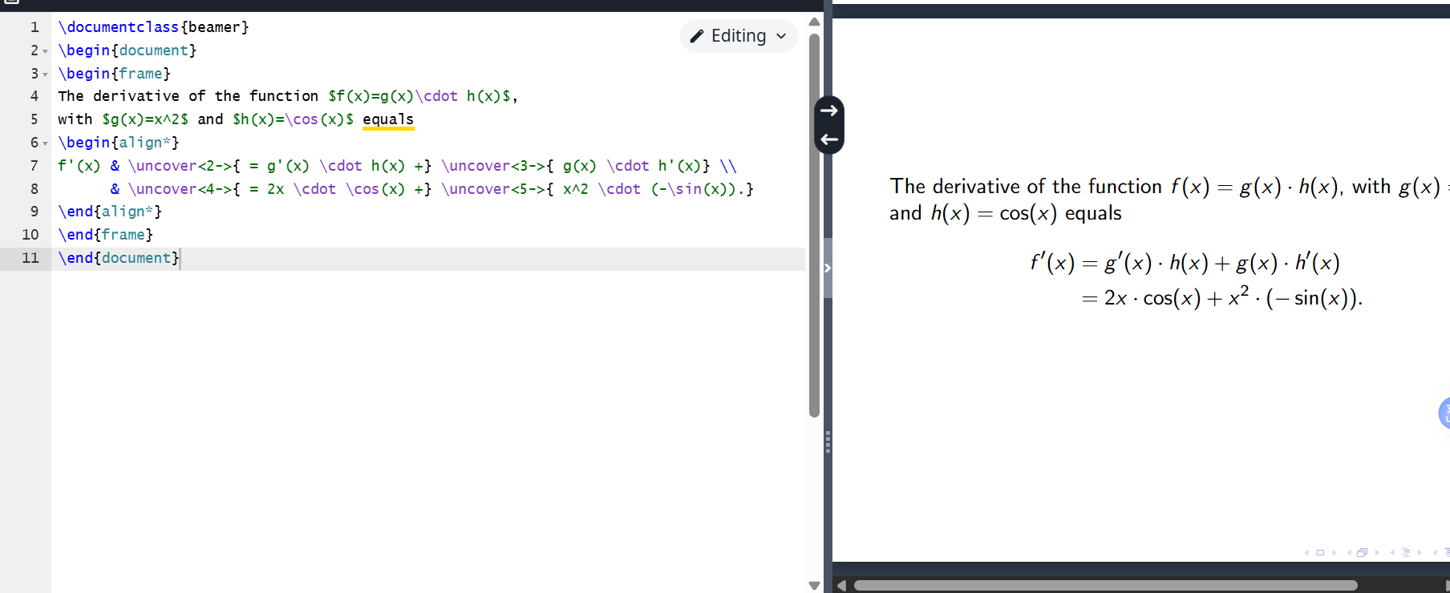
Program 5
There are many different ways to transfer the general structure of a poster into LaTeX. Here’s one of them.
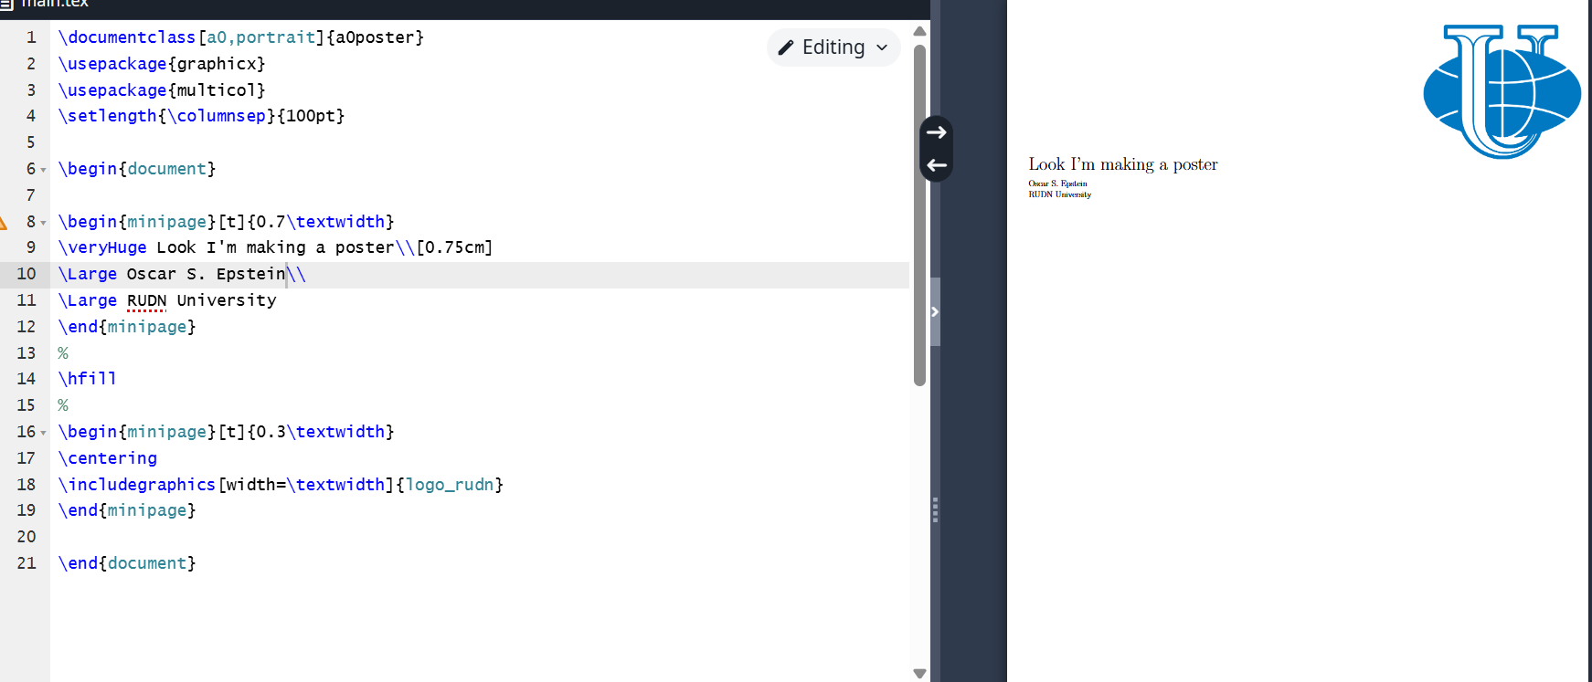
Program 6
The programs work correctly.

Conclusions
I became familiar with the LaTeX language and continued exploring its capabilities.

