Practical scientific writing
  - Laboratory Work No. 8
NONOGA Djintoba
February 11, 2026

Purpose of the work
To become familiar with the LaTeX language and further explore its capabilities.

Task
Run several different programs, learn a new graphics package and new language commands.

Completing the Lab
We’re starting to work with the new package. The graph consists of several points and lines. We begin constructing the graph by determining the coordinates of the points. See the figure below.
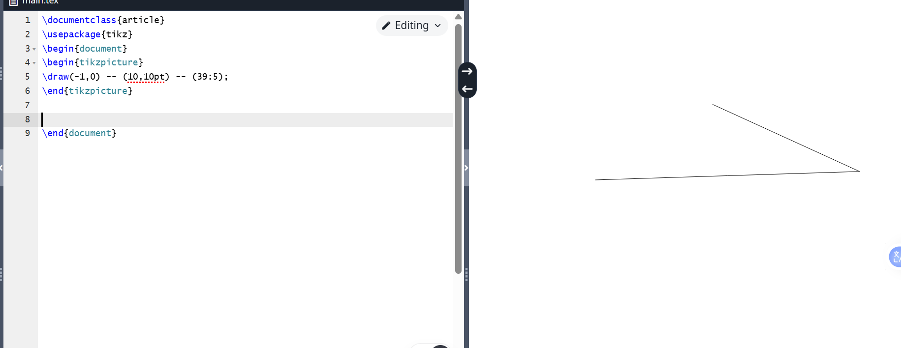
Program 1
In addition to drawing straight lines, we can create other types of lines that can be customized with color, thickness, or pattern. See the image below.
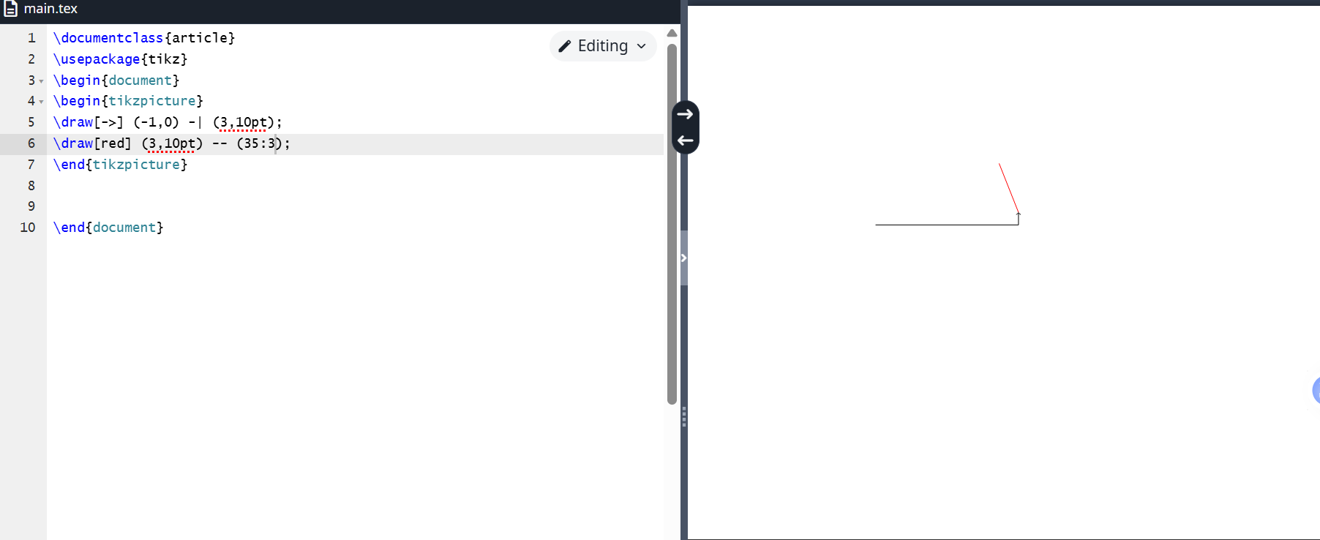
Program 2
We can draw not only straight lines, but also curved lines. See the drawing below.
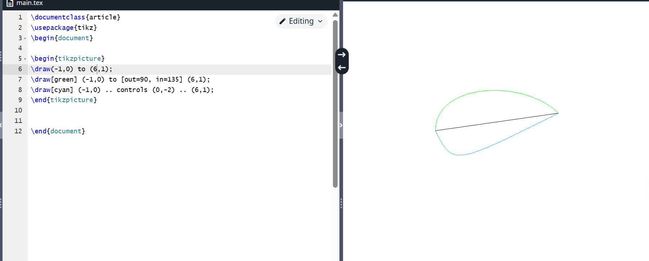
Program 3
The next step in the graph layout is to add labels, text fragments, and numbers to the image. See the image below.
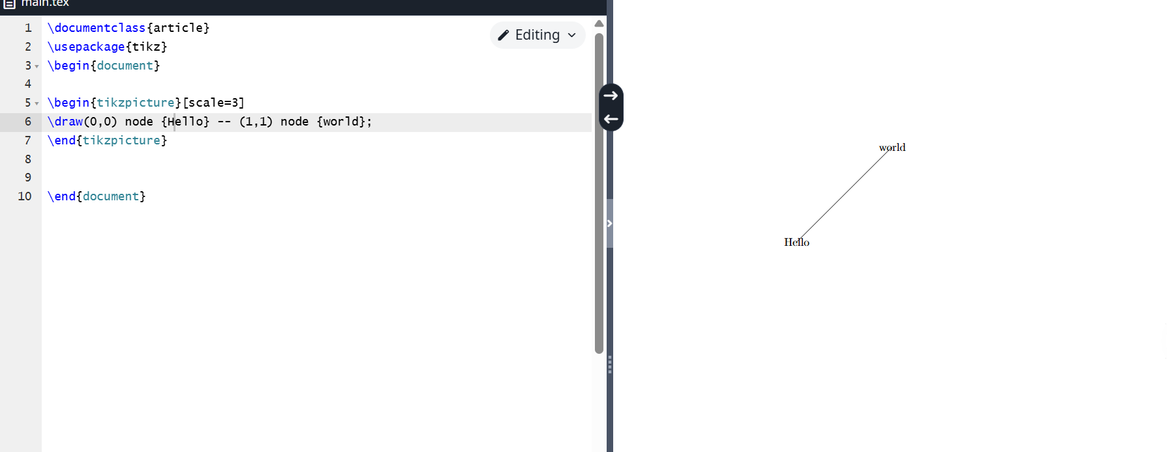
Program 4
Nodes can also be assigned mathematical formulas, and, as mentioned earlier, they can be outlined with a simple line. See the image below.
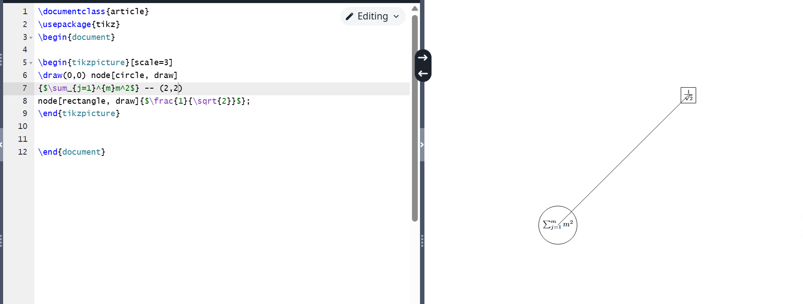
Program 5
Let’s try creating a complex graph with many different elements. See the figure below.
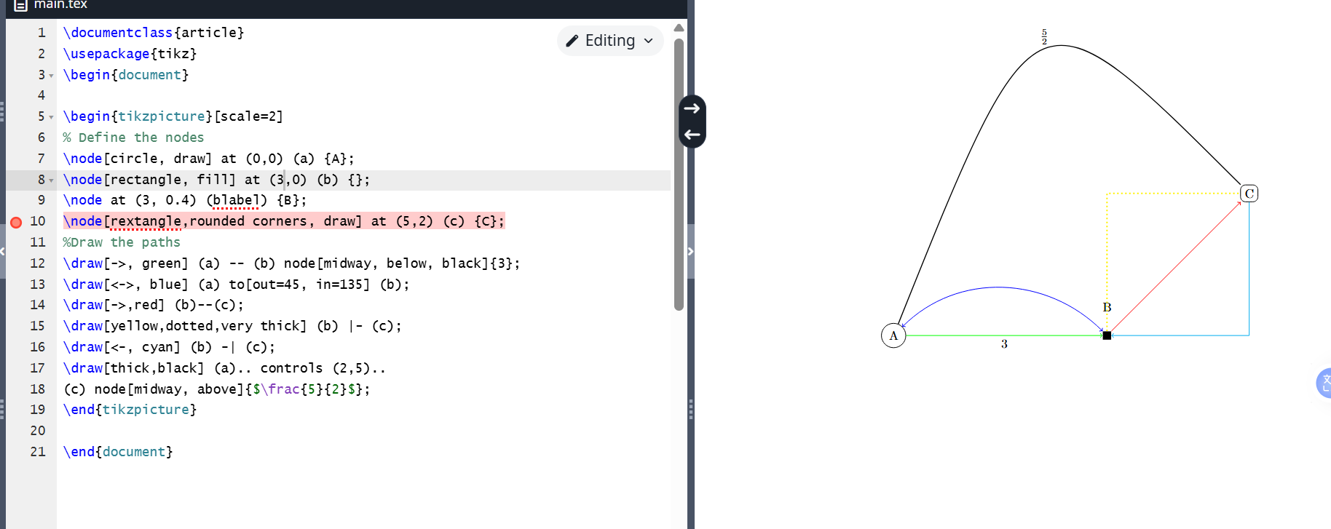
Program 6
TikZ also supports for loops using the foreach command. See the image below.
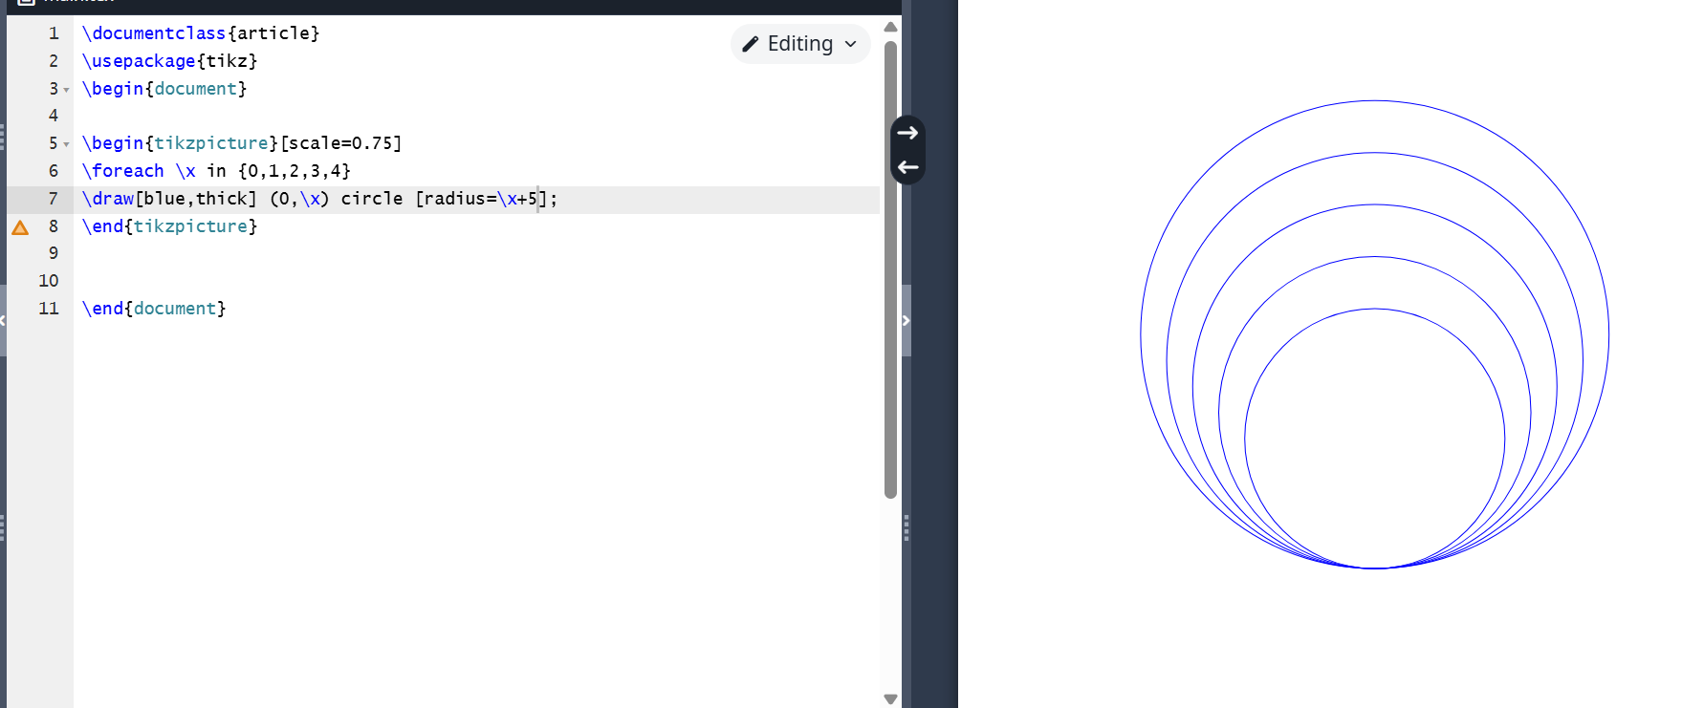
Program 7
The programs work correctly.

Conclusions
I became familiar with LaTeX and continued exploring its capabilities.

