

TASK2

:

REQUI

REMENT GATHERING OF A BIOMETRIC

STUDENT’S

ATTENDANCE

MOBILE APPLICATION



**REPUBLIQUE DU**

**CAMEROUN**

***PAIX***

***–***

***TRAVAIL***

***–***

***PATRIE***

**MINISTERE DE**

**L’ENSEIGNEMENT**

**SUPERIEUR**

**REPUBLIC OF CAMEROON**

***PEACE***

***–***

***WORK***

***–***

***FATHERLAND***

**MIN**

**ISTRY OF HIGHER**

**EDUCATION**

**PRESENTED BY: GROUP 19**

|  |  |  |
| --- | --- | --- |
| **NAME** | **MATRICULE** | **SPECIALTY** |
| AMARACHUKWU GODLOVE AHANONU | FE21A136 | SE |
| DJITUE TOGUE BRINDA SPACHELLE | FE21A171 | SE |
| NKEMCHOU PIANKE OLIVIER | FE21A275 | SE |
| REOUTADE ROLAND | FE21A301 | SE |
| TEGUE NONO MIKEL MODEIRO | FE21A321 | SE |

**INSTRUCTOR: Dr. NKEMENI VALERY APRIL 2024**

Table of content

1.0 INTRODUCTION 2

1.1 Biometric Student Attendance Mobile Application 2

1.2 Requirement Gathering 3

1.2.1 What is Requirement Gathering? 3

2.0 REASONS FOR REQUIREMENT GATHERING 4

3.0 REQUIREMENT GATHERING PROCESSES 4

3.1 ASSIGNING ROLES 5

3.1.1 Technique Used 5

i. Brainstorming (during meeting sessions) 5

3.2 DEFINE THE PROJECT SCOPE 6

3.2.1 Technique Used 6

i. Document analysis 6

a) Objectives 6

b) Boundaries 6

c) Limitations 6

ii. Interview 6

3.3 CONDUCT STAKEHOLDER’S INTERVIEWS 6

3.3.1 Technique Used 7

i. Interview 7

ii. Using Google forms 7

3.4 GATHER AND DOCUMENT 12

3.4.1 Technique Used 12

i. Workshops 12

3.5 VERIFY AND VALIDATE 15

3.5.1 Verification 15

3.5.2 Validation 15

3.6 PRIORITIZE REQUIREMENTS 16

4.0 BENEFIT OF REQUIREMENT GATHERING 17

5.0 PROBLEM FACED DURING REQUIREMENT GATHERING 18

6.0 CONCLUSION 19

7.0 REFERENCE 20

## 1.0 INTRODUCTION

## 1.1 Biometric Student Attendance Mobile Application

Attendance is a concept that exists in different places like institutions, organizations, hospitals, etc. during the start and end of the day to mark a person’s presence. In early days and even now in many places’ attendance is recorded manually in attendance registers by calling out the names. This results in waste of time and human effort. Also, there are many fraudulent issues that happen when we use a register. For example, in educational institution, the teacher calls out the names of the student’s one after the other and marks their presence after they answer. The other way that is followed is the teacher passes the attendance sheet around the class for the students to sign besides their names. But these methods have a major drawback where the students tend to answer or sign for their friends who are not present for that day. These fraudulent issues may become more frequent if the class strength is high.

A solution to overcome these problems is by using a system that will record the attendance automatically. This project presents a fingerprint based biometric system that records the attendance automatically. For example, in educational institutions, the student needs to place their finger on the fingerprint sensor to obtain their attendance. The fingerprint captured is recorded and then each time it is checked whether the obtained fingerprint matches with the recorded one after which the student gets the attendance. By making use of this system, we overcome the issues such as proxy so no student can give attendance for their friends who are absent. Furthermore, it reduces stress and increase attendance accuracy.

**Taking attendance manually:**



Figure1: Class Delegate calling one name after the other

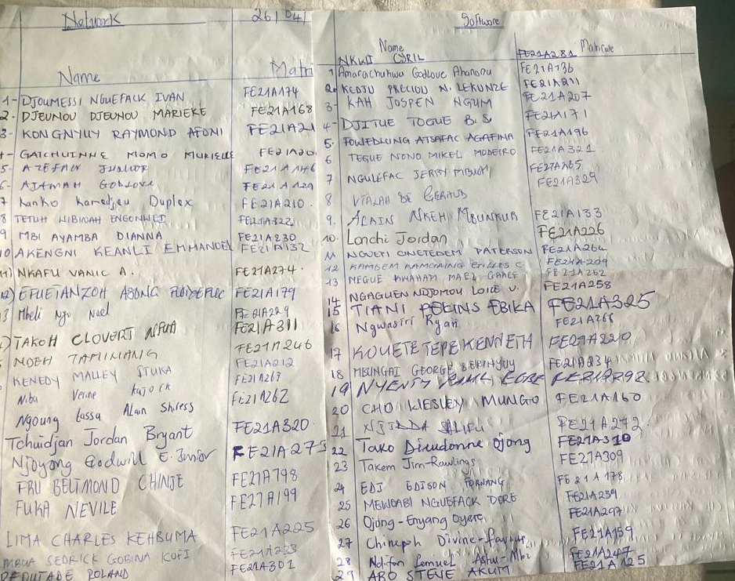

Figure2: Passing typing sheets around the class for students to write their names

## 1.2 Requirement Gathering

In the world of software development, the success of a project relies heavily on a crucial yet often overlooked phase: **Requirement Gathering**. This initial stage acts as the foundation for the entire development life cycle, steering the course of the software and ultimately determining its success. Let’s explore why requirement gathering is so important, what its key components are, and how it profoundly influences the overall development process.

### 1.2.1 What is Requirement Gathering?

Requirements gathering is a crucial phase in the software development life cycle (SDLC) and project management. It is the act of generating a list of requirements to define what a project is about and its goal. You can gather insights from the stakeholders, whether they are clients, employee users, consumers or vendors. Requirement gathering often acts as the blueprints of a project. Poorly established requirements can have a negative impact, while properly established ones can lead to success. The success of a project often depends on the accuracy and completeness of the gathered requirements in software.

## 2.0 REASONS FOR REQUIREMENT GATHERING

* **Understanding Stakeholder Needs**: Requirement gathering ensures that the project team understands the needs, expectations, and constraints of stakeholders, including end-users, customers, business owners, and regulatory authorities.
* **Minimizing Risks and Errors:** By identifying and documenting requirements accurately, the likelihood of misunderstandings, miscommunications, and errors during the development process is reduced, leading to a more efficient and successful project outcome.
* **Guiding Development Decisions:** Clear and comprehensive requirements provide a roadmap for development activities, guiding decisions related to design, implementation, testing, and deployment. This ensures that the final product aligns with stakeholder expectations and business goals.
* **Managing Scope Creep:** Requirement gathering helps in defining the project scope and boundaries, making it easier to manage scope creep by identifying and addressing changes in requirements early in the development process.
* **Enhancing Customer Satisfaction:** By delivering a product that meets or exceeds user expectations, requirement gathering contributes to higher customer satisfaction and loyalty, leading to positive reviews, referrals, and long-term business success.

## 3.0 REQUIREMENT GATHERING PROCESSES

Requirement gathering processes refer to the various steps and methods used to collect, understand, and document the needs and expectations of stakeholders regarding a project, product, or service. These processes are essential for clearly defining what needs to be accomplished and ensuring that the final outcomes meet the agreed-upon requirements and objectives. Requirement gathering techniques may include stakeholder interviews, questionnaires, workshops, field observations, and other methods aimed at gathering valuable insights into user needs, constraints, and preferences. Once the requirements are gathered, they are typically documented in a specification document to guide project planning and execution. There are **six** crucial steps for requirement gathering:

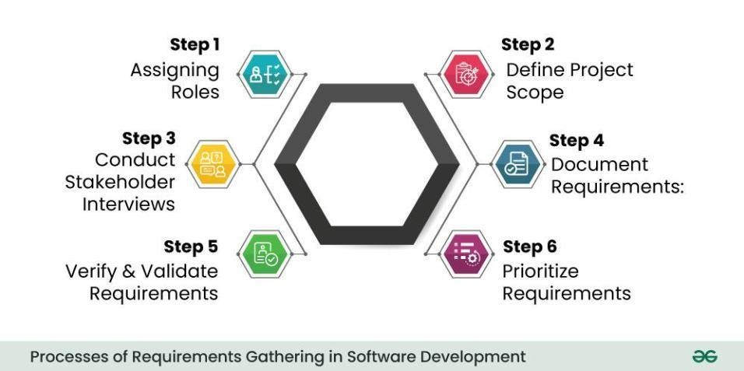

## 3.1 ASSIGNING ROLES

This is the first step in the gathering of requirements which involves the proper identification of the various stakeholders involved. A stakeholder is anyone invested in the project, whether they are internal or external partners. The stakeholders may include users, clients, project managers, project administrators, designers, product testers, and developers.

### 3.1.1 Technique Used

# i. Brainstorming (during meeting sessions)

During our meeting, we thoroughly analyze the project and identified several key stakeholders who will play crucial roles in the development and implementation of the biometric student attendance system. These stakeholders encompass a diverse range of individuals and groups with vested interests in the project's success. They include:

* **Students**: These are the primary stakeholders who will interact directly with the system. They will use the biometric system to mark their attendance quickly and accurately. Understanding their needs and ensuring user-friendliness is crucial.
* **Administration**: They are responsible for overseeing attendance management. They might need access to attendance records, reports, and analytics generated by the system. Their feedback on the system's usability and functionality is valuable.
* **Instructors:** Teachers or instructors are responsible for managing classes and monitoring attendance. They rely on the biometric system to accurately track student attendance, which helps them assess student engagement and participation.
* **Developers**: These are the individuals tasked with building and maintaining the software that powers the biometric attendance system. They will translate requirements into code, ensuring the system functions reliably and securely. In this project, the developers are AMARACHUKWU

GODLOVE, DJITUE BRINDA, NKEMCHOU PIANKE OLIVIER, REOUTADE ROLAND, and TEGUE MODEIRO (group members)

* **Product Testers/QA Team**: They are responsible for testing the system thoroughly before deployment. This includes unit testing (carry out by the developers), usability testing (carry out by the users in this case, students and lecturers), just to name a few, to identify and address any issues or bugs.
* **Designers:** Designers will create the user interface (UI) and user experience (UX) of the biometric attendance system. They will ensure that the interface is intuitive, accessible, and visually appealing to users. The designers in this project are the group members.
* **Project Manager:** Responsible for overseeing the entire project, ensuring it stays on track, and meets its objectives. He facilitates communication between different stakeholders and manage risks and resources effectively. The project manager of this project is NKEMCHOU PIANKE OLIVIER

By identifying and involving these stakeholders from the outset, we can ensure that their needs and concerns are addressed throughout the development and implementation of the biometric student attendance system.

## 3.2 DEFINE THE PROJECT SCOPE

Clearly define the scope of the project by outlining its **objectives**, **boundaries**, and **limitations**.

Write them down, State them clearly and get all your stakeholders to sign off on them.

### 3.2.1 Technique Used

# i. Document analysis

# a) Objectives

* This project aims to leverage biometric technology, especially fingerprint recognition, to create a secure reliable system for recording student attendance.
* The application will provide an intuitive interface for both students and instructors, allowing for seamless real-time attendance tracking (in not less more than 5 seconds) in classrooms and other academic settings.

# b) Boundaries

* The scope of the project includes the design, development, and deployment of the biometric attendance system for use in classrooms or designated attendance areas.
* The system will utilize biometric identifiers such as fingerprints, for student authentication.

# c) Limitations

* The project timeline is constrained to a four-month period from project initiation to project completion.
* The accuracy and reliability of the biometric attendance system may be affected by external factors such as environmental conditions and the quality of biometric data captured.

# ii. Interview

Conducting interviews with stakeholders (lecturers, students) to understand their needs, preferences, and expectations for the biometric student attendance application.

* Integration with existing student information systems (SIS) will be limited to the transmission of attendance data for record-keeping purposes.
* The project will not involve the collection or storage of sensitive biometric data beyond what is necessary for attendance tracking.

## 3.3 CONDUCT STAKEHOLDER’S INTERVIEWS

Once you have identified your project stakeholders, meet with them to have an idea of what they are hoping to get out of the project, through open-ended questions and discussions, aiming to uncover both explicit and implicit requirements. This provides a valuable insight into a better understanding of the project.

### 3.3.1 Technique Used

# i. Interview

Here we conducted interviews with some students and faculty instructors. This helped us to define what they expect and identify the exact requirements we need to launch the project. Their expectations include:

* **Accuracy and Reliability**: Users expect the biometric authentication system to be highly accurate and reliable in identifying students based on their biometric characteristics. False positives or false negatives can undermine the credibility of the attendance data.
* **Ease of Use**: The application should be intuitive and easy to use for both teachers and students. It should require minimal training and effort to record attendance using biometric authentication on a mobile device.
* **Customization and Flexibility**: Users may have different requirements and preferences for attendance management. The application should offer customization options and flexibility to adapt to various educational settings and workflows.

# ii. Using Google forms

We created Google forms to get requirements and expectations from both faculty instructors and students.

**Link of the Google form**:

[https://docs.google.com/forms/d/1AmzFtgheLmmHNyn6_g0y2ajIXozEIIpqDk72vX6NGGI/edi t?ts=6625f4e4](https://docs.google.com/forms/d/1AmzFtgheLmmHNyn6_g0y2ajIXozEIIpqDk72vX6NGGI/edit?ts=6625f4e4)

From the response, we could get the following expectations:

1. **Instructors**

The system should be capable of the following:

* + The system should be efficient
  + Permits a lecturer to login and select the course he/she wish to record attendance
  + Record attendance within 5 seconds
  + Capable of generating the percentage attendance per student, per course on a monthly, quarter, or semester.
  + Capable of generating a report of students who have an attendance percentage below a defined threshold.
  + Send email notifications to students whose attendance percentage in a month is below the prescribed threshold value.

1. **Students**

* Notify students on their attendance status.
* No one should be able to help the other mark their names when they are not there.
* Fast and easy to use.
* It should be very reliable, efficient (in terms of speed) so as to reduce the time spent to take attendance as well as to ensure proper user identification.
* The system should be able to correctly distinguish individuals so attendance records are fair.
* It should convinient to all.
* The system must be capable to confirm the presence of students who attend the lectures in that

particular day. It Will permit to easily track those who say they are present while they are not

* Reduce the malpractice.
* Taking attendance without errors.
* Have a nice and beautiful interface.
* Should be user friendly.
* Should be reliable.
* Should be Secured. Our finger print should be used only for the purpose of attendance.

**Administration**

* Enable administrators to observe the attendance rate for each course across weekly, monthly, quarterly, and semester periods.
  + Generate an exam list with the name of students who have an attendance percentage greater than or equal to 70%.

Below are found the images of the form that we created:

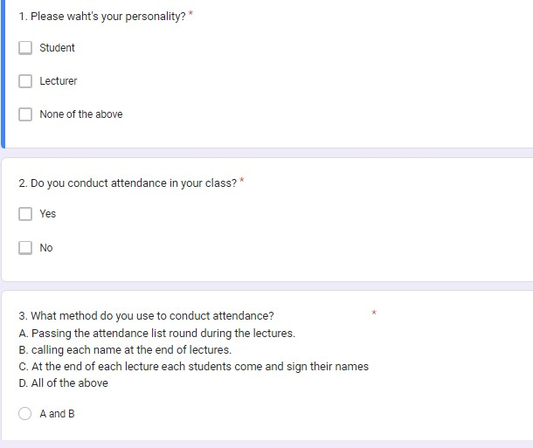

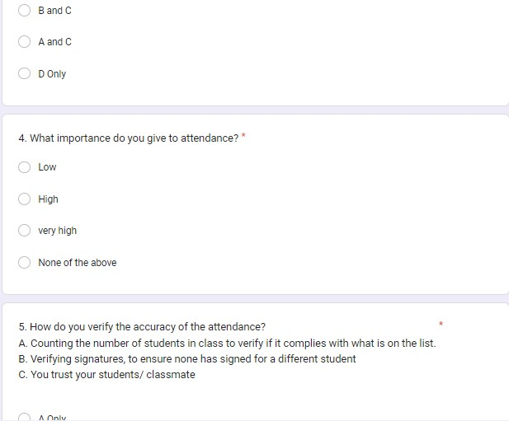

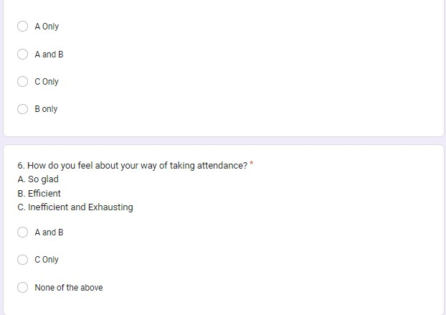

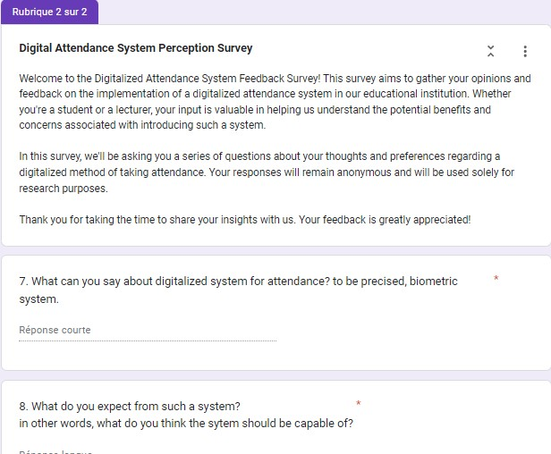

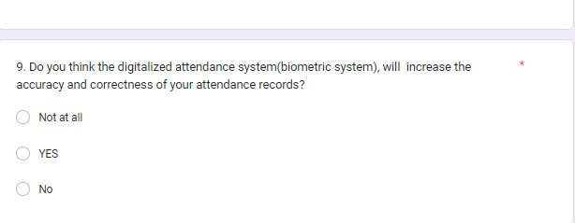

**Responses:**

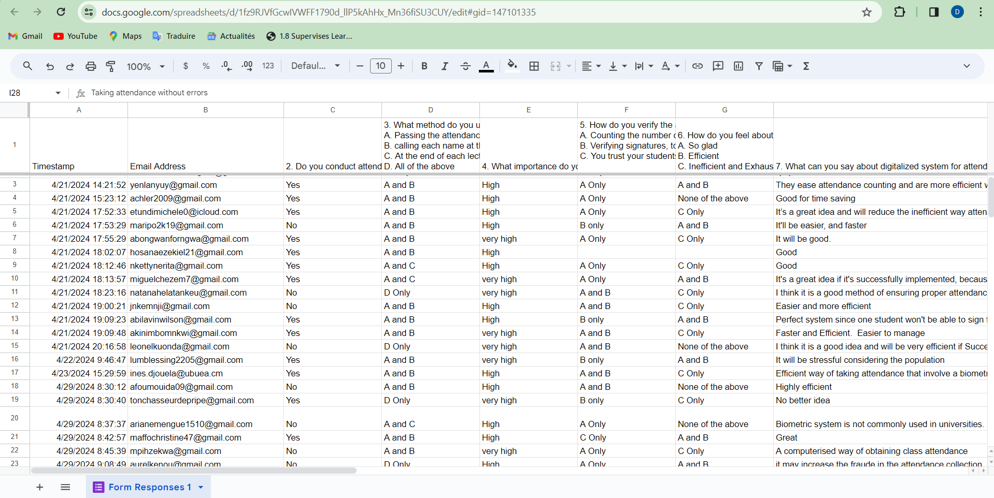

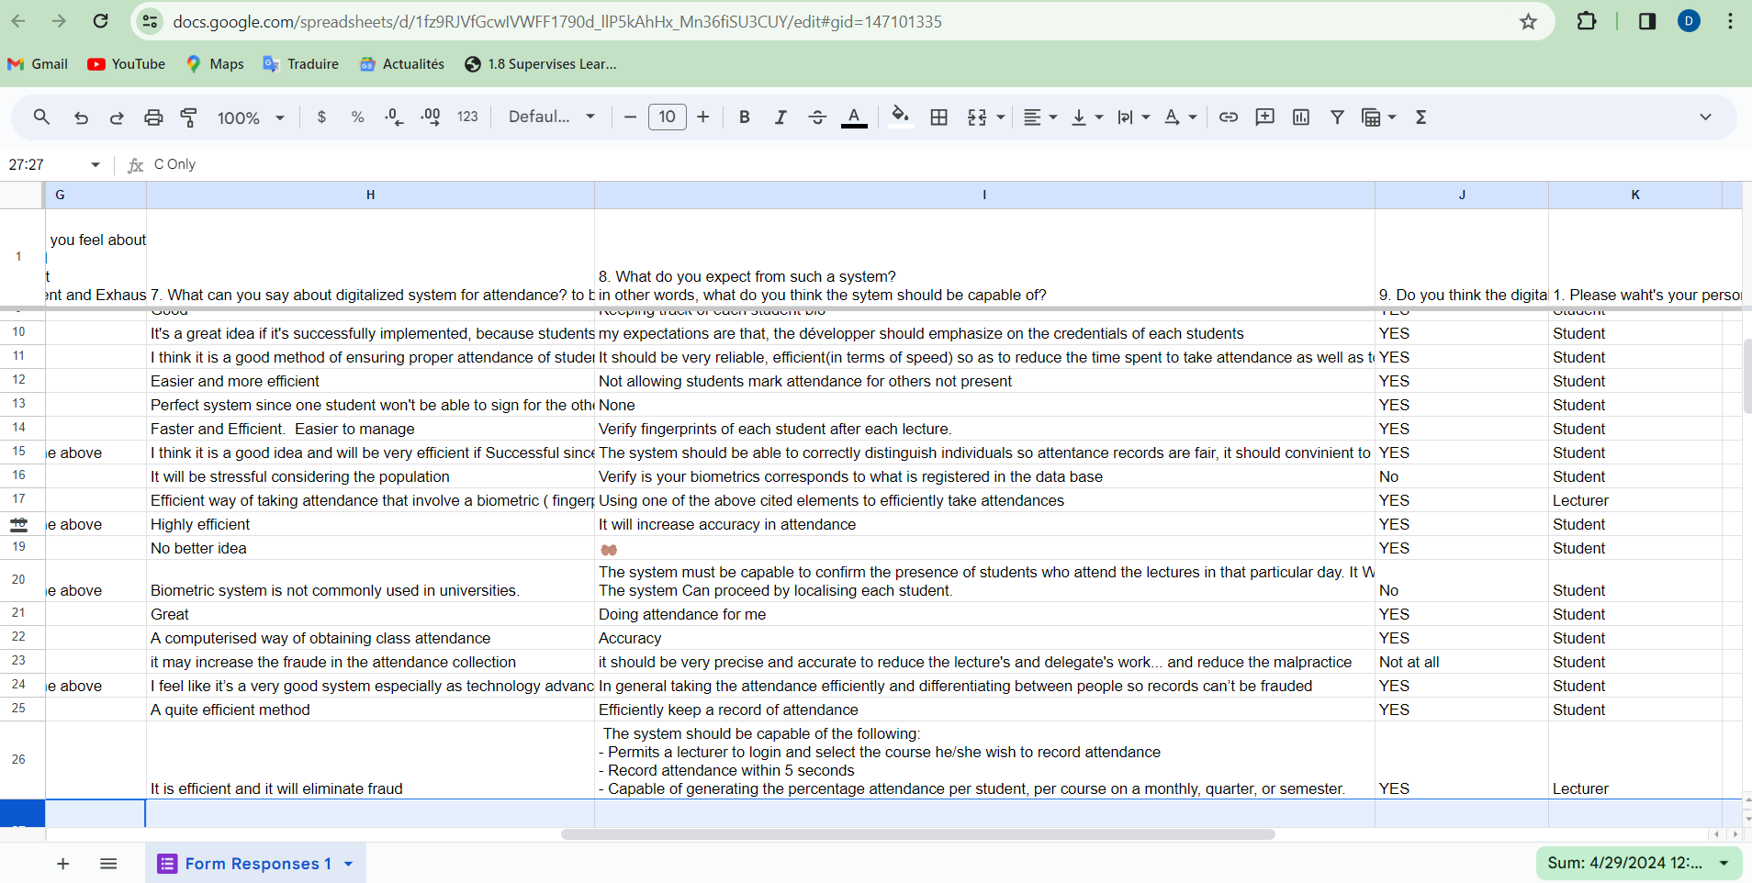

## 3.4 GATHER AND DOCUMENT

Systematically document the gathered requirements. This documentation can take various forms, such as user stories, use cases, or formal specifications.

### 3.4.1 Technique Used

# i. Workshops

Workshops were carried out by the group members to document the overall collected requirements from the previous steps.

|  |  |  |  |  |
| --- | --- | --- | --- | --- |
| **Stakeholders**  **Techniques** | **Interview** | **Form** | **Brainstorming** | **Research from existing work** |
| **Students** | Nice interface  Security  Confidentiality  Integrity  Record attendance in few seconds | Send notification on student’s status  Reliable  Taking attendance without errors.  Have a beautiful interface.  User friendly. | Use of biometric information only for attendance purpose.  Take attendance effectively | Fingerprint Enrollment: Students need to enroll their fingerprints into the system for attendance tracking.  Attendance Confirmation: Students should receive confirmation that their attendance has been recorded accurately after scanning their fingerprints. |
| **Instructors** | Easy to use  Flexible  Scalable  Efficient  Convertible to another format | Permits a lecturer to login and select the course he/she wish to record attendance  Efficient  Record attendance within 5 seconds  Capable of generating the percentage attendance per student, per course on a monthly, quarter, or semester.  Generate an exam list with the name of students who have an attendance percentage greater than or equal to 70%.  Send email notifications to students whose attendance percentage in a month is below the prescribed threshold value.  Capable of generating a report of students who have an attendance percentage below a defined threshold. | Each Instructor should have access to the courses that he/she teaches only  Efficient | The proposed system will provide a suite of information security features provided. Security features include the traditional confidentiality, authentication, integrity, availability and accountability. Security features are required in most application.  Access to Attendance Data: Instructors should have access to attendance data for their respective courses to monitor student participation and identify any patterns or issues. |
| **Administration** | Easy to use  Scalable  Efficient  Flexible  Provide student’s attendance status |  | Easy to use  Scalable  Efficient  Flexible | Visualization of Attendance Data: Administration should be able to visualize attendance percentages for courses on various time scales (weekly, monthly, quarterly, and semester) to monitor overall student engagement and identify trends.  Database Management: Administration should be able to oversees the management and maintenance of the attendance database, ensuring data integrity, security, and compliance with regulations. |
| **Developer team** |  |  | Easy to develop  Less expensive  Efficient  Offline usage | Scalability and Performance: Developers design the system to be scalable and performant, capable of handling large volumes of data and supporting growth in the number of users and attendance records.  Compliance and Regulations: Developers ensure that the system complies with relevant laws and regulations governing the collection, storage, and use of biometric data, implementing necessary security and privacy measures. |

## 3.5 VERIFY AND VALIDATE

Once the requirements are documented, it’s crucial to verify and validate them. Verification ensures that the requirements align with the stakeholders’ intentions, while validation ensures that the documented requirements will meet the project’s goals. This step often involves feedback loops and discussions with stakeholders to refine and clarify requirements.

### 3.5.1 Verification

* **Purpose:** Verification focuses on confirming that the documented requirements accurately represent stakeholders' intentions and are consistent, complete, and feasible.
* **Technique used:** Verification involves reviewing the documented requirements against established criteria to ensure they meet quality standards and align with project objectives. This may include:
  + **Requirement walkthroughs**: Conducting structured meetings or sessions where stakeholders review and discuss the documented requirements to ensure mutual understanding and agreement.
  + **Requirement traceability**: Establishing traceability links between requirements and their sources (e.g., stakeholder requests, business processes) to ensure comprehensive coverage and alignment.
* **Outputs:** The output of the verification process is a validated set of requirements that have been confirmed to accurately capture stakeholders' needs and expectations.

### 3.5.2 Validation

* **Purpose:** Validation focuses on ensuring that the documented requirements, once implemented, will effectively meet the project's goals and deliver the intended value to stakeholders.
* **Methods:** Validation involves assessing the documented requirements in the context of the project's objectives and constraints to determine their suitability and fitness for purpose. This may include:
  + **Prototyping**: Building prototypes or mockups of the system or solution to allow stakeholders to interact with and provide feedback on the proposed functionality and user experience.
  + **User acceptance testing** (UAT): Engaging stakeholders to perform hands-on testing of the implemented system against the documented requirements to verify that it meets their expectations and needs.
* **Outputs:** The output of the validation process is confirmation that the documented requirements, once implemented, will meet stakeholders' needs and contribute to the achievement of the project's objectives.

#### **Feedback Loops and Stakeholder Engagement**

* Throughout the verification and validation process, it is essential to maintain open lines of communication with stakeholders and actively solicit their feedback and input.
* Feedback loops allow for iterative refinement and clarification of requirements based on stakeholders' insights, changing priorities, or emerging requirements.
* Regular discussions, meetings, and demonstrations with stakeholders help ensure alignment and consensus on requirements, fostering a shared understanding and commitment to project success.

## 3.6 PRIORITIZE REQUIREMENTS

Prioritize the requirements based on their importance to the project goals and constraints. This step helps in creating a roadmap for development, guiding the team on which features to prioritize. Prioritization is essential, especially when resources and time are limited. We have a detailed explanation of how prioritization is carried out:

i. **Importance to Project Goals and Objectives**

* The first criterion for prioritizing requirements is their alignment with the project's goals and objectives. Requirements that directly contribute to achieving project success or addressing key stakeholder needs should be given higher priority.

For example, the primary goal of this system is to record attendance in real-time using biometric credentials of students thereby addressing attendance fraud or impersonation, will be prioritized accordingly

ii. **Stakeholder Input and Feedback**

* Stakeholder input and feedback play a crucial role in prioritizing requirements. Engage with stakeholders to understand their priorities, preferences, and expectations regarding project deliverables.
* Conducting stakeholder workshops, surveys, or interviews can help gather input on which requirements are most important to different stakeholders, allowing for informed prioritization decisions.

## 4.0 BENEFIT OF REQUIREMENT GATHERING

Requirements gathering is more than beneficial for your project—it’s essential. Can you remember why the last unsuccessful project you handled didn’t go well? Did you run out of resources or go over budget? Did you underestimate the time you’d need to complete the project? These are project risks that you can prevent when you follow the requirements gathering process.

There are many benefits of requirements gathering, which include:

1. **Improves stakeholder satisfaction**

When you follow an effective requirement gathering process, you improve stakeholder satisfaction by providing more on-target project deliverables. Your stakeholders will be happy when they know what to expect with your project.

1. **Increases project success rate**

Requirements gathering also increases your project success rate because the more prepared you are for your upcoming project, the less likely you are to encounter project risks.

1. **Reduces project costs**

Encountering project risks can lead to increased project costs. By avoiding these risks, you can reduce costs and stay within budget. You understandably don’t want to spend more money on a project than necessary, so this is a big benefit of requirements gathering.

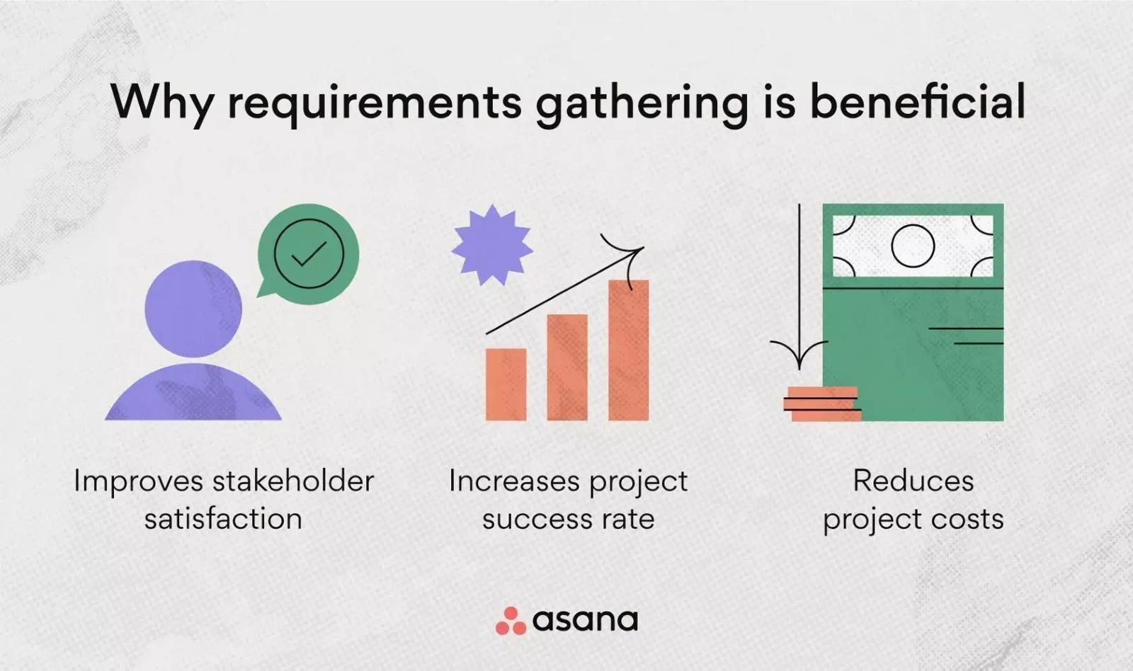

## 5.0 PROBLEM FACED DURING REQUIREMENT GATHERING

Requirement gathering is a crucial phase in any project, but it often comes with its fair share of challenges. Below are problems that we faced during requirement gathering:

**Electricity Problems**

* + It not only slows down the pace of work but also disrupts the use of essential electrical devices required for data collection.
  + Power outages may lead to data loss and interruptions during stakeholder meetings, causing delays in decision-making.

**Availability of Stakeholders**

* + Difficulty scheduling meetings with key stakeholders.
  + Delays in obtaining input from stakeholders

**Poor Internet Connection**

* + Unstable or slow internet connectivity poses a significant barrier to effective requirement gathering.
  + Difficulty accessing online collaboration tools, communication platforms, and document repositories hinder teamwork and information sharing.
  + It results to missed deadlines, communication breakdowns, and increased frustration among team members.
  + Inability to collect data or receive feedback online as planned disrupt the workflow.

## 6.0 CONCLUSION

In conclusion, requirement gathering stands as the cornerstone of software development projects, shaping their trajectory from inception to completion. It serves as the guiding light, ensuring alignment with stakeholders' needs, minimizing risks, and fostering customer satisfaction. By meticulously defining project scopes, conducting thorough stakeholder interviews, and prioritizing requirements, teams can navigate complexities effectively. While challenges such as stakeholder availability and technical hiccups may arise, the benefits of a robust requirement gathering process far outweigh these obstacles. Ultimately, investing time and effort into this foundational phase significantly enhances the likelihood of project success, propelling teams toward their objectives with clarity and confidence.

## 7.0 REFERENCE

* [https://www.jamasoftware.com/requirements-management-guide/requirementsgathering-andmanagement-processes/what-is-requirements-gathering v](https://www.jamasoftware.com/requirements-management-guide/requirements-gathering-and-management-processes/what-is-requirements-gathering)isited on the April 17, 2024
* [https://www.geeksforgeeks.org/requirements-gathering-introduction-processesbenefits-and-tools/](https://www.geeksforgeeks.org/requirements-gathering-introduction-processes-benefits-and-tools/) visited on the April 17, 2024
* <https://asana.com/resources/requirements-gathering>visited on the April 17, 2024
* [https://www.sdd-technology.com/blog/mobile-app-development-process-step-by-stepguide](https://www.sdd-technology.com/blog/mobile-app-development-process-step-by-step-guide) visited on the April 17, 2024
* <https://dev.co/mobile/preparation>visited on the April 17, 2024