**­­­­**

**REPUBLIC OF CAMEROON**

***PEACE – WORK – FATHERLAND***

**MINISTRY OF HIGHER EDUCATION**

**REPUBLIQUE DU CAMEROUN**

***PAIX – TRAVAIL – PATRIE***

**MINISTERE DE L’ENSEIGNEMENT SUPERIEUR**



TASK2: REQUIREMENT GATHERING OF A BIOMETRIC STUDENT’S ATTENDANCE MOBILE APPLICATION

**PRESENTED BY: GROUP 19**

|  |  |  |
| --- | --- | --- |
| **NAME** | **MATRICULE** | **SPECIALTY** |
| AMARACHUKWU GODLOVE AHANONU | FE21A136 | SE |
| DJITUE TOGUE BRINDA SPACHELLE | FE21A171 | SE |
| NKEMCHOU PIANKE OLIVIER | FE21A275 | SE |
| REOUTADE ROLAND | FE21A301 | SE |
| TEGUE NONO MIKEL MODEIRO | FE21A321 | SE |

**APRIL 2024**

**INSTRUCTOR: Dr. NKEMENI VALERY**

Table of content

**1.0** **INTRODUCTION** 2

1.1Biometric Student Attendance Mobile Application 2

1.2 Requirement Gathering 2

1.2.1 What is Requirement Gathering? 2

**2.0 REASONS FOR REQUIREMENT GATHERING** 2

**3.0 REQUIREMENT GATHERING PROCESSES** 3

3.1 ASSIGNING ROLES 4

3.1.1 Technique Used 4

i. Workshop (meeting sessions) 4

3.2 DEFINE THE PROJECT SCOPE 4

3.2.1 Technique Used 5

i. Document analysis 5

a) Objectives 5

b) Boundaries 5

c) Limitations 5

3.3 CONDUCT STAKEHOLDER’S INTERVIEWS 5

3.3.1 Technique Used 5

i. Interview 5

ii. Using Google forms 5

3.4 GATHER AND DOCUMENT 9

3.4.1 Technique Used 9

i. Workshops 9

ii. Document analysis 14

3.5 VERIFY AND VALIDATE 14

3.5.1 Verification 14

3.5.2 Validation 14

3.6 PRIORITIZE REQUIREMENTS 15

**4.0 BENEFIT OF REQUIREMENT GATHERING** 16

**5.0 PROBLEM FACED** 17

**6.0 CONCLUSION** 18

**7.0 REFERENCE** 19

# **INTRODUCTION**

# 1.1Biometric Student Attendance Mobile Application

In modern educational institutions, effectively managing student attendance is essential for monitoring student engagement and ensuring accountability. Traditional methods like manual roll calls are often inefficient, prone to errors, and susceptible to misuse or fraud. To overcome these challenges, this project suggests creating a Biometric Student Attendance Mobile Application. This initiative seeks to utilize biometric technology, particularly **fingerprint recognition**, to establish a secure and dependable system for tracking student attendance.

# 1.2 Requirement Gathering

In the world of software development, the success of a project relies heavily on a crucial yet often overlooked phase: **Requirement Gathering**. This initial stage acts as the foundation for the entire development life cycle, steering the course of the software and ultimately determining its success. Let’s explore why requirement gathering is so important, what its key components are, and how it profoundly influences the overall development process.

# 1.2.1 What is Requirement Gathering?

Requirements gathering is a crucial phase in the software development life cycle (SDLC) and project management. It is the act of generating a list of requirements to define what a project is about and its goal. You can gather insights from the stakeholders, whether they are clients, employee users, consumers or vendors. Requirement gathering often acts as the blueprints of a project. Poorly established requirements can have a negative impact, while properly established ones can lead to success. The success of a project often depends on the accuracy and completeness of the gathered requirements in software.

# **2.0 REASONS FOR REQUIREMENT GATHERING**

* **Understanding Stakeholder Needs**: Requirement gathering ensures that the project team understands the needs, expectations, and constraints of stakeholders, including end-users, customers, business owners, and regulatory authorities.
* **Minimizing Risks and Errors:** By identifying and documenting requirements accurately, the likelihood of misunderstandings, miscommunications, and errors during the development process is reduced, leading to a more efficient and successful project outcome.
* **Guiding Development Decisions:** Clear and comprehensive requirements provide a roadmap for development activities, guiding decisions related to design, implementation, testing, and deployment. This ensures that the final product aligns with stakeholder expectations and business goals.
* **Managing Scope Creep:** Requirement gathering helps in defining the project scope and boundaries, making it easier to manage scope creep by identifying and addressing changes in requirements early in the development process.
* **Enhancing Customer Satisfaction:** By delivering a product that meets or exceeds user expectations, requirement gathering contributes to higher customer satisfaction and loyalty, leading to positive reviews, referrals, and long-term business success.

# **3.0 REQUIREMENT GATHERING PROCESSES**

Requirement gathering processes refer to the various steps and methods used to collect, understand, and document the needs and expectations of stakeholders regarding a project, product, or service. These processes are essential for clearly defining what needs to be accomplished and ensuring that the final outcomes meet the agreed-upon requirements and objectives. Requirement gathering techniques may include stakeholder interviews, questionnaires, workshops, field observations, and other methods aimed at gathering valuable insights into user needs, constraints, and preferences. Once the requirements are gathered, they are typically documented in a specification document or similar artifact to guide project planning and execution. There are **six** crucial steps for requirement gathering

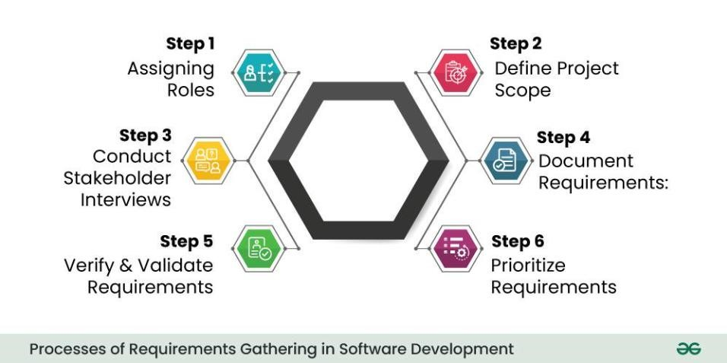

# 3.1 ASSIGNING ROLES

This is the first step in the gathering of requirements which involves the proper identification of the various stakeholders involved. A stakeholder is anyone invested in the project, whether they’re internal or external partners. The stakeholders may include users, clients, project managers, project administrators, designers, product testers, and developers.

# 3.1.1 Technique Used

1. Workshop (meeting sessions)

During our meeting, we thoroughly analyzed the project and identified several key stakeholders who will play crucial roles in the development and implementation of the biometric student attendance system. These stakeholders encompass a diverse range of individuals and groups with vested interests in the project's success. They include:

* **Students**: These are the primary stakeholders who will interact directly with the system. They will use the biometric system to mark their attendance quickly and accurately. Understanding their needs and ensuring user-friendliness is crucial.
* **Faculty and Staff**: They are responsible for overseeing attendance management. They might need access to attendance records, reports, and analytics generated by the system. Their feedback on the system's usability and functionality is valuable.
* **Developers**: These are the individuals tasked with building and maintaining the software that powers the biometric attendance system. They will translate requirements into code, ensuring the system functions reliably and securely. In this project, the developers are AMARACHUKWU GODLOVE, DJITUE BRINDA, NKEMCHOU PIANKE OLIVIER, REOUTADE ROLAND, and TEGUE MODEIRO(group members)
* **Product Testers/QA Team**: They are responsible for testing the system thoroughly before deployment. This includes unit testing (carry out by the developers), usability testing (carry out by the users in this case, students and lecturers), just to name a few, to identify and address any issues or bugs.
* **Designers:** Designers will create the user interface (UI) and user experience (UX) of the biometric attendance system. They'll ensure that the interface is intuitive, accessible, and visually appealing to users. The designers in this project are the group members.
* **Project Manager:** Responsible for overseeing the entire project, ensuring it stays on track, and meets its objectives. He facilitates communication between different stakeholders and manage risks and resources effectively. The project manager of this project is NKEMCHOU PIANKE OLIVIER

By identifying and involving these stakeholders from the outset, we can ensure that their needs and concerns are addressed throughout the development and implementation of the biometric student attendance system.

# 3.2 DEFINE THE PROJECT SCOPE

Clearly define the scope of the project by outlining its **objectives**, **boundaries**, and **limitations**. Write them down, State them clearly and get all your stakeholders to sign off on them.

# 3.2.1 Technique Used

# Document analysis

# Objectives

* This project aims to leverage biometric technology, especially fingerprint recognition, to create a secure reliable system for recording student attendance.
* The application will provide an intuitive interface for both students and instructors, allowing for seamless real-time attendance tracking (in not less more than 5 seconds) in classrooms and other academic settings.

# Boundaries

* The scope of the project includes the design, development, and deployment of the biometric attendance system for use in classrooms or designated attendance areas.
* The system will utilize biometric identifiers such as fingerprints, for student authentication.
* Integration with existing student information systems (SIS) will be limited to the transmission of attendance data for record-keeping purposes.
* The project will not involve the collection or storage of sensitive biometric data beyond what is necessary for attendance tracking.

# Limitations

* The project timeline is constrained to a four-month period from project initiation to project completion.
* The accuracy and reliability of the biometric attendance system may be affected by external factors such as environmental conditions and the quality of biometric data captured.

# 3.3 CONDUCT STAKEHOLDER’S INTERVIEWS

Once you’ve identified your project stakeholders, meet with them to have an idea of what they are hoping to get out of the project, through open-ended questions and discussions, aiming to uncover both explicit and implicit requirements. This provides a valuable insight into a better understanding of the project.

# 3.3.1 Technique Used

# Interview

Here we conducted interviews with some students and faculty instructors. This helped us to define what they expect and identify the exact requirements we need to launch the project.

# Using Google forms

We created Google forms to get requirements and expectations from both faculty instructors and students.

**Link of the Google form**: <https://docs.google.com/forms/d/1AmzFtgheLmmHNyn6_g0y2ajIXozEIIpqDk72vX6NGGI/edit?ts=6625f4e4>

Below are found the images of the form that we created:

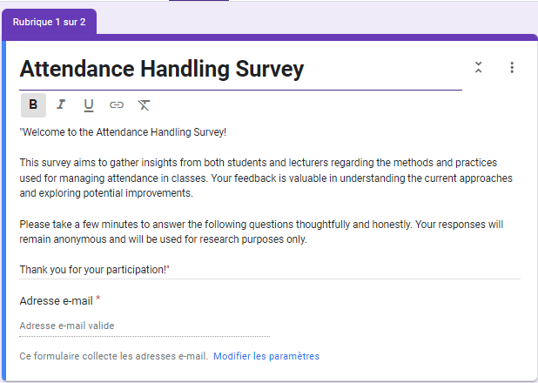

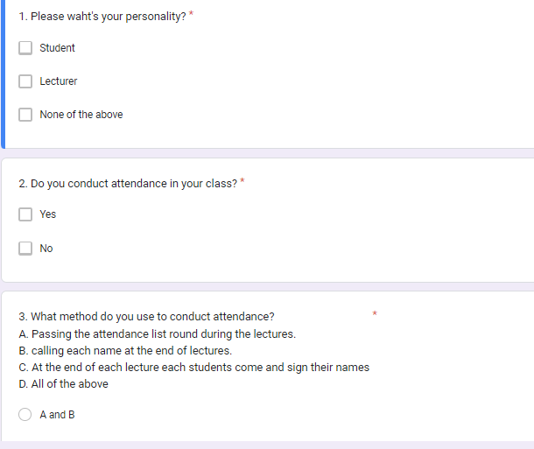

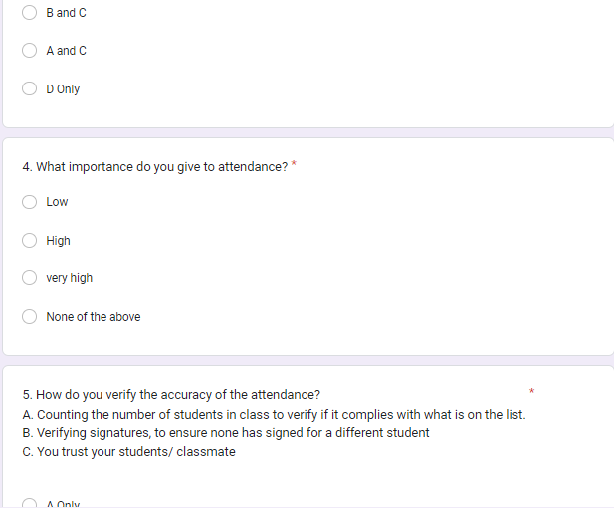

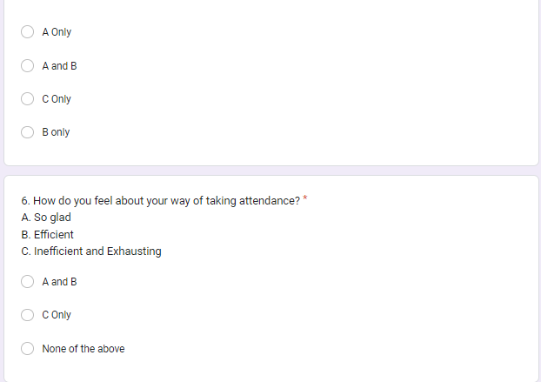

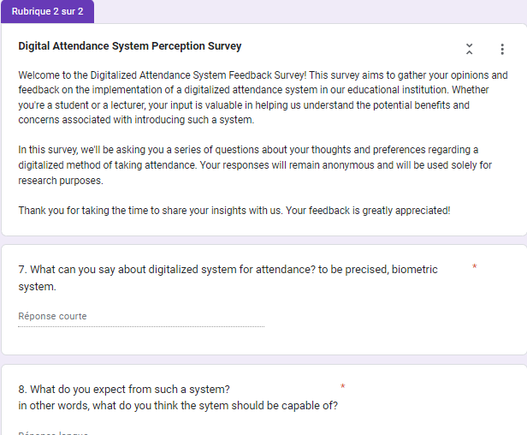

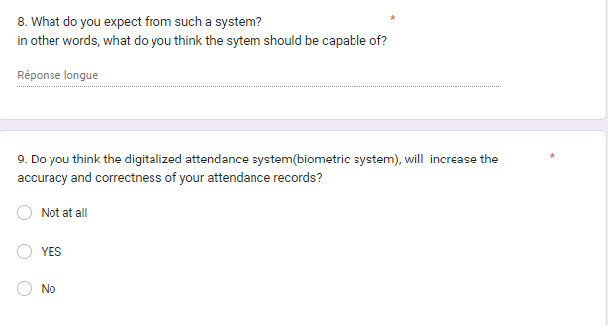

# 3.4 GATHER AND DOCUMENT

Systematically document the gathered requirements. This documentation can take various forms, such as user stories, use cases, or formal specifications. Clearly articulate functional requirements (what the system should do) and non-functional requirements (qualities the system should have, such as performance or security).

# 3.4.1 Technique Used

# Workshops

Workshops were carried out by the group members to document the overall collected requirements from the previous steps. Below are the information collected from the Google forms.

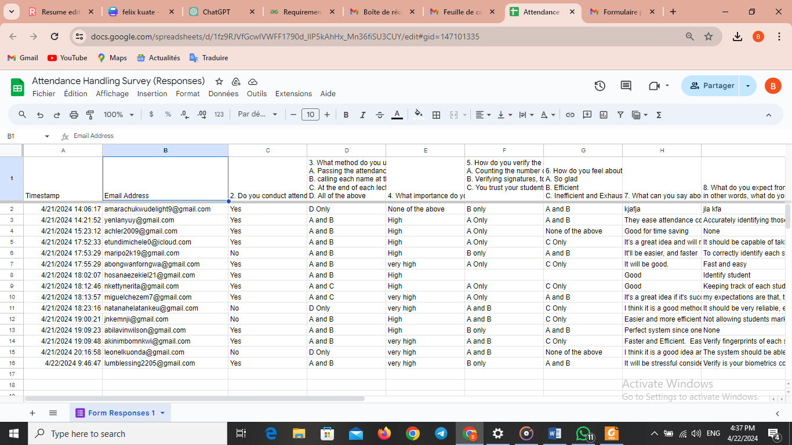

# 

Google form also provides us with responses represented on chats as shown below:

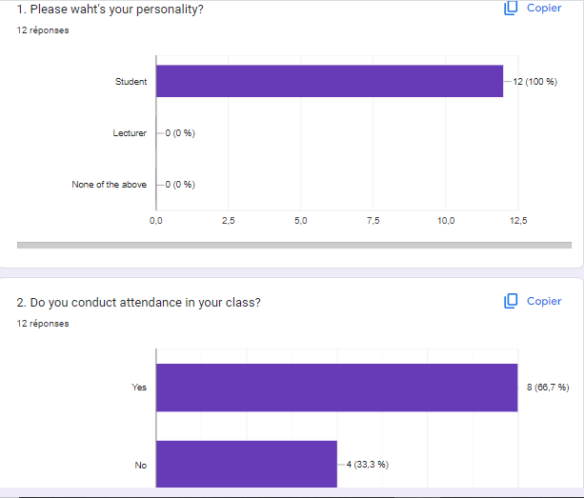

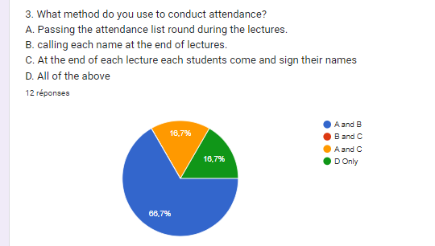

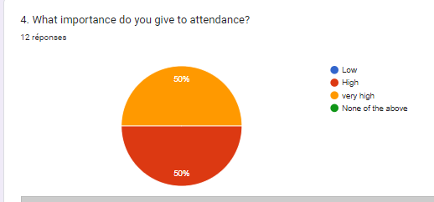

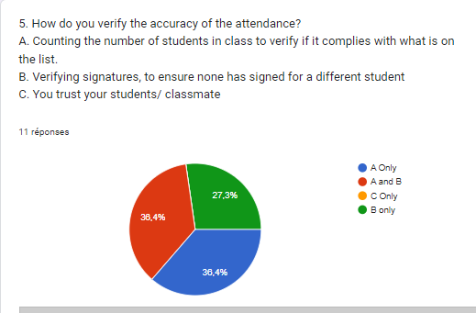

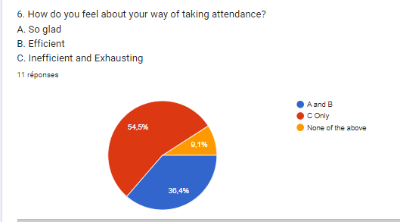

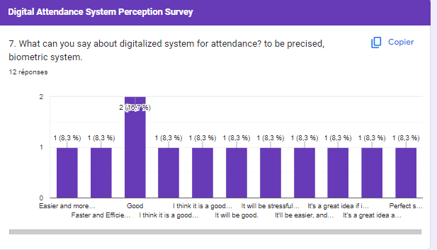

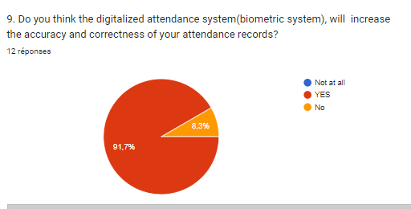

# Document analysis

With the provided Project Description we were able to gather out the following relevant information:

* The application should be cross-platform with an intuitive user interface to facilitate easy attendance tracking
* The application will incorporate biometric authentication functionality, enabling students to verify their identities using fingerprint recognition technology, thereby enhancing the security of attendance recording process and mitigate the risk of impersonation
* The proposed solution will be designed with scalability and customization, allowing educational institutions to adapt the application to their specific requirements
* The application will support real time attendance tracking, allowing instructors to view attendance records instantly as students check in using their biometric credentials

# 3.5 VERIFY AND VALIDATE

Once the requirements are documented, it’s crucial to verify and validate them. Verification ensures that the requirements align with the stakeholders’ intentions, while validation ensures that the documented requirements will meet the project’s goals. This step often involves feedback loops and discussions with stakeholders to refine and clarify requirements.

# 3.5.1 Verification

* **Purpose:** Verification focuses on confirming that the documented requirements accurately represent stakeholders' intentions and are consistent, complete, and feasible.
* **Technique used:** Verification involves reviewing the documented requirements against established criteria to ensure they meet quality standards and align with project objectives. This may include:
  + **Requirement walkthroughs**: Conducting structured meetings or sessions where stakeholders review and discuss the documented requirements to ensure mutual understanding and agreement.
  + **Requirement traceability**: Establishing traceability links between requirements and their sources (e.g., stakeholder requests, business processes) to ensure comprehensive coverage and alignment.
* **Outputs:** The output of the verification process is a validated set of requirements that have been confirmed to accurately capture stakeholders' needs and expectations.

# 3.5.2 Validation

* **Purpose:** Validation focuses on ensuring that the documented requirements, once implemented, will effectively meet the project's goals and deliver the intended value to stakeholders.
* **Methods:** Validation involves assessing the documented requirements in the context of the project's objectives and constraints to determine their suitability and fitness for purpose. This may include:
  + **Prototyping**: Building prototypes or mockups of the system or solution to allow stakeholders to interact with and provide feedback on the proposed functionality and user experience.
  + **User acceptance testing** (UAT): Engaging stakeholders to perform hands-on testing of the implemented system against the documented requirements to verify that it meets their expectations and needs.
* **Outputs:** The output of the validation process is confirmation that the documented requirements, once implemented, will meet stakeholders' needs and contribute to the achievement of the project's objectives.

**Feedback Loops and Stakeholder Engagement**

* Throughout the verification and validation process, it is essential to maintain open lines of communication with stakeholders and actively solicit their feedback and input.
* Feedback loops allow for iterative refinement and clarification of requirements based on stakeholders' insights, changing priorities, or emerging requirements.
* Regular discussions, meetings, and demonstrations with stakeholders help ensure alignment and consensus on requirements, fostering a shared understanding and commitment to project success.

# 3.6 PRIORITIZE REQUIREMENTS

Prioritize the requirements based on their importance to the project goals and constraints. This step helps in creating a roadmap for development, guiding the team on which features to prioritize. Prioritization is essential, especially when resources and time are limited. We have a detailed explanation of how prioritization is carried out:

1. **Importance to Project Goals and Objectives**

* The first criterion for prioritizing requirements is their alignment with the project's goals and objectives. Requirements that directly contribute to achieving project success or addressing key stakeholder needs should be given higher priority.

For example, the primary goal of this system is to record attendance in real-time using biometric credentials of students thereby addressing attendance fraud or impersonation, will be prioritized accordingly

1. **Stakeholder Input and Feedback**

* Stakeholder input and feedback play a crucial role in prioritizing requirements. Engage with stakeholders to understand their priorities, preferences, and expectations regarding project deliverables.
* Conducting stakeholder workshops, surveys, or interviews can help gather input on which requirements are most important to different stakeholders, allowing for informed prioritization decisions.

# **4.0 BENEFIT OF REQUIREMENT GATHERING**

Requirements gathering is more than beneficial for your project—it’s essential. Can you remember why the last unsuccessful project you handled didn’t go well? Did you run out of resources or go over budget? Did you underestimate the time you’d need to complete the project? These are project risks that you can prevent when you follow the requirements gathering process.

There are many benefits of requirements gathering, which include:

1. **Improves stakeholder satisfaction**

When you follow an effective requirement gathering process, you improve stakeholder satisfaction by providing more on-target project deliverables. Your stakeholders will be happy when they know what to expect with your project.

1. **Increases project success rate**

Requirements gathering also increases your project success rate because the more prepared you are for your upcoming project, the less likely you are to encounter project risks.

1. **Reduces project costs**

Encountering project risks can lead to increased project costs. By avoiding these risks, you can reduce costs and stay within budget. You understandably don’t want to spend more money on a project than necessary, so this is a big benefit of requirements gathering.

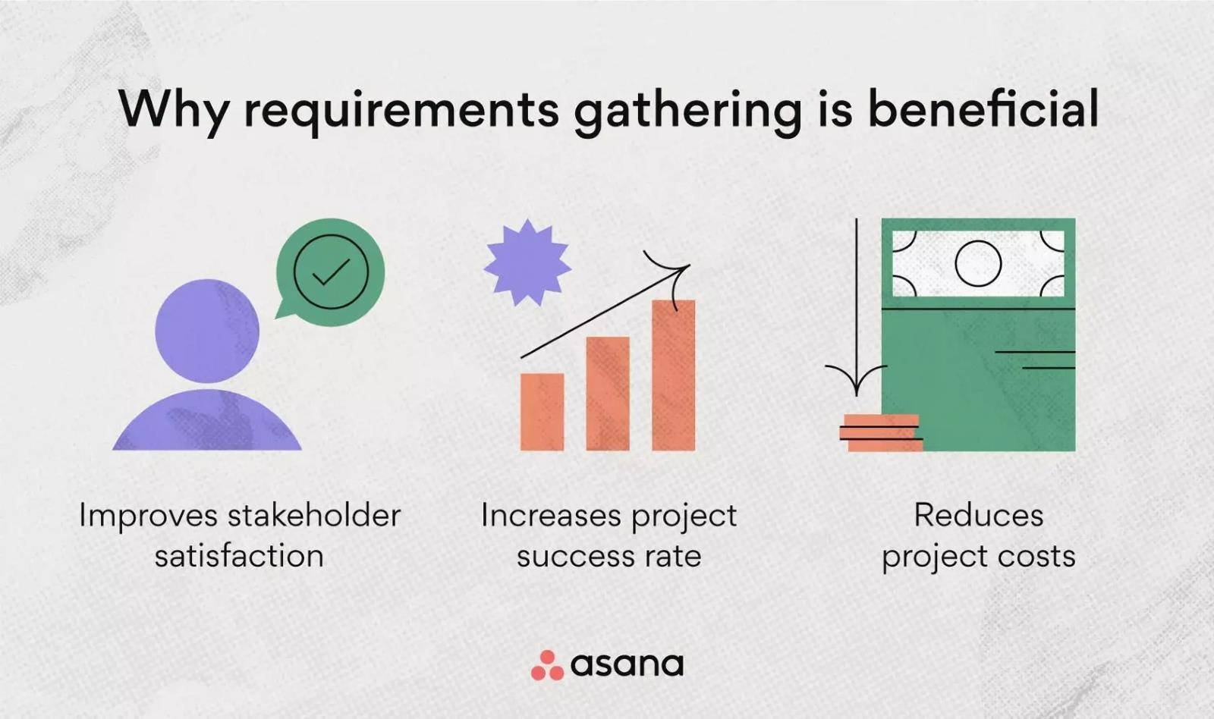

# **5.0 PROBLEM FACED**

**Electricity problem:** This was one of the main obstacles we faced, electricity issues that slows our working speed since the main tools we use are our electrical devices.

**Availability of Stakeholder:** We faced some difficulties meeting with some stakeholders like instructors.

**Poor internet connection:** That made it difficult to create and get feedback from the forms as planned on our working agenda.

# **6.0 CONCLUSION**

In conclusion, requirement gathering stands as the cornerstone of software development projects, shaping their trajectory from inception to completion. It serves as the guiding light, ensuring alignment with stakeholders' needs, minimizing risks, and fostering customer satisfaction. By meticulously defining project scopes, conducting thorough stakeholder interviews, and prioritizing requirements, teams can navigate complexities effectively. While challenges such as stakeholder availability and technical hiccups may arise, the benefits of a robust requirement gathering process far outweigh these obstacles. Ultimately, investing time and effort into this foundational phase significantly enhances the likelihood of project success, propelling teams toward their objectives with clarity and confidence.

# **7.0 REFERENCE**

* [https://www.jamasoftware.com/requirements-management-guide/requirementsgathering-and-management-processes/what-is-requirements-gathering](https://www.jamasoftware.com/requirements-management-guide/requirements-gathering-and-management-processes/what-is-requirements-gathering) visited on the April 17, 2024
* [https://www.geeksforgeeks.org/requirements-gathering-introduction-processesbenefits-and-tools/](https://www.geeksforgeeks.org/requirements-gathering-introduction-processes-benefits-and-tools/)  visited on the April 17, 2024
* <https://asana.com/resources/requirements-gathering> visited on the April 17, 2024
* [https://www.sdd-technology.com/blog/mobile-app-development-process-step-by-stepguide](https://www.sdd-technology.com/blog/mobile-app-development-process-step-by-step-guide)  visited on the April 17, 2024
* <https://dev.co/mobile/preparation> visited on the April 17, 2024