**­­­­**

**REPUBLIC OF CAMEROON**

***PEACE – WORK – FATHERLAND***

**MINISTRY OF HIGHER EDUCATION**

**REPUBLIQUE DU CAMEROUN**

***PAIX – TRAVAIL – PATRIE***

**MINISTERE DE L’ENSEIGNEMENT SUPERIEUR**



TASK3: REQUIREMENT ANALYSIS OF A BIOMETRIC STUDENT’S ATTENDANCE MOBILE APPLICATION

**PRESENTED BY: GROUP 19**

|  |  |  |
| --- | --- | --- |
| **NAME** | **MATRICULE** | **SPECIALTY** |
| AMARACHUKWU GODLOVE AHANONU | FE21A136 | SE |
| DJITUE TOGUE BRINDA SPACHELLE | FE21A171 | SE |
| NKEMCHOU PIANKE OLIVIER | FE21A275 | SE |
| REOUTADE ROLAND | FE21A301 | SE |
| TEGUE NONO MIKEL MODEIRO | FE21A321 | SE |

**MAY 2024**

**INSTRUCTOR: Dr. NKEMENI VALERY**

Table of contents

1.0 INTRODUCTION 2

1.1 DEFINITION 2

1.2 PURPOSE OF REQUIREMENT ANALYSIS 2

2.0 METHODS USED TO ANALYZE THE REQUIREMENTS 3

2.1. Workshops 3

2.2 Research 3

2.2.1 Existing Systems and Solution Review 4

2.2.2 Biometric Authentication Technologies Exploration 4

2.2.3 Regulatory and Compliance Research 5

3.0 ACTIVITIES INVOLVED IN REQUIREMENT ANALYSIS 5

3.1 Problem Recognition 6

3.2 Evaluation and Synthesis 6

3.2.1 Evaluation 6

3.2.2 Synthesis 6

3.3 Modeling 7

3.4 Specification 7

3.4.1 Overall description 7

3.4.2 Specific requirements 8

3.4.3 System Architecture 11

3.5 Review 13

3.5.1 Accuracy Verification 13

3.5.2 Identification of Ambiguities and Inconsistencies 13

3.5.3 Validation of Feasibility and Viability 13

3.5.4 Enhancement of Quality and Usability 13

3.5.5 Risk Mitigation 14

4.0 POTENTIAL RISKS/CONFLICTS IN THE REQUIREMENTS 14

5.0 CONCLUSION 15

6.0 REFERENCES 15

# INTRODUCTION

In the contemporary educational landscape, the efficient tracking of student attendance stands as a pivotal aspect of institutional management. The emergence of biometric technology offers a promising solution to streamline this process, ensuring accuracy, security, and convenience. However, the successful implementation of a biometric student attendance system hinges upon a comprehensive understanding of its requirements. Requirement analysis serves as the bedrock of this endeavor, encompassing the systematic gathering, analysis, and definition of the specific needs, objectives, functionalities, and constraints of such a system. This paper delves into the multifaceted aspects of requirement analysis for a biometric student attendance system, aiming to elucidate its significance, methods, activities, and potential challenges.

## DEFINITION

Requirement analysis of a biometric student attendance system involves the systematic process of gathering, documenting, analyzing, and defining the specific needs, objectives, functionalities, and constraints of developing a mobile application or system aimed at automating and optimizing the process of tracking student attendance in educational institutions using biometric authentication technology.

## PURPOSE OF REQUIREMENT ANALYSIS

The purpose of requirement analysis is multifaceted, encompassing several key objectives aimed at ensuring the success of a project. The primary purposes of requirement analysis are:

**Understanding Stakeholder Needs:** Requirement analysis enables project stakeholders, including clients, end-users, and other relevant parties, to articulate their needs, goals, and expectations for the project. By engaging with stakeholders, requirement analysts gain insights into the problem domain and gather valuable input to inform the development process.

**Defining Project Scope:** Requirement analysis helps define the boundaries and objectives of the project, clarifying what is within the scope of the project and what is not. By establishing clear project scope, requirement analysts prevent scope creep and ensure that the project stays focused on delivering value to stakeholders.

**Identifying Functional and Non-Functional Requirements:** Requirement analysis involves identifying and documenting both functional requirements (desired system behaviors and capabilities) and non-functional requirements (quality attributes such as performance, security, usability, and scalability). This process ensures that the system meets the needs of stakeholders while adhering to quality standards.

**Minimizing Risks and Uncertainties:** Requirement analysis helps identify potential risks, constraints, and dependencies that may impact the project's success. By proactively addressing these risks during the analysis phase, project teams can develop mitigation strategies and contingency plans to minimize disruptions and uncertainties throughout the project lifecycle.

**Facilitating Communication and Collaboration**: Requirement analysis serves as a communication bridge between project stakeholders, fostering collaboration and alignment across diverse perspectives and interests. Through workshops, interviews, surveys, and other engagement activities, requirement analysts facilitate productive discussions and ensure that all stakeholders are heard and represented.

**Guiding Design and Development:** The requirements documented during analysis serve as a blueprint for the design and development phases of the project. They provide clear guidance to designers, developers, and testers, informing the creation of system architectures, user interfaces, and functionality that meet stakeholders' needs and expectations.

**Enabling Change Management:** Requirement analysis establishes a baseline for managing changes throughout the project lifecycle. By documenting requirements in a structured manner and establishing change control processes, requirement analysts ensure that changes are properly evaluated, prioritized, and implemented while minimizing the impact on project timelines and budgets.

# METHODS USED TO ANALYZE THE REQUIREMENTS

Requirement analysis involves several methods and techniques aimed at identifying, eliciting, documenting, analyzing, and validating requirements for a system or project. The methods we used to analyze the requirements gathered from the requirement gathering task or phase include;

## Workshops

Here we had meeting sessions with the group members to analyze the requirements gathered from the various stakeholders gotten through interviews, surveys and questionnaires. Then brainstorm on the requirements gathered and classify them based on the functional, non-functional and prioritized requirements and also identify the possible conflicts and resolve them.

## 2.2 Research

We made research on existing systems or projects to come out with some functional and non-functional requirements of a biometric student attendance application.

Research played a crucial role in our requirement analysis process for the biometric student attendance application. We conducted comprehensive research on existing systems and projects related to student attendance management, biometric authentication, and mobile applications to gather insights and identify relevant functional and non-functional requirements. Below are the various research mechanisms we used:

### 2.2.1 Existing Systems and Solution Review

We thoroughly examined existing student attendance management systems, both traditional and digital, to understand their features, functionalities, and limitations. This review encompassed systems used in educational institutions, ranging from manual attendance registers to more advanced electronic systems. By analyzing these systems, we gained valuable insights into common practices, user expectations, and areas for improvement. Examples of existing systems we went across to gain insights about the implementation of the biometric mobile attendance application include;

* **BioConnect**: BioConnect's attendance tracking system enables employees or students to record attendance using biometric fingerprint readers or mobile devices equipped with fingerprint sensors. Individuals enroll their fingerprints in the system, and each fingerprint is associated with a unique identifier. When individuals scan their fingerprints, the system verifies their identity and records their attendance in real-time. Administrators can monitor attendance data, manage user access, and generate reports for analysis and compliance purposes.
* **uAttend**: Employees enroll their fingerprints in the uAttend system, which assigns a unique identifier to each fingerprint template. When employees arrive at work, they use biometric fingerprint scanners to clock in. The system verifies the employee's identity by matching the scanned fingerprint with stored templates and records the time and date of attendance. Administrators can manage attendance data online, track employee hours, and generate reports for payroll processing.
* **ZKTeco Time Attendance System**: Employees register their fingerprints in the system, which assigns a unique biometric template to each individual. When employees arrive at work, they use fingerprint scanners to clock in. The system compares the scanned fingerprint with stored templates to verify the employee's identity and record their attendance. Administrators can monitor attendance data in real-time and generate reports for payroll and compliance purposes.

### 2.2.2 Biometric Authentication Technologies Exploration

Biometric Authentication Technologies Exploration: Our research also focused on exploring various biometric authentication technologies, with a specific emphasis on fingerprint recognition due to its widespread use and reliability. We studied the principles behind biometric authentication, evaluated the accuracy and security of fingerprint recognition systems, and examined case studies of biometric authentication implementations in educational settings. This exploration helped us determine the feasibility and effectiveness of integrating biometric authentication into our attendance application.

### 2.2.3 Regulatory and Compliance Research

We conducted research on relevant regulations, standards, and compliance requirements related to student data privacy, biometric data protection, and mobile application security. This included reviewing legislation such as the Family Educational Rights and Privacy Act (FERPA) and General Data Protection Regulation (GDPR), as well as industry guidelines and best practices for handling sensitive data. By ensuring compliance with applicable regulations, we aimed to build trust with stakeholders and mitigate legal risks associated with data privacy and security.

Our research encompassed a wide range of sources and topics, including existing systems, biometric technologies. By synthesizing these insights, we were able to identify and prioritize functional and non-functional requirements that would guide the development of our biometric student attendance application, ensuring its relevance, usability, and compliance with industry standards.

# ACTIVITIES INVOLVED IN REQUIREMENT ANALYSIS

Software requirement analysis simply means complete study, analyzing, describing software requirements so that requirements that are genuine and needed can be fulfilled to solve problem. There are several activities involved in analyzing Software requirements. Some of them are:

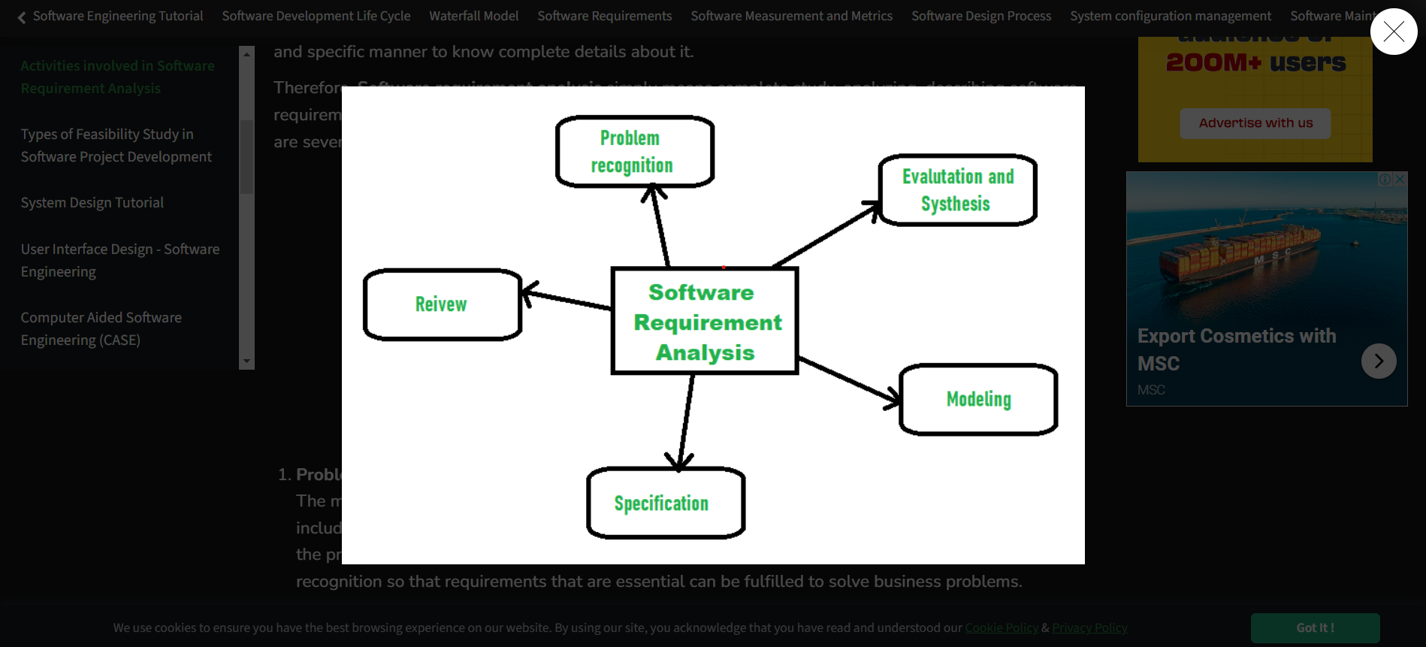

## 3.1 Problem Recognition

Problem recognition has to do with fully understanding the main objective of requirement, including why it is needed, does it add value, will it be beneficial, and does it have side effects.

For a biometric student attendance mobile application, it involves identifying the challenges and shortcomings of traditional attendance tracking methods in educational institutions. This includes recognizing issues such as manual attendance recording, which can be time-consuming, error-prone, and susceptible to fraudulent practices. By acknowledging these problems, the requirement analysis aims to develop a solution that leverages biometric technology to improve the accuracy, efficiency, and security of the attendance tracking process.

## 3.2 Evaluation and Synthesis

In requirement analysis, evaluation and synthesis are crucial activities aimed at understanding, assessing, and consolidating various requirements gathered from stakeholders. Here's what each activity entails

### 3.2.1 Evaluation

This involves assessing the gathered requirements to determine their quality, completeness, consistency, and feasibility. During evaluation, requirements are scrutinized to ensure they are clear, unambiguous, achievable, and relevant to the project's objectives. Evaluation also involves checking for conflicts or contradictions between requirements and identifying any gaps or missing information.

In the context of a biometric student attendance mobile application, Evaluation involves assessing the requirements gathered from stakeholders, such as accuracy of biometric data capture, security of data storage, ease of use for students and staff, compliance with privacy regulations, integration with existing systems, and scalability for future growth, real time tracking, ability to get a full record for the attendance either for a week, month, semester depending on the need of the Stakeholder. Evaluation ensures that the requirements are clear, feasible, and aligned with the goals of improving attendance tracking and management.

### 3.2.2 Synthesis

Once the requirements have been evaluated, synthesis involves combining and organizing them into a cohesive and comprehensive set. This process entails categorizing similar requirements, identifying relationships between them, and prioritizing them based on their importance to the project's success. Synthesis aims to create a unified and structured representation of the requirements that serves as a foundation for the subsequent phases of the project lifecycle, such as design, development, and testing.

## 3.3 Modeling

After complete analyzing of the gathered requirements and structuring them into functional, non-functional requirements, behavioral models and unified modelling language diagrams usually known as UML diagrams are established. This will be well explained and demonstrated in the upcoming task that has to do with System Modelling and Design.

## 3.4 Specification

Specification is an activity carried out that helped us to come out with a very important and crucial document called the **Software Requirement Specification** **(SRS).**

A Software Requirement Specification (SRS) is a document that outlines the functional and non-functional requirements of a software system or project. It serves as a blueprint for the software developers, guiding them in building the software according to the needs and expectations of stakeholders.

Our SRS contains the following information ;

### 3.4.1 Overall description

1. **Product Perspective**

* The system is a standalone application designed to facilitate the automated tracking of student attendance using biometric identifiers.
* It may integrate with existing educational systems, such as student information systems (SIS) or learning management systems (LMS) (example Go-Student), to exchange data and enhance functionality.

1. **Product Functions**

* **Enrollment**: Allows students to securely enroll their biometric data into the system.
* **Attendance Recording**: Automatically captures and records student attendance during class sessions or events using biometric authentication.
* **Real-Time Monitoring**: Provides real-time monitoring of attendance status for teachers and administrators.
* **Data Management**: Stores attendance data securely and provides features for managing and analyzing attendance records over time.

1. **User Characteristics**

* **Students**: Users who enroll their biometric data and participate in class sessions or events.
* **Teachers**: Users who monitor and manage student attendance using the system.
* **Administrators**: Users who oversee the system's operation and manage attendance data at an institutional level.

1. **Constraints, Assumptions, and Dependencies**

* **Constraints**: No budget, and little time allocated for system development and implementation.
* **Assumptions**:
  + Assumes that students and staff are willing to participate in the biometric enrollment process.
  + Assumes that all users have fingers and lecturers take attendance
* **Dependencies**: Relies on the availability of biometric hardware and software components for system functionality. Additionally, integration with other educational systems depends on their compatibility and cooperation.

### 3.4.2 Specific requirements

#### 3.4.2.1 Functional requirements

Functional requirements specify the specific functions or features that the system must perform to meet user needs. These requirements describe what the system should do in terms of its behavior and capabilities. For our biometric attendance student mobile application, the functional requirements will be classified based on; Overall requirement for every one that will have access to the system, based on the students, instructors and administrator.

##### Overall Functional Requirement

1. **Biometric Authentication**

All users should be able to authenticate themselves using biometric data, in this case, fingerprint.

Upon successful biometric authentication, users should gain access to the application's functionalities and features based on their roles and permissions.

##### For Students

1. **User Registration and Profile Management**

* Students should be able to register on the mobile application using their personal details.

1. **Attendance Tracking**

* Students should be able to mark their attendance using biometric (fingerprint).
* The application should provide real-time feedback on the attendance status after successful biometric authentication or failure.

1. **View Attendance Records**

* Students should be provided with their attendance status for individual courses or sessions.
* The attendance records should display course code, course instructor, dates, time (including the time slot for a particular course, and the time the fingerprint was taken, and percentages of attendance).

##### For Instructors

1. **Attendance Monitoring**

* Instructors should be able to monitor attendance records for their courses in real-time.
* They should have access to attendance statistics and reports for individual students and class sessions.

##### For Administrators

1. **User Management**

* Administrators should have the overall permission to manage user accounts, including students, instructors, and other staff members.
* They should be able to add, remove, or update user profiles as necessary.
* Administrators should be able to create and manage courses and class sessions within the application.

1. **System Configuration**

* Administrators should have access to system settings to configure biometric authentication methods, attendance thresholds, and notification preferences.

1. **Attendance Reporting and Analytics**

* Administrators should have access to comprehensive attendance reports and analytics.
* Reports should include attendance trends, statistics, and insights to facilitate decision-making and improve attendance management strategies.

1. **System Maintenance and Support**

* Administrators should oversee system maintenance activities, including updates, backups, and troubleshooting.
* They should provide support to users regarding application usage, technical issues, and training.

#### 3.4.2.2 Non - Functional requirements

Non-functional requirements (NFRs) of a system define the attributes, qualities, or constraints that specify how the system should behave, rather than what the system should do. They encompass various aspects such as performance, reliability, security, usability, and scalability, which collectively contribute to the overall effectiveness and quality of the system. NFRs typically outline the characteristics that govern the system's operation and interaction with its environment, ensuring that it meets the desired standards of performance, reliability, and user experience.

For our Biometric student attendance mobile application, the Non-functional requirements are;

##### Performance

* Our biometric attendance application should respond promptly to user actions, with minimal latency during biometric authentication and attendance tracking processes.
* It should be able to handle concurrent user requests efficiently, maintaining high responsiveness even under peak loads.
* Our biometric attendance application should be capable of processing attendance data in 5seconds

##### Reliability

* Our biometric attendance application should operate reliably without frequent crashes, errors, or system failures.
* It should have built-in mechanisms for error handling, recovery, and fault tolerance to ensure continuous availability.

##### Security

* Biometric data storage and transmission should be encrypted to protect users' privacy and prevent unauthorized access or interception.
* Our biometric attendance application should implement robust authentication mechanisms and access controls to prevent unauthorized access to sensitive data and functionalities.

##### Usability

* The user interface of our biometric attendance application should be intuitive, user-friendly, and accessible to users of all skill levels not forgetting one thing which is to be easily used.
* Our biometric attendance application should provide clear instructions and feedback to guide users through biometric authentication and attendance tracking processes.

1. Scalability

* Our biometric attendance application should be scalable to accommodate a growing user considering the fact that the application is to be further used in our faculty and there will be an increasing number of students, lecturers and why not courses, so our biometric attendance application should be able to function properly with this change.

##### Compatibility

* Our biometric attendance application should be compatible for both IOS and ANDROID operating systems.

##### Data Integrity and Consistency

* Attendance data should be stored securely and accurately to maintain data integrity and consistency.
* Our biometric attendance application should use user’s biometric credential just for attendance purpose, ensuring Integrity or user’s information
* Our biometric attendance application should be able to prevent the frauds that are prone in the traditional attendance system there by ensuring integrity and consistency.

#### 3.4.2.3 Hardware Requirement

Hardware requirements for a software project refer to the specific physical components and capabilities necessary for the software to operate effectively. These requirements typically include specifications such as the type and configuration of devices on which the software will run.

For our biometric student attendance mobile application some Hardware requirements include;

* 1. **Mobile Devices**

The fact that our biometric attendance application will be a native one that is run both on IOS and ANDROID operating systems, mobile devices on which the app will run must be compatible to one of the specified operating systems.

* 1. **Biometric Sensors**

Mobile devices with built-in biometric sensors such as fingerprint scanners are highly recommended and necessary for running our mobile attendance biometric application for capturing biometric data from users.

* 1. **Network Connectivity**

For the start of our biometric student attendance mobile application, stable internet connection is necessary for to effectively run the application, as well as to synchronize data with backend servers.

While looking forward in providing an offline functionality.

* 1. **Battery Life**

Mobile devices should have sufficient battery life or have a battery that last for days, given that electricity can be down for a number of days, ensuring that attendance is taken to the maximum despite the electricity shortage and also to support continuous usage of the application throughout the day given that we could have more than 3 courses in a day and each course need an attendance record.

### 3.4.3 System Architecture

System architecture for a software project refers to the high-level structure, components, and interactions of the software system. It encompasses the organization of software elements such as modules, components, layers, and subsystems, as well as the relationships and dependencies between them. The system architecture defines how different parts of the software work together to achieve the project's objectives, including aspects such as data flow, communication protocols, security mechanisms, and performance optimizations. It serves as a blueprint for designing, implementing, and maintaining the software, providing a roadmap for developers to follow throughout the development lifecycle.

For our Biometric student attendance mobile application, from the various architectures presented during the first task the architecture to be used is the **MODEL VIEW PRESENTER ARCHITECTURE (MVP).**

MVP is a new architecture that separates an application into three parts: Model, View, and Presenter. This is similar to MVC but puts more responsibility on the Presenter to manage the interaction between Model and View.

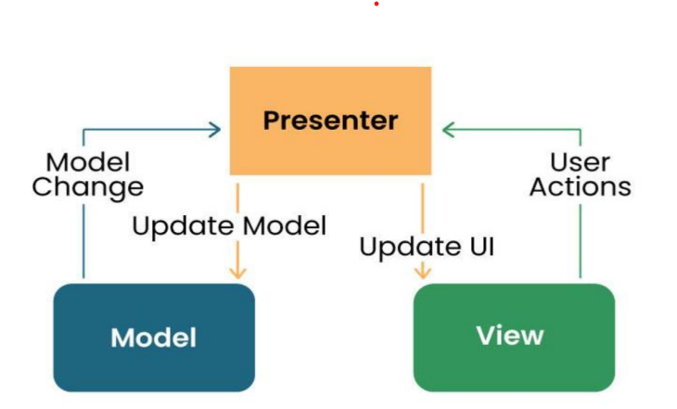

**Model**: Manages data and business logic.

**Presenter**: it contains the logic that processes data for the user.

**View**: Represents the user interface.

**Designer**: Acts as an intermediary processing user input and updating the View and Model.

Below is how the architecture of our app will look like.

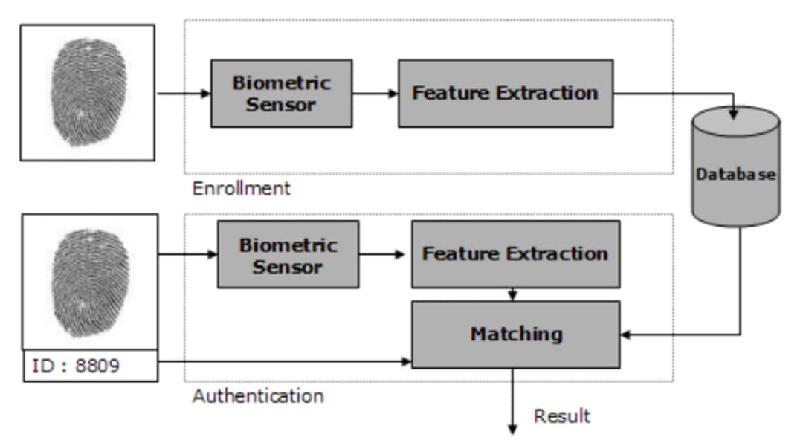

From the above architecture, we have basically two principal steps

* + **Enrollment (Registration):** here the user registers into the system by placing his fingerprint on the biometric sensor, then there is feature extraction, where a digital key is gotten and stored in the Database
  + **Authentication:** here upon use of the system, when the user places his or her fingerprint on the biometric sensor, feature extraction is still done and matching is done to verify and validate that the input information complies with what was stored in the database upon registration.

## 3.5 Review

After developing the SRS, it must be reviewed to check whether it can be improved or not and must be refined to make it better and increase the quality.

Reviewing the Software Requirements Specification (SRS) is a crucial step in the requirement analysis as it ensures that the documented requirements accurately reflect the needs and expectations of stakeholders. Let us dive deeper into why this review process is essential and how it was conducted effectively with respect to our biometric student attendance application:

### 3.5.1 Accuracy Verification

The primary goal of reviewing the Software Requirements Specification (SRS) for our biometric student attendance mobile application is to ensure the accuracy and completeness of the gathered requirements. Stakeholders, including school administrators, teachers, students, and we the developers, must verify that all necessary functionalities related to biometric authentication, attendance tracking, and user roles are accurately documented.

This verification process helps prevent misunderstandings and ensures alignment between stakeholders' expectations and the final application.

### 3.5.2 Identification of Ambiguities and Inconsistencies

During this review process, we meticulously examine each requirement statement to identify ambiguities, contradictions, or inconsistencies within the document. Ambiguous requirements related to fingerprint authentication, attendance recording, or user permissions can lead to misinterpretations and potentially flawed implementation. By resolving these issues early in the development process, we can save time and resources and ensure a smoother development journey.

### 3.5.3 Validation of Feasibility and Viability

We reviewed the SRS allowing stakeholders to assess the feasibility and viability of implementing biometric authentication for student attendance tracking via a mobile application. This involves evaluating technical aspects such as the compatibility of fingerprint sensors with mobile devices, the accuracy of fingerprint recognition algorithms, and the scalability of the solution to accommodate varying school environments.

### 3.5.4 Enhancement of Quality and Usability

Refining the SRS based on feedback from the review process is crucial for enhancing the overall quality and usability of our biometric student attendance mobile application. Here we performed restructuring of requirement statements for clarity, removing redundant or unnecessary requirements, and adding additional details or examples to improve understanding. By continuously refining the SRS, we can create a more user-friendly and reliable application that meets the specific needs of schools and educational institutions.

### 3.5.5 Risk Mitigation

Identifying and addressing issues in the SRS early in the development lifecycle helps mitigate risks associated with requirement errors or misunderstandings. By proactively resolving potential issues during the review process, we can reduce the likelihood of costly rework or project failures downstream. This is particularly important in ensuring the security and reliability of biometric authentication mechanisms and compliance with privacy regulations.

In summary, the review and refinement of the SRS for our biometric student attendance mobile application are critical activities that contribute to its success. By verifying the accuracy, identifying potential issues, and enhancing the quality of the requirements documentation, we can reduce risks, improve communication, and ultimately deliver a high-quality application that meets the needs of schools and educational institutions.

## POTENTIAL RISKS/CONFLICTS IN THE REQUIREMENTS

Implementing a biometric student attendance system can offer numerous benefits, including accuracy, efficiency, and convenience. However, it also comes with potential risks and conflicts in its requirements. Here are some to consider:

* + - **Privacy Concerns:** Biometric data, such as fingerprints or facial recognition, raises significant privacy concerns. Students may feel uncomfortable providing such sensitive information, especially if they fear it could be misused or compromised.
    - **Data Security:** Storing biometric data securely is crucial to prevent unauthorized access or hacking. Any breach of this data could have serious consequences for both the students and the institution.
    - **Legal and Regulatory Compliance:** Depending on the jurisdiction, there may be legal requirements regarding the collection, storage, and use of biometric data. Failure to comply with these regulations could result in legal penalties or reputational damage.
    - **Inclusivity and Accessibility**: Biometric systems may not be accessible to all students, particularly those with disabilities or certain medical conditions that affect their biometric markers. Ensuring inclusivity and providing alternative attendance methods is essential.
    - **Cultural Sensitivities:** Biometric systems may not be culturally acceptable in certain communities or regions due to cultural beliefs or norms regarding privacy and personal identification. Institutions operating in diverse environments must be sensitive to these cultural differences and adapt their approach accordingly.

# CONCLUSION

In conclusion, the requirement analysis of a biometric student attendance system is a multifaceted endeavor that plays a pivotal role in shaping the success of the project. By comprehensively understanding stakeholder needs, defining project scope, identifying functional and non-functional requirements, and mitigating potential risks, project teams can lay a solid foundation for the design, development, and implementation of an effective and efficient biometric attendance solution. Through collaborative engagement, meticulous analysis, and strategic planning, educational institutions can harness the power of biometric technology to revolutionize attendance tracking, enhance institutional management, and ultimately, enrich the educational experience for students and educators alike.

# REFERENCES

<https://www.geeksforgeeks.org/activities-involved-in-software-requirement-analysis> visited on May 06, 2024

<https://acrobat.adobe.com/id/urn:aaid:sc:EU:8523122d-57f3-4f31-813f-2fc966ef58ed> visited on May 06, 2024

<https://www.researchgate.net/publication/349327088_Implementing_Student_Attendance_System_Using_Fingerprint_Biometrics_for_Kolej_Universiti_Poly-Tech_Mara> visited on May 12, 2024

<https://www.halvorsen.blog/documents/programming/software_engineering/software_engineering.php> visited on May 12, 2024