**JUNE 2024**

**UNIVERSITY OF BUEA**

**FACULTY OF ENGINEERING AND TECHNOLOGY (FET)**

**DEPARTMENT OF COMPUTER ENGINEERING**

**COURSE: INTERNET PROGRAMMING AND MOBILE PROGRAMMING (CEF440)**

**REPUBLIQUE DU CAMEROUN**

***PAIX – TRAVAIL – PATRIE***

**MINISTERE DE L’ENSEIGNEMENT SUPERIEUR**

**REPUBLIC OF CAMEROON**

***PEACE – WORK – FATHERLAND***

**MINISTRY OF HIGHER EDUCATION**



**PRESENTED BY : GROUP 19**

|  |  |  |
| --- | --- | --- |
| **NAME** | **MATRICULE** | **SPECIALTY** |
| NKEMCHOU PIANKE OLIVIER | FE21A275 | SE |
| DJITUE TOGUE BRINDA SPACHELLE | FE21A171 | SE |
| TEGUE NONO MIKEL MODEIRO | FE21A321 | SE |
| REOUTADE ROLAND | FE21A301 | SE |
| AMARACHUKWU GODLOVE AHANONU | FE21A136 | SE |

TASK5: USER INTERFACE (UI) DESIGN

**INSTRUCTOR : Dr. NKEMENI VALERY**

Table of content

1. INTRODUCTION 2

2. UI DESCRIPTION 2

. 2.1 Visual Design 2

2.1.1 Color Scheme 2

2.1.2 Typography 4

2.1.3 Icons 5

2.2 User Interface Design 5

2.2.1 Login Screen 5

2.2.2 Fingerprint Scan Screen 7

2.2.3 Dashboard 8

2.2.4 Attendance Record Screen 9

2.2.5 Settings Screen 10

2.3 Interactive Design 13

2.3.1 Navigation 13

2.4 Accessibility 13

2.5 Prototype and Testing 13

3. FINAL UI DESIGN 14

3.1 Admin Section 14

3.1.1 Manage Student Section 15

3.1.2 Manage Instructor Section 16

3.1.3 Manage Course Section 19

3.2 Instructor Section 22

3.2.1 Track Attendance 23

3.1.1 View Attendance Record 24

3.1.2 View Course Info 24

3.3 Help Page 25

4. CONCLUSION 26

# INTRODUCTION

This report covers the design aspects of the Biometric Student’s Attendance Application called **BioTrack**, detailing the interface elements, design considerations, and features that make it user-friendly and effective for students, instructors, and administrators. By prioritizing ease of use and accessibility, the app aims to deliver a superior user experience while addressing the specific needs of its users.

# UI DESCRIPTION

## . 2.1 Visual Design

### Color Scheme

Creating a well-defined color scheme for our application is crucial for establishing a strong visual identity and enhancing user experience. Below is a detailed breakdown of the color scheme we choose and why it was chosen:

#### Primary Color

This is the main color used throughout the application. It should reflect the brand’s identity and be used consistently to create a cohesive look. As our primary color, we decided to use the color below:

* ***#415AF1 (Blue)***

**Reason**: Blue is often associated with trust, reliability, and professionalism, making it an ideal primary color for an app that needs to instill confidence in its accuracy and security. It also provides a calming effect, making it user-friendly and appealing.

#### Background Color

The colors used for backgrounds. They should be neutral and unobtrusive to make sure content is easily readable. The following colors were used:

* ***#FFFFFF (White)***

**Reason**: White is used for backgrounds and negative space to ensure clarity and readability. It provides a clean, modern look that helps users focus on the content without distraction. It also contrasts well with the primary blue color, enhancing readability.

* ***#D9D9D9*** *(****Light Silver*)**

**Reason: Light Silver (#D9D9D9) reflects its neutrality, professionalism, readability, minimalism, and aesthetic appeal.** This subtle shade provides good contrast for text, ensuring a pleasant user experience.

#### Warning Color

Specific colors to indicate status messages like errors, warnings.

* **#F4445A (Red)**

**Reason**: Red is commonly used to indicate errors or warnings because it naturally draws attention and is associated with caution. It ensures that error messages and critical warnings are noticed immediately, which helps in preventing user mistakes.

#### Success Color

Specific colors to indicate status messages like success notifications and confirmation dialog.

**#4CAF50 (Green)**

**Reason**: Green is associated with success and positive actions. It is used to indicate successful operations, such as a successfully recorded fingerprint scan, to give users immediate and clear feedback that their action was completed correctly.

#### Text Color

Colors used for various types of text, ensuring readability and proper contrast with background colors. For the text color, we used the following colors depending on the background color, the information we want to pass.

* ***Blue*:**
  + **Readability:** Light blue provides good contrast against white backgrounds, enhancing readability and the blue color is our app’s main color
* ***Black*:**
  + **Elegance and Formality:** Black is classic and elegant
  + **Contrast:** Black text on a light background ensures high contrast and readability.
* ***Red*:**
  + **Attention and Urgency:** Red grabs attention. It’s commonly used for warnings, alerts, or urgent messages. This is the reason why we used it in our delete pages in order to draw attention on the action to be taken
* ***White*:**
  + **Clean and Minimalistic:** White represents simplicity, cleanliness, and minimalism.
  + **Background Contrast:** White text on a blue background provides a modern look and ensures readability.
* ***Gray*:**
  + **Neutrality:** Gray is neutral and versatile. It complements other colors well. Also, it is suitable for placeholder.

Benefits of a Well-Defined Color Scheme

* **Enhanced User Experience**: A well-chosen color scheme can make an application more aesthetically pleasing and easier to use.
* **Brand Recognition**: Consistent use of colors helps reinforce brand identity and makes the application more memorable.
* **Improved Readability and Accessibility**: Proper contrast and thoughtful color choices ensure content is readable by all users.
* **Emotional Impact**: Colors can influence users' emotions and behaviors, contributing to a more engaging experience.
  + 1. Typography

Using a specific set of typography guidelines ensures that your application has a cohesive and professional appearance. Below is a breakdown of why we use each element of the specified typography:

#### Primary Font: Inter, Regular

* **Readability and Accessibility**: Inter is known for its high readability. Its design features make it accessible for various users, including those with visual impairments.
* **Consistency**: Using Inter as the primary font throughout ensures that the text across different sections of our application looks consistent and harmonious.

#### Headings: Inter, Semi-Bold, 36pt

* **Hierarchy**: Semi-Bold weight for headings helps distinguish them from body text, making the hierarchy clear. This helps users quickly scan and understand the structure of our content.
* **Visibility**: The 36pt size ensures that headings are prominent and easily noticeable, guiding users through the content.

#### Body Text: Inter, Regular, 20-40pt

* **Flexibility**: Specifying a range (20-40pt) allows flexibility depending on the context (e.g., larger sizes for main body text, smaller sizes for captions or annotations).
* **Readability**: Inter Regular at these sizes ensures that body text is comfortable to read for extended periods, enhancing the user experience.

#### Buttons: Inter, Extra-Bold, 24pt

* **Emphasis**: Extra-Bold weight makes button text stand out, ensuring that call-to-action elements are noticeable and distinct from other text elements.
* **Interaction**: The 24pt size is large enough to be easily tappable on touch devices, improving usability and accessibility.

#### App’s Name: Nunito, Extra-Bold, 96pt

* **Brand Identity**: Using a different font like Nunito for the app’s name creates a distinctive brand identity. Nunito’s rounded, friendly appearance contrasts with Inter, making the app name stand out.
* **Impact**: The Extra-Bold weight and large size (96pt) make the app’s name highly visible, ensuring it leaves a strong impression and is easily recognizable.

General Benefits of These Typography Choices

* **Visual Hierarchy:** Clear distinctions between headings, body text, buttons, and the app's name help users navigate the interface intuitively.
* **Consistency and Professionalism**: A unified typography scheme enhances the visual coherence of your application, giving it a polished and professional look.
* **Readability and Usability:** Choosing fonts and sizes that are easy to read improves the overall user experience, making your application more accessible.
* **Brand Identity:** Specific choices, such as using Nunito for the app’s name, help in establishing a unique brand identity that users can remember and relate to.

### 2.1.3 Icons

* **Consistent iconography for actions (using Material Design Icons):** The same style and set of icons were used throughout an application to represent actions like back, next, editing, submit, just to name a few. Consistency helps users recognize and understand what each icon represents, improving usability and user experience. Below are some of the icons used:









Back

Successful

Submit

Danger









Instructor

Student

Next

Admin

* **High-resolution and scalable vector icons:** Vector icons are graphics that can be scaled to any size without losing quality.

## 2.2 User Interface Design

### 2.2.1 Login Screen

*Elements*

* App Logo
* Username Field
* Password Field
* Login Button
* Forgot Password Link

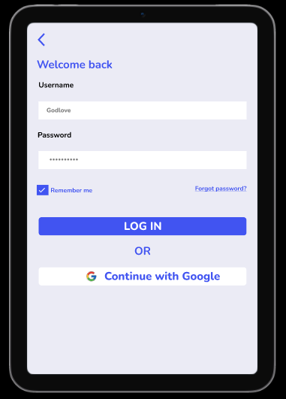

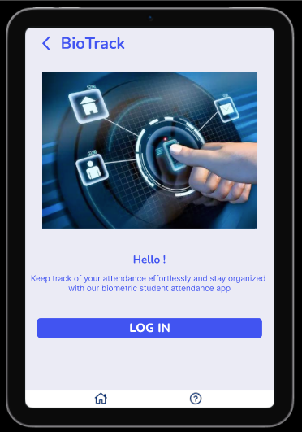

*Design Considerations*

* + - Simple and clean layout.
    - High-contrast colors for readability.

### 2.2.2 Fingerprint Scan Screen

*Elements*

* Instruction Text ("Place your finger on the scanner")
* Fingerprint Scanner Animation
* Status Indicator (Success)

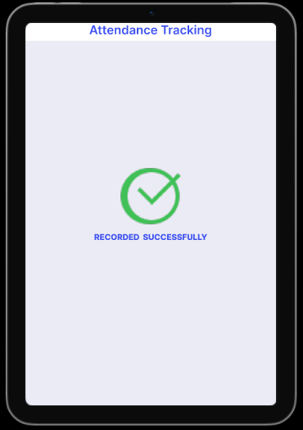

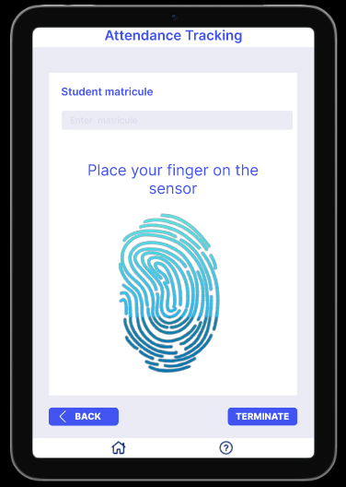

*Design Considerations*

* Clear and concise instructions.
* Real-time feedback on scan status.

### 2.2.3 Dashboard

*Elements*

* Quick Actions (Mark Attendance, View Reports, Manage Student, Manage Courses)

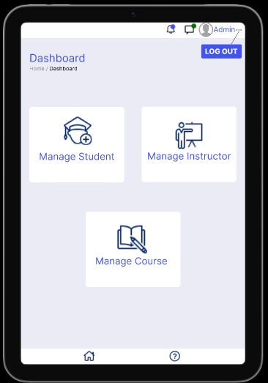

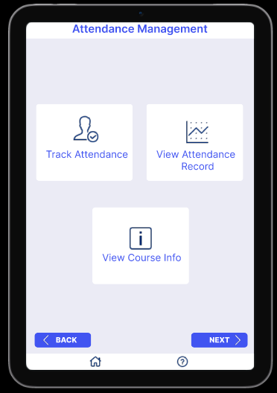

*Design Considerations*

* Information hierarchy to prioritize critical data.

### 2.2.4 Attendance Record Screen

*Elements*

* Calendar View (Highlighting Present/Absent Days)
* Filter Options (Date Range, Course, Student)
* Detailed Attendance List (Date, Status)
* Download Button (PDF)

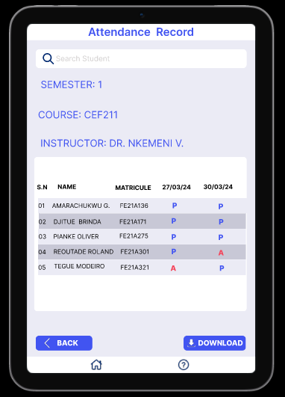

*Design Considerations*

* Visual clarity for the calendar view.
* Easy-to-use filters for quick access to specific records.
* Export functionality for offline access.

### 2.2.5 Settings Screen

*Elements*

* Profile Settings (Edit Name)

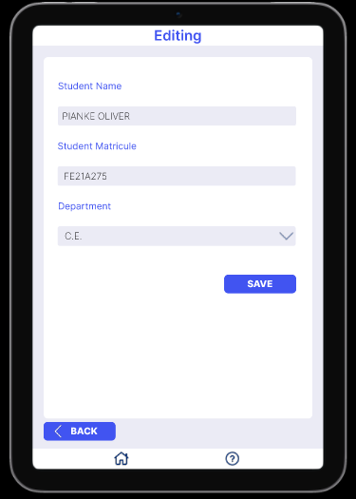

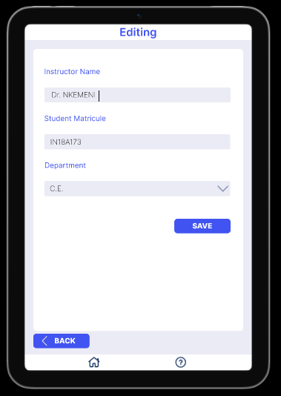

* User Management (Add/Remove Users )

1. Add Students/ Instructor

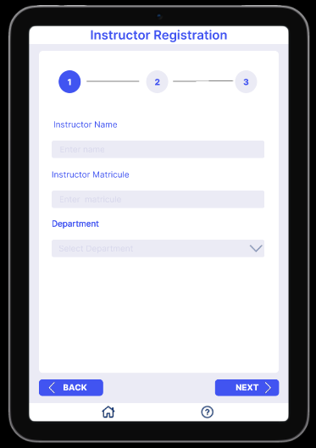

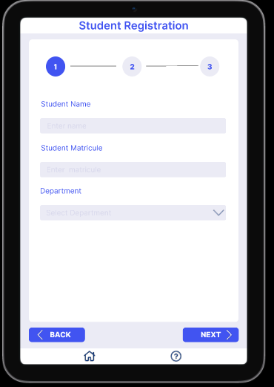

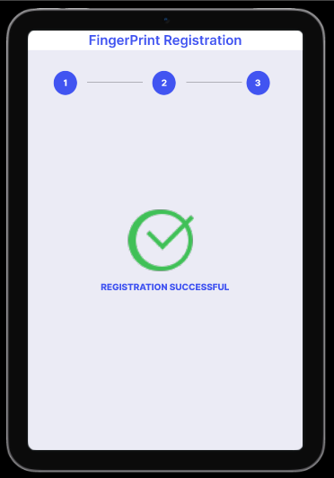

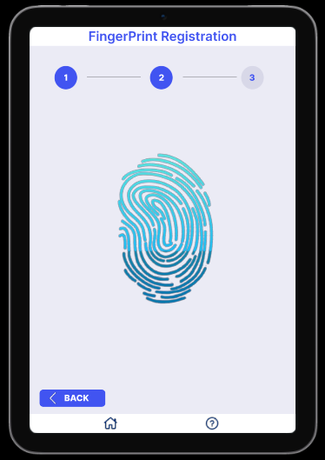

1. Remove Students/ Instructor

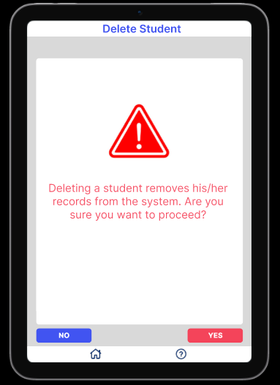

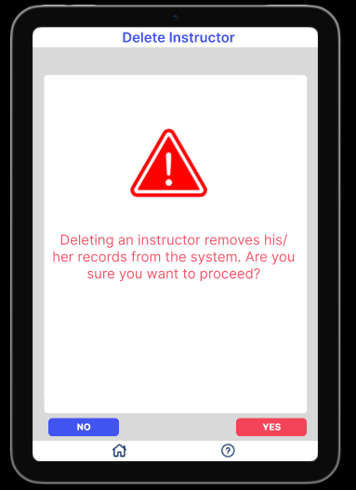

*Design Considerations*

* Organized categories for easy navigation.
* Customizable settings to enhance user experience.

## Interactive Design

### 2.3.1 Navigation

* Bottom Navigation Bar for main sections (Dashboard, Help)
* Hamburger Menu for additional options (User Profile, Logout)

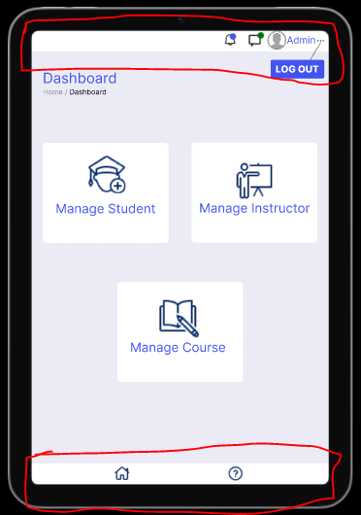

## 2.4 Accessibility

* **Color Contrast:** Ensuring high contrast for text and important UI elements.
* **Screen Reader Support:** Descriptive text for icons and images.
* **Touch Targets**: Large and well-spaced touch targets for buttons and interactive elements.

## 2.5 Prototype and Testing

* Prototyping Tools: Figma
* User Testing: Conduct usability testing sessions with actual users to gather feedback and iterate on the design.

# FINAL UI DESIGN

## Admin Section

When the Admin opens the app, he sees the app’s logo and the app’s name. Few seconds after a new page pops out where he chooses ***Admin*** then he login and has access to his dashboard.

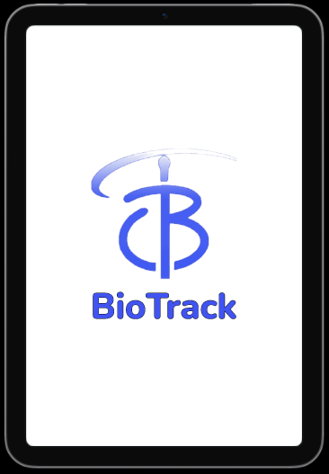

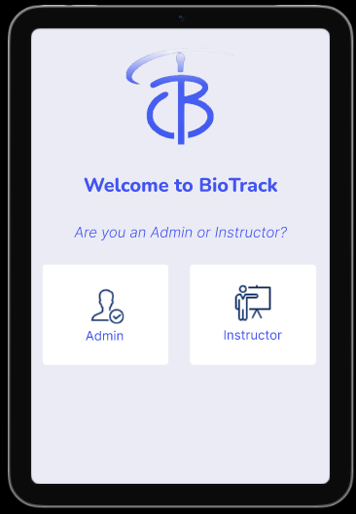

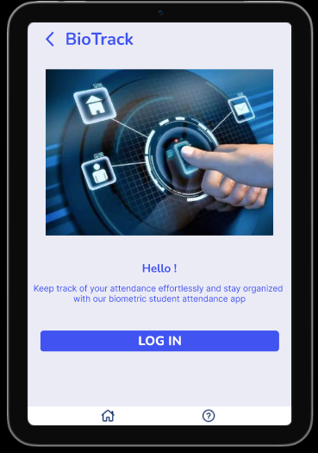

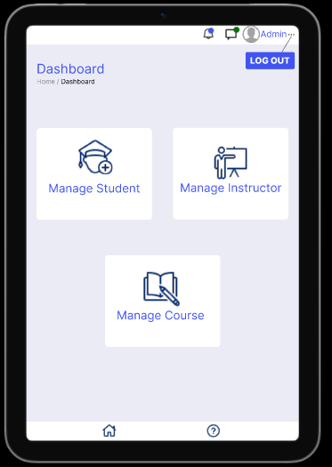

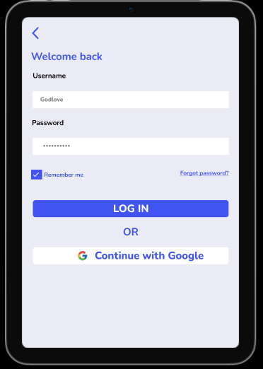

### Manage Student Section

1. **Register Students**

When the admin clicks on ***manage student***, he has the possibility to register new student with the use of their finger print

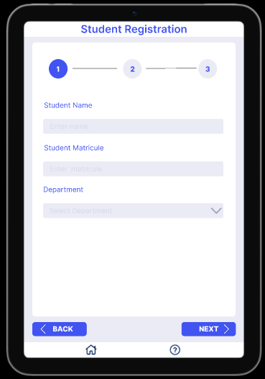

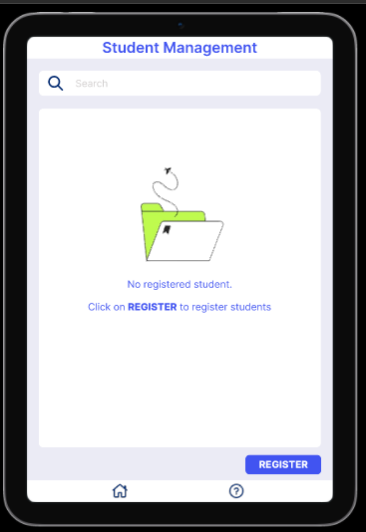

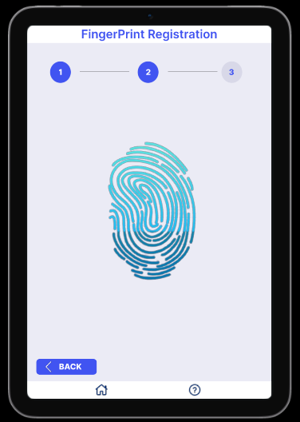

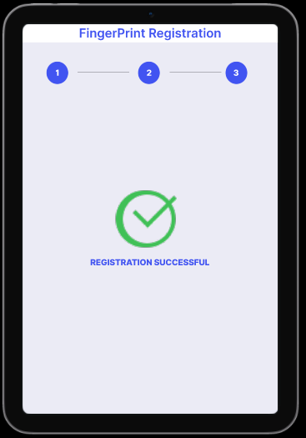

1. Edit Student Info
   1. **Edit Student Info**

When the admin clicks on a registered student, he has the possibility to edit the student’s information.

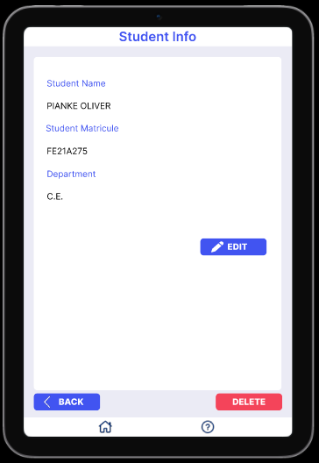

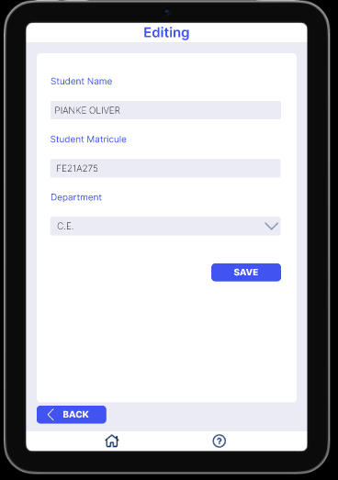

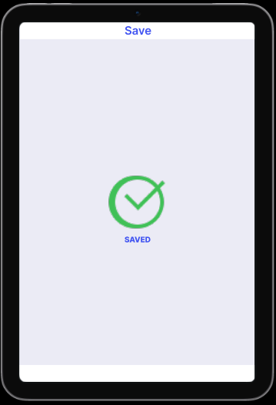

1. **Delete Students**

When the admin clicks on a registered student, he has the possibility to delete the student’s record.

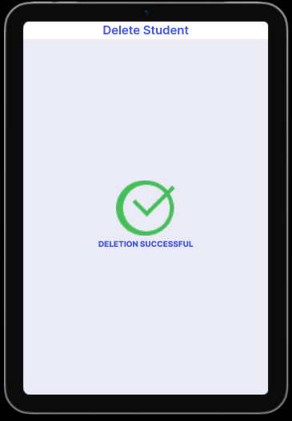

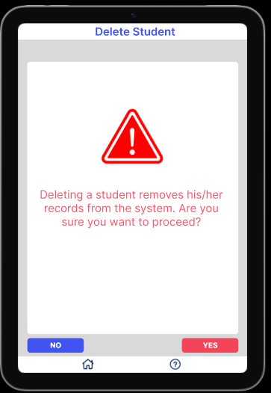

### Manage Instructor Section

1. **Register Instructor**

3.1.2 Manage Instructor Info

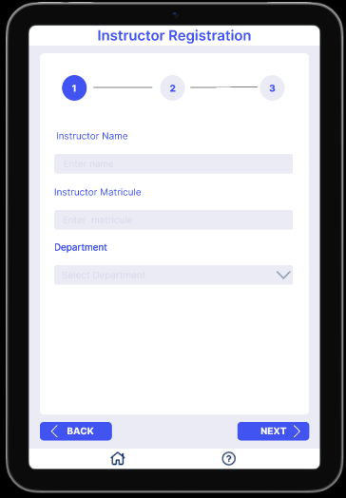

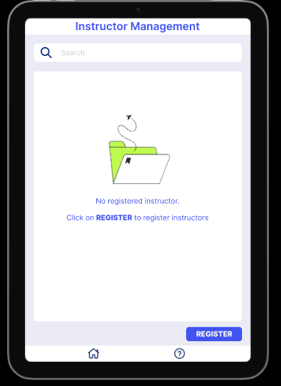

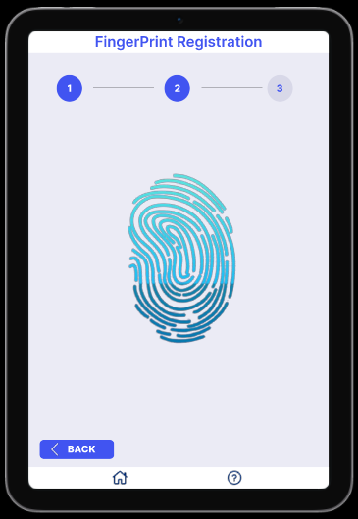



1. **Edit Instructor Info**

When the admin clicks on a registered instructor, he has the possibility to edit the instructor’s information.

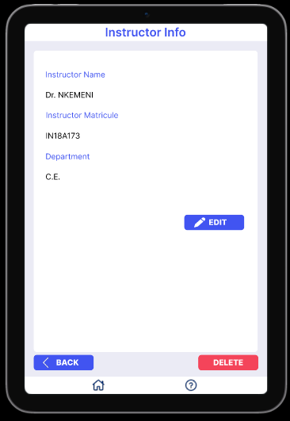



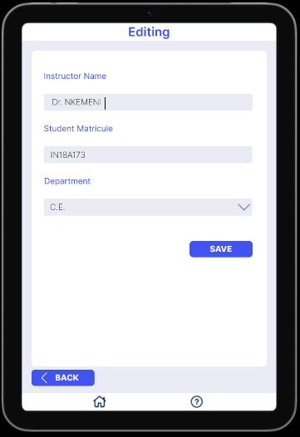

1. **Delete Instructor**

When the admin clicks on a registered instructors, he has the possibility to delete the instructor’s record.

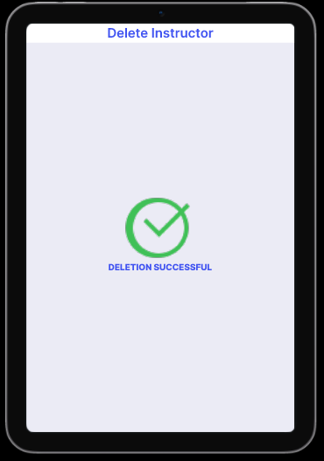

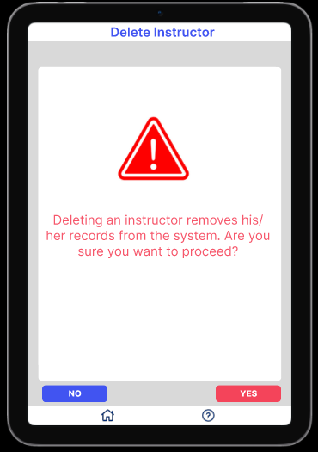

### Manage Course Section

1. **Add Courses**

When the admin clicks on ***manage course***, he has the possibility to add new course.

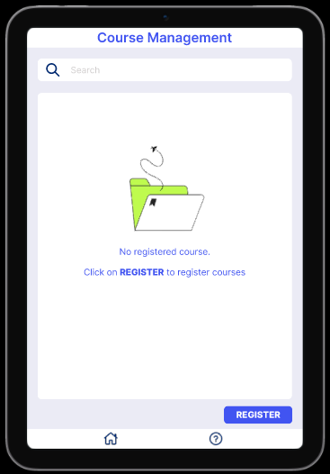

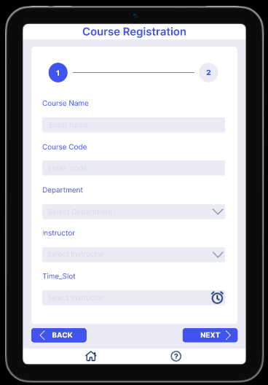

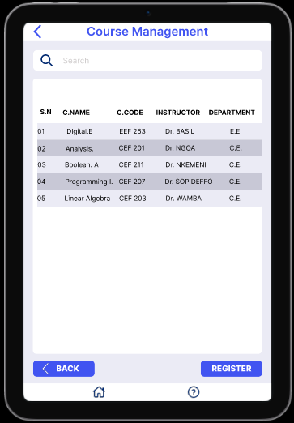

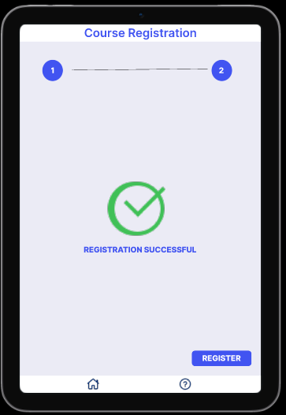

1. **Edit Course Info**
2. **Edit Course Info**

When the admin clicks on a registered courses, he has the possibility to edit the course’s information.



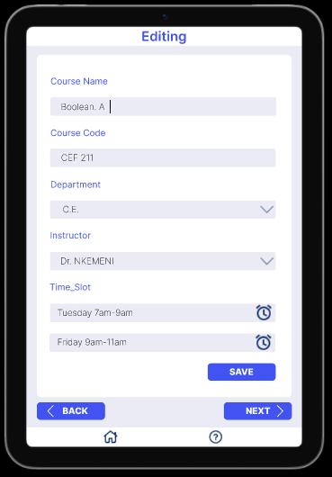

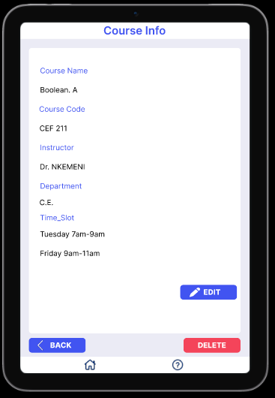

1. **Delete course**

When the admin clicks on a registered courses, he has the possibility to delete the course record.

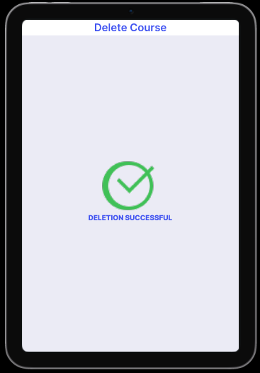

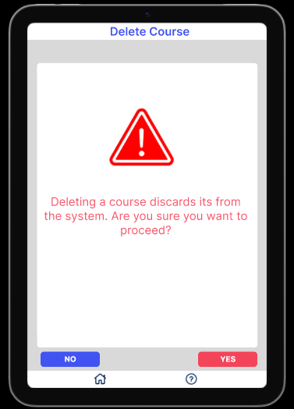

## Instructor Section

When the Instructor opens the app, he sees the app’s logo and the app’s name. Few seconds after a new page pops out where he/she chooses ***Instructor.*** After, a list of course pops out where he/she chooses his/her course. He/she is then asked to authenticate with his/her finger print before tracking attendance, view attendance record and view course information





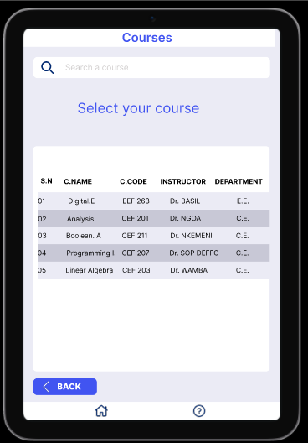

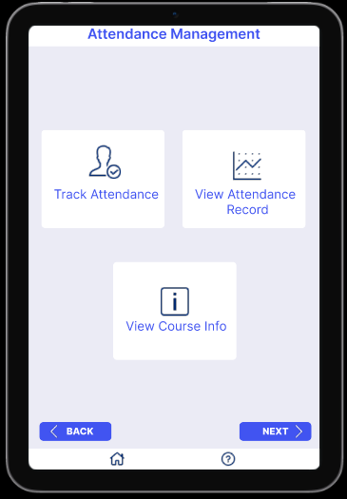

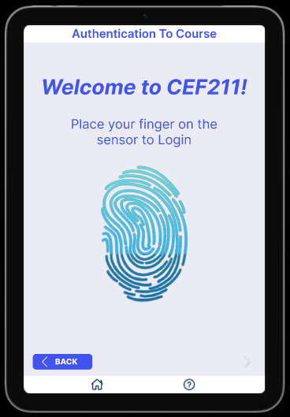

### Track Attendance

When the instructor clicks on ***Track Attendance*** the page below pops out where the student can put his finger print to be recorded as present.

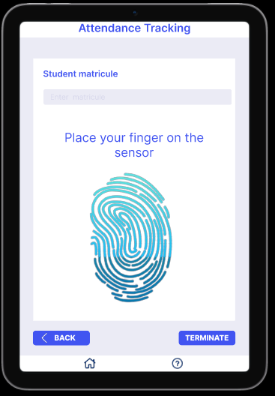

### View Attendance Record

When the instructor clicks on ***View Attendance Recorded*** the page below pops out he/she can see those that were present and those that were absent during his/ her course.

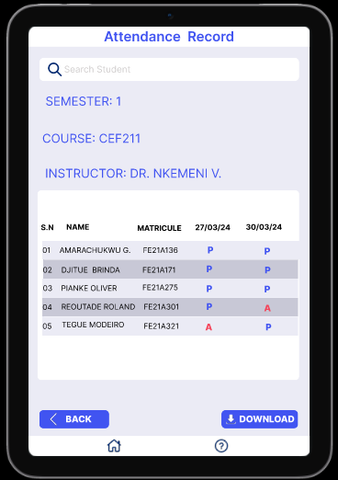

### View Course Info

When the Instructor selects the ***View Course Info*** he can have some information about his course.

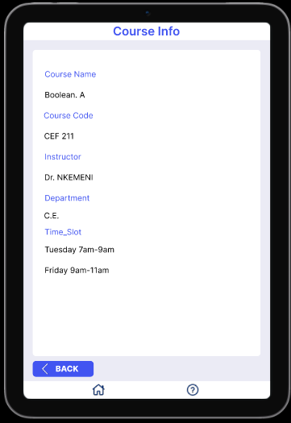

## Help Page

This page is represent with a logo as shown below:



This page is for the user to send feedback concerning the with the app, ask questions about the app. The user provides his name, email address and the message which could be a question or a worry.

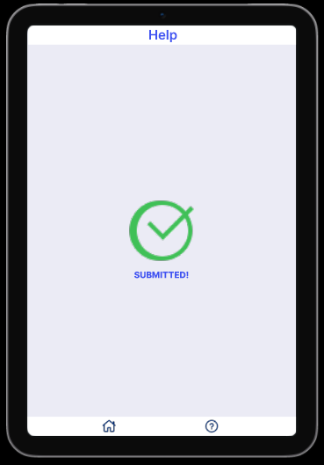

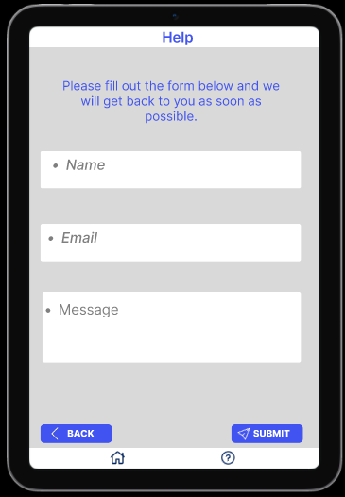

# 4. CONCLUSION

The Fingerprint Student Attendance App is designed to offer a seamless and efficient user experience with a focus on ease of use, security, and accessibility. Through intuitive design and robust functionality, the app aims to modernize attendance tracking in educational institutions.