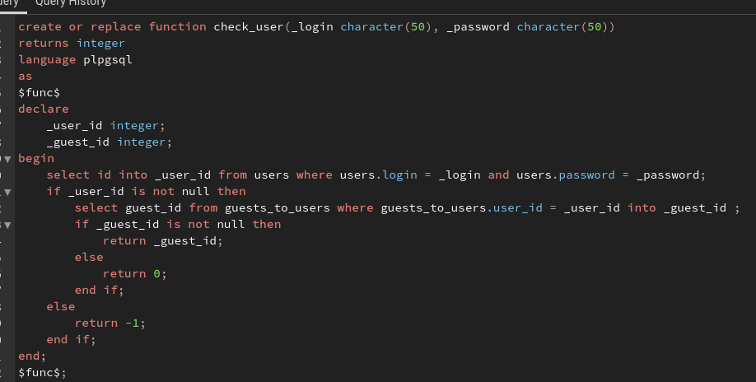
create or replace function check_user(_login character(50), _password character(50))
returns integer
language plpgsql
as
$func$
declare
_user_id integer;
_guest_id integer;
begin
select id into _user_id from users where users.login = _login and users.password = _password;
if _user_id is not null then
select guest_id from guests_to_users where guests_to_users.user_id = _user_id into _guest_id ;
if _guest_id is not null then
return _guest_id;
else
return 0;
end if;
else
return -1;
end if;
end;
$func$;

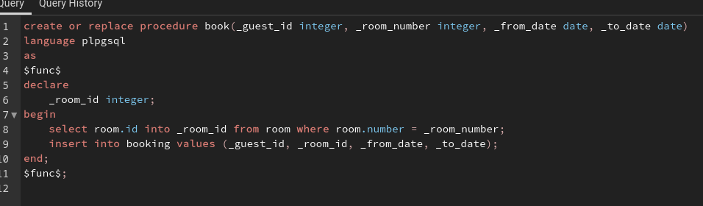
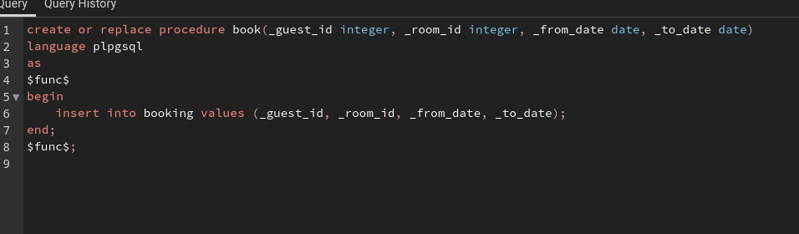

create or replace procedure book(_guest_id integer, _room_number integer, _from_date date, _to_date date)
language plpgsql
as
$func$
declare
_room_id integer;
begin
select room.id into _room_id from room where room.number = _room_number;
insert into booking values (_guest_id, _room_id, _from_date, _to_date);
end;
$func$;

