Research Methods Assignment: Theories, Hypotheses, and Graphs
Name: ____________________ Date: ____________________

Question 1: Hypothetical Relationships
In each graph the independent variable (IV, the cause) is on the horizontal x-axis and the dependent variable (DV, the effect) is on the vertical y-axis. The IV must come first in time.

a. Level of corruption and trust in government
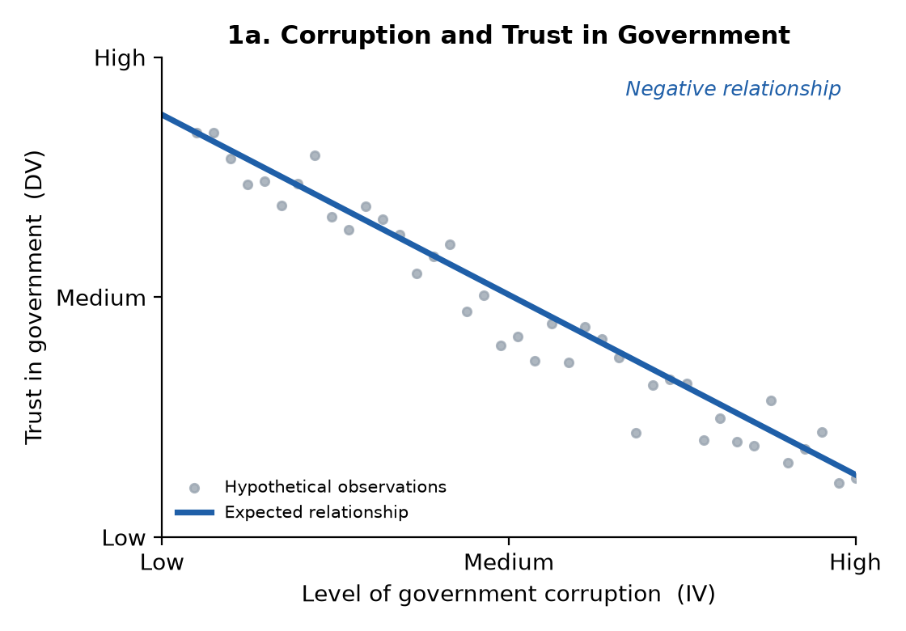
Variables: IV: level of government corruption. DV: citizens' trust in government. Expected: negative.
Theoretical reasoning: People judge whether government is trustworthy from how officials actually behave. When citizens see bribery, scandals, or officials using their office for personal gain, they learn that government does not act in the public's interest and that the rules are not applied fairly. This lowers their confidence in government. So as corruption increases, trust decreases.
Temporal order: Corruption happens and becomes public first (through scandals, news coverage, or personal experience, such as being asked for a bribe). Citizens then change their attitudes. Trust is the reaction, so it comes after the corruption.

b. Parental education and child's income
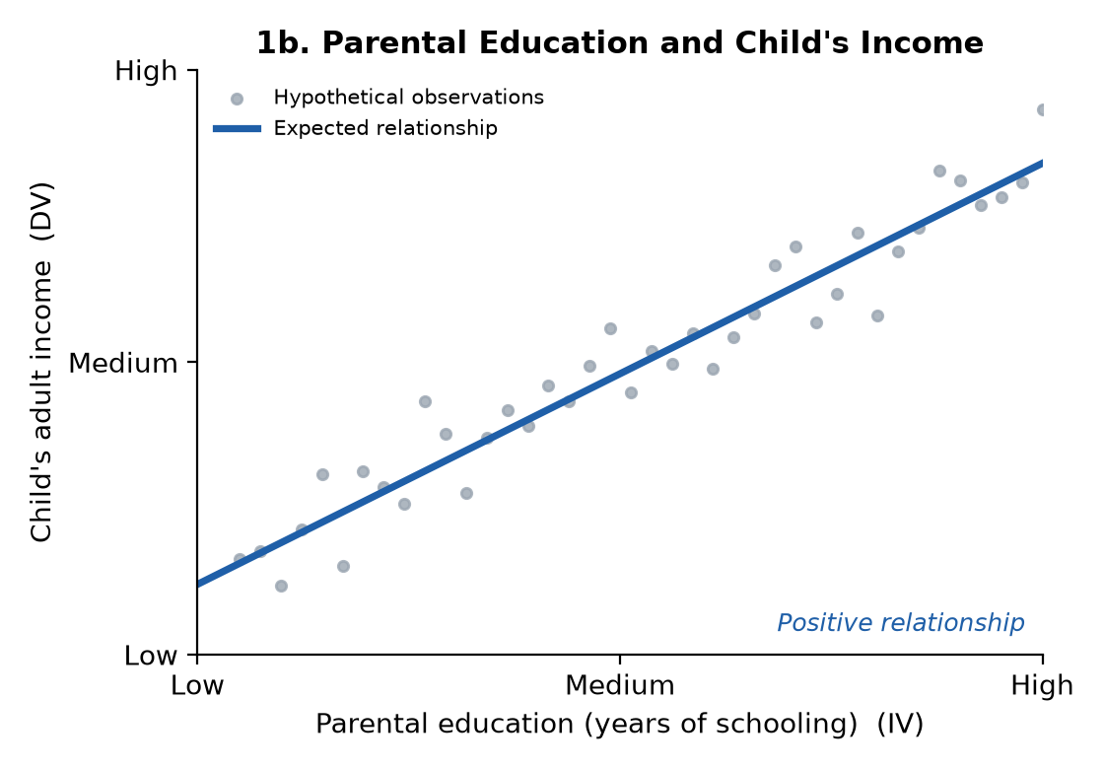
Variables: IV: parents' education (years of schooling). DV: the child's income as an adult. Expected: positive.
Theoretical reasoning: Parents with more education usually earn more, so they can afford better neighborhoods, schools, tutoring, and college. They also pass on skills and habits, such as reading to children, valuing school, and knowing how to apply to college and jobs. They tend to have professional networks that help with internships and jobs. Children with these advantages get more education themselves and go into higher-paying jobs. So as parental education increases, the child's income increases.
Temporal order: The parents finish their schooling before or while the child is growing up. The child earns an income years later as an adult. The child's income cannot cause the parents' education, so the order is clear.

c. House members' donations from the oil industry and number of votes favorable to that industry
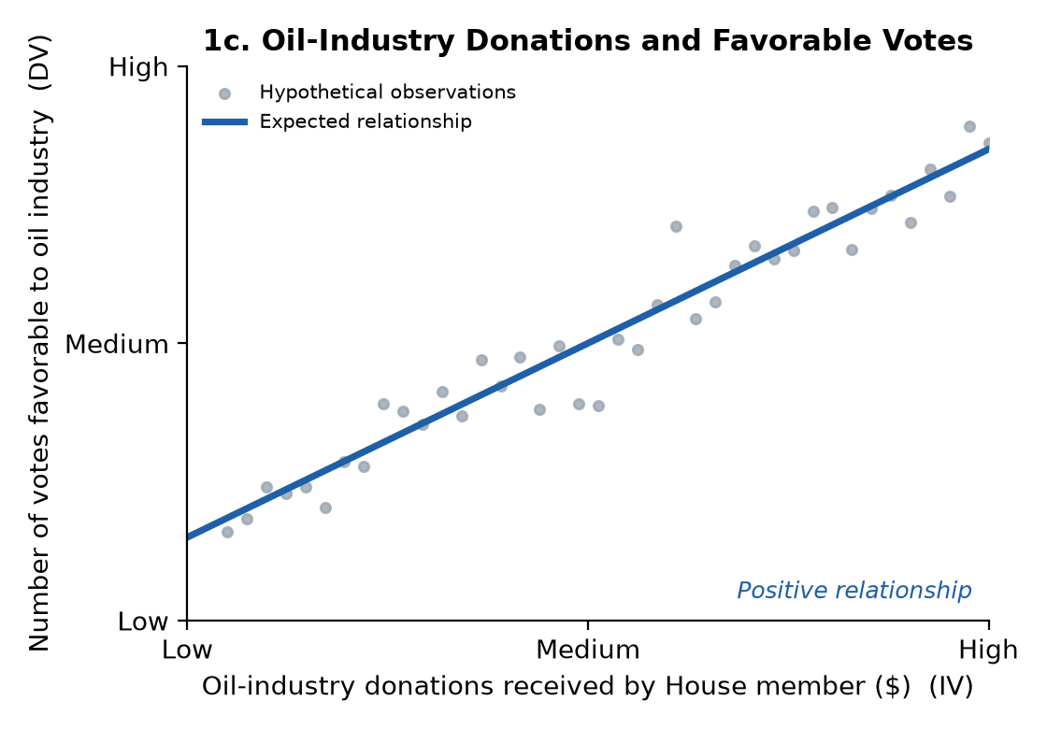
Variables: IV: amount of campaign money a House member receives from the oil industry. DV: number of votes the member casts that favor the oil industry. Expected: positive.
Theoretical reasoning: Members of the House need money to run for reelection every two years. Donations buy donors access to the member, and members want to keep that money coming in for the next campaign. As a result, they are more likely to vote for bills the oil industry supports, such as subsidies, drilling permits, and fewer environmental rules. So more oil money leads to more pro-oil votes.
Temporal order: The donations must be received before the votes are cast. We would measure donations in one election cycle and votes in the session after it. (It could also run the other way, with industry giving to members who already vote its way. Measuring donations first helps separate the two.)

d. Infant mortality rate and water pollution
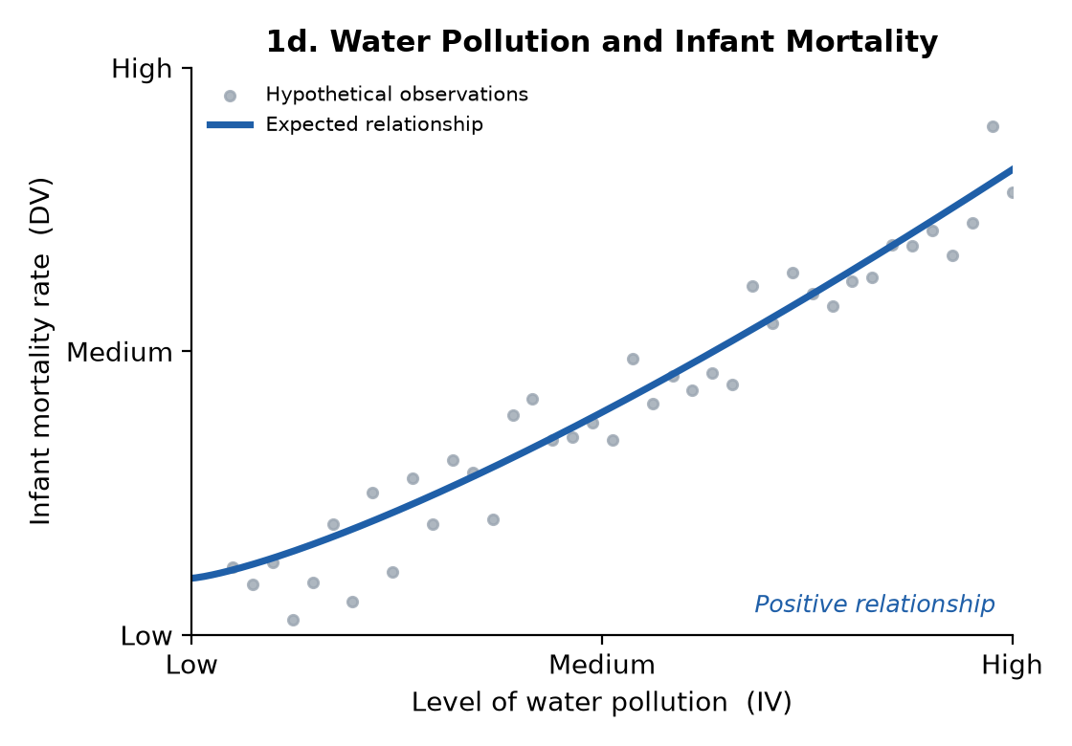
Variables: IV: level of water pollution. DV: infant mortality rate (deaths under age 1 per 1,000 live births). Expected: positive. Water pollution is the cause, so it goes on the x-axis even though the question names infant mortality first.
Theoretical reasoning: Infants have weak immune systems and small bodies, so they are especially vulnerable to contaminated water. Bacteria in the water cause diarrheal disease and dehydration. Chemicals like lead and nitrates cause developmental problems and "blue baby syndrome." Mothers who drink polluted water during pregnancy are more likely to have premature or low-birth-weight babies. All of these raise the chance an infant dies. So as water pollution increases, infant mortality increases. The line gets steeper at high pollution levels because heavy contamination is especially deadly.
Temporal order: The water becomes polluted first. Infants and pregnant mothers are exposed to it, and then illness and death follow. Infant deaths do not pollute the water, so pollution must come before mortality.

e. Level of diversity in environment and number of racist attitudes held
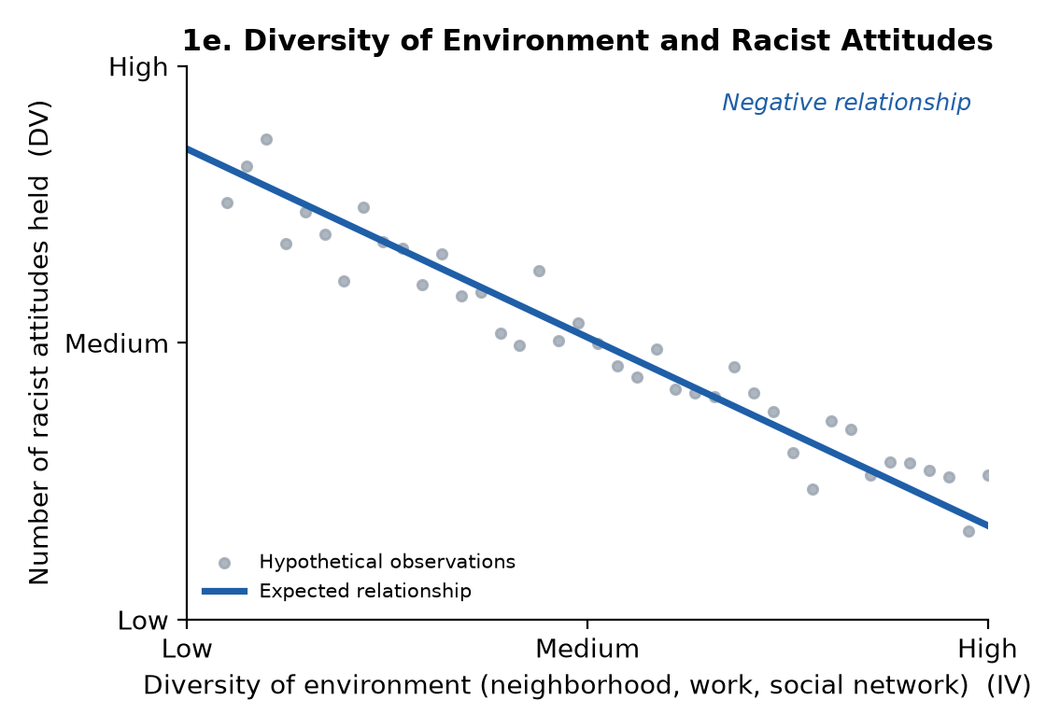
Variables: IV: diversity of a person's environment (neighborhood, workplace, social network). DV: number of racist attitudes the person holds. Expected: negative.
Theoretical reasoning: This follows the contact hypothesis (Allport, 1954). Racist attitudes are often based on stereotypes, fear of the unknown, and a lack of personal experience with other groups. When people live, work, and make friends with people of other races, they get to know them as individuals. Stereotypes get challenged, and people start to feel empathy and see what they have in common. This works best when people meet as equals and cooperate, as coworkers or teammates do. So as the diversity of someone's environment increases, the number of racist attitudes they hold decreases.
Temporal order: The person must be exposed to the diverse environment first. Their attitudes change over time after that contact. One concern is self-selection: people who are already tolerant may choose to live in diverse areas. Measuring attitudes before and after someone enters a diverse setting, such as a new job, a college roommate, or a military unit, helps confirm that exposure comes first.

Question 2: My Own Theory
a. Research question: Does giving voters more days of early voting increase turnout among young adults (ages 18-29)?
b. Theory: Young adults vote at lower rates than any other age group. That is not mainly because they don't care. It is because voting costs them more. People aged 18-29 move often, many work hourly jobs with shifts they can't change, many are in school, and many have never voted before, so they don't know where their polling place is. When voting is limited to a single Tuesday, any conflict that day (a work shift, a class, no car, a sick child) means they don't vote. Rational choice theory says a person votes when the benefits outweigh the costs. More early-voting days lower the cost of voting. Young people get more chances to find a time that works, can vote on a weekend, can vote near campus or work, and can recover if something goes wrong on one day. Campaigns and student groups also get more time to reach young voters and bring them to the polls. Older voters have steady routines and long-standing voting habits, so they vote no matter what. Young voters are the group whose decision to vote is most affected by convenience. So states that offer more early-voting days should have higher youth turnout.
c. Hypothesis: States that offer more days of early voting will have higher voter turnout among 18-29 year olds than states that offer fewer days (or none).
d. Null hypothesis: There is no relationship between the number of early-voting days a state offers and voter turnout among 18-29 year olds.
e. Variables:
- Independent variable (IV): number of early-voting days offered by the state before Election Day.
- Dependent variable (DV): percentage of eligible 18-29 year olds who vote in the election.
Temporal order: States set their early-voting rules before the election. Turnout is measured on and after Election Day, so the IV comes before the DV.
f. Graph of the expected relationship:
