***CAN_Protocol: Lesson_1***

**Le bus de données CAN:**

(Controller Area Network) est un bus système séries très répandu dans beaucoup d'industries, notamment l'automobile.

Il a été normalisé avec la norme *ISO11898.*

**In-vehicle networks (IVN):**

are specialized internal communication networks that interconnect various components inside a vehicle. The components inside the vehicle include ECUs, gateways, sensors, actuators, etc.

To coordinate communication among ECUs, In-Vehicle Networks (IVNs) are composed of several kinds of bus protocols.

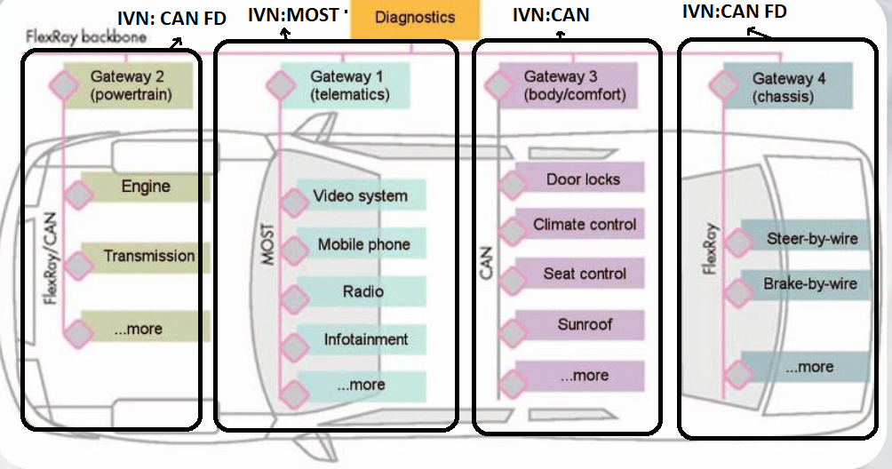

**Evolution of in-vehicle networks:**

Historically, in-vehicle networks were organized into logical domains, such as"Body", "Chassis", and "Powertrain".

These domains were interconnected through a central gateway.

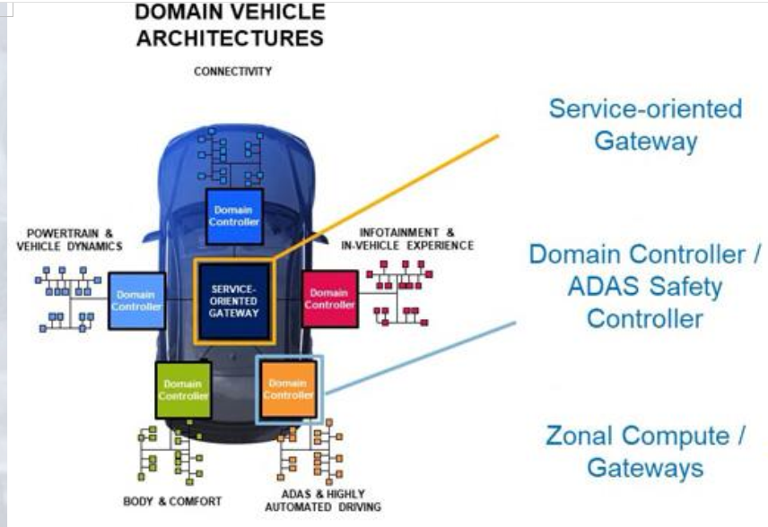

*:* In the future, the concept of specialized ECUs fordomain-specific functions will continue, **but** the general trendis moving toward separation according to physical location (Zones) rather than by logical function.

*:* Zone ECUs connect via high-speed networks to a central ECU where much of the processing is done.

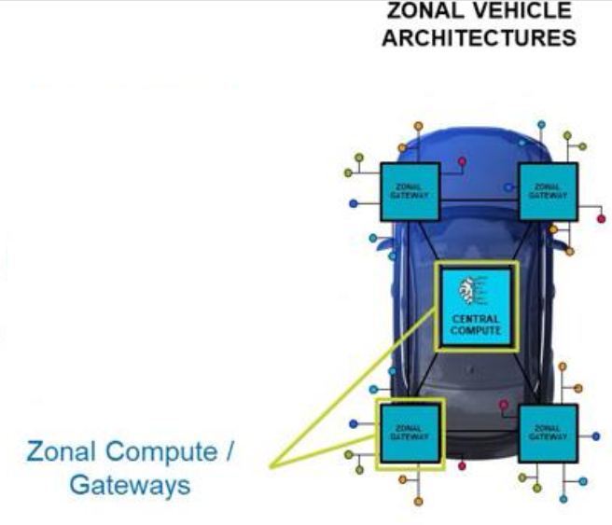

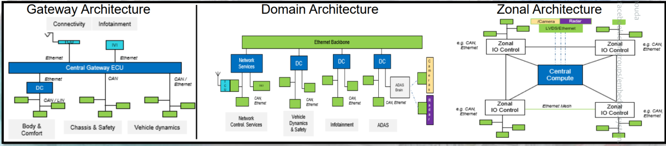

**Why CAN Bus ?**

From slide 10 to slide 16

**Remote Frame** is a request with specific ID from a node to tell other nodes that it wants to receive Data of this ID.

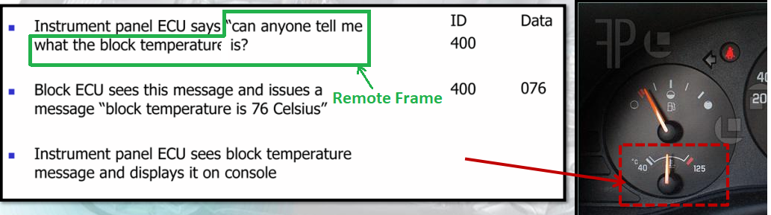

**CAN Overview:**

* Multi-master protocol
* **Broadcasting:**

refers to the way CAN messages are transmitted across the network. Unlike point-to-point communication where messages are sent directly from one device to another, broadcasting in CAN means that when a device (node) sends a message, it is sent to all other devices on the network simultaneously. Each node receives the message and decides whether it needs to process it based on the message ID.

* Event-Driven
* Asynchronous communication (Event Triggered)
* Serial communication technology
* Priority-basedbit-wise arbitration
* Variable message priority basedon 11-bit(or extended29 bit) packet identifier